Schiebler Barrier Replacements 2013 Implementation Monitoring Report

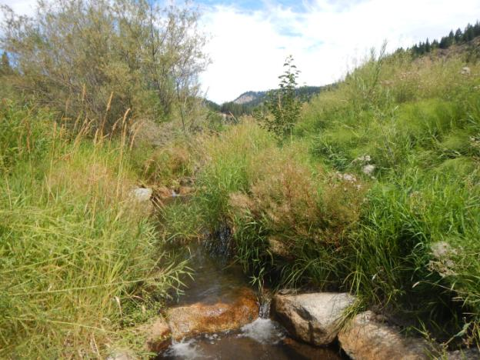

Prepared by: Chelan County Natural Resources Department

Adrienne Roumasset

**Introduction/Background**

The Schiebler Barrier Removal Project replaced 3 fish passage barriers between river mile 7.8 and 8.0 of Chumstick Creek as part of the Chumstick Barrier Removal project – a multi-agency partnership that removed all 30 Chumstick Creek fish passage barriers (26 culvert barriers and 4 irrigation dams) from RM 0.28 to RM 8.5 from 2001-2013. The Schiebler Barrier removal project was completed in 2011 and consisted of the removal of three rock and concrete dams (Figure 1). The 6 ft high upper barrier was removed and replaced with a 120 ft long roughened channel, average slope 4.8%, that includes woody material on the banks and floodplain. The middle and lower barriers were replaced with 6 (middle barrier) and 7 (lower barrier) channel spanning rock weirs that form a series of step pools. Woody material was placed within the right bank floodplain area of the middle barrier. By replacing the three barriers ESA listed species have access to an additional 1.8 miles of Chumstick Creek.

Chumstick Creek is historical spawning and rearing habitat of steelhead, bulltrout, and coho salmon. The overall objective of the Chumstick Barrier Removal project was to reopen habitat and reinstate migration of these species into Chumstick Creek. The specific goals of the Schiebler Barrier removal project is to 1)allow migration of salmonids past RM 7.8 by removing the three dams 2) re-vegetate the work area to provide a diverse riparian habitat. The goal of monitoring Schiebler is to assess whether these goals are being met. Observations and data collected will be used to recommend adaptive management actions as needed to meet project objectives.

Figure 1. The lower, middle and upper barriers pre-project construction

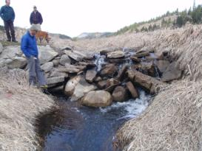 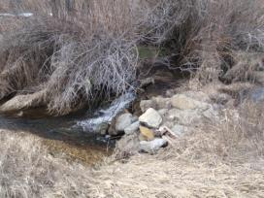

Lower barrier Middle Barrier

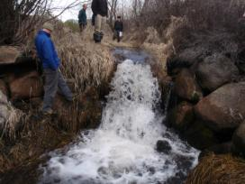

Upper Barrier

**Monitoring Methods**

CCNRD staff made a site visit on August 16th, 2013 and estimated flow to be near baseflow at 3 or 4 cfs. Exact flow is unknown due to malfunctions with the DOE gage. Specific monitoring goals during the site visit were to 1) Document channel condition at low flow 2) document weir condition and pool depths 3) assess the status of riparian revegetation. Fish passage through the three pit tag arrays in 2013 is also reported.

*Low flow Monitoring*

CCNRD staff took photos at established photo points during the August 16th visit during low flow. Pictures were compared to post construction (2011) and last year’s (2012) photos to document channel geomorphology and riparian cover. CCNRD staff also documented condition of the roughened channel LWD structures and recorded water temperature at the reach scale.

*Weir monitoring*

CCNRD staff measured pool depths below each of the 13 weirs (6 middle weirs, 7 lower weirs) and documented weir undermining if present. Numbers of weirs increase in a downstream direction.

*Riparian Monitoring*

Visual estimates of percent shrub cover were done throughout the planted area on both banks of the roughened channel, middle weirs and lower weirs. CCNRD staff also preformed a stem counts at the roughened channel and middle weirs, and recorded percent sedge cover on the sedge mats installed at the middle weirs.

**Results/Discussion**

*Low flow Monitoring*

Figure 2. Photo points- post-construction (left) and August 16th 2013 (right)

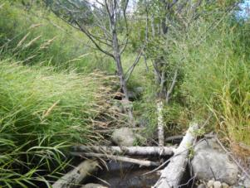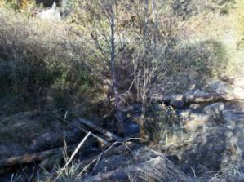

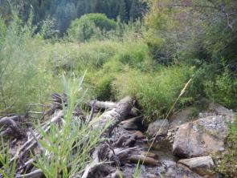PP1A (Roughened Channel)

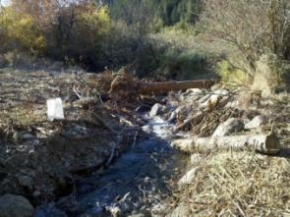

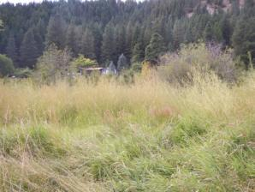PP2 (Roughened Channel)

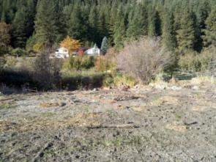

PP3 (Roughened Channel)

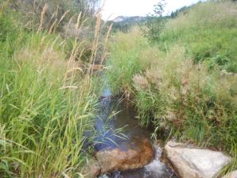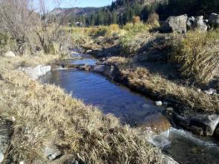

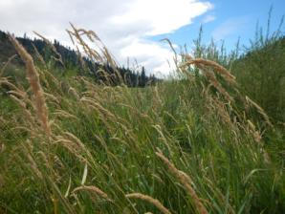  
PP4a (Middle Weirs)

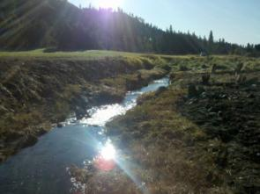

PP4b (Middle Weirs)

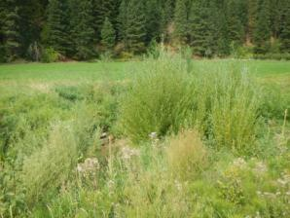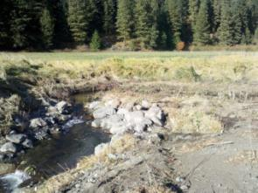

PP5A (Lower Weirs) shows willow stand (table 6 column one)

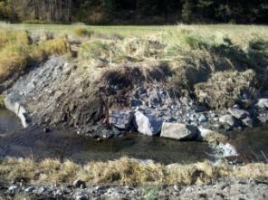 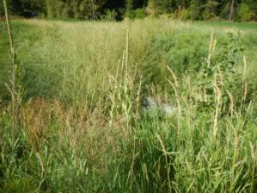

PP5B (Lower Weirs)

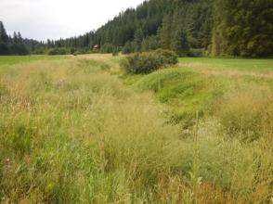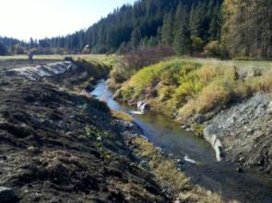

PP5C (Lower Weirs)

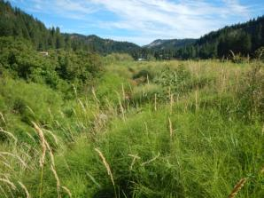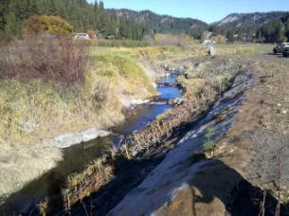

PP7 (Lower Weirs)

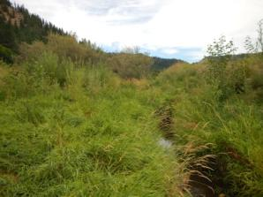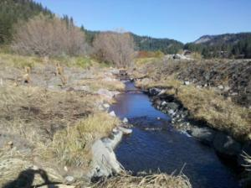

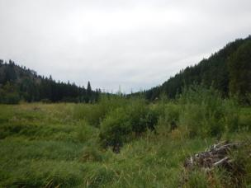PP10a looking up at middle weirs

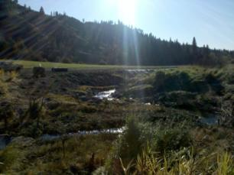

PP10b, looking down at lower weir floodplain area

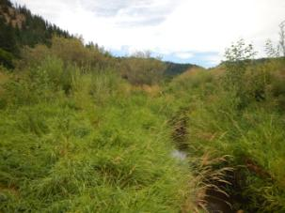 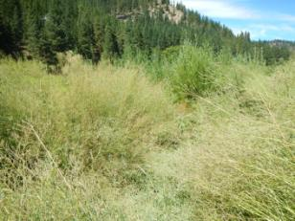

Tall willows on log, middle weirs

Sweet pea stream cover

Tall willows in floodplain

*View of photo points 1B and 1C were blocked by weeds and were not repeated (see photo below of left bank). Weeds impeded other photo points so many were taken at a slightly different spot.

Photo points and observations during the August 2013 indicate that the Schiebler project functions as designed as a fish passable, 0.2 mile reach consisting of a series of log structures (roughened channel, PP1A and PP2) and step pools (weirs, PP4a). All LWD structures remain in place and have acquired some additional branches and debris (PP2). The slide area just below the lower weirs has 90% re-vegetated. There is some deposition of the left side of the pool below middle weir 1 (most upstream) but does not appear to be affecting the function of the structure. No other areas of erosion or deposition were observed. Measured stream temperature on August 16th, 2013 was 15.0°C, which is within EPA’s optimal range for salmonids (≥16°C).

*Weir monitoring*

Table 1. Maximum pool depths and undermining at the middle and lower weirs on August 16th 2013

|  |  |  |  |
| --- | --- | --- | --- |
| **Middle weirs** | **approx. pool depth (ft)** | **Undermined?** | **notes** |
| 1 | 1.5 | no |  |
| 2 | 2 | yes | minor undermining left side |
| 3 | 1 | no |  |
| 4 | 2 | no |  |
| 5 | 3 | no | juvenile fish seen |
| 6 | 0.75 | no |  |

|  |  |  |
| --- | --- | --- |
| **Lower weirs** | **approx. pool depth (ft)** | **Undermined?** |
| 1 | 3 | no |
| 2 | 1 | no |
| 3 | 3.5 | no |
| 4 | 3 | no |
| 5 | 2 | no |
| 6 | 2.5 | no |
| 7 | 1 | no |

All weirs at the Schiebler project function as designed with no major undermining of weirs. Only middle barrier weir two had some minor undermining on the left side. Pool depth at low flow ranged from 0.75-3.5 feet with an average of 2 feet deep (Table 1).

*Riparian Monitoring*

Figure 3. Summary of Results of Percent shrub cover estimates at Schiebler.

Table 3. Roughened channel riparian stem count and percent shrub cover.

|  |  |  |  |  |  |
| --- | --- | --- | --- | --- | --- |
|  | stem count | |  | % cover |  |
| **Species** | **Left bank** | **Right bank** | **notes** | **Left Bank** | **Right Bank** |
| *SALIX -*willow | 26 | 24 | 10 (RB) are natural regeneration | 25 | 25 |
| *ALNUS INCANA spp. tenuifolia-* mountain alder | 1 |  |  | <5 |  |
| *POPULUS BALSAMIFERA*- black cottonwood |  | 2 |  |  | 5 |
| *CORNUS SERICEA*- red osier dogwood | 1 |  |  |  |  |
| *BETULA OCCIDENTALIS*- Western water birch |  |  |  |  |  |
| *ROSA NUTKANA*- nootka rose |  | 1 |  |  |  |
| **Total shrub cover** |  |  |  | **26-29** | **30** |
|  |  |  |  | Rest of cover sweet pea, RCG, knapweed | rest of cover mostly rock, RCG, and wood |

Table 4. Middle weirs stem count. Survival (total counted/total planting plan) = 53%

|  |  |  |  |  |
| --- | --- | --- | --- | --- |
| **Species** | **Left bank** | **Right bank** | **total** | **from planting plan** |
| *SALIX LASIANDRA-* pacific willow | 30 | 58 | **88** | 110 |
| *SALIX EXIGUA*- coyote willow | 8 | 11 | **19** | 109 |
| *ALNUS INCANA spp. tenuifolia-* mountain alder | 2 | 3 | **5** | 17 |
| *POPULUS BALSAMIFERA*- black cottonwood | 4 | 8 | **12** | 5 |
| *CORNUS SERICEA*- red osier dogwood | 3 | 3 | **6** | 5 |
| *BETULA OCCIDENTALIS*- Western water birch | 1 | 1 | **2** | 2 |
| Notes | lots of RCG, horsetail, knapweed btwn weirs 1 and 4 | mostly all from willows planted on logs |  |  |

Table 5. Percent cover along Middle weirs. Segments (i.e. 6-5) refer to adjacent weirs.

Average Left Bank shrub cover = 29%; Average Right Bank shrub cover = 73%

|  |  |  |  |  |  |
| --- | --- | --- | --- | --- | --- |
|  | **Left Bank** |  |  | **Right Bank** |  |
| **Species** | **6-5** | **5-4** | **4-1** | **6-3** | **3-1** |
| *SALIX LASIANDRA-* pacific willow | 40 | 7 | 5 | 30 | 10 |
| *SALIX EXIGUA*- coyote willow | 7 | 5 | 5 | 15 | 75 |
| *ALNUS INCANA spp. tenuifolia-* mountain alder | 7 |  |  | 10 |  |
| *POPULUS BALSAMIFERA*- black cottonwood | 5 |  | 2 | 5 |  |
| *CORNUS SERICEA*- red osier dogwood |  | 1 | 1 |  |  |
| *BETULA OCCIDENTALIS*- Western water birch |  |  | 2 |  |  |
| **Total shrub cover** | **59** | **13** | **15** | **60** | **85** |
| Notes |  |  | Horsetail and RCG dominate cover. |  |  |

Table 8. Lower weirs percent cover. Average left bank cover = 64% Average right bank cover = 26%

|  |  |  |  |  |
| --- | --- | --- | --- | --- |
|  | Left Bank |  | Right Bank |  |
| **Species** | **Upstream of weir 2** | **Weir 7 - 2** | **Upstream of weir 2** | **Weir 7 - 2** |
| *SALIX* - willow |  | 15 | 30 | 10 |
| *SALIX LASIANDRA-* pacific willow | 95 |  |  |  |
| *SALIX EXIGUA*- coyote willow | 5 |  |  |  |
| *ALNUS INCANA spp. tenuifolia-* mountain alder |  | 10 |  | 2 |
| *PRUNUS VIRGINIANA*- choke cherry |  | < 1 % |  |  |
| *POPULUS BALSAMIFERA*- black cottonwood |  | < 1 % |  |  |
| *CORNUS SERICEA*- red osier dogwood |  | < 1 % |  | 10 |
| **Total shrub cover** | **100** | **27** | **30** | **22** |
| Notes | Willows in thick stand 10-20 ft tall and together provide 80% shade cover along bend | Willows all near bank and 4-10ft tall. About 15 alders, 4-7 ft tall. 45% of cover is sweet pea, horsetail, prickly lettuce, RCG, knapweed, alfalfa, and mullein |  | Horsetail 55%, RCG 20%, mullein and sweet pea also present. Sweet pea dominates weirs 2-3, RCG and horsetail 3-7. Willow stakes (6-7 ft high) and a few birch have established on weirs. |

Table 6. Percent willow cover on perpendicular (to channel) placed logs on right bank

|  |  |
| --- | --- |
| **adjacent weir** | **% willow cover** |
| 6 | 90 |
| 5 | 85 |
| 4 | 95 |

Table 7. Sedge mat cover on Middle Barrier weirs

|  |  |  |  |
| --- | --- | --- | --- |
| **Weir** | **Bank** | **cover** | **notes** |
| 1 | L | 15 | mat is hanging off weir rocks |
| 1 | R | 70 |  |
| 2 | L | 30 |  |
| 2 | R | 50 |  |
| 3 | L | 20 |  |
| 3 | R | 25 |  |
| 4 | L | 15 |  |
| 4 | R | 40 |  |
| 5 | L | 60 |  |
| 5 | R | 20 |  |
| 6 | L | 80 | lower most weir |
| 6 | R | 75 |  |

Head high reed canary grass lined the banks at the Schiebler project. Cover estimates are based on native shrubs that were visible through the grass (i.e. were competing successfully). Average riparian shrub cover ranges from 26-73% site wide. Areas with high native shrub cover include a row of alders on the left bank of the lower barrier, the willows along the floodplain logs on the right bank of the middle weirs (Table 6), and the wetland area above lower weir 2. Maximum height of the pacific and coyote willows on the lower weir left bank wetland is 20 feet, resulting in 100% vegetative cover (Table 8) and 80% shade on the adjacent creek bend (during midday August visit). Lowest shrub cover was observed adjacent to lower weirs 1-5 (13-15%). The dominant shrub was pacific willow but plant diversity is high and includes western water birch, red osier dogwood, black cottonwood, mountain alder, choke cherry, Nootka rose, and coyote willow.

Based on the final planting plan for the site calculated plant survival at the middle weirs was 53%. This estimate may be low due to missed plants in the reed canary grass. Sedge mat cover at the middle weirs ranges from 15- 80 % (Table 7) with the lowest cover in locations where there is no soil on top of the rock beneath them.

Introduced species present at the site included reed canary grass, prickly lettuce and mullein and the noxious knapweed. Reed canary grass lines both banks throughout the site, and is particularly heavy on the right bank of the lower barrier, the left bank of the middle weirs, and both banks of the roughened channel. A significant amount of knapweed was observed on the left bank of the roughened channel, on the left bank of middle weirs 1-4, and on the left bank of middle weirs 2-7. Mullein and prickly lettuce were observed on both banks of the lower weirs 2-7. Sweet pea was thickest on the left bank of the lower barrier and at the roughened channel. Although intruded, sweet pea may benefit the site by fixing nitrogen in the soil and overhanging the stream and providing fish cover.

*Fish Passage*

Table 8. Adult salmonids detected at 3 fish arrays on Chumstick Creek in 2013

|  |  |  |  |
| --- | --- | --- | --- |
| **Species** | **North Road (RM 0.28)** | **Sunitch (RM 5.3)** | **Merry (RM 8.82)** |
| Wild Summer Steelhead | 11 | 2 | 1 |
| Hatchery Summer Steelhead | 9 |  |  |
| Hatchery Coho | 4 |  |  |
| Wild Spring Chinook | 2 |  |  |
| Hatchery Spring Chinook | 4 |  |  |
| **Total** | **30** | **2** | **1** |

Fish array data indicates that at least 2 tagged wild summer steelhead migrated past RM 5.3 at Sunitch and 1 migrated past RM 8.82 at Merry (Scheibler is between RM 7.8 and 8.0). This represents 20% and 10% of the overall wild summer steelhead detected at North Road array located at the mouth of the Creek. Detections at fish arrays represent approximately 10% of the actual run.

**Conclusions and Recommendations**

Data from the fish array at Merry Canyon indicates the Scheibler project has meeting the goal of opening up historical fish habitat to wild summer steelhead (Table 8). Weir monitoring and photo points indicate the project functions as designed as a fish passable reach with LWD structures, pools of varying depths (0.75 – 3.5 feet at low flow), and overall complex habitat. No major erosion or sediment deposition was observed and all weirs appeared functional with the exception of some minor undermining on the river left side of middle weir 2. The LWD structures within the roughened channel have recruited some additional small woody debris. Stream temperature was within the optimal range for salmonids on a very hot summer day (August 16th 2013, 15°C).

The riparian area impacted by the Scheibler barrier removal project has completely revegetated with a mix of native shrubs and introduced species. Thick reed canary grass lined the banks of most areas within the reach. However, shrub cover is high in many areas (i.e. 90-100% on lower weir wetland and middle weir floodplain logs), ranges from 26-73% and is diverse (7 native shrub species). Sweet pea was present and although introduced is not a concern. Introduced species observed include the noxious weed knapweed and reed canary grass, prickly lettuce, mullein and sweet pea. Sedge mat cover is better at the middle barrier (average ~ 42%) than at the lower barrier.

It is recommended that the CCNRD visit the site on a yearly basis to repeat photo points and monitor weir integrity, pool depth, and riparian cover. Ideally, the visit should be in mid-July to avoid the peak of reed canary growth and coordinated with individuals from other agencies who wish to visit the site. Native shrubs are competing well with invasives so no planting is recommended at this time. Upon landowner agreement, the CCNRD should work with the Chelan County Weed Board to eradicate the knapweed at the site.