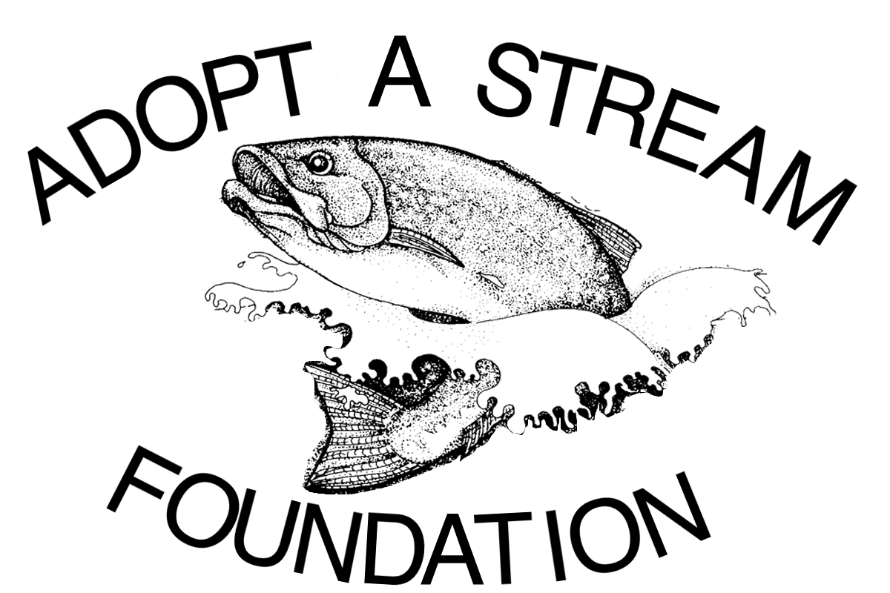

Bear Creek Reach 6 Restoration - Phase II

Prepared August 27, 2015

Proprietary and Confidential

R E Q U E S T F O R P R O P O S A L

**PURPOSE OF THE REQUEST FOR PROPOSAL**

The Adopt A Stream Foundation (AASF) is seeking proposals from qualified firms and individuals to complete permit-ready engineered final design drawings for Bear Creek Stream Restoration, Phase II, located in the Friendly Village Mobile Home Park in Redmond, WA, along Bear Creek Reach 6 (Map 1). The Salmon Recovery Funding Board (SRFB) is funding this project. The primary objective of the project is to design a stream restoration project that will provide the maximum benefit to rearing juvenile Chinook salmon.

In 2013, AASF completed Phase I of this project immediately upstream of the current project location. Phase I included the installation of 42 pieces of large woody debris (LWD) and converted 0.35 acres of lawn to a native riparian plant community. Our successful completion of Phase I has gained us the trust of the landowner and allowed us to pursue additional stream restoration opportunities. Phase II will result in designs to enhance instream habitat along 330 linear feet of mainstem Bear Creek and convert 1.0 acres of lawn into a native riparian forest (Map 1).

Project shall be designed to improve salmon habitat and increase fish production by: installing LWD, re-vegetating the riparian, increasing flood plain connectivity and re-establishing stream processes.  Final designs will not be considered as complete until they have been approved by The Adopt A Stream Foundation, The Salmon Recovery Funding Board WIRA 8 and Friendly Village Park landowner, Matt Marcus.

**ASSUMPTIONS**

The goal of the project is to maximize benefit to salmonids (primarily juvenile Chinook) in a reach that has been identified in salmon recovery plans as having:

* Decreased floodplain connectivity and decreased off-channel habitat because of channel confinement.
* Very little large woody debris.
* Poor native riparian vegetation cover.

Due to development the channel is somewhat disconnected from its historic flood plain and is constricted by several stream crossings, leading to degraded habitat conditions and flooding in developed portions of the property. LWD increases channel complexity, contributes to channel stability, develops pools, traps sediment, and reduces water temperature. Restoring riparian vegetation will improve channel stability, provide sources of large woody debris that can contribute to creation of pools, and reduce peak water temperatures that favor non-native species.

Degraded channel conditions in this reach have significantly reduced fish production when compared to historic levels. The loss of a native riparian buffer has resulted in an increase in summer peak temperatures which can be lethal to salmonids, a loss of natural filtering and ground water recharging processes, a widening and shallowing of the channel and channel incision, all of which limit salmonid production in this reach either directly by killing fish (temperature) and increasing exposure to predators (shallow), or indirectly by limiting spawning and rearing habitat (intraspecific competition).

SRFB Condition:

“To improve in-stream spawning and rearing, larger structures further out into the main channel would likely be required. This could be achieved by alternating the bank sloping from left to right bank, etc. and creating a meander pattern and hydraulic complexity. We understand the potential for this change in channel form may be limited due to infrastructure or utilities on site”. See below for map of onsite sewage system.

It is desirable to the AASF that any proposed designs can be permitted under the Washington Department of Fish and Wildlife Application for Streamlined Process for Fish Habitat Enhancement Projects.

**PROPOSALS**

AASF is seeking proposals from qualified firms and individuals to complete permit-ready engineered final design drawings for the second phase of stream restoration at the Friendly Village Mobile Home Park in Redmond, WA along Bear Creek Reach 6 (Map 1). The Salmon Recovery Funding Board (SRFB) is funding this project. The primary objective of the project is to design a stream restoration project that will provide the maximum benefit to juvenile Chinook salmon, increase rearing habitat.

Project Specifics:

The proposed project is located within the Friendly Village Mobile Home Park in Redmond, WA. The project area starts immediately downstream of the Snohomish drive bridge and continues downstream for approximately 330’ along both banks to the Friendly Village property boundary. The planting area widths extend approximately 50’ on the left bank and 100’ on the right bank (Map 2). The footbridge in the project area will be removed as part of the steam restoration project. It is essential that all proposed restoration, primarily installed logjams, does not increase flood stage.

The Contractor shall coordinate with the City of Redmond, Habitat Bank LLC and other agencies to make this project compatible with future restoration efforts in Bear Creek Reach 6.

The outputs of this design work must be consistent with guidelines outlined in the SRFB Manual 18 (<http://www.rco.wa.gov/documents/manuals&forms/Manual_18.pdf>).

If a contract is awarded, the successful Contractor must provide a certificate of coverage at the time of contract execution, indicating proof of insurance coverage with limits not less than $1,000,000 property damage per claimant, $2,000,000 all other claims per claimant, $5,000,000 all claims. Such insurance shall be evidenced by Certificate of Insurance provided to the Adopt A Stream Foundation, indicating coverage, limits and effective dates, by an insurance company licensed to do business in the State of Washington. If a contract is awarded, the successful Contractor must provide documentation of Errors and Omissions (professional liability) Insurance Coverage.

**TASK TABLE**

The following table contains tasks that the AASF desires to be completed. Additional tasks may be added and should be described in the proposal.

|  |  |
| --- | --- |
| Task | Description |
| 1 | Conduct field investigations of current site and structure conditions. |
| 2 | Communicate with stakeholders during design process. |
| 3 | Develop Preliminary designs (must be approved by AASF, SRFB and landowner before moving to final designs) |
| 4 | Prepare permit-ready final designs |
| 5 | Produce design drawings for inclusion in permit applications. |
| 7 | Prepare a design report |
| 8 | Satisfy cultural resources requirements for this project |

Work on the design project will be completed by December 31, 2016.

Please submit your proposal to perform the tasks listed above and any additional tasks. In your proposal provide costs associated with each task separately and a timeline for completing the tasks. In addition to your proposal, please submit a Statement of Qualifications for performing similar work.

Additional resources are available which may be helpful when responding to this RFP. Please contact the Adopt A Stream Foundation to gain access to these additional documents through the Recreation and Conservation Office’s PRISM database for SRFB projects. If you already have access to PRISM you can find the resources by looking at the approved grant application for this project #15-1059 “Bear Creek Reach 6 Restoration Phase II” under the “attachments” tab.

AASF is seeking to identify and select an outside independent organization to perform the tasks listed above. The remainder of this document provides additional information that will allow prospective contractors to understand the scope of the effort and develop a proposal in the format desired by AASF.

**ADMINISTRATIVE**

CONTACT

Any questions concerning technical specifications, Scope of Work requirements or contractual terms and conditions should be directed to:

Walter Rung  
Senior Ecologist, Habitat Program Manager   
Adopt A Stream Foundation  
Everett, WA 98208  
P. 425.316.8592 ext. 111| F. 425.338.1423   
<walterr@streamkeeper.org>

**DUE DATES**

All proposals are due at the Adopt A Stream Foundation physical office by 5:00 pm on September 30th, 2015. Any proposal received at the designated location after the required time and date specified for receipt shall be considered late and non-responsive. Late proposals will not be evaluated for award.

**SCHEDULE OF EVENTS**

|  |  |
| --- | --- |
| 1. RFP Distribution to Contractors | 1/4/2016 |
| 2. Site Visit to Project Site – 10:00-11:00 am | 1/12/16 |
| 2. Proposal Due Date | 2/4/16 |
| 3. Target Date for Review of Proposals | 2/29/16 |
| 4. Final Contractor Selection – Week of | 3/1/16 |
| 5. Contract negotiation – Week of | 3/7/16 |
| 6. Anticipated commencement date of work | 4/1/16 |
| 7. Project Completion date | 12/31/16 |

**GUIDELINES FOR PROPOSAL PREPARATION**

**PROPOSAL SUBMISSION**

Award of the contract resulting from this RFP will be based upon the most responsive contractor whose offer will be the most advantageous to AASF in terms of work product, functionality, cost and other factors as specified elsewhere in this RFP.

AASF reserves the right to:

* Reject any or all offers and discontinue this RFP process without obligation or liability to any potential contractor,
* Accept other than the lowest priced offer,
* Award a contract on the basis of initial offers received, without discussions or requests for best and final offers, and
* Award more than one contract.

Contractor's proposal shall be submitted in several parts as set forth below. The Contractor will confine its submission to those matters sufficient to define its proposal and to provide an adequate basis for AASF evaluation of the Contractor’s proposal.

Contractor’s proposal in response to this RFP will be incorporated into the final agreement between AASF and the selected Contractor(s). The submitted proposals should include each of the following sections:

Executive Summary

Approach and Methodology

Project Deliverables

Project Management Approach

Detailed Budget

Appendix: References

Appendix: Project Team Staffing

Appendix: Company Overview

The detailed requirements for each of the above-mentioned sections are outlined below. Total proposal length (including Appendices) should not exceed 25 pages.

**DETAILED RESPONSE REQUIREMENTS**

**EXECUTIVE SUMMARY**

This section will present a high-level synopsis of the Contractor’s responses to the RFP. The Executive Summary should be a brief overview of the engagement, and should identify the main features and benefits of the proposed work.

**SCOPE, APPROACH, AND METHODOLOGY**

Describe proposed data collection and analysis procedures and technical expertise. This section should include a description of each major type of work being requested of the Contractor. The proposal should reflect each of the tasks in the Task Table.

AASF and their partner organizations will provide the following information in support of completing this work:

* Map of project area (Map 1).
* Riparian restoration areas (Map 2).
* Sewer lines (Map 3).
* AASF will notify landowners and arrange entry for the Contractor.

**DELIVERABLES**

Deliverables for this project shall consist of: 1) design drawings suitable for construction; 2) engineer’s cost estimates of permitting and construction; 3) procure through a third party a cultural resources report; and 4) a design report.

**PROJECT MANAGEMENT APPROACH**

Briefly describe the method and approach used to manage the overall project and client correspondence.

**DETAILED BUDGET**

Include a cost breakdown by Task, including labor costs and estimates of all reimbursable items. Provide a rate sheet listing the title and hourly billing rate for all personnel who will be involved in the project

**APPENDIX A: REFERENCES**

Provide project descriptions and contact information for three current references for whom you have performed similar work.

**APPENDIX B: PROJECT TEAM STAFFING**

Identify the team organization and key staff members proposed for work on this project. Include resumes and brief biographies describing the relevant experience of key staff and management personnel.

**APPENDIX C: COMPANY OVERVIEW**

Provide the following for your company:

* Official registered name and legal structure (e.g. sole proprietorship, partnership, corporation)
* Address, main telephone number, toll-free numbers, and facsimile numbers.
* Washington State Business License Number (UBI). A UBI number is a 9-digit number that registers you with several state agencies and allows you to do business in Washington State. A UBI number is sometimes called a tax registration number, a business registration number, and a business license number.
* Key contact name, title, address (if different from above address), direct telephone and fax numbers.
* Person authorized to contractually bind the organization for any proposal against this RFP.

**EVALUATION** **CRITERIA**

Any award to be made pursuant to this RFP will be based upon the proposal with appropriate consideration given to operational, technical, cost, and management requirements. Evaluation of offers will be based upon the Contractor’s responsiveness to the RFP and the total price quoted for all items covered by the RFP.

The following elements will be the primary considerations in evaluating all submitted proposals and in the selection of a Contractor or Contractors:

* The extent to which Contractor’s proposed solution fulfills AASF’s stated requirements as set out in this RFP (20%)
* An assessment of the Contractor’s ability to deliver the indicated service in accordance with the specifications and timeline set out in this RFP (20%)
* The Contractor’s stability, experiences, and record of past performance in delivering such services (20%)
* Availability of sufficient high quality Contractor personnel with the required skills and experience for the specific approach proposed (20%)
* Overall cost of Contractor’s proposal (20%)

AASF may, at their discretion and without explanation to the prospective Contractors, at any time choose to discontinue this RFP without obligation to such prospective Contractors.