##### Meadowdale: Informing Coastal Stream Restoration

##### (Viability and function of Stream Mouth / Embayment Restoration along Sediment Starved Coastal Puget Sound Shorelines)

##### PRISM project # 22-1754 P

##### Cost

Requested ESRP Funds: $139,821

Matching Funds:  $60,318

Project Total: $200,158

##### Abstract

The Tulalip Tribes and partners will investigate the ecological and geomorphic outcomes of the Meadowdale Park estuary restoration project to inform the siting, design, and successful outcomes of future barrier-lagoon and coastal stream mouth restoration projects. The Meadowdale project is the first stream mouth restoration project along the Puget Sound railroad corridor. Improving understanding of required elements including excavation size and design of the restored estuary and inlet and maintain sufficient fluvial and coastal hydrodynamic processes that will function for fish and wildlife and account for sea level rise is paramount for informing restoration of 100s of additional small stream mouths needed to support salmon recovery in light of lost estuary functions. The proposed investigation will inform onsite and offsite benefits of restored sediment transport conditions, as well as the sustainability of the estuary design.

##### Contact Information

**Project Proponent:** Todd Zackey - Marine & Nearshore Program Manager

Tulalip Tribes Natural Resources Department

[tzackey@tulaliptribes-nsn.gov](mailto:tzackey@tulaliptribes-nsn.gov)

 (360) 716-4637

**Project Partners:**Paul Schlenger – Principal Associate Elisa Dawson – Senior Planner

ESA | Environmental Science Associates Snohomish County Surface Water Management

[pschlenger@esassoc.com](mailto:pschlenger@esassoc.com) [elisa.dawson@snoco.org](mailto:elisa.dawson@snoco.org)

(206) 601-1405 (253) 215-8782

Frank Leonetti – Fisheries Biologist Eric Grossman, PhD – Research Geologist

Snohomish County Surface Water Management USGS/Western Washington University

[Frank.leonetti@snoco.org](mailto:Frank.leonetti@snoco.org) [egrossman@usgs.gov](mailto:egrossman@usgs.gov)

(425) 262-2588 (360) 650-2538

##### Start and End Date

July 1, 2023 through September 30, 2025

##### Technical Information

###### 1. Problem Statement

The Meadowdale Estuary Restoration Project is the first coastal stream mouth restoration project along the railroad-impacted shoreline of Puget Sound. The restoration project, funding in part by ESRP project #18-1587, replaces an undersized culvert through the railroad embankment with a 130-foot long bridge and excavates a 1.3-acre estuary upstream of the railroad embankment. This regionally significant restoration project presents a unique opportunity to future stream mouth restoration siting and design along the railroad as well as throughout Puget Sound along sediment starved shorelines.

The proposed investigation will focus on the geomorphic and ecological outcomes of the restoration. The stream mouth reconnection and estuary expansion is intended to restore sediment transport and deposition processes to provide improved conditions in the lower stream, estuary, and adjacent nearshore areas. The proposed investigation will document the adjustment of the restored site as fluvial and coastal processes act on it and will inform the sustainability of the design and investment. Understanding the “offsite” benefits to the adjacent nearshore habitats will add information on how stream mouth restoration can improve conditions along sediment starved beaches where feeder bluffs are substantially disconnected through extensive railroad or shoreline armoring stressors.

Investigation of the ecological benefits, notably use by juvenile Chinook salmon originating in other river systems will be highly informative for future restoration siting and design, and provide key information documenting project benefits to stakeholders, funders, restoration practitioners, and the entire community. Salmon habitat restoration was a significant desired outcome of the restoration and the contributing funding sources. The proposed investigation will inform the return on the investment, thus guiding where and how to work in the future. Assuming juvenile chinook salmon use the restored habitats, the proposed investigation can help document the salmon benefits of independent coastal stream mouth restoration. This information is important for land and infrastructure owners along the shoreline who are asked to allow or partner on or even lead restoration. The information is also important for grant funding programs and state, local, tribal, non-profit entities considering future shoreline restoration.

###### 2. Hypothesis Statement

The proposed investigation will evaluate the geomorphic and ecological outcomes of the restoration. The geomorphic data will primarily inform site design based on information about sediment transport and deposition, adjustments in inundation area, and outlet channel dynamics. The ecological data will inform site selection and design through information on salmon use, natal streams of salmon, design features most used by salmon, and use by broader nearshore fish community.

Following are selected hypotheses from the Meadowdale Beach Park and Estuary Restoration Monitoring Plan (attached in PRISM) that are particularly relevant for site selection and site design. The Monitoring Plan divided the site into five areas (Figure 1 in Monitoring Plan) where different data collection is planned and which are referenced in the hypotheses:

* **Lower Lund’s Gulch Creek** – Portion of the stream where restoration occurred
* **Creek Outlet** – Transitional area as creek widens as it enters the restored upper estuary.
* **Upper Estuary** – Restored tidal estuary landward of the railroad including the area under the railroad bridge.
* **Lower Estuary** – Estuary waterward of the railroad bridge and including the entire shoreline delta.
* **Adjacent Nearshore** – Adjacent areas north and south of the project area.

Hypothesis for Upper Estuary and Creek Outlet Sediment Dynamics and Habitat Area

* The low flow channels will dynamically move around in location to occupy different parts of the upper estuary as sediment from the stream is delivered and redistributed.
* After an initial period of net sediment deposition, the annual net deposition volumes will decrease, presumably as more sediments are transported through the upper estuary and into the lower estuary.
* For an initial period following construction, there will be marked adjustments in the inundated area and volume in the upper estuary due to the deposition of stream sediments.
* A flood-tidal deposit will form inside the upper estuary and the extent of sediment supply (littoral and residual fluvial) will dictate whether the restored lagoon remains open year round or only temporarily during sufficient creek discharge.

Hypothesis for Lower Estuary and Adjacent Nearshore Sediment Dynamics

* The lower estuary channel will remain oriented in a north-south configuration and provide pocket estuary habitat.
* The pocket estuary area between MLLW and mean higher high water (MHHW) in the lower estuary will increase following construction.
* Over time, sediment from Lund’s Gulch Creek will increase the elevations across the transects sampled in the adjacent nearshore area to the north.
* The increase in inlet size, flow, and sediment exchange between the creek and nearshore will lead to additional habitat complexity in the small stream delta and greater wildlife diversity and productivity in the nearshore.

Hypothesis for Fish Use

* Juvenile Chinook salmon will occupy the site in higher numbers compared to pre-construction numbers.
* Juvenile Chinook salmon will occupy portions of the estuary providing cover habitat, such as large wood, deep pools, or large substrate.
* More juvenile Chinook salmon will be captured in the restored habitats compared to the adjacent nearshore habitats.
* Juvenile Chinook salmon from multiple river systems, including north and south of the site, will use the restored habitats.
* A diverse community of fish species – other than Chinook salmon – will occupy restored habitats in the upper estuary and lower estuary.
* There will be a greater diversity of fish prey in the restored estuary compared to the adjacent nearshore.

###### 3. Methods and Efficiency/Technical Merit

Methods & Analysis

Aerial Imagery - Aerial imagery will be collected three times a year, spring, summer, & fall, at a tidal elevation of 0’ or less. Imagery will be collected utilizing an Ebee fixed wing drone with a pre-programmed flight path. 16 ground control point (GCP) targets will be surveyed with an RTK GPS for use in orthorectifying the imagery (Casella et al. 2020). Generation of a DSM will be done using Pix4D software which will be imported into ESRI ArcGIS for analysis of changes in elevations across the project site between UAV flights. Additional check of elevations derived from the DSM will be done utilizing RTK GPS transect profiles that are done during or within a week of when the UAV flight was conducted following guidance from Casella et al. 2020 and Long et al. 2016.

RTK GPS Beach Profiles - Nine beach profile transects have been established for the study site. An RTK GPS is used to take point measurements every 3 meters and at locations where the beach slope or surface substrate changes. Beach profiles will be collected 3 times annually after a UAV flight and additional data collection will be conducted after significant climatic events, heavy precipitation and/or wind storms which may significantly alter the beach and estuary configuration. Profile data will be QA/QC and used to produce a DTM utilizing ArcGIS software.

The final profile data will be compared to the UAV imagery derived DSM to help determine the accuracy and precision of the DSM. Comparison of profile elevations will be conducted to determine profile elevation changes over time. The series of derived DTMs will be analyzed in ArcGIS to evaluate beach elevation and morphological changes over time and to assess volumetric changes in substrate over time utilizing methods outlined in Miller 2011.

Tracking of RFID PIT Tagged Sediment - RFID PIT Tagged sediment has been used to track travel times and distance for different sized sediment classes to determine sediment transport rates and direction of travel, Miller 2011, Miller et al. 2011, & Weaver. 2013, which is important to determine the fate of updrift and stream sediment to the restored estuary embayment. For this study we will utilize RFID PIT tagged sediment ranging in size from 3 to 13 cm in diameter and follow procedures outline in Miller 2011 and Weaver 2013. We will deploy sets of clasts of different sizes at different elevations, locations and times with respect to tides, storms and creek discharge to evaluate how the combination of coastal and fluvial processes move materials through the system. Maps of sediment transport trajectories will be generated with the surveys of the located clasts and related to transport mechanisms (e.g., tides, waves, winds, stream discharge) and used to test models.

Analysis of the tagged sediment results will be conducted in coordination with WWU staff and will assess transportation rates and direction of movement based on prevailing winds, precipitation/ streamflow, starting location (stream, beach, tidal elevation), and if we are able to deploy a wave meter, mean wave height.

Sediment Transport Tracking - Sediment tracking will make use of several approaches to quantify rates and processes driving sediment transport, characterize habitat change, and gather important validation data for modeling sediment transport across estuaries, inlets, and beaches. The sediment tracking component of this grant includes collection of:

* Aerial imagery and generation of digital surface models (DSM) via UAV for tracking changes in beach elevations, surface sediment class sizes, and changes in the beach and estuary configuration.
* Beach and estuary embayment RTK GPS profiles to generate and georeference digital terrain models (DTM) and track changes in beach profiles, volume changes, and to classify substrates in aerial imagery s and UAV derived DSMs.
* Tracking of RFID PIT tagged sediment to determine transport dynamics and rate of transport of varying sized clasts across the study area
* Sediment mapping and classification will be conducted utilizing a combination of substrate type recorded during RTK GPS beach profile surveys as well as supervised classification and machine learning approaches utilizing remote sensed aerial imagery from UAS surveys and time-lapse imagery from fixed cameras

Biological Data Collection and Analysis - Biological data collection started in February 2021 with fish data collection and will expand to include the collection of plankton samples, invertebrates from fallout traps, juvenile salmon stomach content, and DNA samples of all juvenile chinook caught. All of this data collection is and will be funded by an EPA NEP grant as match. However, we do not have sufficient funds to process these samples and have added into the application the option of funding the processing and laboratory analysis of the samples. Processing would entail:

* Plankton - processing of approximately 20 plankton samples collected over two years to identify plankton assemblages and proportion inside the estuary and the adjacent shoreline to determine prey field for juvenile salmon.
* Terrestrial Invertebrates - Processing of approximately 60 invertebrate samples from fallout trap to determine the terrestrial invertebrate prey field available to juvenile salmon within the estuary.
* Juvenile Salmon Stomach Content - processing of up to 40 stomach content samples to determine if juvenile salmon are consuming prey from the restored site.
* Juvenile Chinook DNA samples - processing up to 50 DNA samples of juvenile chinook to determine river of origin utilizing the restored system to identify which populations benefit from restoration efforts along this portion of the railroad corridor.

Time-lapse Photography (Match) - A solar powered Erdman Video Systems Mako TL time-lapse camera system has been installed in a tree on the bluff overlooking the shoreline project area. The camera is a 18MP DSLR camera in a weatherproof housing with a cellular modem. The picture interval can be changed remotely as needed and the images are automatically uploaded via cellular network to a webpage on the Erdman website where the images can be easily downloaded. Imagery from the time-lapse camera will be used to make qualitative observations of beach morphology changes and time-stamping events that have caused significant changes in the beach and estuary morphology and for use in the USGS CoSMoS model.

Fish Sampling (Match) - Bi-weekly sampling will be conducted February through June with electrofishing sampling being conducted at low tide in the stream channel, and beach seining at high tie in the estuary and outside nearshore areas.

Invertebrate sampling (Match) - a neuston plankton net will be used to sample plankton during beach seining sampling. Samples will be preserved in buffered formalin in labeled vials.  Fall-out traps will be used to collect terrestrial invertebrates and will be conducted monthly March through June. Samples will be preserved in ethanol in labeled vials.

Juvenile Salmon Stomach Content (Match) - lavage samples will be collected from juvenile salmon during fish sampling efforts and preserved in buffered formalin in labeled vials.

Juvenile Chinook DNA (Match) - Caudal clips will be collected for all juvenile chinook encountered during fish sampling and preserved in ethanol in labeled vials

###### Budget Narrative

**1.0 Project Administration**

* + - Salary-     $1,905
    - Fringe-    $438

Salary and fringe for PM for project tracking, budgeting, and reporting.

* + - Contractual- $5,000

Consultant will assist with reporting the required grant updates and reporting

* + - Indirect-    $461.28

Tulalip Tribes current indirect rate is 19.69% and is not applied to equipment or contracts

**2.0 Project Plan**

* + - Salary-     $1,905
    - Fringe-    $438

Salary and fringe for staff do develop the required project plan

* + - Contractual- $3,500.00

    Contracting will work with PM and Snohomish County staff to develop project plan

* + - Indirect-    $461.28

    Tulalip Tribes current indirect rate is 19.69% and is not applied to equipment or contracts

**3.0 Wiki Content**

* + - Salary-     $1,143
    - Fringe-    $263

Salary and Fringe for Staff to create Content and upload to Project Wiki webpage

* + - Contractual-$2,500

Contracted staff will generate Wiki and update as necessary

* + - Indirect-    $276.77

Tulalip Tribes current indirect rate is 19.69% and is not applied to equipment or contracts

**4.0 Data Collection and Processing**

**4.1 Beach & Embayment Transects**

* + - Salary-     $10,143
    - Fringe-    $2,415

Salaries and fringe for staff to conduct stream, embayment and beach surveys.

* + - Travel-    $100

Cost of 8 - 50 mile round trips in GSA vehicle at a rate of $0.25/mile

* + - Supplies-    $50

Supplies budget for miscellaneous survey supplies, safety vests, flagging, tape measure, etc.

* + - Contractual- $4,000

Contractor data collection of beach and embayment transects. Need several parties available to collect data because of the need to get transects at odd times at night in winter and after episodic weather events (wind storm and/or heavy precipitation which will affect beach and embayment sediment distribution.

* + - Indirect-    $2,502.15

Tulalip Tribes current indirect rate is 19.69% and is not applied to equipment or contracts

**4.2 RFID PIT Tagged gravel tracking**

* + - Salary-     $10,143
    - Fringe-    $2,415

Salaries and fringe for two staff to track pit tagged gravel across the project site. Estimated 3-4 deployment/year, with a follow up of 3 surveys to find tagged sediment after deployment

* + - Travel-    $100

Cost of 8 - 50 mile round trips in GSA vehicle at a rate of $0.25/mile

* + - Equipment-    $3,360.00

HPR Plus Handheld PIT Tag Reader for tracking PIT tagged sediment as it moves due to coastal and stream processes

* + - Supplies-    $200.00

Supplies budget for miscellaneous supplies needed to configure PIT Tag reader for scanning ground and items like marker flags, buckets for caring tagged sediment

* + - Contractual- $4,000

Contractor data collection of gravel movement. Need several parties available to collected data because of the need to track tagged sediment at odd times, at night in winter and after episodic weather events (wind storm and/or heavy precipitation which will effect transportation of sediment at the site.

* + - Indirect-    $2,531.68

Tulalip Tribes current indirect rate is 19.69% and is not applied to equipment or contracts

**4.3 Aerial imagery acquisition (UAS flights)**

* + - Salary-     $4,119
    - Fringe-    $988

Three UAV flights will be conducted annually for 2 years requiring two staff to conduct the flights and associated logistics and imagery processing.

* + - Travel-    $100

Cost of 8 - 50 mile round trips in GSA vehicle at a rate of $0.25/mile

* + - Indirect-    $1,025.36

Tulalip Tribes current indirect rate is 19.69% and is not applied to equipment or contracts

**4.4 Sediment mapping and classification**

* + - Contractual- $10,000

Contracting with WWU staff to assist with analyzing PIT tagged sediment movement and processing of time-lapse camera data to evaluate changes in substrate composition. Advance modeling of sediment transport and beach morphologic change in response to tides, waves, storms and stream discharge and associated fluvial sediment inputs.

**4.5 Biological Sample Analysis**

* + - Contractual - $19,750

Analysis of 20 neuston tow plankton samples at estimated $200 per sample ($4,000), Analysis of the stomach content of 40 juvenile salmon estimated at $200 per sample ($8,000), Analysis of 60 fall out samples at an estimated $100 per sample ($6,000), and analysis of 50 chinook DNA samples at an estimate $35 per sample ($1,750)

**5.0 Interim Results Analysis**

* + - Salary-     $5,262
    - Fringe-    $1,251

Salaries and fringe for PM to conduct data QA/QC, preliminary data analysis, and data interpretation

* + - Contractual- $20,000

Contractor will assist PM with data QA/QC and geomorphic data analysis and interpretation ($10,000) and contract with WWU staff to assist with data analysis of sediment transport and volume analysis ($10,000)

* + - Indirect-    $1,282.43

Tulalip Tribes current indirect rate is 19.69% and is not applied to equipment or contracts

**6.0 Final Project Report**

* + - Salary-     $5,262
    - Fringe-    $1,251

Salaries and fringe for staff to final report analysis, interpretation, and write up

* + - Contractual- $5,000

Contractor will assist PM with final report analysis, interpretation, and write up

* + - Indirect-    $1,282.43

Tulalip Tribes current indirect rate is 19.69% and is not applied to equipment or contracts

**7.0 Final Project Presentation**

* + - Salary-     $1,343
    - Fringe-    $325

Salaries and fringe for PM to prepare and present a final project presentation

* + - Contractual- $1,000

Contractor will work with PM to prepare and present final presentation

* + - Indirect-    $328.46

Tulalip Tribes current indirect rate is 19.69% and is not applied to equipment or contracts

###### 5. Map

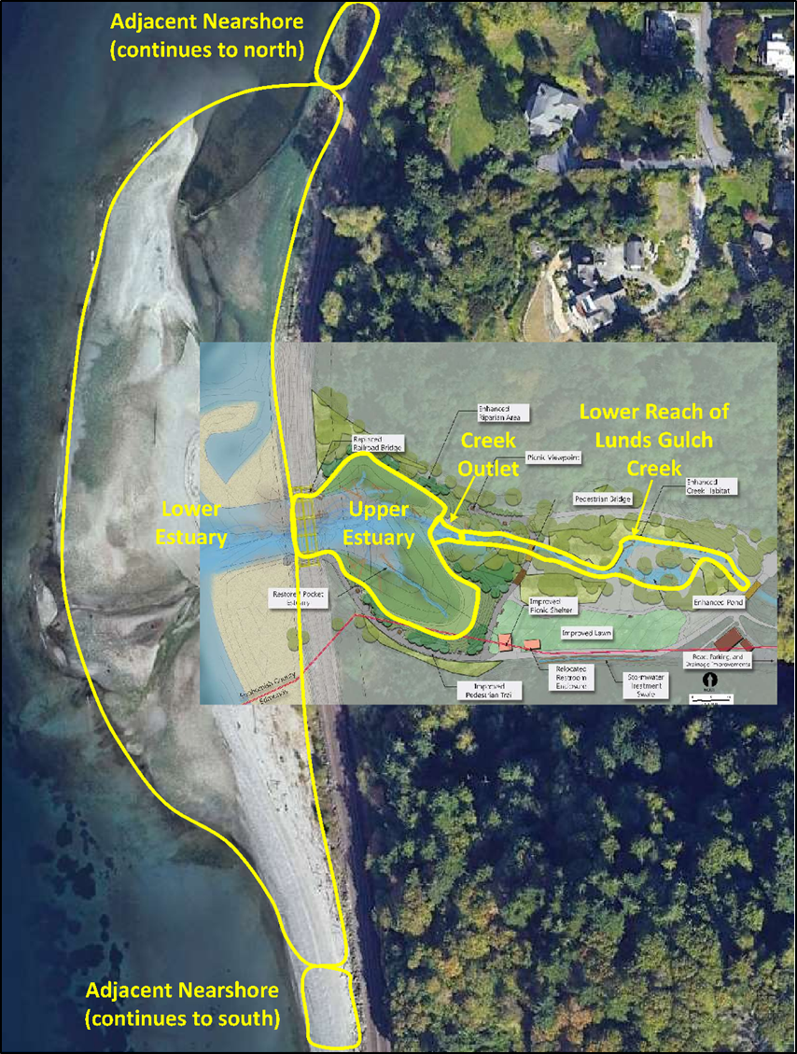

##### Outputs and Outcomes

###### Task Descriptions

For matching tasks see Appendix A.

Task 1. Project Management (July 1, 2023 - September 30, 2025)

Project Management will include project reporting including PRISM reports, grant budget management, and assuring all grant requirements are met.

Task 2. Project Plan (July 2023 - October 2023)

We will develop a project plan that includes: (1) project goals and objectives, (2) scope and schedule for implementation and deliverables, (3) sampling plan and methods, (4) descriptions of factors affecting accuracy and precision of mapping products, (5) assessment of how the sampling plan will address these factors, (6) descriptions of staff roles and expertise, (7) product descriptions, and (8) estimated costs. This project plan will be completed during the initial phase of our project timeline and will include coordination with project partners and ESRP to develop a clear plan to address the desired project outputs.

Task 3. Create Wiki Page Content (July 2023 - July 2025)

We will develop and maintain a set of wiki pages that describe the project including:

* An effort page describing the project and links to any content published on the web.
* A workgroup page describing the project proponent.
* A document page for the final project report.

Task 4. Data Collection and processing

Data collection and processing will take place for the duration of the project and multiple data collection tasks will be collected during each site visit.

Task 4.1 Beach & Embayment Profile Transects - September 2023 - May 2025

4.1.a - Conduct beach profile surveys during tides of 0’ or lower three times annually within a week of UAV acquired site imagery (see Gantt chart below for data collection dates)

4.1.b QA/QC RTK GPS data

4.1.c upload data to shared project cloud drive

4.1.d Process profile data to generate DTMs for each survey event and analyze changes in profile elevations and changes in volumes using DTMs

4.2 RFID PIT Tagged Gravel Tracking October 2023 - February 2025

4.2.a Finalize gravel tracking methods and protocols

4.2.b Acquire all necessary supplies and equipment for gravel tracking

4.2.c Conduct gravel tracking data collection annually from October to February 2023-2025.

4.2.d QA/QC gravel tracking data after each data collection event.

4.2.e Upload data to shared project cloud drive

4.2.f Analyze gravel tracking data with assistance from consultant and WWU staff

4.3 Aerial Imagery Acquisition (UAV flights) - April 2022 - June 2025

4.3.a Conduct UAV aerial image flights during daytime low tides of 0’ or less every June, October, and May 2022-2025

4.3.b Process aerial imagery to generate orthorectified aerial imagery and DSM

4.3.c QA/QC DSM to RTK GPS transect profiles collected within a week of the flight.

4.3.d Upload data to shared project cloud drive

4.3.e Analyze imagery to track change in project site morphology, substrate composition, and site elevations

4.4 Sediment mapping and classification - April 2022 - June 2025

4.4.a Compile sediment mapping, classification, and associated aerial and time lapse camera imagery.

4.4.b Analyze and model sediment changes

4.4.c Upload sediment change maps to shared project cloud drive

4.5 Biological Sample Analysis - January 2025 - June 2025

4.5.a Collect biological samples during fish sampling efforts (plankton, terrestrial invertebrates, juvenile salmon stomach content, juvenile chinook DNA.

4.5.b Catalog and store samples for processing in 2025

4.5.c Send samples to laboratories for analysis - January 2025

4.5.d Upload sample result to shared project cloud drive

4.5.e Analyze laboratory results to determine prey field, target species for juvenile salmon, and river of origin of juvenile chinook sampled

Task 5. Interim Results Analysis - September 2024 - December 2024

We will complete a preliminary analysis of data and results in a draft report. The report will include:

* A synopsis of the period of data collection to that point.
* Tabular summary of relevant parameters.
* Any statistical analysis or figures
* A brief discussion of any findings and anomalies.

Task 6. Final Project Report – May 2025 - August 2025

We will deliver a draft and final learning project report that will address the subjects identified in the final Learning Plan and also include the following elements:

* A preferred bibliographic citation for the final report.
* An appendix providing a discussion of lessons learned and a bibliographic citation
* An appendix describing the final data
* An appendix describing the image archive provided

Task 7. Final Project Presentation – September 2025

We will provide a presentation of results after delivery of a final project report, with the PowerPoint presentation being published to PRISM, Wiki, and PSP’s Data Portal.

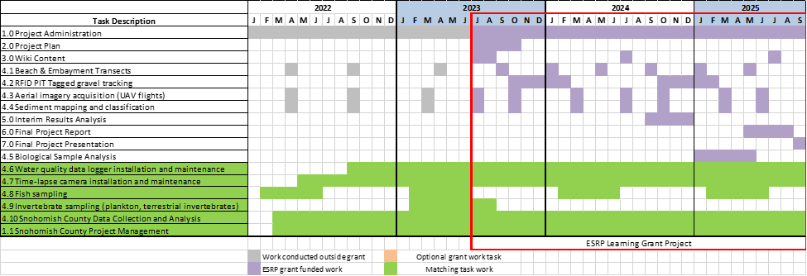

Gantt chart of tasks

##### 2. Deliverables

1. A final report will be delivered describing data collection methods, QA/QC results, analysis methods and results, results discussion, and recommendations for design considerations for restoration of an estuary embayment and stream mouth along a sediment starved shoreline. The report will include a descriptive statistics of the findings that is geared towards answering the geomorphic and ecological hypothesis in the proposal.

2. A summary of all tabular ecological and geomorphic data collected will be provided in a digital format. If desired, all QA/QC’d data collected as part of the project will be provided in a spreadsheet or database format. Summary statistics for fish sampling and invertebrate data will include, catch per unit effort (CPUE), relative abundances, and assemblage data.

3. All aerial imagery and products derived from it will be provided along with the accompanied metadata.

4. Stream channel, embayment, and shoreline cross-section and profile survey data will be plotted to show the changes at each transect over time and included in the final report and on the wiki page.

5. Post-restoration substrate classification maps and change analysis GIS data layers will be provided. These maps and data layers will document changes in the surface substrate types and distribution over a two-year period providing insight into what sized sediment is being transported to different areas across the site.

6. Time lapse photography and derived metrics of shoreline changes overtime, post-restoration will be provided. This data will help document when significant transport of sediment occurs and allow us to correlate it with site conditions and processes e.g. tidal elevation, waves, stream flooding

7. Map and GIS layer showing movement of tagged gravel over time and associated metrics e.g. gravel size, distance traveled over time or during episodic event.

8. Continuous water quality data from data loggers. Summary plots of embayment water levels, salinity, and temperature will be generated and incorporated into the final report. QA/QC’d data will also be made available.

9. A short summary report detailing restoration recommendations and guidance for the restoration community. We are hoping to develop this with ESRP staff.

In addition to the report and associated deliverables, the study findings will be communicated via presentations an ESRP webinar, at technical conferences, and to restoration planning groups that are interested. Potential groups to present to include:  Lead Entities, Snohomish MRC, Snohomish Technical group, and PSEMP Nearshore Working Group.

##### 3. Application to Capital Restoration or Protection and Policy Impact

The deliverables of this investigation will provide information on the geomorphic and ecological responses of the restoration. This information will be valuable to multiple groups interested in leading other restoration projects, allowing restoration that affects their property/infrastructure, and funding restoration. These groups include local and state agencies, tribes, habitat restoration non-profit organizations, BNSF, WSDOT, local roads departments, and local/state/federal/private funding programs. Restoration partners will benefit from information to apply in site selection and site design. BNSF, WSDOT, and local roads departments will be interested in the information documenting the beneficial project outcomes to validate that the changes to their infrastructure is beneficial. Funding programs will be interested in the information documenting the beneficial project outcomes to justify the investments in coastal stream mouth restoration.

The project team will use multiple approaches to share the outcomes of the investigation and promote use of its findings to inform future site selection and design. Snohomish County is underway adding to their project website more information about site performance. The deliverables generated in this project will be available there. In addition, materials will be posted to the Salish Sea wiki and a webinar will be held at the end of the project.

The project team will also create opportunities to do site visits with others considering stream mouth restoration. The site visits to Meadowdale and to their prospective sites will enable the project team to discuss the applicable findings for the proposed site. Site visits with BNSF, WSDOT, local roads departments, and funding organization representatives can also be highly effective in observing and explaining the outcomes of restoration.

##### 4. Transferability

The results of the proposed investigation will be applicable to stream mouths throughout Puget Sound. This includes stream mouths impacted by the railroad, shoreline roads, and other shoreline stressors. While the Meadowdale site is railroad restoration, the project outcomes are applicable to all stream mouth restoration.

##### Budget Worksheet (XLS) –

Attached separately in PRISM

##### Curriculum vitae (CV)

Attached separately in PRISM

##### References

Casamayor, M., Alonso, I., Cabrera, J.A., Rodriguez, S.J., & Sánchez-García, M.J. (2015). Long term recovery rates obtained using RFID technology at a mixed beach. *Geologica Acta, 13*, 85-96.

Casella, E., Drechsel, J., Winter, C., Benninghoff, M., & Rovere, A. (2020). Accuracy of sand beach topography surveying by drones and photogrammetry. *Geo-Marine Letters, 40*, 255-268.

Cassel, M., Dépret, T., & Piégay, H. (2017). Assessment of a new solution for tracking pebbles in rivers based on active RFID. *Earth Surface Processes and Landforms, 42*, 1938 - 1951.

Chen, B., Yang, Y., Wen, H., Ruan, H., Zhou, Z., Luo, K., & Zhong, F. (2018). High-resolution monitoring of beach topography and its change using unmanned aerial vehicle imagery. *Ocean & Coastal Management*.

Elsner, P., Dornbusch, U., Thomas, I., & Amos, D.F. (2015). Monitoring mixed sand and gravel beaches using unmanned aerial systems.

Kirk, R.M. (1991). River-beach interaction on mixed sand and gravel coasts: a geomorphic model for water resource planning. *Applied Geography, 11*, 267-287.

Hart, D.E. (2007). River-mouth lagoon dynamics on mixed sand and gravel barrier coasts.

Hemmingsen, M.A., Eikaas, H.S., & Marsden, D.C. (2019). A GIS approach to sediment displacement in mixed sand and gravel beach environments. Journal of environmental management, 249, 109083 .

Long, N., Millescamps, B., Guillot, B., Pouget, F., & Bertin, X. (2016). Monitoring the Topography of a Dynamic Tidal Inlet Using UAV Imagery. *Remote. Sens., 8*, 387.

Measures, R., Hart, D.E., Cochrane, T.A., & Hicks, D.M. (2020). Processes controlling river-mouth lagoon dynamics on high-energy mixed sand and gravel coasts. *Marine Geology, 420*, 106082.

Miller, I.M. 2011. Mixed beach morphodynamics and shoreline evolution on the dammed Elwha River delta, Washington State, USA. Doctoral dissertation, UC Santa Cruz, Santa Cruz, CA.

Miller, I.M., Warrick, J.A., Morgan, C., 2011. Observations of coarse sediment movements on the mixed beach of the Elwha Delta, Washington. Marine Geology 282, 201-214.

Miller, I.M., & Warrick, J.A. (2012). Measuring sediment transport and bed disturbance with tracers on a mixed beach. *Marine Geology, 299*, 1-17.

Weaver, Meghan E. (Meghan Elizabeth), "Characterization of coarse sediment transport on a mixed sand and gravel beach: Cherry Point Aquatic Reserve, Blaine, Washington" (2013). WWU Graduate School Collection. 269. <https://cedar.wwu.edu/wwuet/269>