**REVIEW PANEL APPROVAL TO USE SRFB FUNDS TO ACQUIRE LEQUE PROPERTY**

**From:** Jen O'Neal <jen@naturaldes.com>   
**Sent:** Monday, January 16, 2023 2:06 PM  
**To:** Caromile, Kay (RCO) <Kay.Caromile@rco.wa.gov>; Elod Toth <thomtoth@nwlink.com>; Paul Schlenger (pschlenger@esassoc.com) <pschlenger@esassoc.com>  
**Subject:** RE: seeking your comment on pending Livingston Bay acquisitions

External Email

HI Kay and Steve (and Paul!),

In looking at the feasibility study, I would still vote to fund the acquisition of the parcels, given that there is a longer-term gain of nearshore habitat even without the availability of all the parcels.  As shown by their cost benefit analysis, the Option 2 with the land swap does not provide as much benefit for the cost, so that would not be my first choice, but the overall gain of 200 acres of nearshore habitat is a positive step.

Paul and Steve – super open to talk more about this if you are seeing things differently.  I am around most of the week except for Thursday afternoon.

Thanks,

Jen O’Neal

Senior Fish Biologist

Natural Systems Design

425-785-0510

[jen@naturaldes.com](mailto:jen@naturaldes.com)

**From:** Caromile, Kay (RCO) <[Kay.Caromile@rco.wa.gov](mailto:Kay.Caromile@rco.wa.gov)>   
**Sent:** Sunday, January 15, 2023 1:15 PM  
**To:** Jen O'Neal <[jen@naturaldes.com](mailto:jen@naturaldes.com)>; Elod Toth <[thomtoth@nwlink.com](mailto:thomtoth@nwlink.com)>  
**Subject:** RE: seeking your comment on pending Livingston Bay acquisitions

Hello.  After speaking with Steve on Friday, I just wanted to stress that the only reason I’m bringing this back to you after you already cleared it is because the application included misleading information (it stated that the properties did not require restoration, which was not the case, at least for the Leque property).  I just wanted to be sure that, now you know the property is behind a berm and tidegate that will need to be restored, that you still feel comfortable clearing the project.

Basically-- if you knew the situation during the application process, would you still have cleared the project, or would you have conditioned or POC’d it?  I know these tidal projects can generate a lot of discussion.

Thanks again for your time, Kay

_____________________________________________________________________________________________

**Kay Caromile** |Salmon Grants Manager

Washington State Recreation and Conservation Office

C360-867-8532 | TDD call 711| [https://rco.wa.gov](https://gcc02.safelinks.protection.outlook.com/?url=https%3A%2F%2Frco.wa.gov%2F&data=05%7C01%7CKay.Caromile%40rco.wa.gov%7Caf2aac5888b04c11fd8108daf80de25f%7C11d0e217264e400a8ba057dcc127d72d%7C0%7C0%7C638095036361462129%7CUnknown%7CTWFpbGZsb3d8eyJWIjoiMC4wLjAwMDAiLCJQIjoiV2luMzIiLCJBTiI6Ik1haWwiLCJXVCI6Mn0%3D%7C1000%7C%7C%7C&sdata=spmbBNZyRH0XfViRuv7%2BhTDxiiPRCEMJgrV1SJALM5k%3D&reserved=0)

RCO

**From:** Caromile, Kay (RCO)   
**Sent:** Tuesday, December 27, 2022 12:21 PM  
**To:** Paul Schlenger <[pschlenger@esassoc.com](mailto:pschlenger@esassoc.com)>; Jen O'Neal <[jen@naturaldes.com](mailto:jen@naturaldes.com)>; Elod Toth <[thomtoth@nwlink.com](mailto:thomtoth@nwlink.com)>  
**Cc:** Warinner, Bob (RCO) <[bob.warinner@rco.wa.gov](mailto:bob.warinner@rco.wa.gov)>; Kaminski, Bridget (RCO) <[bridget.kaminski@rco.wa.gov](mailto:bridget.kaminski@rco.wa.gov)>  
**Subject:** seeking your comment on pending Livingston Bay acquisitions  
**Importance:** High

Happy Holidays.  I hope you are all doing well and enjoying the holiday season.  I’m writing to you since Elod and Jen were the review panelists for Island County in 2020 and Paul … well, he’s just a nice guy, and has strong nearshore knowledge and background.

In 2020, we funded srfb project [20-1134](https://gcc02.safelinks.protection.outlook.com/?url=https%3A%2F%2Fsecure.rco.wa.gov%2Fprism%2Fsearch%2Fprojectsnapshot.aspx%3FProjectNumber%3D20-1134&data=05%7C01%7CKay.Caromile%40rco.wa.gov%7Caf2aac5888b04c11fd8108daf80de25f%7C11d0e217264e400a8ba057dcc127d72d%7C0%7C0%7C638095036361462129%7CUnknown%7CTWFpbGZsb3d8eyJWIjoiMC4wLjAwMDAiLCJQIjoiV2luMzIiLCJBTiI6Ik1haWwiLCJXVCI6Mn0%3D%7C1000%7C%7C%7C&sdata=kLiNB4Bpew%2BfK3t%2FXhxVBFzjFXmxWw5hHduX3sj%2Fhhw%3D&reserved=0) *WRIA 6 Nearshore Protection Tool Implementation* in Island County.  It is sponsored by Whidbey-Camano Island Land Trust.  I understand it initially proposed acquiring “priority parcels” in Island County that had been identified by a recently completed Nearshore Protection Tool.  The review comments asked them to be more specific and they responded by choosing two parcels in Livingston Bay—Leque and the Livingston Bay Association tidelands, both located at the north end of Livingston Bay and Camano Island (please see the vicinity map and parcel map below).   I am writing to you as there may have been some incorrect information in the application (a legacy of the original proposal) that indicated no restoration was necessary.  That may be the case for the Livingston Bay Association tidelands, but is not the case for the Leque property.  The Leque property is separated from the bay by a low dike so breeching the dike, dike setback, and additional property acquisition is necessary to fully restore salmon access to the larger project area.  The land trust recently completed a DRAFT restoration [feasibility study](https://gcc02.safelinks.protection.outlook.com/?url=https%3A%2F%2Fsecure.rco.wa.gov%2Fprism%2Fsearch%2FProjectSnapshotAttachmentData.aspx%3Fid%3D543195&data=05%7C01%7CKay.Caromile%40rco.wa.gov%7Caf2aac5888b04c11fd8108daf80de25f%7C11d0e217264e400a8ba057dcc127d72d%7C0%7C0%7C638095036361462129%7CUnknown%7CTWFpbGZsb3d8eyJWIjoiMC4wLjAwMDAiLCJQIjoiV2luMzIiLCJBTiI6Ik1haWwiLCJXVCI6Mn0%3D%7C1000%7C%7C%7C&sdata=BXiTUdDa8c50ivYOXlzGoKxORuTH0oL1fuAhzSTTbR8%3D&reserved=0) that considered full and partial restoration of the site.  The partial restoration scenario considers the feasibility of restoring tidal connection in the event only the Leque and Roberge properties are willing to sell (which is currently the case).  I am writing to confirm the review panel still supports SRFB funds going towards acquisition of the Leque property and learn of any additional concerns or questions given the results of the study .

Background:

*Current agreement*

This project is funded by both SRFB/PSAR and ESRP funds, plus it also has USFWS Coastal Wetland funds.  The SRFB/PSAR funds were to acquire the Leque and Livingston Bay Community tideland properties.  The ESRP funds were to acquire the same, but also to acquire the Roberge &/or Sherman properties and complete a preliminary design to restore the 317 acres.   We combined the funds into one contract [20-1461](https://gcc02.safelinks.protection.outlook.com/?url=https%3A%2F%2Fsecure.rco.wa.gov%2Fprism%2Fsearch%2Fprojectsnapshot.aspx%3FProjectNumber%3D20-1461&data=05%7C01%7CKay.Caromile%40rco.wa.gov%7Caf2aac5888b04c11fd8108daf80de25f%7C11d0e217264e400a8ba057dcc127d72d%7C0%7C0%7C638095036361462129%7CUnknown%7CTWFpbGZsb3d8eyJWIjoiMC4wLjAwMDAiLCJQIjoiV2luMzIiLCJBTiI6Ik1haWwiLCJXVCI6Mn0%3D%7C1000%7C%7C%7C&sdata=Aixzger%2FDQnzv%2FLgKWPw4YIm1qVmiD69Bhk2asG8jKE%3D&reserved=0) to facilitate grant management (note that this is the number for the original esrp project application—not the SRFB application) .  The Livingston Bay project 20-1461 agreement is currently funded with:

$20,246 State SRFB

$1,500,000 ESRP

$624,871 PSAR

$529,883 Match

$2,675,000 TOTAL

Currently, the Leque and Roberge property acquisitions are poised to more forward.  The Sherman and Nelson properties are not available at this time. The Livingston Bay tidelands have not yet been pursued, but are outside the dike so not influenced by future restoration.

*2012 Agreement*

In 2012, SRFB funded [12-1395](https://gcc02.safelinks.protection.outlook.com/?url=https%3A%2F%2Fsecure.rco.wa.gov%2Fprism%2Fsearch%2Fprojectsnapshot.aspx%3FProjectNumber%3D12-1395&data=05%7C01%7CKay.Caromile%40rco.wa.gov%7Caf2aac5888b04c11fd8108daf80de25f%7C11d0e217264e400a8ba057dcc127d72d%7C0%7C0%7C638095036361462129%7CUnknown%7CTWFpbGZsb3d8eyJWIjoiMC4wLjAwMDAiLCJQIjoiV2luMzIiLCJBTiI6Ik1haWwiLCJXVCI6Mn0%3D%7C1000%7C%7C%7C&sdata=Y%2Buj9IMextXEHlhf8C1jDkklAhfMUY5dgpCGYvra7sw%3D&reserved=0) Livingston Acq Phase 1 to acquire the Roberge and Sherman properties and Livingston Bay tidelands.  The review panel [conditioned the project](https://gcc02.safelinks.protection.outlook.com/?url=https%3A%2F%2Fsecure.rco.wa.gov%2Fprism%2Fsearch%2FProjectSnapshotAttachmentData.aspx%3Fid%3D168740&data=05%7C01%7CKay.Caromile%40rco.wa.gov%7Caf2aac5888b04c11fd8108daf80de25f%7C11d0e217264e400a8ba057dcc127d72d%7C0%7C0%7C638095036361462129%7CUnknown%7CTWFpbGZsb3d8eyJWIjoiMC4wLjAwMDAiLCJQIjoiV2luMzIiLCJBTiI6Ik1haWwiLCJXVCI6Mn0%3D%7C1000%7C%7C%7C&sdata=ksWo%2BcyGiXEcBmUeLYcPBhFYdtLLuS2q2hLBiRJqTeY%3D&reserved=0) (this link it to the 2012 review form) due to the uncertainty of assembling all properties needed for future restoration.  At the time, the panel understood Ph2 (Leque) and Ph3 (Nelson) properties were key for future restoration and the panel conditioned the project so that the sponsor must secure funding and a PSA/option to acquire the Leque property before authorizing acquisition of the Roberge and Sherman properties.  The sponsor met that condition, but then Sherman backed out.  RCO terminated the 2012 contract.  According to Mike Ramsey, the parties felt that restoration was infeasible within a reasonable timeframe, given only the Leque and Roberge properties were currently available.  They brought the project back in 2020, but this time SRFB funds were focused on the Leque and Livingston Bay tideland—not Sherman or Roberge.  The panel cleared the project and the Leque property acquisition is poised to move forward.

*What’s changed between 2012 and today*

* SRFB funds are just to acquire Leque and Livingston Bay tidelands—not Sherman or Roberge
* Although the Sherman property is not currently for sale, the potential for Sherman property to become available and transfer ownership in next 5-10 years is more likely than it was in 2012
* A feasibility study that looked at three restoration scenarios was recently completed.  Scenario 1 (partial restoration that includes the Leque, Roberge, DOT and just a small portion of the Sherman property) and 3 (full restoration that include the Leque, Roberge DOT, Sherman, and Nelson properties) are depicted below.  Scenario 2 is not depicted below as it had a higher cost:benefit and will not be pursued.  Scenario 3 (full restoration) is the preferred alternative, but the study shows that partial restoration is feasible, but more expensive.
  + Sea Level Rise Projections
    - Likely increase by 1 ft by 2050 and 1-2 ft SLR by 2100
    - Medium risk scenario (>10%) of O.5ft SLR by 2030 & 3ft SLR by 2100
  + Berm/dike overtopping w/no restoration (lies at elevation 11.6 ft NAVD88)
    - 1 yr event currently comes close to overtopping
    - Using medium risk SLR estimates
      * By 2030, overtopped at 1 yr frequency
      * By 2050, overtopped multiple times/year
  + Summary of DRAFT Feasibility Study Findings (the study provides much more information than this summary)
    - Overtopping will result in saline water periodically entering existing agricultural areas via beach berm (regardless of proposed restoration)
    - *Groundwater*
      * Restoration would result in increased GW levels on the restored site and higher salinities in shallow soils caused by periodic inundation
      * This condition is not expected to cause saline intrusion of the upland aquifers
      * Engineering solutions may be required within the lowland areas to prevent saline water from migrating to adjacent agricultural properties.
      * E.g., Dikes separating restored properties from agricultural properties plus parallel ditch/managed wetland and tide gate to control lateral migration of shallow saline GW
    - *Flooding*
      * Restoration will increase the intermediate high water levels in the site compared to existing conditions. BUT may reduce flood risk associated with extreme events that overtop current beach berms.
      * Scenario 1 may increase GW and ag pumping requirements for adjacent parcels (have an adverse flood impact). This is a flood risk unless a flood easement can be purchased, or other water management action can be taken on the project property.
    - An outlet to the west as shown in Scenario 3 is preferred from a geomorphic perspective; however, an outlet near the existing pump station could function for many years as depicted in Scenarios 1 and 2. The tidal prism through the inlet is likely to increase with sea level rise, which would enhance the inlet’s likelihood of staying open in the future.
    - Based on cost-benefit analysis, ESA strongly recommends Scenario 3 (full restoration) even if parcel acquisition takes time to accomplish.
  + Things I don’t yet see addressed in study:
    - Potential impacts of restoration actions plus sea level rise on septic and landscaping (compared to sea level rise alone).  I understand the community is on septic, but it appears that sea level rise alone would force some alternative means of sewage treatment.  The study seemed to talk more about potential impacts and needs related to the neighboring agricultural community than impacts to the Livingston Bay Association community.
    - The study states that “an outlet near the existing pump station could function for many years as depicted in Scenarios 1 and 2”.  But it doesn’t indicate what “for many years” means and what type of maintenance may be necessary in the event Scenario 1 is implemented.

*Other Funders Decisions*

* *USFWS* has no concerns;  ok with acquisition for acquisition’s sake, even if never fully restored. The improved bird habitat, water quality, and open space supported by the acquisitions support the purpose of the funding, even if full restoration is never achieved.
* *ESRP* has approved funding for the acquisitions.  ESRP’s mission is to restore shoreline and nearshore habitats critical to salmon and other species in Puget Sound. The Livingston Bay restoration project (including tidal reconnection to the project area) supports that mission and is identified as a PSNERP priority project in Puget Sound for its potential to benefit all 8 species of salmonids.  The ESRP management team recognizes that the proposed Roberge and Leque acquisitions represent early, but necessary, steps towards achieving future restoration; that additional information is needed to fully determine the feasibility of future restoration in the developed landscape; acquisition of additional properties will be required; full restoration is unlikely to occur within the next 5 years; and that the acquisitions alone offers water quality and waterfowl habitat improvements to Livingston Bay, both of which may be further enhanced with interim restoration measures while awaiting the opportunity for full tidal restoration of the project area.  Considering all of the above, the ESRP team supports moving forward to acquire the Leque and Roberge properties.  ESRP’s long-term interest is in restoring tidal reconnection to the project area.  ESRP staff request the project co-sponsors gather a group of interested parties prior to closing on the acquisitions to discuss plans for moving ahead, including priority assessments and analyses, landowner outreach, interim land use and project phases, and decision triggers and timelines.

SRFB/PSAR’s mission is more narrowly focused on salmon recovery so the waterfowl benefits offered by the acquisition alone (without future restoration) complement, but do not meet the purpose of the funding.  Restoring tidal connection to the project area is necessary to meet salmon recovery goals.  Although the lead entity ranked the project and the SRFB review panel cleared it without comment, the application did not indicate there was a need for future restoration of the properties and it is unclear if all parties were fully aware of the condition of the properties and needed restoration when they approved project funding.  For this reason, I am reaching out to both groups to gather comments and recommendations for SRFB and PSAR funding.

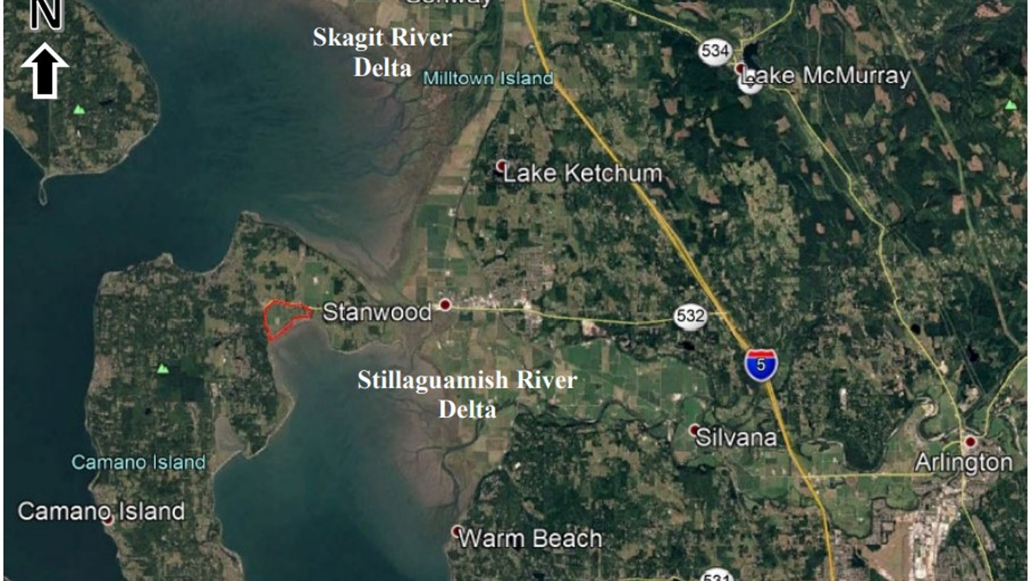

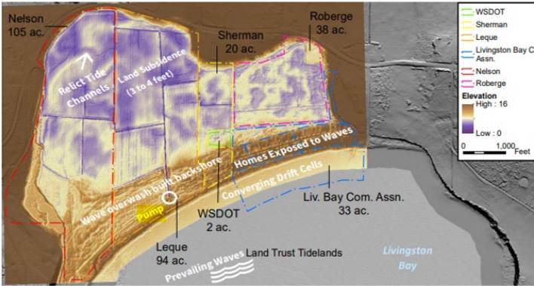

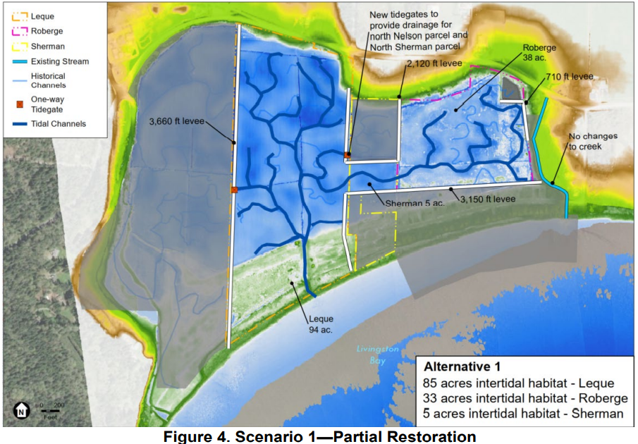

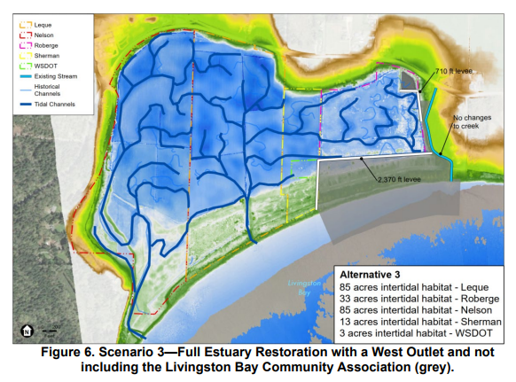

_____________________________________________________________________________________________

**Kay Caromile** |Salmon Grants Manager

Washington State Recreation and Conservation Office

C360-867-8532 | TDD call 711| [https://rco.wa.gov](https://gcc02.safelinks.protection.outlook.com/?url=https%3A%2F%2Frco.wa.gov%2F&data=05%7C01%7CKay.Caromile%40rco.wa.gov%7Caf2aac5888b04c11fd8108daf80de25f%7C11d0e217264e400a8ba057dcc127d72d%7C0%7C0%7C638095036361462129%7CUnknown%7CTWFpbGZsb3d8eyJWIjoiMC4wLjAwMDAiLCJQIjoiV2luMzIiLCJBTiI6Ik1haWwiLCJXVCI6Mn0%3D%7C1000%7C%7C%7C&sdata=spmbBNZyRH0XfViRuv7%2BhTDxiiPRCEMJgrV1SJALM5k%3D&reserved=0)

RCO