# State of Washington

**Recreation and Conservation Office / Governor’s Salmon Recovery Office**

***PSMFC allocation of $291,000 to Washington State for tasks/ deliverables, July 1 2019 – June 30 2020***

**Submission of the**

**Scope of Work for NOAA / PSMC –funded Intensively Monitored Watersheds, located in the Snake River Salmon Recovery Region – Asotin IMW Complex.**

**Introduction**

The Pacific States Marine Fisheries Commission (PSMFC) has provided sorely needed on-going monitoring support for two (2) intensively monitored watershed complexes (IMWs) in Washington State, located in the Lower Columbia and Snake River salmon recovery regions. Through the auspices of the Recreation and Conservation Office (RCO), and with administrative oversight provided by the

Governor’s Salmon Recovery Office (GSRO), this critical support has been leveraged by the Salmon Recovery Funding Board (SRFB), among others, to answer certain resource questions regarding habitat treatments associated with salmonid abundance and productivity, and localized limiting factors that have been identified in these IMWs. Monitoring these IMWs facilitates validation of the treatments.

Great strides have been made by the collaborative partnership of the Lower Columbia Fish Recovery Board (LCFRB), the Snake River Salmon Recovery Board, and their sub-contractors. The collaborative effort includes the aforementioned entities overseeing this program, along with the Washington Department of Ecology (WECY) and WA Fish and Wildlife (WDFW), among others.

Due to the co-management relationship of fisheries resources between the WDFW and those Indian tribes with treaty-protected resources in located within Washington’s salmon recovery regions, these collaborations foster healthy alliances. These alliances have engaged complementary partnerships with the Columbia River Inter- Tribal Fisheries Commission (CRITFC), and has led towards productive and pro-active initiatives in the Pacific Northwest. These initiatives are in areas that support multiple life-histories of ESA-listed salmon stocks.

The PSMFC support has provided the critical resources for additional monitoring, program analysis, recommendation development, as well as the modifying or adaptively managing the restoration treatment plans and implementation. Leveraged support from the Washington SRFB has provided project funds from the Pacific Coastal Salmon Recovery Funds (NOAA-PCSRF) to for five (5) IMWs from its annual PCSRF allocation to Washington. The distribution of these resources include the Asotin and Abernathy IMW complexes in the Snake Region and Lower Columbia Region that also receive PSMFC funds.

It should also be noted the SR4/30/20194/30/2019FB provided nearly $6 million over a three-year period specific to funding restoration treatments in IMWs. This was in response from regional requests due to the fact the IMWs were selected for their geomorphic and landscape conditions, with optimal pairing with, and adjacent to, a proximal sub-basin as reference or control, and not necessarily due to ESA- listed salmon stocks in the area. Because of that fact, and that the “Washington Way” for salmon recovery has a localized process for prioritizing habitat restoration projects, IMWs would not necessarily rank high for project implementation. This program ended in 2016, but it may be considered again in future years. It is one of a number of recommendations being brought forth to SRFB via its Monitoring Panel, established in 2013. The SRFB waives “match” requirements as an added incentive for IMW project sponsors to implement restoration treatments.

The two state salmon recovery regions with PSMFC –supported IMWs in Washington- the Snake and the Lower Columbia regions-have fostered a relationship where the PSMFC-allocated funds have been distributed following an equitable process following inter-regional discussions every year. This relationship has developed in such a way whereby each region has recognized and agreed upon the annual distribution of the PSMFC funds.

As in years past, the distribution is determined by the unique and individual processes, objectives, and goals of each region. For this new award proposal for **2019/2020,** the Lower Columbia Fish Recovery Board (LCFRB) has requested NO new funds for this year. The Snake River Salmon Recovery Region’s Asotin IMW project, will receive a majority of the $291,000 of the PSMFC allocation to Washington State, totaling approximately $245,000. These funds support the Asotin IMW’s primary contractor and principle investigator, EcoLogical Research. Continued contract support through a sub-award will be provided to the Washington Department of Fish and Wildlife (WDFW) as they have in years past.

The Snake Salmon Recovery Region, and the primary project sponsor have a well-developed and implemented IMW monitoring project in the Asotin IMW complex that owes its success to ongoing and consistent collaboration. As in many natural resource efforts, adaptive management is a key element. This program follows the adaptive management process of “learning by doing” and providing feedback, to the project principles and modifying project elements as appropriate.

The award also provides administrative oversight to the RCO, as well as other IMW project sub-award support, including power and phone lines for telemetry for PIT tags, along with project reporting, communication and outreach with the Pacific NW Aquatic Monitoring Partnership (PNAMP).

The Snake River Salmon Recovery Region has worked diligently with their partners of the Asotin Conservation District, Ecological Research and WDFW, in completing restoration treatments AND monitoring, by leveraging other funds. The Snake Salmon Recovery Region intends to continue to support monitoring efforts in the Asotin IMW, which provides an eastern Washington analogue for the western Washington IMWs. The Asotin IMW is unique in its implementation of treatments and monitoring efforts due the coordination by the original sponsor of the project experimental design. The associated descriptive elements of the scope of work follow as well as the project budget.

Keith Dublanica, Science Coordinator - Washington Recreation and Conservation Office / Governor’s Salmon Recovery Office / 360.902.2242 keith.dublanica@gsro.wa.gov

**Snake River Intensively Monitored Watershed Asotin IMW Complex Summary**

## Asotin Monitoring and Restoration- EcoLogical Research, Stephen Bennett, principle investigator

***Sub-recipient summary of the PSMFC award for 2019 / 2020 (excerpt from 2017)***

**SUMMARY**

***Background***

The Asotin Creek Intensively Monitored Watershed (IMW) was implemented in 2008. The focal species are natural reproducing summer steelhead. Based on previous habitat assessments and preliminary IMW monitoring it was decided that riparian function and instream habitat complexity were impaired. The restoration proposed was fencing, native plant revegetation, and weed control to enhance riparian function in the **long-term**, and the addition of large woody debris (LWD) in the **short-term** to increase habitat diversity and promote a more dynamic channel (e.g., increase sediment sorting, pool frequency, and floodplain connection). We implemented the IMW using a staircase experimental design where restoration actions were implemented in different years starting in 2012 and ending in 2016 in three different streams. Each stream is divided into three 4 km long sections and one or more sections has been restored in each stream with the remaining sections acting as controls. We completed the restoration actions in 2016 and have built 654 large woody debris structures at an average density of 4.7 structures per 100 m in the treatment sections (~39% of the study area has been restored and 61% remains as controls). We are using extensive habitat sampling and fish PIT tagging and re-sighting to estimate habitat changes and changes juvenile steelhead abundance, growth, survival, movement, production, and productivity in each experimental section.

**BACKGROUND**

In 2008, Asotin Creek was chosen as a location to implement an Intensively Monitored Watersheds (IMW) project in southeast Washington (**Figure 1**). We are implementing the IMW experiment within an adaptive management framework and have revised aspects of the experimental design, restoration plan, and monitoring based on the iterative evaluation process of adaptive management (Bouwes et al. 2016). An experimental study design has been developed and refined for the Asotin Creek IMW that includes treatment and control sections within the Asotin Creek tributaries of Charley Creek, North Fork Asotin Creek (North Fork), and South Fork Asotin Creek (South Fork; hereafter referred to together as “study creeks”). The study creeks generally exhibit homogenized and degraded habitats, with poor riparian function and low frequencies of large woody debris and pool habitat which is thought to be limiting salmonid production (SRSRB 2011). A detailed Restoration Plan was developed that proposed *riparian enhancement and large woody debris additions as restoration treatments in the Asotin Creek IMW* (Wheaton et al. 2012).

The Asotin Creek IMW has been funded from NOAA's Pacific Coastal Salmon Recovery Fund (PCSRF) and the Pacific States Marine Fisheries Commission (PSMFC). The NOAA funds are used to fund the ongoing fish and habitat monitoring and data collection and analysis. These funds are administered via the Governors Salmon Recovery Office. A separate project funded by the Bonneville Power Administration (BPA) and implemented by the WDFW provides fish-in, fish- out monitoring for the Asotin watershed (Crawford et al. 2016).

EcoLogical Research implemented the IMW using a *staircase experimental design* where restoration actions were implemented in different years starting in 2012 and ending in 2016 in three different streams. Each stream is divided into three 4 km long sections. One or more sections has been restored in each stream with the remaining sections acting as controls (Appendix A). See Bennett et al. (2015) for details on activities from 2008-2015.

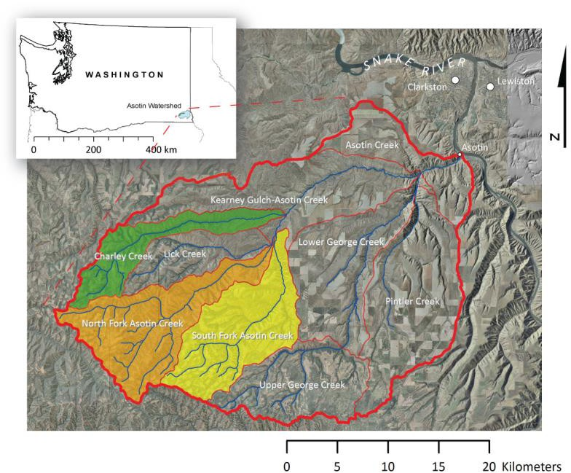

**Figure 1. Location of Asotin Creek within Washington and the Asotin Creek Intensively Monitored Watershed study watersheds (i.e., Charley Creek, North Fork, South Fork) within the Asotin basin.**

**ASOTIN IMW STATUS**

The Asotin IMW began in 2008 and it has been running for ten years (**Figure 2**). We secured funding to install the majority of the monitoring infrastructure (e.g., PIT tag arrays, water height gages, and temperature probes) in 2009. The Asotin IMW also relies on the intensive monitoring of fish-in fish-out conducted by WDFW to provide detailed information on age, condition, size, migration timing, and spawning distribution of steelhead in the Asotin watershed (Crawford et al. 2016). A total of four PIT tag interrogation sites, a smolt trap, and adult weir provide valuable data to the IMW for assessing restoration effectiveness. Restoration has been completed for the IMW: treating 14 km.

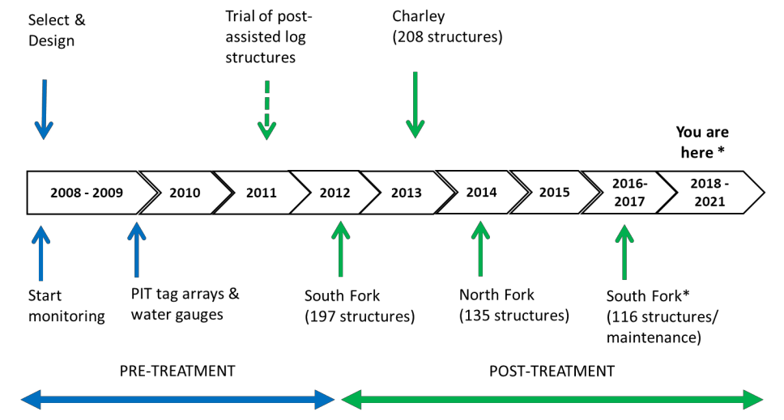**Figure 2. Timeline of Asotin Creek IMW design, monitoring, and restoration implementation. The initial restoration design of 12 km of wood treatments was completed from 2012-2014. Another restoration treatment to extend South Fork was implemented in 2016 along with adding more wood to existing structures to enhance their function in 2016 and 2017. Monitoring of habitat and fish is expected to continue past 2021.**

**Statement of Work, Schedule and Estimated Costs by Task for the Asotin Intensively Monitored Watershed (IMW) Sub- Award to EcoLogical Research July 1, 2019 to June 30, 2020**

|  |  |  |  |  |  |  |  |
| --- | --- | --- | --- | --- | --- | --- | --- |
|  | **End Date** | **Task/Personnel** | **Description and Rational** | **Cost** | **Unit** | **# of Units** | **Budget Request** |
| ***Eco Logical Research Inc. - IMW Management, Coordination, Implementation and Synthesis*** | | | | | | | |
| 7/1/2019 | 6/30/2020 | Project Management, Data Management, Coordination, Data Analysis, and Reporting/ Project Manger; GIS, Statistical, and Database support staff | Management of overall project goals including coordination, permitting, budget and work plan development and tracking; manage PIT tag, fish capture data, PTAGIS and array re-sight data; coordinate with CHaMP to upload and analyze habitat data; manage LiDAR and aerial photography; provide monthly progress and annual reports; manage temperature and discharge data; synthesis and interpret data and test effectiveness of restoration using statistical models. | 100.00 | hours | 783.0 | 78,300.00 |
| 7/1/2019 | 6/30/2020 | Analyst | Data analyst to analyze all CHaMP, temperature, discharge, and fish data and to help develop models for testing effectiveness of restoration | 72.73 | hours | 696.0 | 50,620.08 |
| 7/1/2019 | 6/30/2020 | Field Monitoring Lead (Biologist) | supervise monitoring crew and collect fish and habitat data, maintain field databases, conduct mobile fish surveys in winter and spring | 45.46 | hours | 1044.0 | 47,460.24 |
| 7/1/2019 | 6/30/2020 | Field Monitoring Crew (4 technicians) | Monitor permanent sites for fish abundance, growth, survival, and movement, and habitat condition (CHaMP habitat protocol, photo documentation, rapid habitat surveys), temperature probes, water level gauges; (5 field techs and 1 biologist) | 30.30 | hours | 1044.0 | 31,633.20 |
| 7/1/2019 | 6/30/2020 | Accommodation and Travel | Accommodation (6@1000/month), flights (4@250), meals (300@10/day), vehicle expenses (8@1000/month), ATVs (6@500/month) | - | - | 1.0 | 21,000.00 |
| 7/1/2019 | 6/30/2020 | Acquire, Purchase, Maintain equipment and supplies | Purchase or rent equipment to conduct surveys (PIT tags and supplies, electro-shockers, seine nets, waders, total stations, map-grade GPS, data loggers, mobile PIT tag antennas, office supplies) | - | - | 1.0 | 15,000.00 |

|  |  |  |  |  |
| --- | --- | --- | --- | --- |
| **subtotal – EcoLogical Research Wages, Overhead, Fringe, Equipment, Supplies, and Travel** |  |  |  | **244,013.52** |

**Statement of Work, Schedule and Estimated Costs by Task for the Asotin Intensively Monitored Watershed (IMW) Sub Award to the Washington Department of Fish and Wildlife (WDFW) July 1, 2019 to June 30, 2020**

|  |  |  |  |  |
| --- | --- | --- | --- | --- |
| **Start Date** | **End Date** | **Task/Personnel** | **Description** | **Budget Request** |
| ***Washington Department of Fish and Wildlife – sub-contract to support IMW data gathering in Asotin IMW*** | | | | |
| 7/1/2019 | 6/30/2020 | WDFW Management of data collected for IMW | Oversee tasks and manage data collected by WDFW for IMW; coordinate with IMW coordinator as needed; provide all data to IMW coordinator | 1,800.00 |
| 7/1/2019 | 6/30/2020 | Monitoring | Assist with fish surveys, redd counts, habitat surveys, PIT tag array site maintenance, and contribute to development and publishing on manuscripts related to IMW study as needed and agreed upon between WDFW and the IMW Coordinator | 18,000.00 |
| 7/1/2019 | 6/30/2020 | Expenses | cover direct costs of PIT tags, reading scale samples for up to 1000 juvenile steelhead, other equipment and miscellaneous supplies | 3,500.00 |
| 7/1/2019 | 6/30/2020 | WDDFW indirect  (28.78%) | | 6,700.00 |
| ***subtotal WDFW*** | | | | ***30,000.00*** |

**Total of expected PSMFC contract award agreement to the sub-contract awardees supporting the Snake Region’s Asotin Intensively Monitored Watershed**

|  |  |
| --- | --- |
| **EcoLogical Research**  **(RCO new contract to ELR, PRISM 19-1545)** | **$244,014** |
| **WDFW**  **(RCO new contract to WDFW, PRISM 18-2627)** | **30,000** |
| **RCO program administrative support (utilities, phone line(s)**  **sub-total of above** | **5,500**  **279,514** |
| **WARCO indirect 4.12%** | **11,486**  **TOTAL $291,000** |

Keith Dublanica, Science Coordinator - Washington Recreation and Conservation Office / Governor’s Salmon Recovery Office / 360.902.2242 keith.dublanica@gsro.wa.gov