**Nason Creek - Lower White Pine BNSF**

Surface Water Hydrologic Monitoring, 2012-2013

**Introduction**

The Chelan County Natural Resources Department conducted hydrologic monitoring in the Lower White Pine (LWP) Reach of Nason Creek from 2010-2013 within the Lower White Pine Oxbow Reconnection Project. Completed in October 2013, the project restored access for salmonids to x acres of historic habitat that was previously disconnected by the BNSF railroad embankment. Construction began in June 2013 and consisted of replacing passage barrier culverts with a railroad bridge at the LWP oxbow outlet. This report addresses monitoring done during the year prior and of construction (2012-2013).

A total of 13 sites were monitored during 2012 and 2013. The following monitoring parameters were collected: water surface elevation, discharge, and water temperature. Monitoring sites were located in Nason Creek, within the proposed project area (disconnected oxbows of Nason Creek), and at tributaries to the proposed project area (Figure 1).

Surface water hydrologic monitoring will continue for 5 years post project (2014-2018).

**Methods**

The 13 monitoring locations on Nason Creek, the tributaries, and disconnected oxbow were established in 2010 by the project design team (staff from BOR, ICF International, and CCNRD). Staff followed Washington State Department of Ecology’s Standard Operating Procedure (SOP) for Measuring and Calculating Stream Discharge (WADOE 2011) to measure discharge measurements and establish staff gage and cross section locations.

Data collection began in late April and ceased in November in both 2012 and 2013 for all sites except Lower Nason, Coulter, and Roaring Creek which began in late March (see Figure 1 for monitoring locations and parameters collected). Data was collected via manual measurements (discharge and staff) and with “Mini-Diver” pressure transducer programmed to record every hour (water level and temperature). All sites except Knutsen Creek were equipped with a Mini-Diver (aka water level logger). All level logger data was corrected using the barometric logger placed at “Middle Nason” (on the bank between the Lower Nason and B+ sites) except for the Gill Creek site which used a separate barometric logger due to its higher elevation.

Manual stage measurements and discharge were collected throughout the monitoring period at Lower Nason, Coulter Creek, Roaring Creek, Gill Creek, and Knutsen Creek. Discharge measurements were taken using a SonTek Flowtracker Acoustic Doppler Velocimeter. The Flowtracker was sent out for repairs in early July. Discharge measurements resumed on September 24th 2013.

Manual stage measurements were also collected at the B+ and Oxbow sites. For all oxbow sites, a once a year water surface elevation survey by the Bureau of Reclamation (BOR, 2012) and CCNRD (2013) was used to convert logger data into water surface elevation. All location and elevation data in this report are presented in Washington State Plane North coordinate system, NAD 1983 and NAVD 1988 (feet) to coordinate with project design.

Data analysis of collected measurements resulted in the following metrics: Hydrographs for Lower Nason, Coulter Creek, Roaring Creek and Gill Creek, continuous water temperature at all sites except Knutsen Creek, and continuous water elevation at all oxbow sites, B+ and Lower Nason. Results of data collection and analysis for years 2012 and 2013 are below. For specifics on data analysis methods, site installation and locations, cross sections for discharge measurements, and 2010 and 2011 data please see the 2010/2011 report.

Figure 1. Map of sites monitored in 2012 and 2013 in the Lower White Pine reach of Nason Creek.

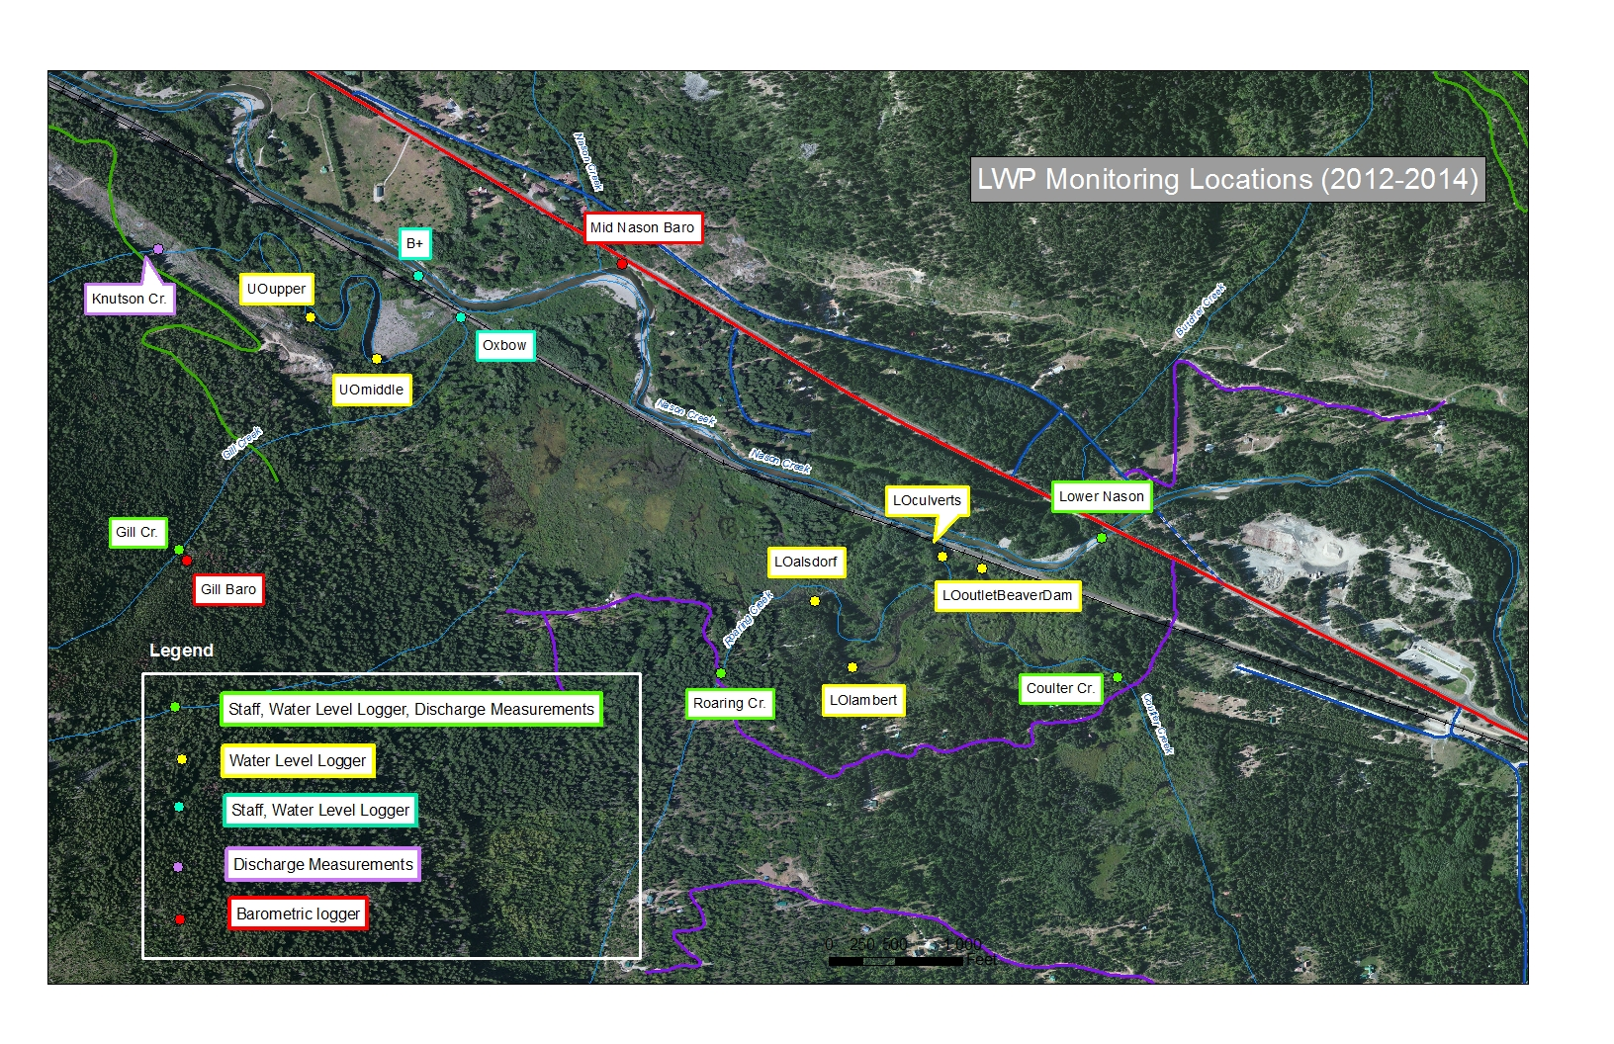

**Results**

*Mainstem and tributary sites*

**B+**

*Location:*120 ft upstream of transect A on right bank of Nason Creek;

N: 282228.12, E: 1642932.73

*Year Established:* 2011

*Measurements:* Staff readings, continuous water surface elevation and temperature

*Data rating*: Excellent 2012, Good 2013

This site is adjacent to the BNSF railroad right-of-way and is difficult to access. Two staff readings were recorded in 2012 and seven in 2013. No discharge measurements were taken at this location. Water level logger values were calibrated using manual stage readings, and then converted to real world elevations using elevation surveys. Logger data was shifted once in 2012 to relate to staff readings. Data was shifted twice in 2013, first to relate to CCNRD staff readings and second because a branch during high flow bent that staff gage and changed the relationship with the logger. Maximum and minimum water surface elevations (after converting logger data to real-world elevation) were 2151.93/2147.93 feet in 2012 and 2153.57/2148.34 feet in 2013 (Figure 2 and 3).

Water surface elevation should be considered excellent in 2012 and very good in 2013.

Figure 2. Mainstem Nason water surface elevations, summer 2012

Figure 3. Mainstem Nason water surface elevations, summer 2013

**Lower Nason**

*Location:* Left bank of Nason Creek ; Hwy 2 bridge 0.5 miles east of Nason Creek rest area

Downstream of LWP connection N: 280503.61, E: 1647894.75

*Year Established:* 2010

*Measurements:* Staff readings, continuous water surface elevation and temperature, discharge

*Data rating*: Very Good 2012, Excellent 2013

The Lower Nason location is an ideal cross-section and staff plate site due to evenly distributed flow and substrate. Discharge measurements were only taken twice in 2012 and twice in 2013 because of dangerous wading conditions above 250 cfs. Rating curves for both 2012 and 2013 used measurements from all previous years, including data from 2011 in which BOR staff measured discharge from the bridge using a StreamPro ADCP (rating curve R² = 0.99). The resulting hydrographs indicate a peak flow of 1983 cfs on May 13th 2013 and 1829 on June 2nd 2012. Low flow was 21 cfs on September 19th 2013 and 14 cfs on September 26th 2012. Water elevation tracked those at B+, with 12-14.5 ft of difference between the two sites in 2012 and 2013 (Figure 2 and 3). Data is rated very good in 2012 due to an unexplained spike in discharge and water elevation in late August, and excellent in 2013 (Figure 4 and 5).

Figure 4. Summer discharge at the Lower Nason site, 2012

Figure 5. Summer discharge at the Lower Nason site, 2012

**Roaring Creek**

*Location:*Just downstream from Dardanelles Road Bridge;

N: 279982.05, E: 1644579.92

*Year Established:* 2010

*Measurements:* Staff readings, continuous water surface elevation and temperature, discharge

*Data rating*: Excellent 2012, Very good 2013

Reliable discharge and staff measurements were collected at this site; however the cross section had some issues. Velocity and depth were not uniform across the channel, with the majority of flow located left of channel center. Medium sized cobble was present in some spots and produced some interference during low flow measurements. The fish array was installed directly upstream of the staff plate and increased measurement error when stage was between 1.5 and 2.0 feet. However, after one shift per year, instantaneous logger readings produced an excellent correlation with staff readings and rating curve correlations were excellent in both years (R² = 0.99). Accurate discharge was measured at this site, and data should be considered excellent in 2012 and very good in 2013 (due to array interference).

Discharge reporting above 99cfs in 2012 and 76 cfs in 2013 is 1.5 times the highest measured discharge and should be considered an estimate (creek is unsafe to wade during high flows). Resulting hydrographs indicate high flow was on June 1st 2012 at 170.7 cfs and May 13th 2013 at 258.9 cfs (Figure 6). Low flow was on and August 25th 2013 at 0.7 cfs on September 21st 2012 at 0.4 cfs (Figure 7).

Figure 6. Summer discharge at the Roaring Creek site, 2012 (readings above yellow line are estimates).

Figure 7. Summer discharge at the Roaring Creek site, 2013 (readings above yellow line are estimates).

**Gill Creek**

*Location:*Just downstream from Dardanelles Road Bridge;

N: 280846.63 E: 1642167.43

*Year Established:* 2010

*Measurements:* Staff readings, continuous water surface elevation, temperature and barometric pressure, discharge

*Data rating*: Very good 2012, Very good 2013

The Gill Creek site is approximately 300 ft higher in elevation than all other LWP sites; therefore it is equipped with a barometric logger. The stream type at this location is high gradient step pool with large woody debris and large substrate. However, the staff gage, water level logger, and cross-section are in a favorable location for accurate collection of measurements.

Level logger data required only one shift per year to accurately reflect manual staff readings. Rating curves also showed excellent correlation (R² = 0.99) in both 2012 and 2013. However, due to some uncertainty in low flow discharge measurements, data for both years is rated very good.

Discharge reporting above 36 cfs in 2012 is 1.5 times the highest measured discharge and should be considered an estimate. Resulting hydrographs indicate high flow was on June 17st 2012 at 50.9 cfs and May 11th 2013 at 63.3 cfs (Figure 8). Lowest flow was on October 5th, 2012 at 0.3 cfs and September 20th, 2013 at 0.4 cfs (Figure 9).

Figure 8. Summer discharge at the Gill Creek site, 2012 (readings above yellow line are estimates).

Figure 9. Summer discharge at the Gill Creek site, 2013.

**Coulter Creek**

*Location:*Just downstream from Dardanelles Road Bridge;

N: 279485.52 E: 1648141.56

*Year Established:* 2010

*Measurements:* Staff readings, continuous water surface elevation and temperature, discharge

*Data rating*: Very good 2012, Very good 2013

The Coulter Creek site is an ideal cross section at high flows; however complex channel features (exposed roots, low growing vegetation near each bank, low water depths and instream vegetation) result in challenging low flow discharge measurements. Therefore, flows measured below approximately 3.0 cfs should be considered less accurate than flows above.

Level logger data required only one shift per year to accurately reflect manual staff readings. Rating curves also showed excellent correlation (R² = 0.98 in 2012, 0.99 in 2013). However, due to uncertainty in low flow discharge measurements data for both years is rated very good.

Discharge reporting above 36 cfs in 2012 is 1.5 times the highest measured discharge and should be considered an estimate. Resulting hydrographs indicate high flow was on April 26th, 2012 at 64.7 cfs and April 27th, 2013 at 28.7 cfs (Figure 10). Lowest flow was on September 10th, 2012 at 0.15 cfs and August 21th, 2013 at 0.25 cfs (Figure 11).

Figure 10. Summer discharge at the Coulter Creek site, 2012 (readings above yellow line are estimates).

Figure 11. Summer discharge at the Coulter Creek site, 2013 (the pressure transducer stopped collecting data on 9/17/2013 due to an unknown malfunction).

**Knutson Creek**

*Location:*Approximately 0.62 miles down USFS Gill Creek Rd.;

N: 282673.02 E: 16405190.16

*Year Established:* 2010

*Measurements:* Tape down, discharge

*Data rating*: Very good 2012, Very good 2013

Discharge and stage are the only monitoring parameters collected at this site. Knutson Creek is a high gradient stream similar in size to Gill and Coulter Creeks. Highest measured discharge was on May 30th, 2012 at 12.3 cfs and on May 13th, 2013 at 20.6 cfs. Lowest measured discharge was on September 25th, 2012 at 0.7 cfs and September 24th, 2013 at 1.0 cfs. Measurements should be rated very good for both years.

**Lower White Pine Oxbow sites**

**Oxbow**

*Location:*Approximately 30’ upstream from existing 36’’ culvert through railroad prism (at B+).

N: 282101.64 E: 1643008.57

*Year Established:* 2010

*Measurements:* Staff readings, continuous water surface elevation and temperature

*Data rating*: Good 2012, Very good 2013

The oxbow site is on the South end of the railroad prism; approximately 450 downstream of the B+ site on the mainstem Nason Creek. During high flow, the oxbow drains through the 36’’ culvert located 30’ downstream of the staff gage.

The oxbow site dries for a couple of months during low flow. Dry elevation is 2150.31 feet, and existed from August 19th, 2012 to October 19th, 2012 and from August 5th, 2013 to September 28th, 2013 (Figure 12 and 13). To reflect staff readings, waterhead data was shifted twice in 2012 and three times in 2013. Shifts were due to sediment elevation changes in the tube. After shifts were applied this data should be considered good for both 2012 and 2013.

**Upper Oxbow (UO)**

*Locations (2):*“Middle” and “Upper”, upstream of Oxbow site

*Year Established:* 2010

*Measurements:* Continuous water surface elevation and temperature

*Data rating*: Good 2012, Good 2013

Water surface elevation at the middle and upper sites on the upper oxbow are largely controlled by Beaver dams. In 2012, water elevation at all three upper oxbow sites (including the oxbow site discussed above) showed similar patterns of change, although UO_upper had a later draw down than the other two sites (Figure 12). In 2013, water level at the uo_upper site fluctuated widely from late July through late September, when it leveled of near 2155.5 ft. Fluctuations are presumably due to a high level of beaver activity (Figure 13). The uo_middle oxbow site was stolen in 2013. Surveys were completed just once per year, therefore data is rated good.

Figure 12. Water surface elevations in 3 upper oxbow sites, 2012

Figure 13. Water surface elevations in 2 upper oxbow sites, 2013 (uo_middle was lost).

**Lower Oxbow (LO)**

*Locations (3):*in oxbow at LWP culverts (2012 only), above beaver dam (breached during construction 2013), Lambert property and Alsdorf property

*Year Established:* 2010

*Measurements:* Continuous water surface elevation and temperature

*Data rating*: Good 2012, Good 2013

Four sites in 2012 and 2 sites in 2013 monitored changes in water level in the lower oxbow throughout the monitoring period (late April-November). A third logger, lo_beaverdam, was installed with the others in late April but pulled on July 2, 2013 when construction on the LWP bridge project began. The lo_culverts site was never installed in 2013.

2012 data indicates that water elevation in the oxbow at the culvert outlet (lo_culvert) were controlled by mainstem Nason elevations, while water elevation above the beaver dam near the outlet (lo_outletbd) were controlled by the dam and therefore show less seasonal change (Figure 14). 2013 lo_outletbd data show waterhead decreased rapidly (~1.5ft in a few days) when the dam was breached on June 30th (Figure 15, no survey in 2013 so real world elevations not available).

Water elevations at the Lambert and alsdorf sites 0.3-0.4 miles upstream also decreased around the time of the 2013 dam breaching (Figure 17). However, the decrease was much slower, and also occurred in 2012 due to the onset of lower flows (Figure 16). This indicates the major controls for Lambert and alsdorf are the beaver dams in closer proximity (staff observed at least 3 dams between lo_outletbd and alsdorf in the fall of 2013), rather than the beaver dam near the oxbow outlet.

On November 21st, 2012, the logger at the alsdorf site was found out of the water with a large fell spruce tree in the beaver pond that had notched the beaver dam directly below the logger. Data indicates the spruce probably fell on November 11th, 2012. CCNRD staff estimated that the pond had drained approximately 2 feet. Water surface elevations throughout the monitoring period are roughly 3 ft lower in 2013 compared to 2012 at both sites (Figure 16 and 17). Although the Lambert site is below and therefore would not be drained by a notch in the alsdorf dam, beaver activity likely sustained a constant difference in elevation between the two sites (the difference in water surface between the sites is relatively constant in both years). CCNRD staff also found the alsdorf logger hung up on a branch post high flow on 6/3/2013. The logger was released and returned to its original elevation; however data from May 7th, 2013 through June 3rd, 2013 is approximate.

Data for all lower oxbow sites should be considered good for both years.

Figure 14. Water surface elevation in Lower Nason and at 2 sites near oxbow outlet

Figure 15. Water head at lo_outletbd site, late spring- early summer 2013. Dam breach June 30th, 2013

Figure 16. Water surface elevations at Lambert and alsdorf sites, lower oxbow 2012

Figure 17. Water surface elevations at Lambert and Alsdorf sites, lower oxbow 2013

**Conclusion**

This report concludes the 2012 and 2013 surface water hydrologic monitoring that CCNRD completed on the Lower White Pine Reach of Nason Creek, as part of a collaborative effort between CCNRD and Bureau of Reclamation. Data for 2010 and 2011 is available in a separate report.

A full hydrologic connection between the LWP oxbow and the mainstem Nason was forged on October 15th, 2013, and access to historic habitat previously disconnected by the BNSF railroad prism was restored. Surface water hydrologic monitoring will continue from 2014-2018 to assess changes to the project area.