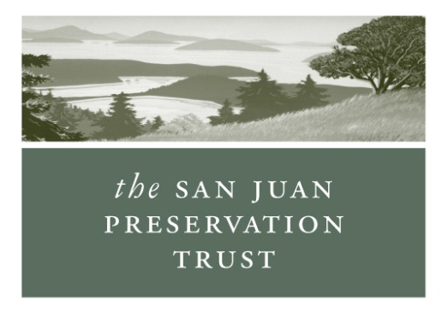

NORTH STAR PRESERVE EASEMENT

BASELINE PRESENT CONDITIONS REPORT

December 17, 2013

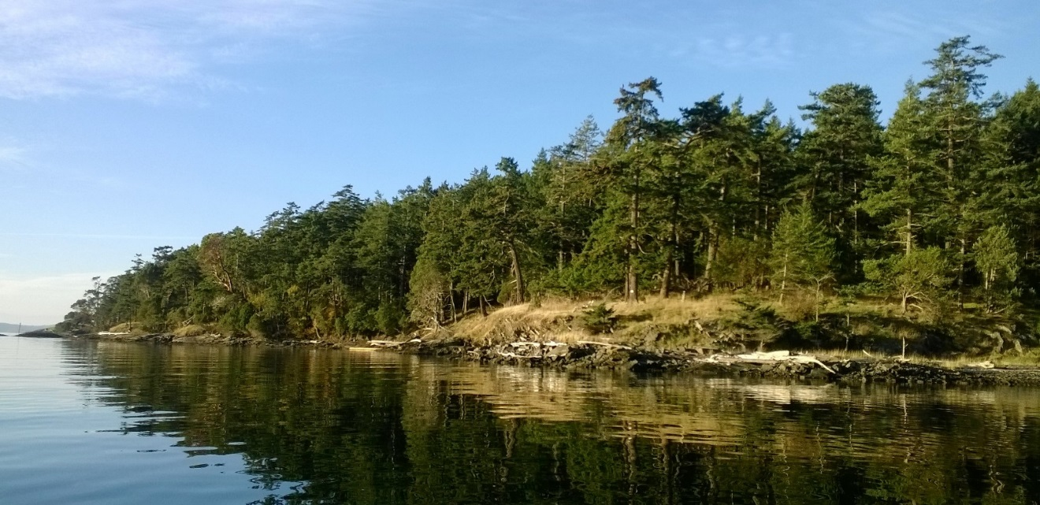

Box 327 Lopez Island, WA 98261 (360) 468 3202

I. Vital Statistics

Document Date: December 17, 2013

Auditor’s File Number: (to be filled in)

SJPT Transaction #: (to be filled in)

Easement Grant Date: (to be filled in)

Location: Southeastern Stuart Island

Site Address: North Star Ranch, Stuart Island

Name and Address of Grantors: North Star Preserve, LLC
265 Robie Drive
Auburn, CA 95603

Tax Parcels: 473350001000; 473350002000; 473421001000;
473421002000; 473421003000; 473421004000;
473421005000

Land Acreage: 61.4 (County Assessor data)

Shoreline: 4,389’ (no tidelands) (County Assessor data)

Brief Description of Easement Restrictions:
The easement restricts residential development to the existing developed area and one additional area in the SE corner of the property. The only structures allowed outside these areas are the Reef Net Cabins and utilities including a water tank.

Easement Conservation Values (Section 1.3):
The Property’s ecological, natural shoreline, forest, scenic, and open-space values (hereinafter, the “Conservation Values”) are of major importance to Grantor, Grantee, and the people of Stuart Island, San Juan County, and the State of Washington. The Property contains several pocket beaches and rocky shoreline that provide important habitat for salmon and forage fish. The Property enhances the rural character and wildlife habitat of Stuart Island. The Property can be viewed by the public from Reid Harbor.

II. Land Description

Geographic Context:
Stuart is a 2.8 square mile island located in the northwest corner of San Juan County at the intersection of Haro Strait and Boundary Pass. This 61.4-acre property is located on the southeastern point of Stuart at the entrance to Reid Harbor. Several properties around Reid Harbor have been protected by the Trust and State Parks. See Reid Harbor Protected Lands Map.

Historic Context:
Stuart Island was actively used by Native Americans, primarily it is thought, as a summer camp area. There is a documented site on Reid Harbor that is at least 2,500 years old (Stein, 2000). The 1889 US Coast and Geodetic Survey map created by JJ Gilbert (attached) shows this property with a very similar structure as is found today. There is a cleared area in the NW corner (with what looks like a large orchard which is gone today) while the remainder of the property is forested. However, the 1949 aerial photo from the San Juan County Soil Survey (Scholts, 1962) and the USGS topographic map from 1953 (below), both show the property as almost entirely logged over. By 1977 (see Washington Coastal Atlas photo below) the forest has nearly recovered to its previous extent.

Ecological Description:
This property has shoreline, forest, grassland and a residential area. Most of the nearly 4,400’ of shoreline can be characterized as steep and rocky, but the east facing shore has several pocket beaches which are considered important rearing areas for juvenile fish. Another indication of the importance of this property for fish is a site just off shore that has been utlilized for reef net fishing for several generations – one of the few remaining active reef net sites in San Juan County. The only improvement allowed along the shoreline is an established dock within Structures Area 1.

Adjacent to the shoreline is a fringe of grasslands that contain some native wildflower species and beyond that the property is almost entirely forested. As noted above, sometime prior to 1949 the property was almost entirely logged and since then a fairly uniform Douglas-fir forest has re-established. While Douglas fir is the predominant species, others tree species found here include grand fir, western hemlock, red alder, Pacific madrone, big-leaf maple, Douglas maple, western redcedar, western juniper, willow and yew. While the forest and grassland structure of this area is relatively undisturbed, the understory has been greatly altered by the presence of feral Mouflon and domestic sheep and, in the recent past, a herd of feral cattle. While the understory has been kept open, the expected shrubs and forbs are still present, but in less density, these include ocean-spray, nutka rose, salal, tall and dull Oregon-grape, orange and hairy honeysuckle and buffalo berry. Also found in the forested area are a couple of scattered balds plus a few remnant old-growth trees.

The residential area is the only substantial clearing on the property. Here is found the residence, barn, a couple of outbuildings, the dock and a manmade pond. The Structures Area 1 Close up Map below is dated 2008, but there have not been any additions to the structures shown on that map.

Improvements:
The majority of the improvements on the property are located within Structures Area 1. The exceptions to this are the well house, water tank and two Reef Net Cabins whose locations are documented on the Site and Aerial Map. The northern Reef Net Cabin has been restored but the southern one has not (see photos below on pg. 19).

Conservation Values:
The greatest conservation value on this property is the nearly 4,400’ of natural shoreline most of which will be forever protected from any shoreline disturbance. In addition, this property adds to other significant protected areas in Reid Harbor (see Reid Harbor Protected Lands Map). Most directly the nearly adjacent Preservation Trust Reid Harbor Preserve which protects another 2,800’ of shoreline.

III. Reserved Areas
The reserved areas are the two structures areas. Structures Area 1 contains a residence, outbuildings, barn, dock and manmade pond. Structures Area 2, a 2-acre plot to be located on the two southernmost lots, is not established at this time.

IV. Property Boundaries
The property boundaries are fairly well marked. There are old fence lines along the western border and most of the southern border. The corners of the two southern lots are marked by survey pipes. Most of the property was surveyed in 1982 as the North Star Ranch, the short plat map of which is below.

Attachments:
- 2008 Aerial Map with Property Lines
- Structure Area 1 Close Up Aerial
- Topographic Map
- US Coast and Geodetic Survey Map (~1895)
- Washington Coastal Atlas Historic Shoreline Photo (1977)
- North Star Ranch Plat Map
- Reid Harbor Protected Lands
- Washington Coastal Atlas Shoreline Photos (2006)
- On-site photographs

Author:
Dean Dougherty
Director of Stewardship for San Juan Preservation Trust since 2005
M.S. University of Washington College of Forestry, 2003
Baseline Report Trained by the Land Trust Alliance

References:

Scholts, F.E, [et al.] 1962. Soil Survey of San Juan County, Washington. United States Department of Agriculture in Cooperation with the Washington Agricultural Experiment Station.

Stein, J.K., 2000. Exploring Coast Salish Prehistory. University of Washington Press. Seattle.

Washington Floral Checklist http://biology.burke.washington.edu/herbarium/waflora/checklist.php

North Star Preserve Site and Aerial Map
2008 Aerial Data

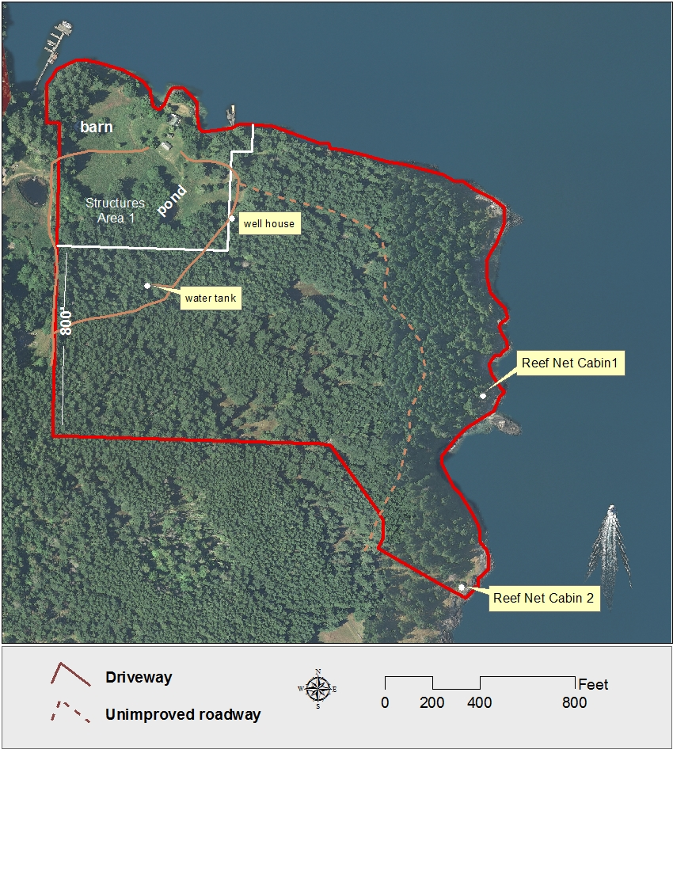

Structure Area 1 Close Up
2008 Aerial Data

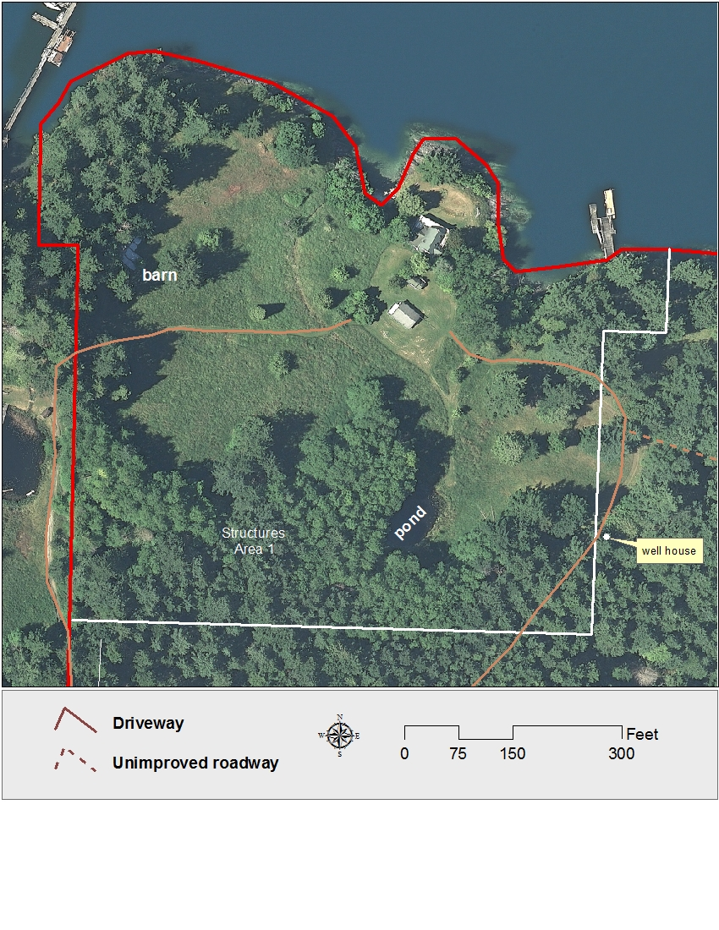

North Star Preserve USGS Topographic Map

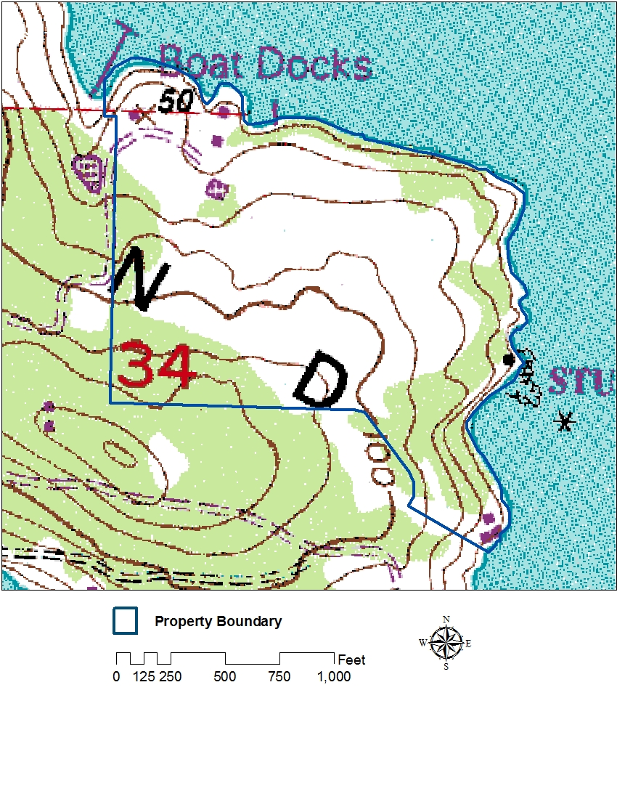

US Coast and Geodetic Survey (~1895)

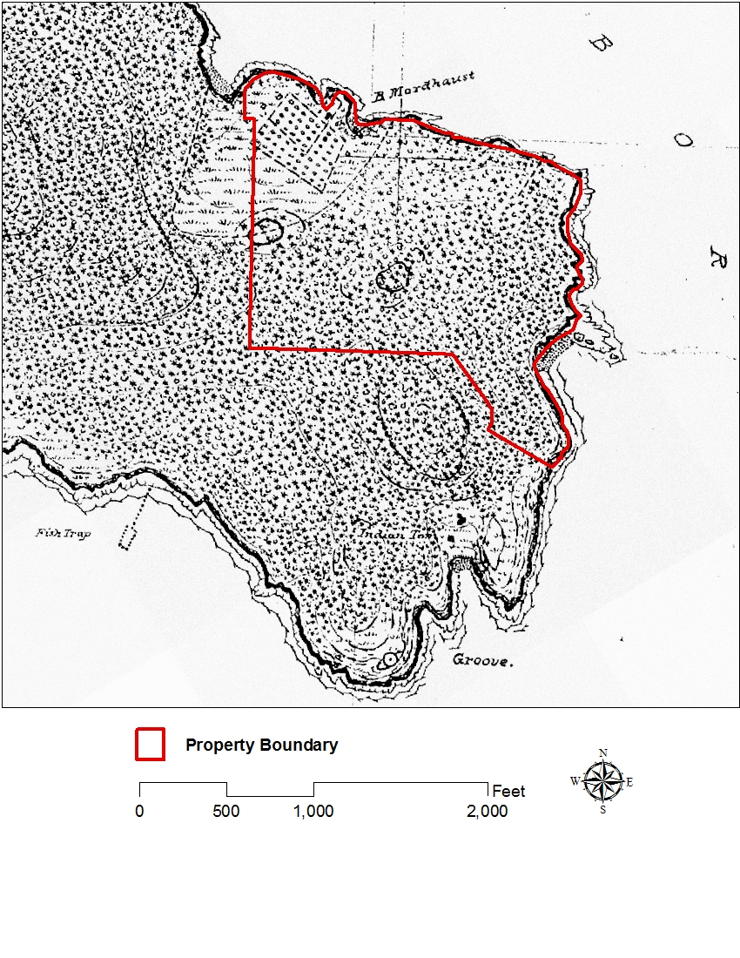

Washington Coastal Atlas Shoreline Photo (1977)

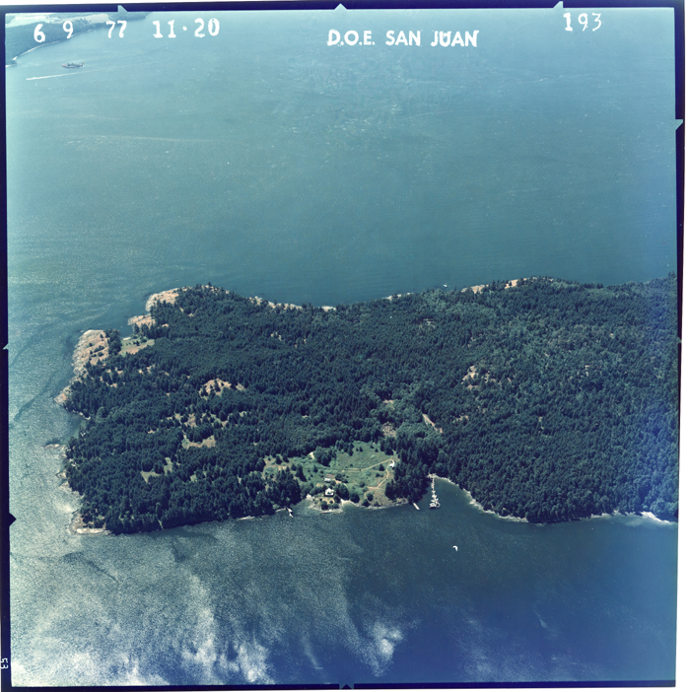

North Star Ranch Short Plat Survey Map

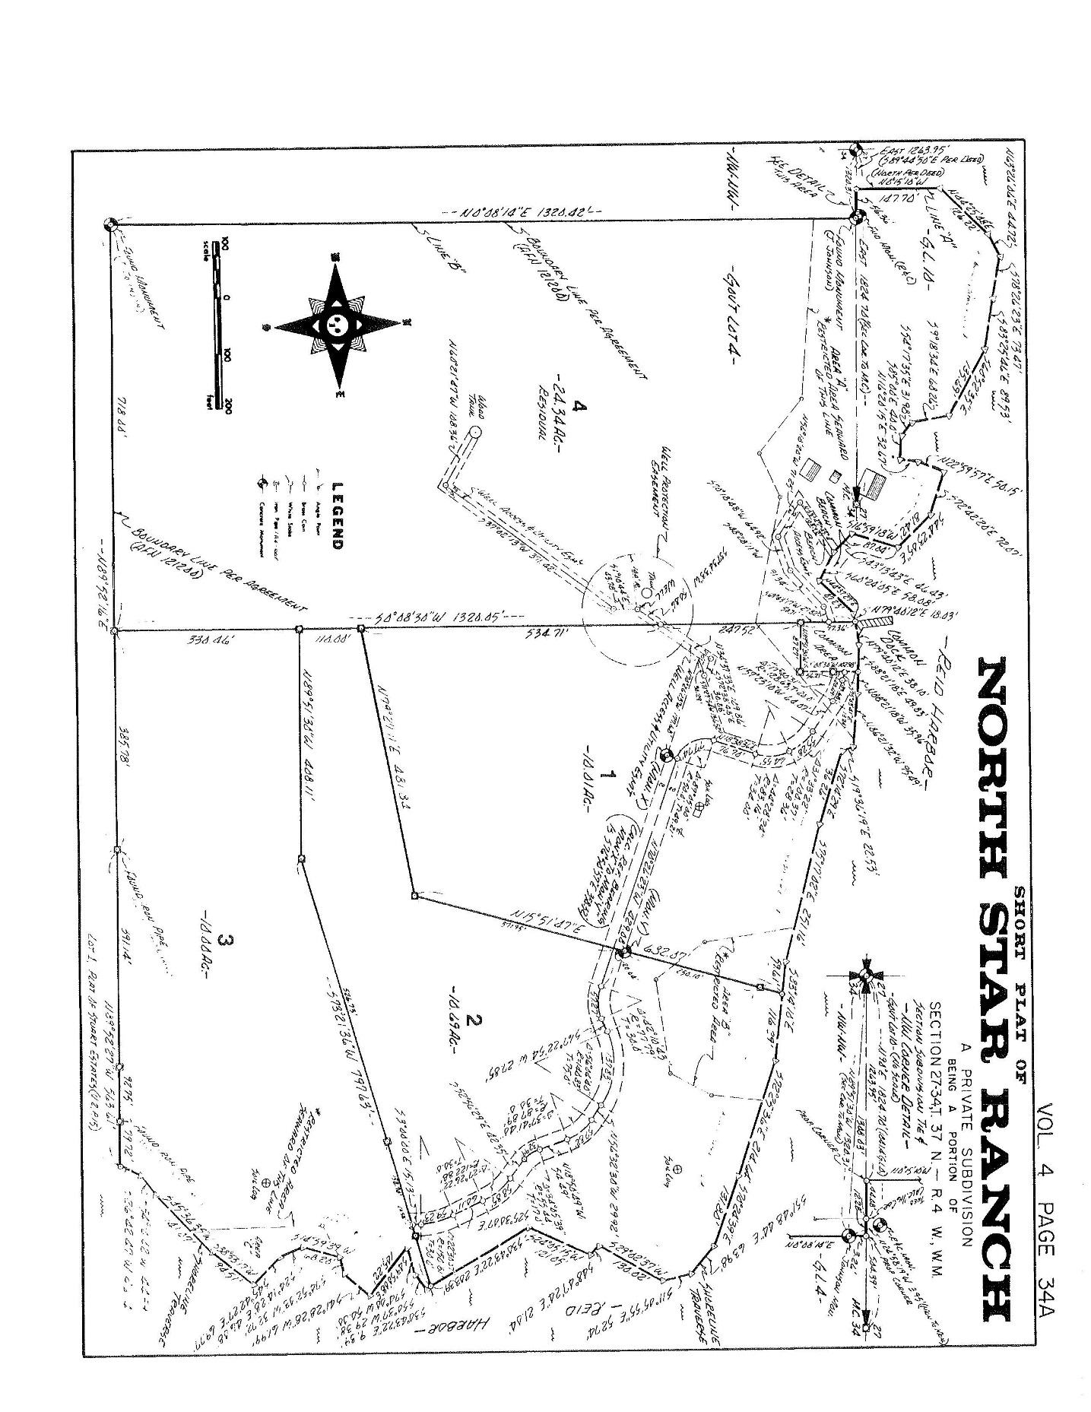

Reid Harbor Protected Lands

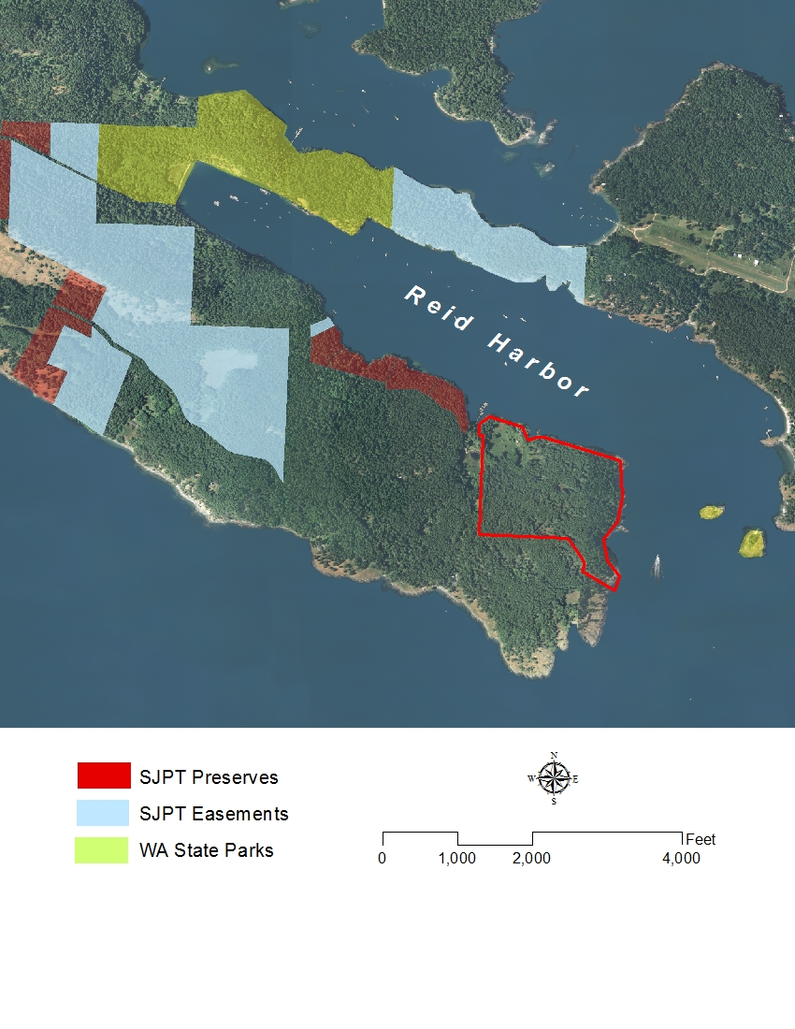

Washington Coastal Atlas Shoreline Photos
8/15/2006

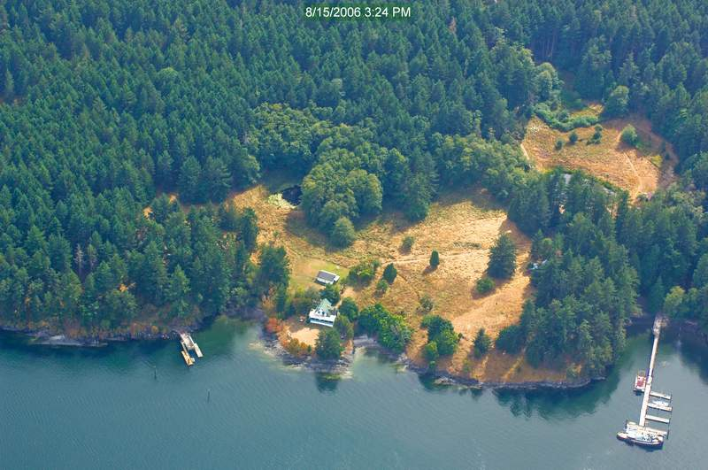
Structures Area 1, approximate boundary in red.

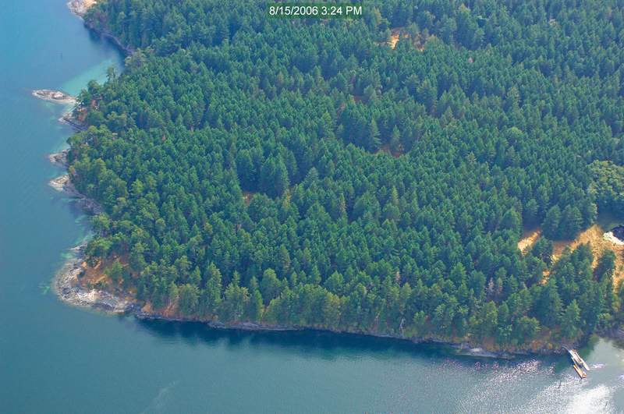
View to SSW

Washington Coastal Atlas Shoreline Photos
8/15/2006

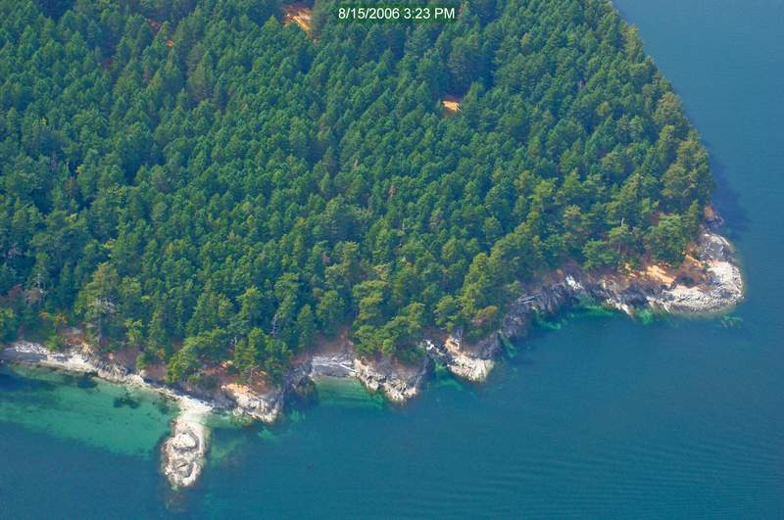
View to West

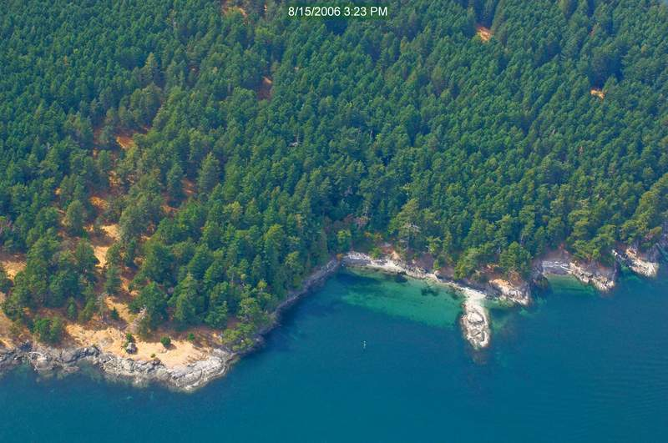
Approximate property line in red.

On-Site Photographs from 10/6/2013

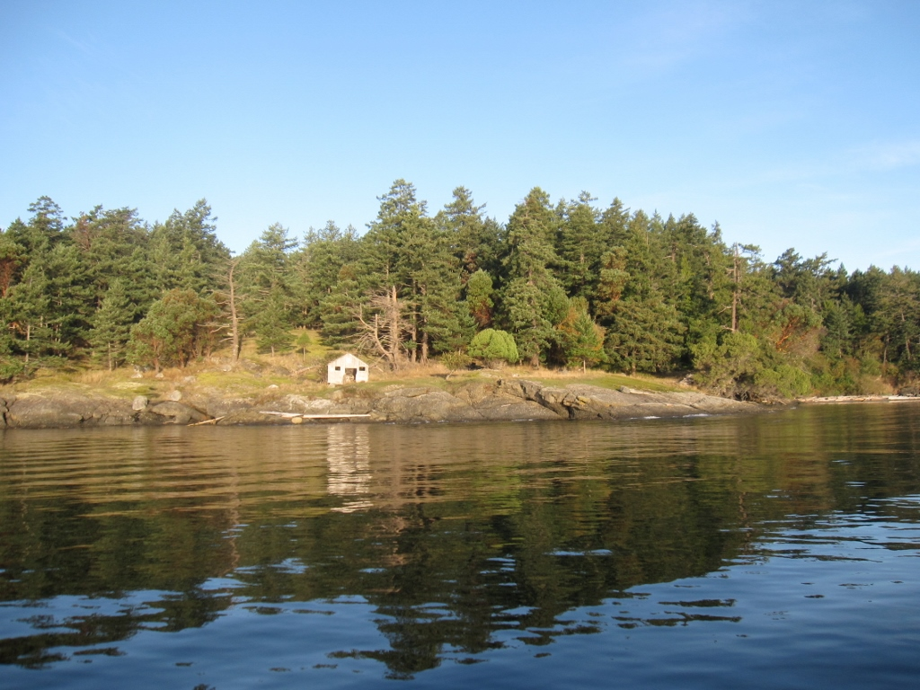
Reefnet Shack 2 and southern boundary, view to NW.

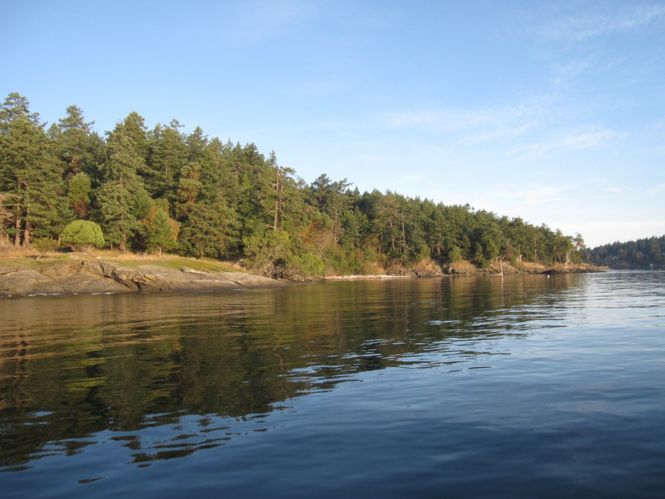
Shoreline just to the north of the southern boundary, view to NNW.
On-Site Photographs from 10/6/2013

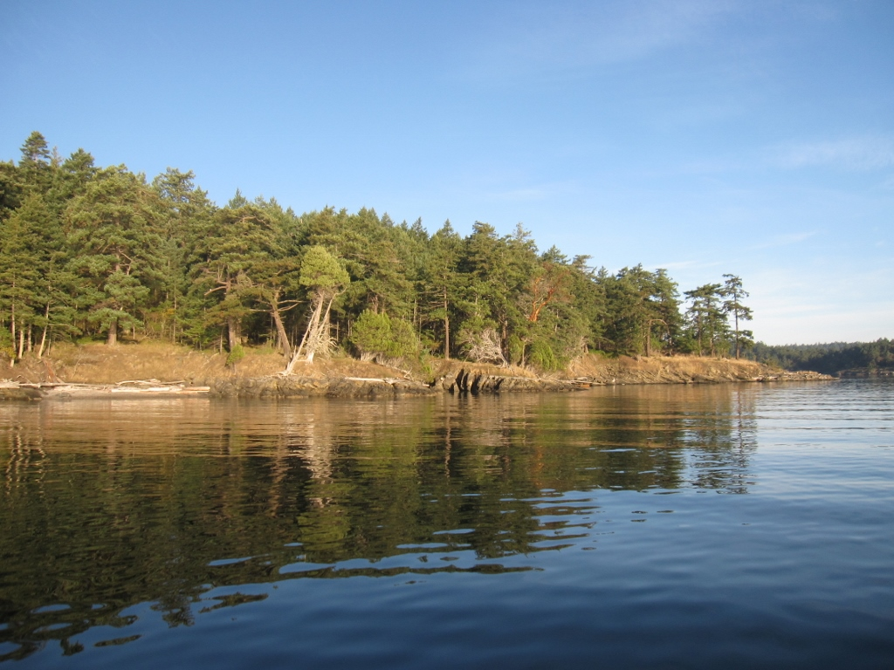
Northern section of east facing shoreline, view to west.

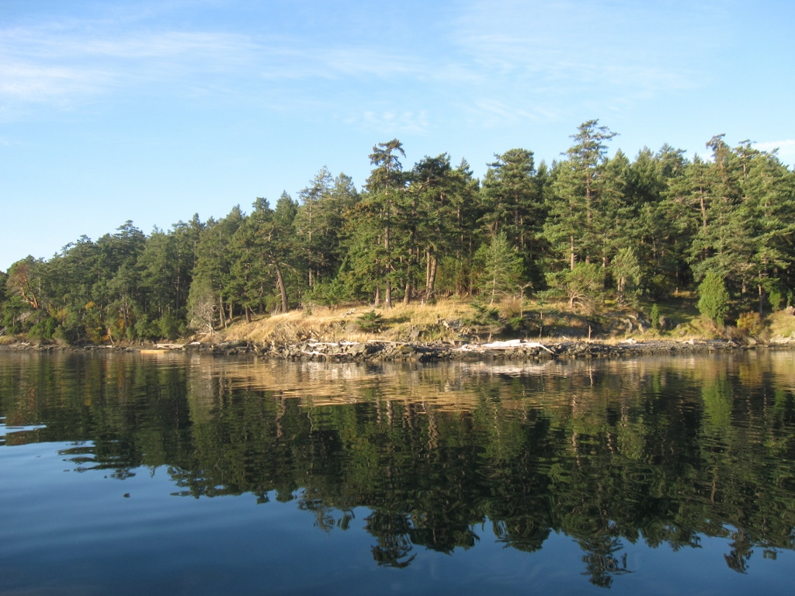
Northeast facing point of shoreline, view to SW.
On-Site Photographs from 10/6/2013

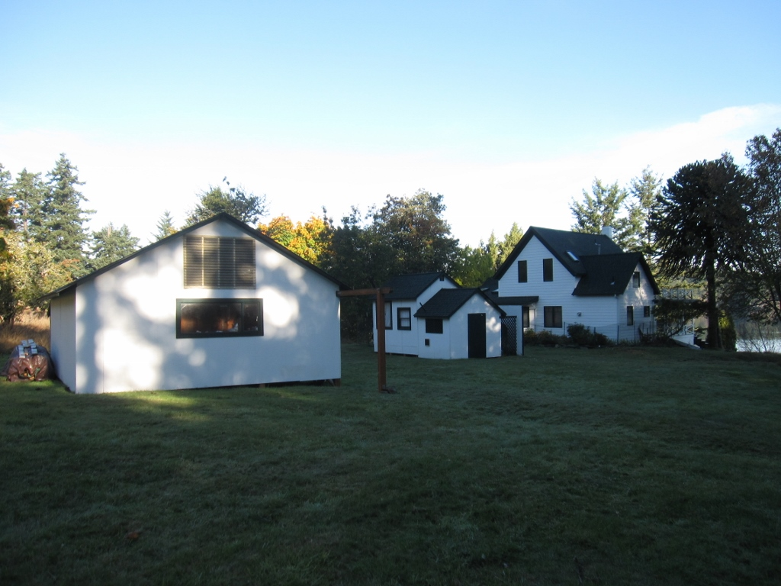
Residence and outbuildings in Structures Area 1.

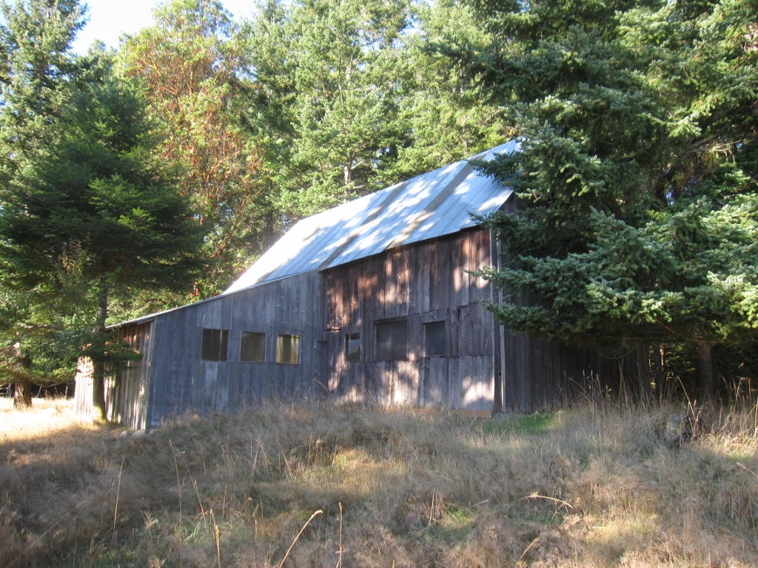
Barn, near west boundary of Structures Area 1.
On-Site Photographs from 7/17/2013

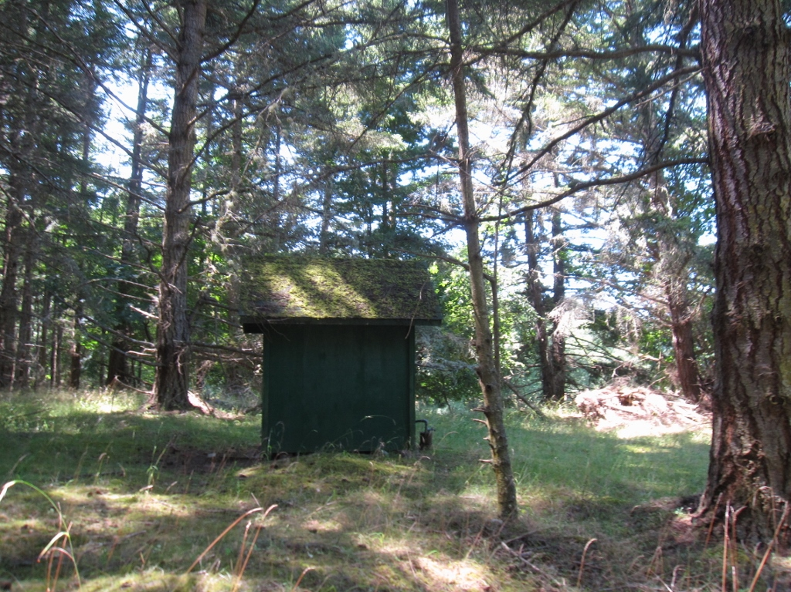
Wellhouse just off eastern boundary of Structures Area 1.

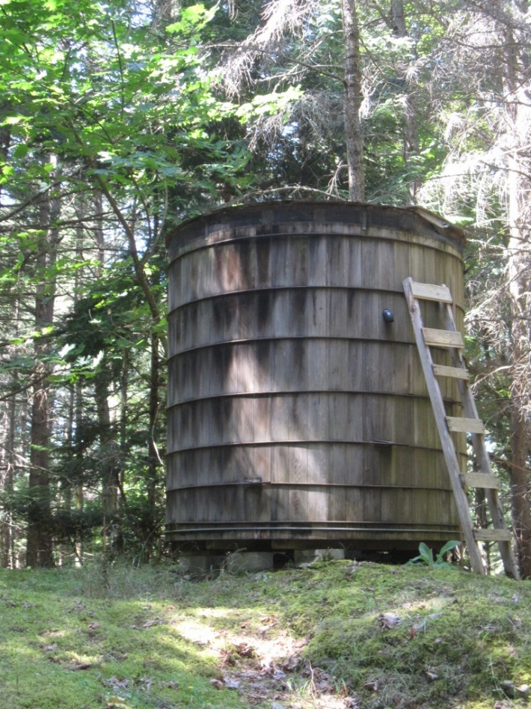
Water tank in SW portion of the property.
On-Site Photographs from 10/6/2013

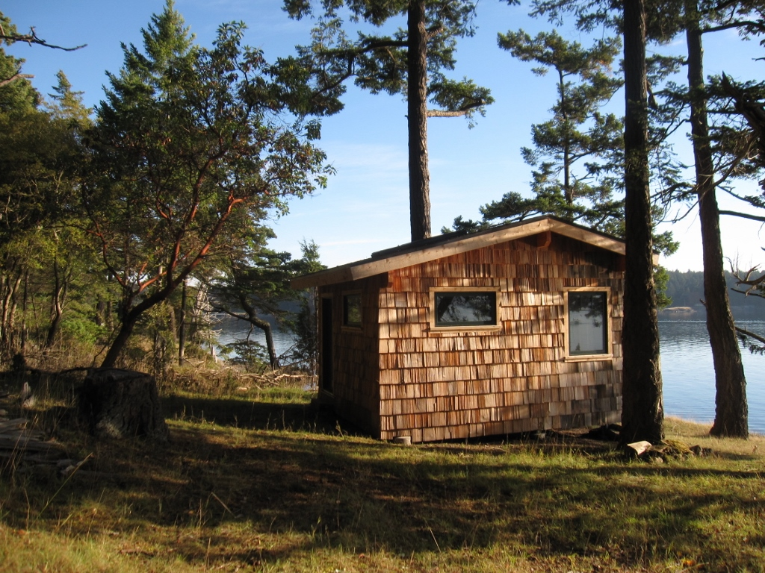
Reefnet Shack 1.

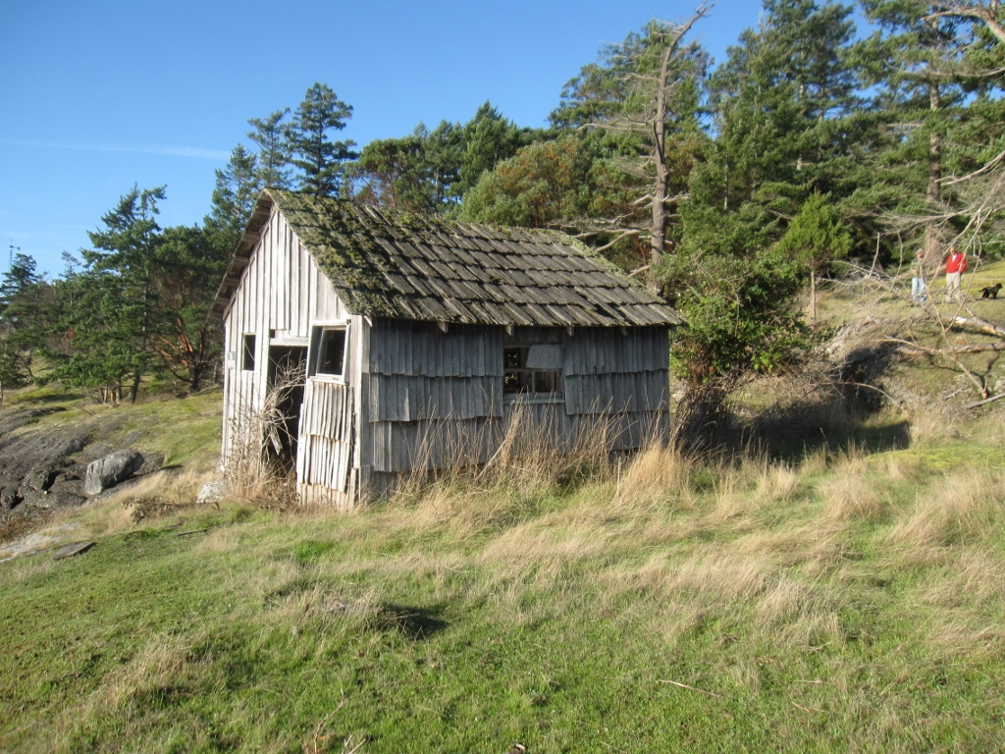
Reefnet Shack 2.
On-Site Photographs from 8/21/2013

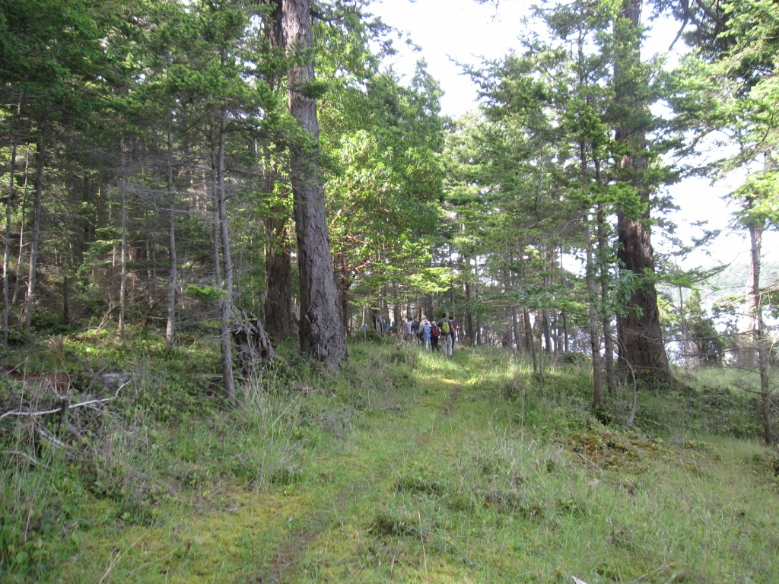
Trail near shoreline.

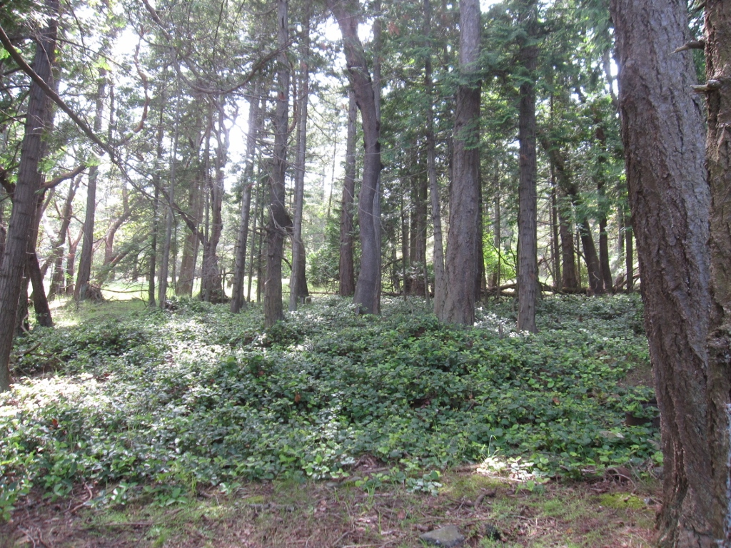
View of forest interior near the shoreline.

