Sen. Cantwell, local leaders tour Meadowdale Beach Park project aimed at restoring fish habitat
Posted: July 9, 2021 480
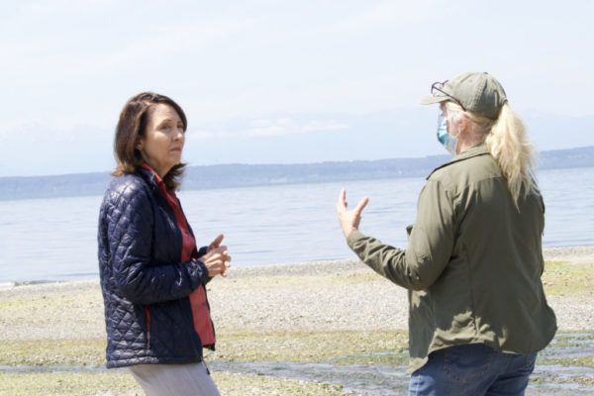Standing on the Meadowdale Beach Park shoreline, U.S. Sen. Maria Cantwell (left) and Snohomish County Project Manager Logan Daniels discuss the restoration work. Daniels said she felt “honored to be part of a project where we can restore the land back to where it wants to be.”
U.S. Sen. Maria Cantwell along with several state, county, local and tribal leaders got a closer look at the Meadowdale Beach Park estuary restoration project Friday afternoon. The project will restore a historic 1.3-acre estuary to provide essential rearing habitat for chinook, chum and coho salmon as well as cutthroat trout. Puget Sound chinook salmon are listed as a threatened species under the Endangered Species Act.
Construction work began on June 15, limiting access to the park, and is anticipated to be completed in spring 2022. The project, which is estimated to cost approximately $15 million, has received more than $6.7 million in various federal and state grants, with the remainder of the money coming from Snohomish County.
Cantwell said the upcoming project, which had been conceived more than a decade ago, was particularly notable for “how collaborative it was by people working a long time who had a vision and stuck with it.”
“I want to say congratulations to everybody — to the county, the legislature, the state office, the tribe, to everybody who’s participated,” she said, calling it “an unbelievable investment” to ensure both people and salmon can access the water.
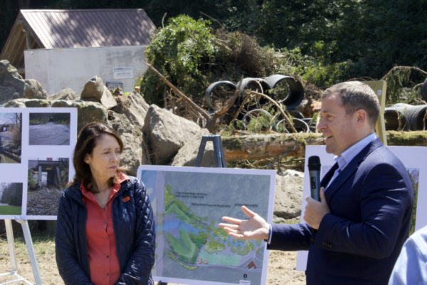Edmonds Mayor Mike Nelson, right, spoke during the media event, touting the project’s restoration efforts and said he would like to see similar work done at the Edmonds Marsh.
Edmonds Mayor Mike Nelson, who toured the area along with Cantwell, said the project “shows what can happen when you have all these different entities working together and you can actually see an idea about restoration actually come to fruition.”
While restoration planning has been underway for several years, Friday’s event celebrated the award of a $3.5 million grant from the Federal Railroad Administration “to help improve this situation,” Cantwell said. The project will remove 128 linear feet of railroad embankment that serves as shoreline armoring and replace a 6-foot-wide culvert running under the BNSF railroad tracks to restore habitat for salmon that spawn in Lund’s Gulch Creek. Workers will install a five-span railroad bridge with a 100-foot opening to address ADA accessibility, beach access, fish passage, flooding, sediment delivery and various maintenance issues associated with the current undersized culvert.
It will also help re-establish nearshore processes considered key to the Puget Sound’s recovery. Additional habitat and stream enhancement will occur upstream of the estuary and a second footbridge will be installed to provide a platform for viewing fish migration.
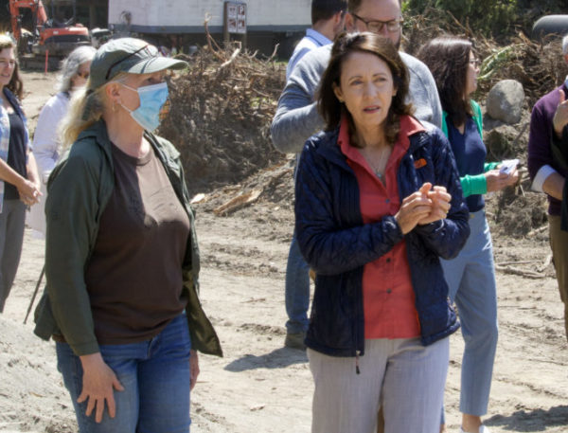U.S. Sen. Maria Cantwell, right, and Project Manager Logan Daniels.
Project manager Logan Daniels, an engineer with Snohomish County Parks and Recreation, said that “every step of the way was a challenge on this thing,” but added that it addresses multiple objectives. Among them, she said, are “public safety, salmon rearing habitat and recreational benefits with ADA accessibility to the beach. I’m honored to be a part of a project where we can restore the land back to what it wants to be.”
While the project’s cost is large compared to its physical size, “we are maximizing the restoration potential for this site,” Daniels said. “It couldn’t be any bigger than the 1.3 acres, that’s what it was, back in the 1800s so we’re matching what was here back then before the railroad came in and there’s room for sea level rise.”
Recreation components include picnic and bench viewpoints of the beach, estuary and Lund’s Gulch Creek; and a foot-wash station. The existing portable restroom enclosure will be relocated out of the floodway and the ADA parking will also be upgraded to current standards.
Cantwell said she was happy to help to help remove a hurdle to restoring the salmon habitat and would like to see more projects of a similar nature being undertaken. “We passed a bill out of the Senate Commerce Committee that authorized for the first time $4 billion for culvert restoration to make us responsible federally to help with the situation of removing things that have been a damage to fish passage and ways to make sure that transportation infrastructure is improving the ‘fish highways’ that we need to have to return the salmon,” she added.
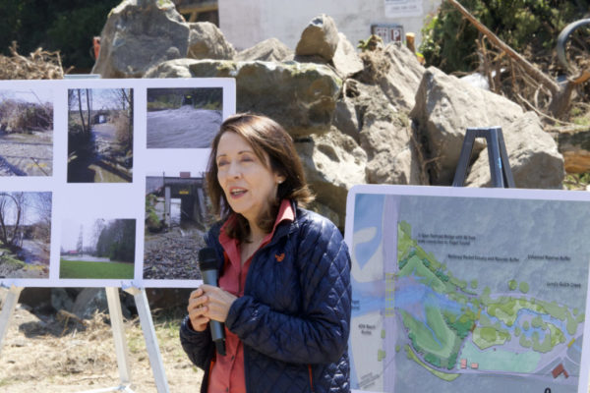Sen. Cantwell called the project, which began construction last month, “an unbelievable investment” to ensure both people and salmon can access the water.
The Sport Fish Restoration, Recreational Boating Safety, and Wildlife Restoration Act of 2021 and the Surface Transportation Investment Act both advanced to Congress during the committee’s executive session last month. The restoration bill was co-authored by Cantwell, who is chair of the U.S. Senate Commerce Committee, and she sponsored the transportation bill. The restoration act authorizes $800 million for each of next five fiscal years, which would help advance both economic and environmental goals by removing manmade barriers in order to recreate natural stream conditions. Culverts in the Pacific Northwest that threaten salmon and steelhead runs would be specifically targeted.
Several speakers thanked Cantwell for championing environmental efforts and the Meadowdale Beach Park project specifically. They noted that having multiple agencies and organizations involved across different levels — both public and private — including BNSF, was crucial to the process and its ultimate success.
“These are critical partnerships that take state, federal and local dollars,” said 21st District State Sen. Marko Liias. “It’s so wonderful to see exactly what it’s going to deliver for our iconic salmon. This is also a testament to why we need federal investment and we’re so thrilled that Sen. Cantwell has been a leader in really demanding more funding for conservation.”
“This was something that has been in the plans for a long time and when you compare it to other estuary projects or restoration projects like Edmonds Marsh, yeah there’s all kinds of plans, but getting it to the point where they’re actually creating it” is especially notable, Nelson said. “People who have been advocating and fighting for these kinds of things have just a great model that other communities and other neighbors can replicate,” he added “Seeing that it can happen is always a good reminder, like, OK — we can get there, and we can do it.”
Cantwell, an Edmonds resident, agreed with Nelson’s sentiment, adding that restoring the Edmonds Marsh is next on the agenda as a way to continue helping fish get back upstream by removing artificial barriers. “It just shows us that we can do the restoration work and give people access to the beach and give salmon access to their streams,” she noted.
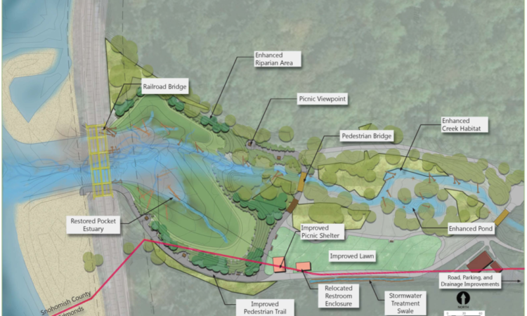
A map of the project work.
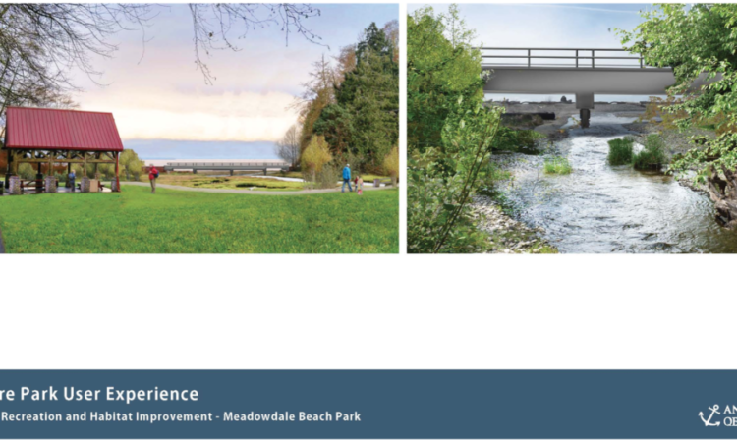
A rendering of what future park users will experience.
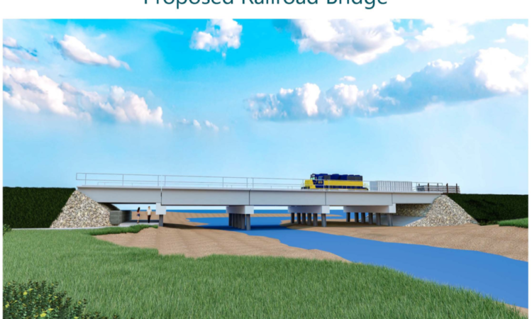
A rendering of the railroad bridge. (All graphics courtesy Snohomish County)
A map of the project work.
A rendering of what future park users will experience.
A rendering of the railroad bridge. (All graphics courtesy Snohomish County)
A map of the project work.
The July 9 media event was an unofficial groundbreaking walking tour of the culvert replacement and salmon habitat restoration project. Owned by Snohomish County, Meadowdale Beach Park was designated a “hike-in” only park when it was built and has a one-mile nature trail that winds through its forest down to the beach. The 108-acre park features more than 500 feet of shoreline and one mile of riparian habitat along Lund’s Gulch Creek, which drains into Puget Sound.
“Don’t always judge a project by the size of the restoration because there’s other benefits too,” Daniels said. “We did an ecosystem evaluation with Earth Economics, and we found that this project had a $4 return on every dollar invested,” which included factoring in the environmental, recreation, educational and area home value benefits.
Cantwell said she has known for a while about the park’s natural beauty and panoramic views offered by its beach area. She recalled one time encountering a couple visiting from Alabama, while on their way to Alaska, who went to the Meadowdale Park Beach based upon the recommendation of a bartender in Seattle. Cantwell said the two were in awe and she found it to be a particularly memorable moment. “That bartender could have told them so many places in Puget Sound to go see for a day” but this place was suggested because it’s “unique and very close to nature,” she noted. “I thought that was great meeting them and sharing with people from someplace far away something so special that’s in our backyard.”
Meadowdale Beach Park closure information:
- The beach is currently closed to the public.
- Trail is open from the main parking lot at 6026 156th St. S.W. to just uphill from the ranger residence only.
- Portable restroom facilities are only available at the parking lot.
- There is no ADA vehicle or pedestrian access from 75th Place West which has limited vehicle access available to people working on the project and residents.
- Kayak beach access and camping is prohibited during construction.
- If construction is suspended during extended periods of unsuitable weather or other conditions, temporary public beach access may be provided.
— Story and photos by Nathan Blackwell

