**Whidbey Camano Land Trust**

**South Camano Nearshore Protection Planning**

**Final Report – April 2011**

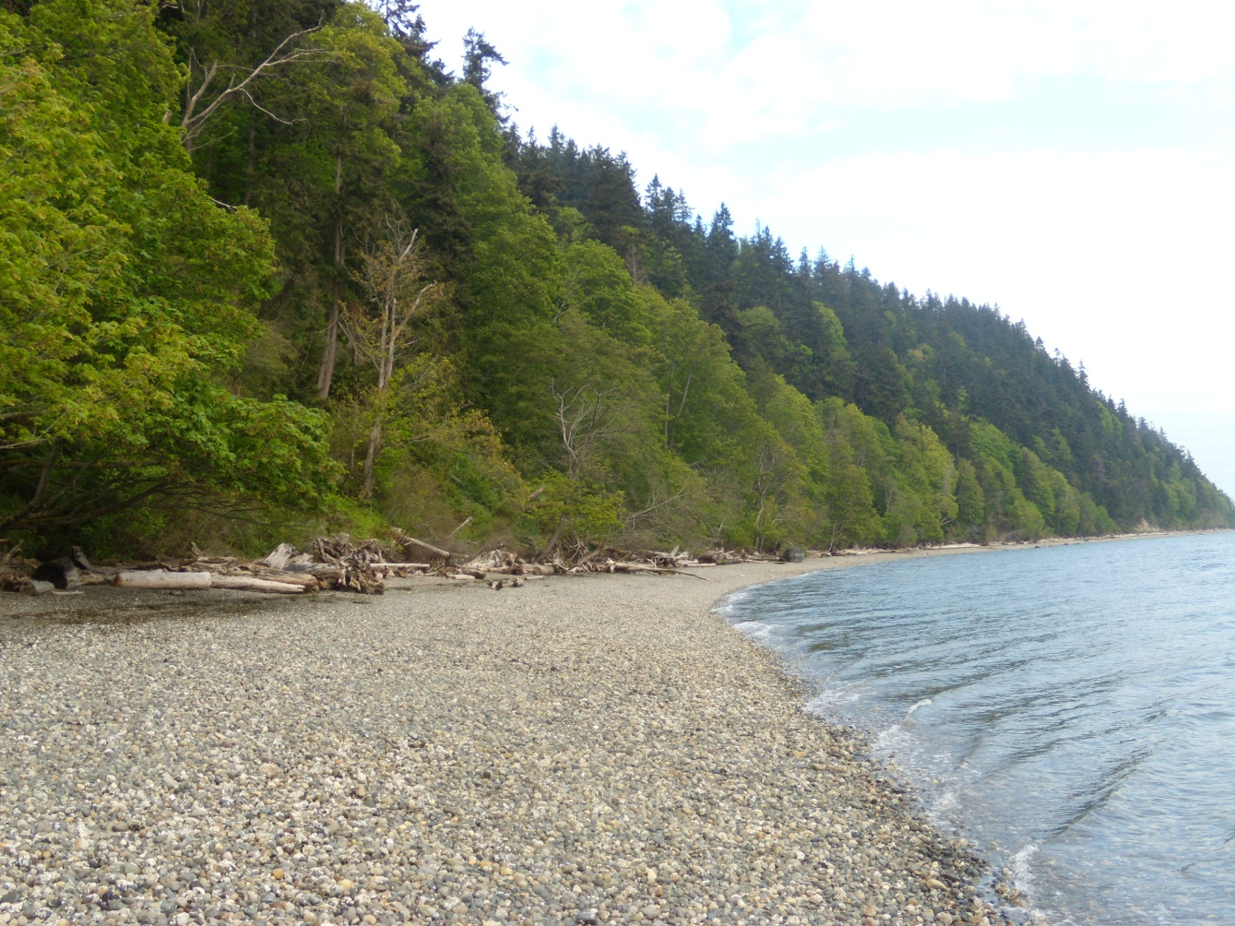

**INTRODUCTION**

In 2007, the Washington State Salmon Recovery Funding Board (“SRFB”) approved the South Camano Nearshore Protection Planning grant submitted by Whidbey Camano Land Trust (“Land Trust”). The goal of the project was to increase information available to help select projects that have high certainty of success and benefit for salmon. Towards that goal, the Land Trust developed a prioritization and implementation plan outlining protection actions for properties important to maintaining naturally functioning nearshore and watershed processes in the project area.

This report summarizes the habitat and landowner assessments, identifies land protection priorities, and provides recommendation for future actions.

**HABITAT RANKING**

In April, 2009, the Land Trust entered into a contract with Keystone Ecological, LLC (“Keystone”) to prioritize all tax parcels within the South Camano project area for future protection based on their habitat values and contribution to salmon recovery. In developing this prioritization, Keystone was directed to conduct an assessment of currently available information regarding the current habitat conditions within the project area. Keystone gathered data necessary to determine which lands within the project area contain the most high quality habitat and contribute to the viability of salmon. This included information on drainage areas and the nearshore, physic all processes, biological processes, and ownership data.

**The resulting *Conservation Strategies Report for South Camano Drainage Basins* is attached to this document.**

**NATURAL HERITAGE SURVEY**

Among the unique elements of the project area are the big leaf maple-red alder/swordfern-fringecup (*Acer macrophyllum – Alnus rubra / Polystichum munitum – Tellima grandiflora)* forest community and wetlands. The Land Trust contracted the Washington Natural Heritage Program to delineate and survey these two elements.

**The resulting *South Camano Heritage Survey Report* is attached to this document.**

**DETERMINATION OF PRIORITY LANDOWNERS**

With the results of the *Conservation Strategies Report for South Camano Drainage Basins* and the *South Camano Heritage Survey Report* Land Trust staff determined which landowners owned the land most critical for salmon viability “Priority Properties.” The goal of developing the list of Priority Properties was to identify landowners who should be contacted and provided with additional information regarding tools for permanent protection of land. These lands, with landowner interest, would then be cultivated into future protection projects, which could include donations of land or conservation easement and/or future applications to the Salmon Recovery Funding Board (SRFB) or other grant sources appropriate for acquisition and/or restoration funding.

The development Priority Properties began with the *Conservation Strategies Report for South Camano Drainage Basins* report completed by Keystone Ecological. All lands which scored as a high priority (scoring 50 points) were considered. From these priorities, small properties (less than 10 acres), and those already significantly cleared and developed, were removed. These smaller or developed properties were determined to be unlikely to provide significant habitat protection or compete well for limited funding sources. Larger, intact properties are more likely to successfully compete for grant funding and be prioritized by organizations and agencies for protection efforts. It often takes the same amount of staff time and expense to protect a small, rather insignificant property as it does a larger, significant property.

From this point, consideration was given to parcels which scored in the 30-45 point range within the *Conservation Strategies Report for South Camano Drainage Basins* report. Land Trust staff identified a number of properties that should be Priority Properties due to the inclusion of wetlands and/or the intact forest as well as larger ownerships.

15 landowners, owning 43 tax parcels were identified for this outreach effort. The Priority Properties include 18 feeder bluff and shoreline properties and 25 interior forest and wetland properties. All of these properties are over 10 acres with limited development and clearing of land. The Priority Properties are identified on the attached Map 2 **“**Priority Properties**.”**

After reviewing the resulting map and list of Priority Properties, Land Trust staff not that lands less than 10 acres may become higher priorities once the Priority Properties are protected. The can increase the size of protected area and provide buffers around protected lands. Map 3 depicts all properties above 5 acres in size, including the Priority Properties.

**OUTREACH EFFORTS**

Outreach efforts included direct contact from the Land Trust staff.

Land Trust staff sent a letter to Priority Property landowners informing them about the work of the Land Trust and indicating interest in discussing possibly protection efforts on their property. The letters were followed by telephone calls two weeks later. Of the landowners contacted, one landowner has expressed significant interest in pursuing protection of their property, which includes 20 acres of shoreline, bluff, and forestland.

All landowners owning land of 5 acres or more were sent a more general letter and Land Trust brochure. These landowners were invited to contact the Land Trust if they have interest in discussing Land Trust work or protection of their property.

**NEXT STEPS**

**Priority Landowners**

As mentioned above, one Priority Property landowner is interested in pursuing protection of their property. The property has been through the Land Trust’s project evaluation process and board approval. The documentation is attached. Land Trust staff is in the process of educating the landowner on land protection and conservation easements, with plans to complete a conservation easement removing development rights and protecting the habitat values of the property.

The Land Trust will continue to monitor the other Priority Properties and take appropriate steps to develop relationships with the landowners to facilitate future land protection conversations if the landowners so desire.

**Lands over 5 acres**

Land Trust staff will remain available to discuss protection with the landowners should they contact the Land Trust following the completion of this contract.

**Attachments**:

**A**: Conservation Strategies for South Camano Drainage Basins

**B:** South Camano Natural Heritage Survey Report

**C:** Map 1: South Camano Priority Area

**D:** Map 2: Priority Landowners

**E:** Map 3: Priority Landowners – including all parcels over 5 acres

**F:** Camano Head property project evaluation