Snohomish County Story Map

<https://storymaps.arcgis.com/stories/e74c3ffa5b814402914f87186578f24e>

Snohomish County website: [News Flash • Snohomish County, WA • CivicEngage (snohomishcountywa.gov)](https://snohomishcountywa.gov/CivicAlerts.aspx?AID=2524)

<https://lynnwoodtimes.com/2023/01/15/meadowdale-beach-park-230115/>

[](https://lynnwoodtimes.com/)

[Lynnwood Times](https://lynnwoodtimes.com/)

Lynnwood's premier news source.

[Announcements](https://lynnwoodtimes.com/category/announcements/) [Featured](https://lynnwoodtimes.com/category/featured/) [Latest News](https://lynnwoodtimes.com/category/latest-news/)

Public beach access reopened at Meadowdale Beach Park

[January 15, 2023](https://lynnwoodtimes.com/2023/01/15/meadowdale-beach-park-230115/)  [Lynnwood Times Staff](https://lynnwoodtimes.com/author/lynnwoodtimesstaff/)[0 Comments](https://lynnwoodtimes.com/2023/01/15/meadowdale-beach-park-230115/#respond)  3 min read

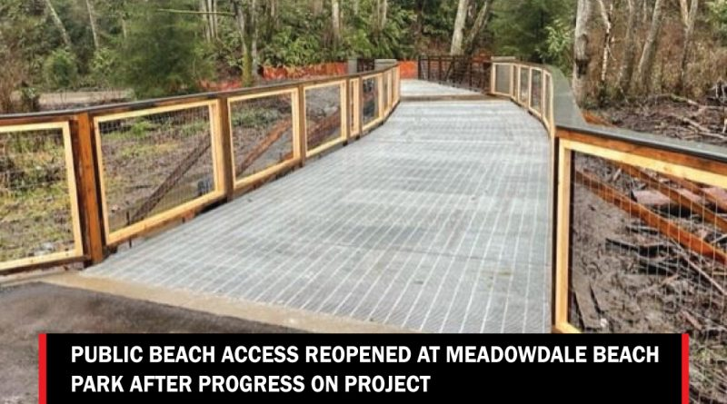

[Facebook](https://lynnwoodtimes.com/#facebook)[Twitter](https://lynnwoodtimes.com/#twitter)[LinkedIn](https://lynnwoodtimes.com/#linkedin)[Email](https://lynnwoodtimes.com/#email)[Print](https://lynnwoodtimes.com/#print)

**EDMONDS, Wash., January 15, 2023**—After completion of significant project milestones in 2022, Meadowdale Beach is once again accessible to the public. The Meadowdale Beach Park and Estuary Restoration Project was initiated by Snohomish County Parks and has been a successful partnership with Snohomish County Surface Water Management (SWM), BNSF Railway, Tulalip Tribes, state and federal agencies, and the local community. This project is regionally significant for its role in salmon recovery and Puget Sound shoreline restoration, while making significant improvements to the park.

Some of the successes accomplished on the construction project in 2022 include:

* Two BNSF train track bridges were installed which replaced 128 linear feet of two-track railroad
* A rock armored railroad embankment and box culvert were removed to allow water and sediment to more freely flow, restoring natural shoreline processes
* A pedestrian walkway under the bridges was installed
* Estuary restoration and landscape work
* A pedestrian bridge was installed over the estuary

Remaining project construction for 2023 will include:

* Installing utilities, including storm, electrical, water, and irrigation
* Installing benches, picnic tables, a picnic shelter, and portable restroom enclosure
* Installing interpretive signs

Beach access will be available for public use through the new accessible pedestrian walkway under the train track bridges. The remaining construction will take place in a fenced off portion of the park and is anticipated to be finished in the summer of 2023. A ribbon cutting event is being planned once the entire project is complete.

This is the first Puget Sound shoreline restoration project that included enlarging a stream crossing under railroad tracks along the shoreline. The installation of a wide railroad bridge to replace the undersized culverts was critical to Snohomish County achieving its vision to convert park lawn areas to high functioning estuarine habitat to benefit salmon. SWM and many partners have conducted habitat monitoring at Meadowdale Beach for many years and will continue to monitor the effectiveness of this project.

The Meadowdale Beach Park and Estuary Project is funded in part by the Federal Rail Administration, NOAA Fisheries, Aquatic Lands Enhancement Account, Estuary and Salmon Restoration Program, Puget Sound Acquisition & Restoration, State Salmon Recovery Grants, Washington Wildlife and Recreation Program, the EPA, and the Restore America’s Estuaries: NEP CWG Program.

**More Information:**

Learn more about the project here: <https://snocoparks.info/MeadowdaleProject>

**About Snohomish County Conservation and Natural Resources**

The Snohomish County Department of Conservation and Natural Resources (DCNR) includes the Division of Surface Water Management; the Division of Parks and Recreation; the Office of Energy and Sustainability and the Office of Agriculture. DCNR works in support of thriving communities; a clean and healthy environment to foster environmental stewardship; ensuring food security; supporting a green economy, and strengthening communities by providing regional parks and infrastructure; protecting the region’s water, air, land and natural habitats; enhancing agriculture and recreation; and reducing flooding. [https://snohomishcountywa.gov/5758](https://gcc02.safelinks.protection.outlook.com/?url=https%3A%2F%2Fsnohomishcountywa.gov%2F5758&data=04%7C01%7CDeb.Harvey%40co.snohomish.wa.us%7C1762fb61af2d4bcba99a08d9dad5c1b8%7C6bd456aabc074218897c4d0a6a503ee2%7C1%7C0%7C637781433870821979%7CUnknown%7CTWFpbGZsb3d8eyJWIjoiMC4wLjAwMDAiLCJQIjoiV2luMzIiLCJBTiI6Ik1haWwiLCJXVCI6Mn0%3D%7C3000&sdata=irN2%2FocCShM9xXdhrWr%2FHNdllgdWRy17g3dikGDxr%2Fs%3D&reserved=0).

<https://dredgewire.com/snohomish-county-beach-to-reopen-after-15-million-restoration-project-nearly-completed/>

