**C.T. BURN**

**CONSERVATION EASEMENT**

**STEWARDSHIP PLAN**

Salmon Recovery Funding Board

RCO-SRFB/PSAR #14-1933A

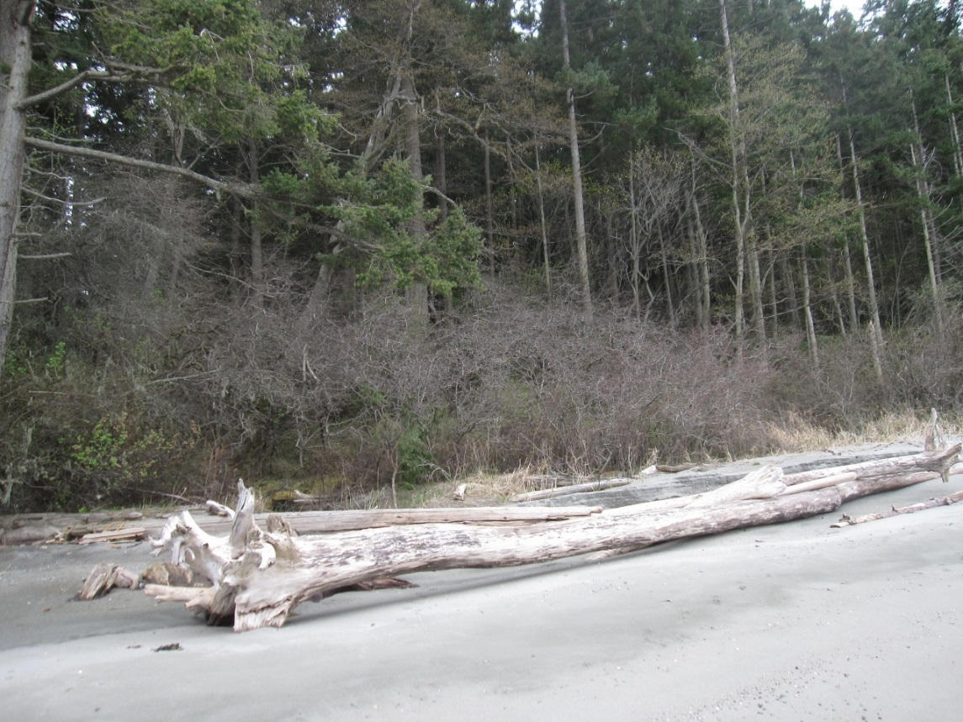

March 2015

Background

C.T. Burn Conservation Easement is an approximately 10.4 acre property composed of two tax parcels located at Fishery Pt. on the northern shoreline of Waldron Island in the San Juan Islands, San Juan County, Washington. The Property encompasses 814 feet of natural medium bank rocky shoreline backed by forested uplands. The Property provides important marine riparian habitat for salmon and forage fish. The Property is part of the Fishery Pt. Neighborhood Shoreline Conservation Project, with the Two Northern Lights, LLC Conservation Easement on the east and the Burn Family Trust and Wernstedt Trust Conservation Easements (in progress) to the west. To the east are two additional Trust Conservation Easements (Cook and Ragen) and a San Juan County Land Bank Conservation Easement (Huntley) in progress. Together these Conservation Easements protect approximately 75% of the northern shoreline of Waldron Island and its accretion beach system that has Point Hammond as its feeder bluff.

Land Use History

From Coast Salish (Lummi) through early settlers Fishery Pt. Waldron Island has a long history of fish harvest. Settlers arrived in the 1860s and began homesteading, small-scale farming and grazing. Much of Waldron Island was logged around 1900. At that time most of the easily accessible merchantable timber was harvested. The majority of harvested timber was processed locally and sold as cord wood. Subsequently, the Property was re-forested to its original extent. Remnant stumps from early 20th century logging can be seen on the Property. A small number of trees were removed in the mid-1980’s to accommodate a small cabin on the Property. In 2006 about 1,000 board feet of logs were removed near the cabin site to provide utility lumber and increase solar exposure to the cabin. The Property has been in the Burn Family since 1931.

Purpose – Landowner’s Goals

The Purpose of the Conservation Easement is to assure the preservation of natural shoreline, wetland and forested open space and to limit the residential use of the Property to one (1) single family residence and appurtenant/accessory structures in a .54 acre Structures Area encompassing and extending inland from the existing cabin. A seasonal tent platform for family use on the Property may be located more than 200 ft. horizontal distance inland from the ordinary high water mark. The forest will be managed in accordance with an approved Forest Management Plan.

Relationship to Other Actions or Plans

The Property adds to existing shoreline conservation on Waldron Island, totaling over six (6) miles of protected shoreline island-wide including approximately 75% of the northern shoreline of Waldron Island from Pt. Hammond to Fishery Pt.

Current and Desired Conditions

Current and desired conditions are identical. The purpose of the Conservation Easement is to protect and preserve current natural conservation values as follows:

1. Fish Use and Habitat – The Property protects important natural shoreline habitat for endangered outmigrating juvenile Chinook salmon; juvenile chum and pink salmon; surf smelt; Pacific sand lance; and Pacific herring along 814 feet of medium bank rocky shoreline that is part of the accretion beach system of northern Waldron Island which has Point Hammond as its feeder bluff.
2. Riparian – The Property has a naturally vegetated shoreline of mature mixed conifer/deciduous forest, wetlands and a spring.
3. Hydrologic – The Property is primarily in a natural, undeveloped state and supports natural hydrological processes. There are two documented Category II wetlands on the eastern parcel and a natural spring located approximately 80ft. inland from OHWM in the northeast corner of the Property.
4. Soils and Soil Stability – The Property is underlain by Indianola loamy sand, derived from glacial outwash and is of a coarse texture. The Property is primarily in a natural, undeveloped state and supports natural sedimentation and unaltered shoreline erosional processes.
5. Upland – The Property is uniformly forested with a mix of Douglas fir, western redcedar, lodgepole pine and occasional grand fir, hemlock, and Douglas maple. Madrone, two Sitka spruce and a grove of crab apple trees are found along the shoreline. The native understory contains salal and oceanspray.
6. Public Use. The Property can be viewed by the public from the waters of Boundary Pass and conservation of its natural shoreline protects salmon and forage fish habitat for the benefit of regional fish and wildlife populations. There is no physical public access granted on the Property.
7. Cultural and Historic Resources – The natural spring and crab apple orchard at Fishery Point may have been used by Native Americans and a reef net fishing site is reported to have been located at Fishery Point. Historically, the Property was logged around 1900 and some farming/grazing may have occurred.
8. Maintenance and Monitoring Schedule – The San Juan Preservation Trust will monitor the Property annually upon sixty (60) days prior written notice.

Adaptive Management Plan

In the event of environmental change through time, issues will be addressed on a case by case basis as they arise.

Roles, Responsibilities and Funding

Maintaining a good working relationship with the Property’s current and future landowners will be a high priority for management of the Conservation Easement. The San Juan Preservation Trust has established a Stewardship Fund to cover legal or other expenses associated with enforcing the terms contained in the Trust’s grant deeds of conservation easement. The Fund enables the Trust to take the actions necessary to uphold the intentions of the Grantors.

Constraints and Uncertainties

None are foreseen.

Attachments

* C.T. Burn Easement Baseline Present Conditions Report
* Burn-Johnson Family Forest Management Plan
* SJC Parcel #371112001 SJC WA Wetland Delineation Report
* Geotechnical Engineering Services, County Road Improvement, Waldron Is. WA