**TWO NORTHERN LIGHTS, LLC**

**CONSERVATION EASEMENT**

**STEWARDSHIP PLAN**

Salmon Recovery Funding Board

RCO-SRFB/PSAR #14-1933A

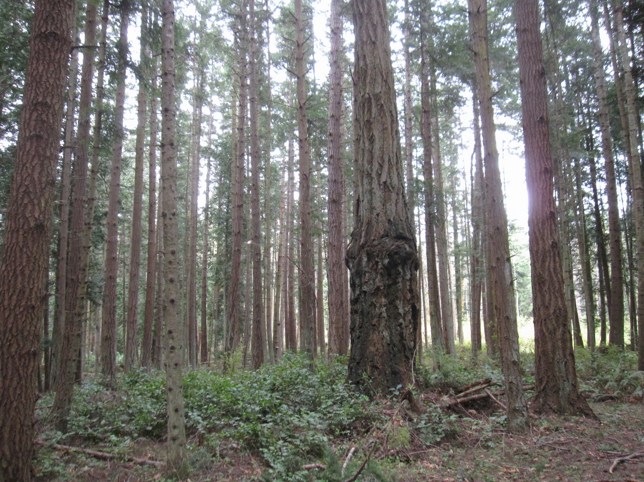

March 2015

Background

Two Northern Lights, LLC Conservation Easement is an approximately 23.66 acre property located at Fishery Pt. on the northern shoreline of Waldron Island in the San Juan Islands, San Juan County, Washington. The Property encompasses 536 feet of natural medium bank rocky shoreline backed by forested uplands. The Property provides important marine riparian habitat for salmon and forage fish. The Property is part of the Fishery Pt. Neighborhood Shoreline Conservation Project, with the C.T. Burn Conservation Easement on its western boundary and the Burn Family Trust and Wernstedt Trust Conservation Easements (in progress) farther to the west. To the east are two Trust Conservation Easements (Cook and Ragen) and a San Juan County Land Bank Conservation Easement (Huntley) in progress. Together these Conservation Easements protect approximately 75% of the northern shoreline of Waldron Island and its accretion beach system that has Point Hammond as its feeder bluff.

Land Use History

From Coast Salish (Lummi) through early settlers Fishery Pt. Waldron Island has a long history of fish harvest. Settlers arrived in the 1860s and began homesteading, small-scale farming and grazing. Much of Waldron Island was logged around 1900. At that time most of the easily accessible merchantable timber was harvested. The majority of harvested timber was processed locally and sold as cord wood. Approximately a dozen old-growth Douglas fir and scattered old-growth western redcedar remained on the Property. Subsequently, the Property was re-forested to its original extent. Remnant stumps from early 20th century logging can be seen on the Property. The parcel has been in the Burn family since 1970. Since 1981, small-scale selective removal of lumber grade trees has occurred and some cord wood has been harvested in conjunction with driveway maintenance.

Purpose – Landowner’s Goals

The Purpose of the Conservation Easement is to assure the preservation of natural shoreline and forested open space and to limit the residential use of the Property to two (2) single family residences and appurtenant/accessory structures, each in a .5 acre Structures Area. Structures Area #1 encompasses the existing cabin. Structures Area #2 will be located a minimum of 200 ft. horizontal distance inland from the Ordinary High Water Mark, consistent with maintenance of Conservation Values of the Conservation Easement. The forest will be managed consistent with an approved Forest Management Plan.

Relationship to Other Actions or Plans

The Property adds to existing shoreline conservation on Waldron Island, totaling over six (6) miles of protected shoreline island-wide including approximately 75% of the northern shoreline of Waldron Island from Pt. Hammond to Fishery Pt.

Current and Desired Conditions

Current and desired conditions are identical. The purpose of the Conservation Easement is to protect and preserve current natural conservation values as follows:

1. Fish Use and Habitat – The Property protects important natural shoreline habitat for endangered outmigrating juvenile Chinook salmon; juvenile chum and pink salmon; surf smelt; Pacific sand lance; and Pacific herring along 536 feet of medium bank rocky shoreline that is part of the accretion beach system of northern Waldron Island which has Point Hammond as its feeder bluff.
2. Riparian – The Property has a naturally vegetated shoreline of mature mixed conifer/deciduous forest.
3. Hydrologic – The Property is primarily in a natural, undeveloped state and supports natural hydrological processes.
4. Soils and Soil Stability – The Property is underlain by Indianola loamy sand, derived from glacial outwash and is of a coarse texture. The Property is primarily in a natural, undeveloped state and supports natural sedimentation and unaltered shoreline erosional processes.
5. Upland – The Property is uniformly forested with a mix of Douglas fir, western redcedar, lodgepole pine and occasional grand fir, hemlock, and Douglas maple. Madrone are found along the shoreline. A grove of native crab apple and some unusually large Douglas maples are found in the northwest corner of the Property. The native understory contains salal and oceanspray.
6. Public Use. The Property can be viewed by the public from the waters of Boundary Pass and conservation of its natural shoreline protects salmon and forage fish habitat for the benefit of regional fish and wildlife populations. There is no physical public access granted on the Property.
7. Cultural and Historic Resources – A reef net fishing site is reported to have been located at Fishery Point. Historically, the Property was logged around 1900 and some farming/grazing may have occurred.
8. Maintenance and Monitoring Schedule – The San Juan Preservation Trust will monitor the Property annually upon sixty (60) days prior written notice.

Adaptive Management Plan

In the event of environmental change through time, issues will be addressed on a case by case basis as they arise.

Roles, Responsibilities and Funding

Maintaining a good working relationship with the Property’s current and future landowners will be a high priority for management of the Conservation Easement. The San Juan Preservation Trust has established a Stewardship Fund to cover legal or other expenses associated with enforcing the terms contained in the Trust’s grant deeds of conservation easement. The Fund enables the Trust to take the actions necessary to uphold the intentions of the Grantors.

Constraints and Uncertainties

None are foreseen.

Attachments

* Two Northern Lights, LLC Easement Baseline Present Conditions Report
* Killara BurnForest Management Plan