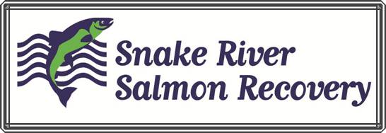

Date: 7/10/2013

Memo: SRSRB Confirmation of Continuity With Asotin IMW – Riparian Restoration - IMW Study Area 13-1405

The Snake River Salmon Recovery Board has worked with Asotin County Conservation District, the Washington Department of Fish and Wildlife and the Coordinator of the IMW Ecologic Inc. to develop scope and the methods to be used. The Conservation District will work with the IMW coordinator and contract with them to identify, prioritize and monitor the restoration sites proposed in this application. That being said the SRSRB supports the actions proposed as they fit the IMW treatment recommendations.

Kris Buelow

Project Coordinator