**South Fork Asotin Creek Habitat Restoration** – Asotin Creek Intensively Monitored Watershed (IMW) Habitat Restoration Treatment

**SRFB Project # 15-1321**

**Stewardship Plan**

**Project Goals**

The Asotin Creek Intensively Monitored Watershed (IMW) project is located in southeast Washington. The goal of the IMW is to determine the effectiveness restoration using large woody debris at increasing the productivity and capacity of Snake River Evolutionary Significant Unit (ESU) wild steelhead. We conducted pre-restoration monitoring of fish and habitat from 2008 to 2012. The experimental design has three 4 km long sections in three streams: Charley, North Fork, and South Fork. Fish and habitat monitoring takes place in each section. We initiated a trial of the restoration method in 2011 by installing five post-assisted log structures (PALS) in the three streams. After assessing the trial structures, full implementation of restoration began in 2012. We restored one 4 km treatment section in South Fork (2012), Charley Creek (2013), and North Fork Creek (2014). We installed 538 post-assisted log structures in the three treatment sections. In 2015, we proposed to maintain/enhance the existing treatments sections by adding more large woody debris to the PALS, and restore another section to the South Fork. Funding for this project (15-1321) was provided by the Salmon Recovery Funding Board (SRFB) in 2016 to implement the new restoration. This stewardship plan is specifically for the work completed for the SRFB funding from 2016-2017; however, stewardship will be identical for all of the IMW restoration efforts. The specific objectives of the LWD treatments are to:

* Increase channel width variability,
* Increase instream habitat diversity (e.g., fish cover, pool frequency and depth), and
* Promote mobilization of and sorting of sediment by encouraging bar development, bed scour, bank erosion, and substrate sorting.

Another ancillary goal of the restoration project and the IMW was to minimize the cost of the design process. Instead of expensive engineering diagrams, we walked the stream and made short (<3 minute videos) of the specific design criteria of each LWD structure. The location, type of wood, orientation, and height of posts were described in the video and recorded in a detailed design form in a FileMaker database on a custom made IPad App (this database and App are available upon request). This allowed us to design 30-40 structures a day and keep design costs down. Each structure is designed to promote a set of specific geomorphic and hydraulic responses based on the existing stream and floodplain features of the site. The existing conditions and expected responses were also recorded in the database to allow us to determine if the expected responses happen after future high flows.

The basic design of each structure was to use pieces of LWD that were small enough to carry by hand instead of using heavy machinery minimize potential damage to the existing vegetation. The pieces of LWD were installed at each site using the design criteria recorded with the IPad App and usually secured in place with wooden fence posts driven into the streambed with a hydraulic driver. Our original proposal called for three basic types of structures:

* Wooden posts only
* Deflector style LWD with posts, and
* Key pieces of LWD (typically with root wad and too large to carry by hand)

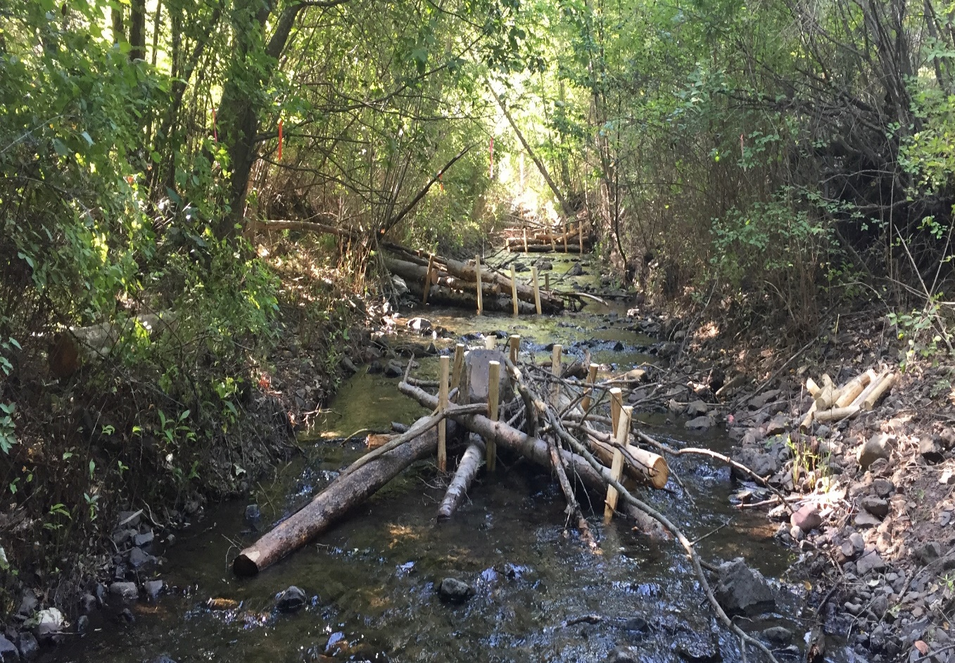

Figure 1. Example of log structures built in the South Fork Asotin Creek in 2017.

**Monitoring and Maintenance**

We will blend three types of monitoring to capture stream habitat responses, which combine the best tradeoffs in spatial extent, spatial resolution, temporal resolution and cost effectiveness. We will rely on relatively expensive, but spatially extensive and reasonably high-resolution remotely sensed imagery (e.g., UAV flights) and airborne LIDAR to provide system-wide context as well as changes in riparian structure over the longer-term (e.g., 5 year time scale). The remotely sensed data is inadequate resolution to resolve in-channel changes to physical habitat and the responses to the restoration treatment for these small study creeks. As such, detailed repeat topographic and habitat surveys will be done at a high resolution (i.e., to resolve decimeter scale features and changes) over reasonably short distances. These stream habitat surveys will be sampled at three discrete 160 m long habitat sites within every fish site. One of the three habitat sites is sampled every year and one of the other two habitat sites is sampled every other year as part of a rotating panel. We will be able to robustly detect change at habitat sites within the treatment sections and attribute that change mechanistically to specific geomorphic processes and infer whether those are a result of the restoration treatment or other drivers. However, to ensure that we are not missing something within the treatment units, we will conduct rapid-assessment geomorphic response surveys along the entire stretch of treatment sections. These rapid assessment surveys will not be able to resolve the same detail of the habitat site surveys, but they should give a complete census of the geomorphic response in the treatment sections and their accuracy can be verified with the overlap at the habitat sites.

The Asotin IMW is designed to be at least a 10-year study to determine stream restoration effectiveness at the fish population level. We expect to continue the effectiveness monitoring for the IMW until at least 2021 through Pacific States Marine Fisheries Commission (PSMFC) and SRFB funds. Therefore, the Asotin Creek Restoration Projects will have robust effectiveness monitoring. Details of the monitoring plan and future restoration efforts associated with this project can be found on the Snake Region Salmon Recovery Board Website Library [http://snakeriverboard.org](http://snakeriverboard.org/) .

Grantee/Landowner Date 3/19/2018

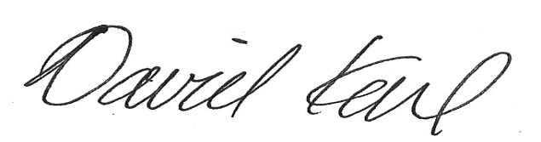

David Karl WDFW Habitat Program Project Sponsor