

### Request for Proposals – PSAR Project Implementation & Development Awards

The Puget Sound Salmon Recovery Council with the Puget Sound Partnership approved a new proactive approach for allocating the remaining 6% “capacity” funds for the 2013-2015 biennium ($1.7M - $2.1M).

Each Puget Sound Lead Entity may submit ***one*** proposal by the deadline **November 15, 2013** using the format below. Because of the project limit per watershed, project sponsors must work with their lead entity to apply. Only one proposal per watershed submitted via the Lead Entity Coordinator will be accepted. Lead Entity Coordinators, please submit final proposals as a Word document or pdf with attachments via email to [**psar@psp.wa.gov**](mailto:psar@psp.wa.gov)(the email should be no more than 10MB with all attachments). See below for details and proposal format.

### Proposal elements

**Please answer each question individually. The full proposal should be 2- 5 pages depending on the number of project elements. Directions and examples in italics should be removed from final proposals.**

1. For which Lead Entity are you requesting funds?

WRIA 6 / Island

2. Who is the proposed fiscal agent?

Primary contact name: Northwest Straits Foundation

Joan Drinkwin

Telephone: (360) 733-1725

Email: drinkwin@nwstraits.org

3. What is the funding range being requested?

$140,000 - $200,000

4. What PSAR capacity funds are being used for the Lead Entity’s 2013-2105 scope of work?

Amount of 2009-2011 PSAR capacity funds rolled over: $0

Amount of 2011-2013 PSAR capacity funds rolled over: $12,071.77

Amount of 2013-2015 allocation: $54,577.00

Total: $66,648.77

5. List the project(s) to be supported by this request, their current funding sources if any, and which category best describes them in relation to the intent of these PIDA funds:

*(e.g. Big River levee setback ($400,000 from PSAR watershed funds) and Elk Estuary restoration ($2.5M from PSAR large capital list. Both projects fall under priority #1: Advances projects on the 2013-2015 PSAR list)*

Ala Spit Design and Permitting, and Cornet Bay Area 5 Pier Design and Permitting are new phases of ongoing projects. The Culvert Replacement Prioritization is also on our 3 year workplan but has not been addressed until this year. They all fall under priority #2: Preparing capital projects for “shovel ready” requests.

Ala Spit Design and Permitting will be preparing Phase 4 for construction based on recent recommendations from the Phase 3 Assessment (12-1260) in continuation of previous nearshore restoration (08-1864 and 05-1491). Phase 4 will be removing a rock groin and bulkhead. This project also addresses one of Island County’s recently approved Near Term Actions and associated sub strategy *B2.3* *Remove armoring, and use soft armoring replacement or landward setbacks when armoring fails, needs repair, is non-protective, and during redevelopment.*

Cornet Bay Area 5 Pier Design and Permitting will develop the next phase of the ongoing nearshore restoration in Deception Pass State Park. The next phase will address the footings of the pier that are currently preventing the proper functioning of the nearshore drift processes between the phase 1 restoration (10-1716) and the phase 2 restoration about to be undertaken (13-1061). This project also addresses an Island County’s recently approved Near Term Action and associated sub strategy *B2.3* *Remove armoring, and use soft armoring replacement or landward setbacks when armoring fails, needs repair, is non-protective, and during redevelopment.*

Island County Culvert Prioritization has been a previously identified high priority need as a first step in replacing culverts that are currently acting as barriers and also need replacement due to high risk of structural failure. This project addresses an Island County’s recently approved Near Term Action and associated sub strategy *A6.1 Implement high priority projects identified in each salmon recovery watershed’s three-year work plan.*

6. Describe the current Lead Entity capacity and why additional funding is needed to accomplish the implementation or development of project(s) proposed below.

Currently, WRIA 6’s Lead Entity capacity allocations, both Salmon-LE and PSAR, are used to cover the FTE for one LE Coordinator. The current funding allocation, including the recently increased Salmon-LE Base funding, covers 97% of the FTE cost. Any project development money for projects on our 3 year work plan must come out of our capital allocation. WRIA 6 receives one of the lowest amounts of capital allocation among all Lead Entities because of our lack of natal streams and resulting low ranking with the allocation formula. WRIA 6 does provide nearshore refugia for all 22 Chinook Populations as they outmigrate. Nearshore and estuary restoration involves a very high amount of private property (beach homeowners) involvement. Nearshore restoration projects take a very large effort to prepare and develop before any restoration work will be accepted by the waterfront homeowners that will be affected. The complexity of nearshore project development quickly expends all of our capital allocation. Our LE only has capacity rollover when there is a gap in employment between previous LE coordinator and new coordinator. Our LE only has capital rollover when a project fails, usually due landowner opposition and inadequate preparation in the past. Increased and restructured project development strategies currently being deployed will ensure better success towards capital project completion in the future.

7. For **each** element of the request please complete the following in order of priority:

A.

* *Project element name*: Ala Spit County Park Restoration Project Phase 3
* *Project element cost:* $40,000
* *How was the cost estimate determined?* Estimates were obtained from licensed engineer based on elements recommended in Ala Spit County Park Restoration Project Phase 3 Feasibility Assessment.
* *Is this project element scalable*? No
* *Will the fiscal agent execute this project element?* No, this element will be subcontracted to the current Phase 3 Sponsor (12-1260), Island County Public Health.
* *What is the timeline for execution and completion of this project element?* The 100% design, scheduling and permitting will be completed by June 2014.
* *Describe the work to be completed with the requested funds:* 100% design, bid documents, scheduling and permitting for partial removal of the rock groin and remaining bulkhead segments (435 feet) and restructuring of the parking area at Ala Spit County Park. This will restore the natural sediment transport processes and complete restoration efforts at Ala Spit.

B.

* *Project element name*: Island County Culvert Prioritization
* *Project element cost*: $40,000-$60,000
* *How was the cost estimate determined?* The cost was determined by the application guidelines as set forth in the RFP. The costs of the other two elements were set first. Knowing the fiscal limits of this RFP, this project is phased into steps, which provides flexibility.
* *Is this project element scalable?* Yes. The strategy to identify all barrier culverts in Island County is broken into steps. The award will be used to advance as far as possible down the list of identified steps towards a full list of the Island County prioritized culverts applicable to Chinook recovery, aka, Steps 1-6. See attached Island County Culvert Prioritization summary for explanations of strategy and steps.
* *Will the fiscal agent execute this project element?* No. This element will be subcontracted to Island County Public Works.
* *What is the timeline for execution and completion of this project element?* Execution will begin immediately upon contracting. The completion will depend on the amount of funding awarded and how many culverts are identified in Steps 1 and 2 for visual assessments. This element will be fully spent down by June 2015.
* *Describe the work to be completed with the requested funds*: The ultimate goal of the Island County Culvert Prioritization Project will be a prioritized set of lists of public and private culverts in order of importance for replacement. The highest priority set of lists to be developed are public culverts in the nearshore that block Chinook from refugia habitat and that are ranked by risk of failure. The work to be done with the requested funds is to complete as many steps as possible. Steps 1-4 will result in the first list of culverts for the highest priority Habitat Area as identified in Island County’s Multi-species Salmon Recovery Plan (2005). Steps 5 and 6 will repeat the process as outlined in steps 1-4 for the second and third priority habitat areas, respectively. Steps 6 - 13 will address culverts that do not directly impact Chinook and will be funded with other sources as they become available.

C.

* *Project element name*: Cornet Bay Nearshore Restoration Project: Retrofitting the Marine Maintenance Pier
* *Project element cost*: $60,000- $100,000
* *How was the cost estimate determined?* The cost estimate was developed in the Habitat Restoration Feasibility Assessment prepared in 2009 by Herrera Environmental Consultants
* *Is this project element scalable?* Yes. The permitting and associated costs could be done during a different phase reducing the current request by about $10,000.
* *Will the fiscal agent execute this project element?* Yes.
* *What is the timeline for execution and completion of this project element?* If funds are received in January, the design work could be completed within 12 months. Permitting will take longer, but applications could be completed within 18 months.
* *Describe the work to be completed with the requested funds*: Design and permitting.

8. Include the budget for each project using the following format.

|  |  |  |  |
| --- | --- | --- | --- |
| **Budget category** | **Project 1** | **Project 2** | **Project 3** |
| Salaries and wages |  |  |  |
| Benefits |  |  |  |
| Goods & Services |  |  |  |
| Travel |  |  |  |
| Contractor | %100 of allocation | %100 of allocation |  |
| Other |  |  |  |
| **TOTAL** |  |  |  |

9. OPTIONAL: Include area and project maps, images, etc as attachments if necessary

Attached:

1. Ala Spit County Park Restoration Project Phase 4 Summary and Figures
2. Island County Culvert Prioritization Summary
3. Cornet Bay Nearshore Restoration Project: Retrofitting the Marine Maintenance Pier Summary

10. CERTIFICATION FROM LEAD ENTITY FOR SUBMITTAL:

Only one proposal from each watershed will be accepted and only via the Lead Entity coordinator.

**\*\*LE Coordinators need to submit final proposals to** [**psar@psp.wa.gov**](mailto:psar@psp.wa.gov) **by 11:59pm Friday, NOVEMBER 15, 2013\*\***

Element 1: Ala Spit County Park Restoration



Project element cost: ~$40,000

How was the cost estimate determined:

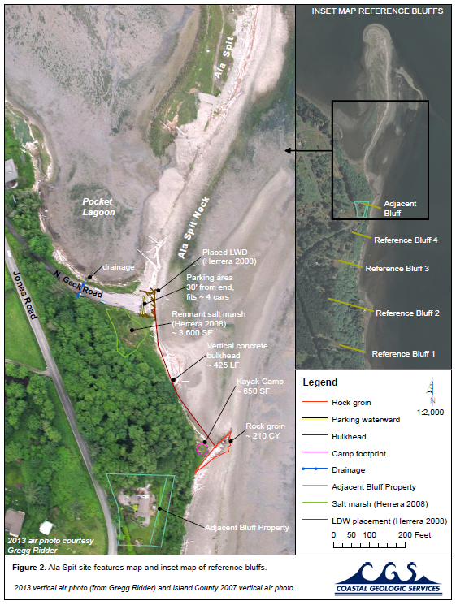Estimates were obtained from licensed engineer based on elements recommended in Ala Spit County Park Restoration Project Phase 3 Feasibility Assessment.

Is this project element scalable:

No

What is the timeline for execution and completion of this project element?

If funded, the 100% design, scheduling and permitting will be completed by June 2014.

Describe the work to be completed with the requested funds:

100% design, scheduling and permitting for partial removal of the rock groin and remaining bulkhead segments (435 feet) and restructuring of the parking area at Ala Spit County Park. This will restore the natural sediment transport processes and complete restoration efforts at Ala Spit

Element 2: Island County Culvert Prioritization

# Island County LogoPriorities

|  |  |
| --- | --- |
| Nearshore Priorities[1]  1. Culvert is blocking    1. habitat area 1 = higher priority    2. lower downstream = higher priority    3. the more habitat opened up = higher priority 2. Culvert is at risk of failure    1. more degraded = higher priority    2. flooding risk = higher priority | Upland Priorities  1. Culvert is at risk of failure 2. Culvert is on a Type F stream with known salmonid residents 3. Culvert is on a Type F stream (fish other than salmonids) |

# Steps[2]

## Nearshore Steps

1. ID Barriers
   1. Use the stream layer developed through the Whidbey Basin Small Streams Study (Zackey 2013).
   2. Starting in Habitat Area 1 as defined in the WRIA 6 Multi-species Salmon Recovery Plan (2005) and referenced as geographic area 1 (figure 1.), survey the publically maintained culverts from the nearshore upstream to a natural barrier or lack of habitat.
2. Strategize and plan how replace publically maintained culverts that are identified as barriers (i.e. flaggers, access, timing)
3. Capture images in order to characterize condition of structural integrity of culvert (failure and flooding).
4. Develop list of culverts in prioritized order.
5. Repeat steps 1 to 3 in Habitat Area 2 (WRIA 6 Multi-species Salmon Recovery Plan, 2005).
6. Repeat steps 1to 3 in Habitat Area 3 (WRIA 6 Multi-species Salmon Recovery Plan, 2005).

## Upland Steps

1. Identify culverts that are at highest risk of failure or causing flooding.
2. Identify fish habitat (Type F streams) upstream of natural migration barriers.
3. Develop list of culverts in prioritized order.

## Privately Maintained Culvert Steps[3]

1. Using culverts on Nearshore Type F streams in Step 1 will be assessed as barriers or not.
2. Develop a list of culverts prioritized based on the amount of potential habitat that would be made accessible if barriers were removed.
3. Identify willing landowners.
4. Design and replace as funding allows.

# Plan

* The proposed project will use the 2013-2015 Puget Sound Acquisition and Restoration (PSAR) Project Implementation and Development Awards (PIDA) funding to identify as many culverts as possible that may improve freshwater habitat. $40-60K request.
* Public Works will be primary sponsor for the PIDA project element, subcontracted by the Northwest Straits Foundation, who is acting as the fiscal agent for this PIDA award
* Other funding opportunities to develop designs and installation of identified culverts will be identified.
* Steps 4 and 5 can occur simultaneously.
* The result of this project will be a series of sequential lists.
  + 1st list (highest priority): Habitat Area 1 Nearshore culverts
  + 2nd list: Habitat Area 2 Nearshore culverts
  + 3rd list: Habitat Area 3 Nearshore culverts
  + 4th list: Upland culverts
  + 5th list: Private Nearshore culverts

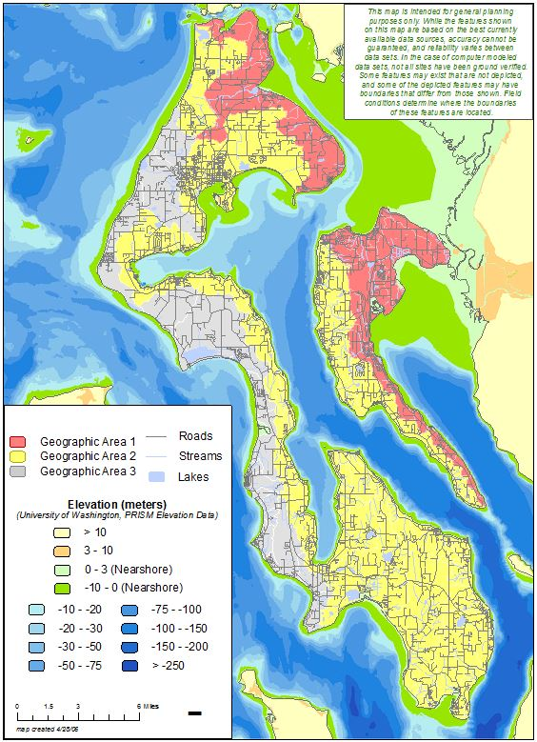

Figure 1. Priority Habitat Areas (WRIA 6 Multi-Species Salmon Recovery Plan, 2005).

Geographic Area 1 = highest priority

Element 3: Cornet Bay Nearshore Project: Retrofitting the Marine Maintenance Pier

The Northwest Straits Foundation proposes to retrofit the Marine Maintenance and Facilities Dock at the Cornet Bay day use area of Deception Pass State Park to allow sediment movement under the pier. State Parks is in support of this project and funding from the PSAR is herein requested to complete the design through permitting.

Currently, the fill supporting the approach to the Marine Maintenance and Facilities Dock, and debris associated with it, extends down to approximately 3 to 5 feet above mean lower low water. The resulting groin has impounded a large amount of sand on the northeast side of the filled area. This has the single largest geomorphic impact to nearshore physical processes (i.e., impairment of longshore sediment transport) in the project area.

Large rubble was removed from under the dock in 2010 by the Island Marine Resources Committee. This improved sediment transport but was not a complete fix.

**Salmon Recovery**

The Cornet Bay area is included in the highest priority Geographic Area 1 in the WRIA 6 Salmon Recovery Plan. This area includes shorelines within ~5 miles of the mouths of the Skagit, Stillaguamish, and/or Snohomish rivers. The largest number of Chinook fry migrants from these rivers use the shorelines in this area. Shoreline Restoration at Cornet Bay is included in the *Three-Year Watershed Implementation Priorities for Island County / WRIA6* as a habitat project aimed at protecting and enhancing the food web for migrating salmon.

**Project history**

Herrera Environmental Consultants completed a Habitat Restoration Feasibility Assessment in 2009 for the project area. The report assessed the feasibility of restoring nearshore habitat throughout the Cornet Bay area of Deception Pass State Park. Recommendations of the report included breaking the assessed area into seven distinct restoration opportunities (see figure).



*Area 5 note fine sediment build-up south of the pier: and coarser sediment and higher elevation of sediment north of the pier*

SRFB project #10-1716 completed restoration of Areas 4, 6, and 7 in 2012. Funding for restoration of Areas 1 and 3 was requested from the SRFB during the current round (#13-1061). Construction is anticipated in summer 2015. The final restoration area along the shoreline at the day use area is Area 5, the retrofit of the marine maintenance pier to allow for full sediment transport.

**Goals and Objectives**

The overall goal of the nearshore restoration at Cornet Bay is to enhance the nearshore habitat for the benefit of salmon and forage fish.

The objectives are:

* Elimination of longshore blockage and resumption of sand supply to areas downdrift (southwest)
* Replacement of adjacent portion of creosote overwater structure

**Partners**

* Northwest Straits Foundation
* Island Marine Resources Committee
* State Parks

**Project Funding**

Funding request: $60,000-100,000

The project funding requested will pay for design and permitting. Construction funding will be sought from SRFB, State Parks, and other sources.

1. This reflects Salmon Recovery priorities. Public Works priorities are reversed with failure risk higher priority than habitat blockage. This is for publically maintained culverts only at this time. However, privately maintained culverts on habitat streams will be noted but not assessed as barriers or for condition at this time.
2. Steps 1-6 are Salmon Recovery-oriented and eligible for Recovery funding. Steps 7-13 will be funded by alternative sources and may occur concurrently with capital projects resulting from Steps 1-6.
3. Privately maintained culverts replacement projects will be overseen and managed outside of Island County Public Works. Those project sponsors have yet to be determined.