[___](https://www.heraldnet.com/news/at-meadowdale-beach-the-salmon-will-return-to-a-new-estuary/)

Skip to main content

Enable accessibility for  
visually impaired

Open the accessibility  
menu

* [Menu](javascript:void(0))
* [Sign In](javascript:void(0))
* [Subscribe Now](https://www.heraldnet.com/subscribe/)
* [Local News](https://www.heraldnet.com/news/)
* [Business](https://www.heraldnet.com/business/)
* [Sports](https://www.heraldnet.com/sports/)
* [Life](https://www.heraldnet.com/life/)
* [Opinion](https://www.heraldnet.com/opinion/)
* [Obituaries](http://www.legacy.com/obituaries/heraldnet/)
* [Classifieds](https://www.heraldnet.com/classifieds/)
* [Jobs](http://www.pnwcareers.com/)
* [Contests](https://www.heraldnet.com/contests/)
* [Real Estate](https://www.heraldnet.com/homes/)
* [Marketplace](https://www.heraldnet.com/marketplace/)

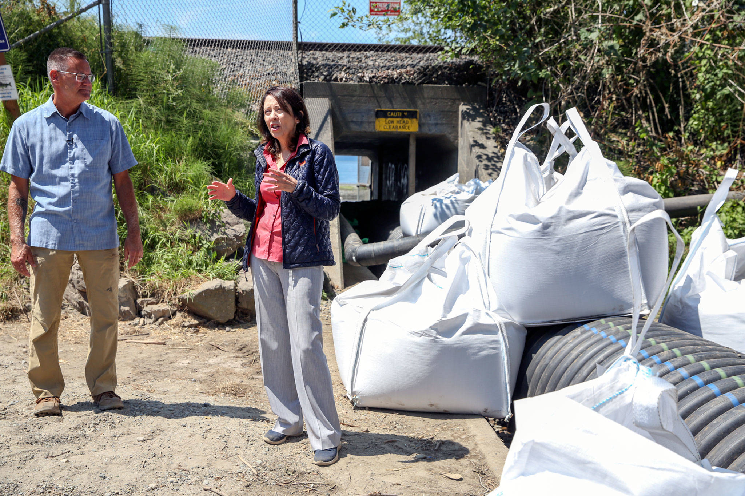

Tom Teigen (left), Snohomish County Conservation and Natural Resources director, and U.S. Sen. Maria Cantwell tour the estuary restoration project at Meadowdale Beach Park in Edmonds on Friday. (Kevin Clark / The Herald)

**At Meadowdale Beach, the salmon will return to a new estuary**

Construction is underway on a new railroad bridge that will open a connection between gulch and sea.

* by [Zachariah Bryan](https://www.heraldnet.com/author/zachariah-bryan/)
* Friday, July 9, 2021 9:55am
* [Local News](https://www.heraldnet.com/news/)[Edmonds](https://www.heraldnet.com/tag/edmonds/)[Environment](https://www.heraldnet.com/tag/environment/)

EDMONDS — One day not long from now, threatened salmon species will return to Lunds Gulch at Meadowdale Beach Park.

[After a decade of planning](https://na01.safelinks.protection.outlook.com/?url=https%3A%2F%2Fwww.heraldnet.com%2Fnews%2Frailroad-bridge-would-help-fish-habitat-but-at-a-high-cost%2F&data=02%7C01%7Clogan.daniels%40snoco.org%7C0a488983cb48407f957308d5e2b410d2%7C6bd456aabc074218897c4d0a6a503ee2%7C1%7C1%7C636664185362645137&sdata=cDYigIqULyB13eQ58toaYcH%2FQmpabOGGg46Akol8FyE%3D&reserved=0), construction has begun on renovations at the waterfront park to create a 1.3-acre pocket estuary that will bring back Chinook, chum and coho salmon, as well as cutthroat trout.

The centerpiece of the renovations is a new five-span railroad bridge that will create a 90-foot opening for the creek to flow through. It will replace the current six-foot culvert — essentially a hobbit-sized tunnel to the beach for visitors who make the mile-and-a-half trek down the ravine trail.

Though the acreage might be small, the project was a complicated and expensive affair involving a collection of state and federal grants. It also required a unique partnership with BNSF Railway, representing new possibilities in how to approach important habitats that butt up against railroads.

All told, the bill will likely exceed $15 million. Less than half of that is funded by grants, with the rest coming from Snohomish County. Strider Construction of Bellingham won the bid for the work.

[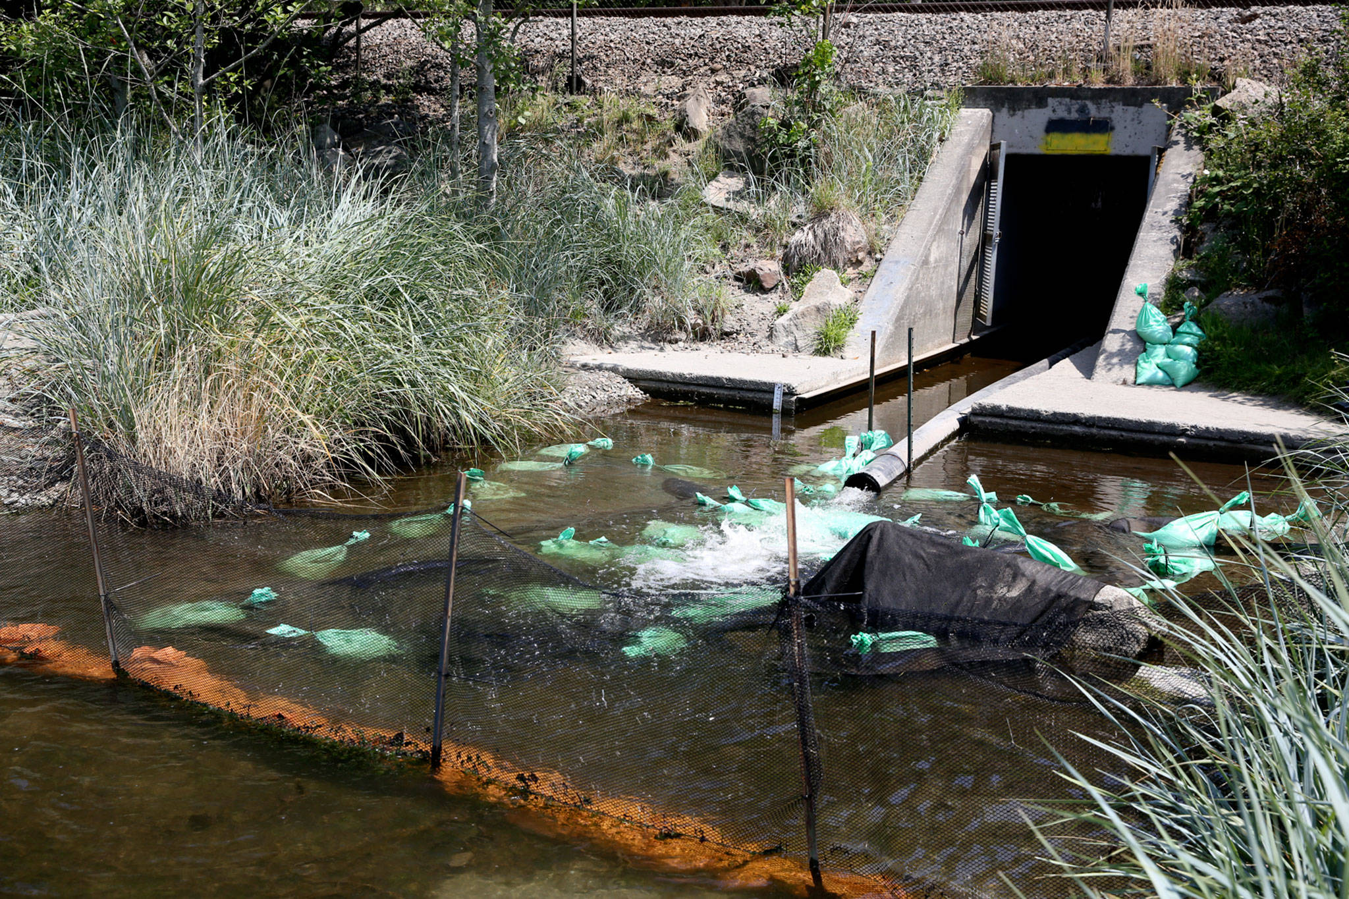](https://2qibqm39xjt6q46gf1rwo2g1-wpengine.netdna-ssl.com/wp-content/uploads/2021/07/25750115_web1_L2-meadowdalebeach-edh-210709.jpg)

The culvert at Meadowdale Beach Park in Edmonds will be replaced and widened as part of an estuary restoration project. (Kevin Clark / The Herald)

The county estimates construction will be done by next spring. In the meantime, the beach is closed to the public.

On Friday, local politicians and advocates assembled for a tour of the site. Among the speakers were U.S. Sen. Maria Cantwell, state Sen. Marko Liias, Edmonds Mayor Mike Nelson and county Councilmember Megan Dunn.

“This is just an unbelievable investment that kind of, I think, is going to be symbolic for what we need to do,” Cantwell said. “… We’re learning if we want a shot at saving salmon, then we need to stop and think about how to pull out these blockages.”

Daryl Williams, of the Tulalip Tribes, was there, too. He was one of the first members of the Snohomish County Marine Resources Committee, about 20 years ago. Back then, he said, they considered taking on the project at Meadowdale Beach, but the scope soon became overwhelming. He congratulated everyone on finally pulling off the immense feat.

[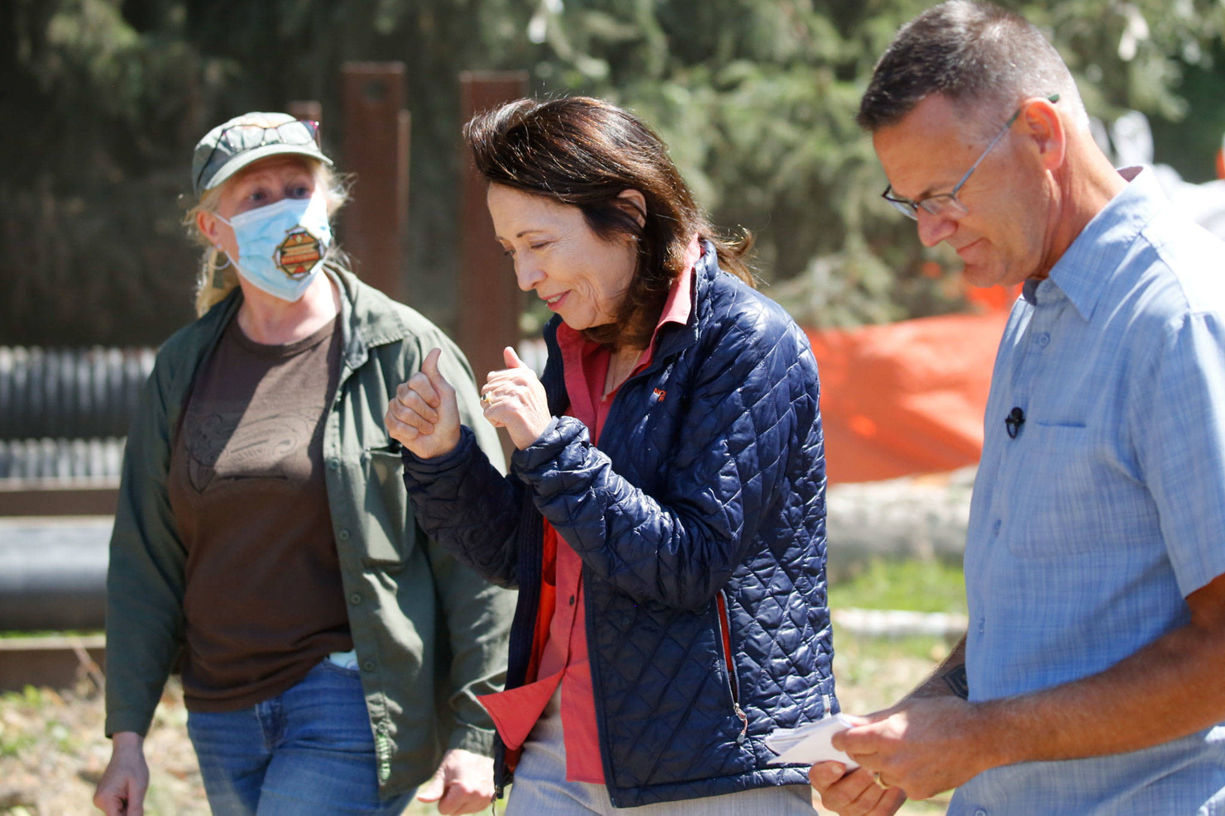](https://2qibqm39xjt6q46gf1rwo2g1-wpengine.netdna-ssl.com/wp-content/uploads/2021/07/25750115_web1_L3-meadowdalebeach-edh-210709.jpg)

From left, Logan Daniels, Snohomish County Parks and Recreation lead engineer, U.S. Sen. Maria Cantwell and Tom Teigen, Snohomish County Conservation and Natural Resources director, tour the estuary restoration project Friday at Meadowdale Beach Park in Edmonds. (Kevin Clark / The Herald)

Likewise, when parks engineer Logan Daniels first started working on the restoration plan, she said, no one believed it could be done.

She took it one step at a time, fighting “all the way to the end” for every grant she could find.

“I basically just went after everything I could,” Daniels said.

It wasn’t until the project [scored a $3.5 million grant](https://www.heraldnet.com/news/infusion-of-federal-money-propels-meadowdale-beach-project/) in 2019 from the Federal Railroad Administration that it started feeling like reality. Cantwell, who lives in Edmonds, wrote a letter to the administration in support of the grant application.

In addition to building the railroad bridge, crews will remove 17,000 cubic yards of fill, plant vegetation, reroute paths, add viewpoints and install interpretive signs. They also will install woody debris upstream, creating calm, cool spots for fish to settle. A pedestrian bridge will allow visitors to watch the migrating fish. And Americans with Disabilities Act improvements, including new parking spots, will provide better access to the beach for those who can’t make it down the trail.

The size of the estuary-to-be doesn’t sound all too impressive when compared to other, much larger restoration projects. But these smaller pieces play an important part, too.

[Work has begun of the Estuary Restoration Project Friday afternoon at Meadowdale Beach Park on July 9, 2021. (Kevin Clark / The Herald)
Work has begun on a estuary restoration project at Meadowdale Beach Park in Edmonds. (Kevin Clark / The Herald)](https://2qibqm39xjt6q46gf1rwo2g1-wpengine.netdna-ssl.com/wp-content/uploads/2021/07/25750115_web1_L4-meadowdalebeach-edh-210709.jpg)

Work has begun of the Estuary Restoration Project Friday afternoon at Meadowdale Beach Park on July 9, 2021. (Kevin Clark / The Herald) Work has begun on a estuary restoration project at Meadowdale Beach Park in Edmonds. (Kevin Clark / The Herald)

Erik Neatherlin, executive coordinator of the governor’s Salmon Recovery Office, said little estuaries are critical for salmon, and the lack of them has been one of the main limitations for their growth. When juvenile salmon come down from the rivers, they’re not big enough to survive all the challenges of the ocean.

The salmon are like teenagers, Neatherlin said, and pocket estuaries are like rest stops, where they can safely hang out to get some much needed rest and grow bigger.

These days, there are too few rest stops, Neatherlin said. People have a way of building on shorelines, whether its railroads or regular roads, or any other kind of development. Throughout the decades, all of that building has erased the pocket estuaries that once peppered Puget Sound. Studies have shown that without such habitats, 30% or so fewer salmon will make it to adulthood, Neatherlin said.

The habitat helps bolster other animals in the ecosystem, too, like forage fish, orcas and birds.

[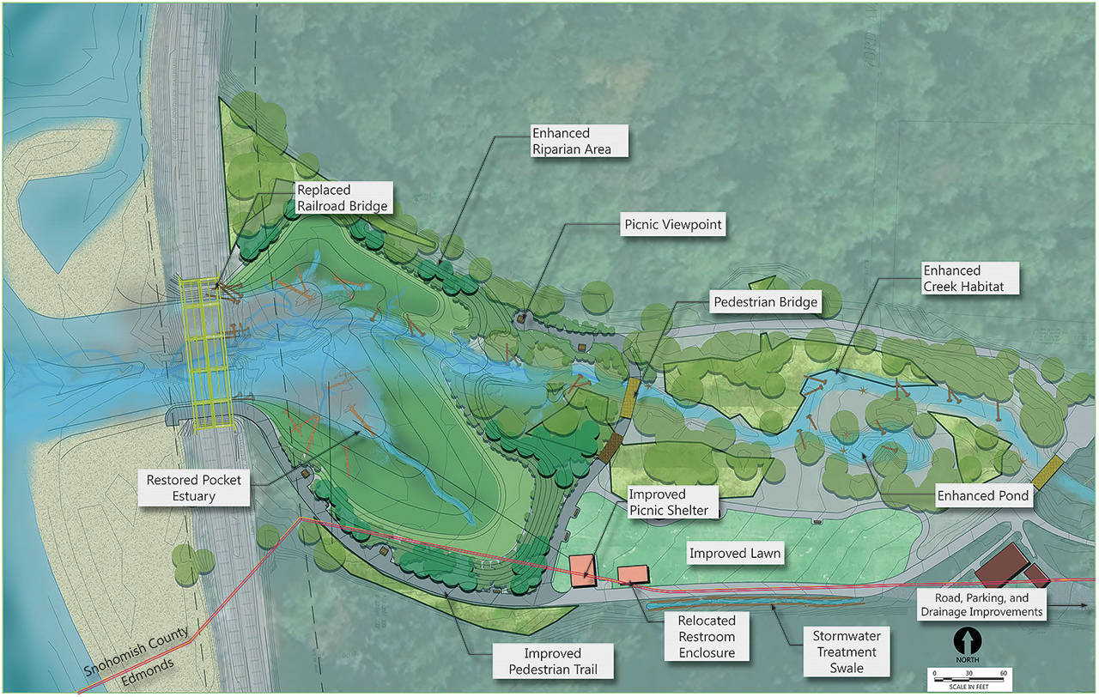](https://2qibqm39xjt6q46gf1rwo2g1-wpengine.netdna-ssl.com/wp-content/uploads/2021/07/25750115_web1_M-Meadowdale-Map-EDH-210710.jpg)

A map of planned improvements at Meadowdale Beach Park in Edmonds. (Snohomish County)

“If we want to have a healthy Puget Sound, we have to have healthy estuary,” Neatherlin said.

Salmon already are knocking at the door at Meadowdale Beach Park. When the water rises, flooding parts of the park, they have been spotted swimming around the restrooms, said Tom Teigen, Snohomish County Conservation and Natural Resources Director.

Daniels said she’s passionate about returning places to their natural state, to the extent possible. She pointed to a topographic map showing that the site was an estuary in the late 1800s, before the railroad was built.

The new estuary will be just as big as the old one. Once its complete, the results should be almost immediate. The fish will quickly find their way to a place where they’ve been blocked for more than a century.

“I’m just honored I could restore it back to what it used to be,” Daniels said.

*Zachariah Bryan: 425-339-3431;* [*zbryan@heraldnet.com*](mailto:zbryan@heraldnet.com)*. Twitter:* [*@zachariahtb*](http://www.twitter.com/zachariahtb)*.*

|  |
| --- |
|  |
| https://soundpublishing.blueconic.net/rest/dialogues/files/59ccec71-8505-4174-a23e-fb181d38bcf6/MTN_Zachariah+Bryan.jpg | Zachariah Bryan is a public safety reporter with The Daily Herald, covering crime, the criminal justice system and breaking news. [Learn more about Zachariah](https://www.heraldnet.com/newsroom/zachariahbryan/). |

**Talk to us**

* You can tell us about news and ask us about our journalism by emailing [newstips@heraldnet.com](mailto:newstips@heraldnet.com) or by calling 425-339-3428.
* If you have an opinion you wish to share for publication, send a letter to the editor to [letters@heraldnet.com](mailto:letters@heraldnet.com) or by regular mail to The Daily Herald, Letters, P.O. Box 930, Everett, WA 98206.
* [More contact information is here.](https://www.heraldnet.com/contact/)