**Progress / descriptions report(s) for Washington intensively monitored watersheds (IMWs) funded through the Recreation and Conservation Office (RCO)**

***PRISM Project 13-1001 - $219,648***

***RCO contract with Walla Walla Community College for the Asotin IMW***

This project is a continuation of the Asotin Creek multi-year IMW project. The project is an Intensively Monitoring Watershed monitoring project. The project focuses on three tributaries to the Asotin Creek in Southeast Washington. The tributaries are: Charley Creek, North Fork Asotin Creek, and South Fork Asotin Creek. The purpose of the project is to link salmon and steelhead responses to specific mechanisms related to habitat restoration. The fundamental approach is to treat restoration as an experiment and concentrate a large restoration effort in order to increase the likelihood of detecting a population increase. This type of project will increase our understanding of which restoration activities are most effective, demonstrate how changes in habitat influence survival of various life stages of salmon and steelhead, determine what magnitude of restoration is required to cause a significant population response, and ultimately provide information to better evaluate the efficacy of habitat restoration. The restoration effort is focused on summer run steelhead habitat. The funds for this grant award will focus on continuing the IMW effort in the Asotin. This phase will include:

1) Continue baseline monitoring of 12 permanent sites for fish abundance and habitat condition,

2) Implement restoration treatment plan based on approval of the plan by the Regional Technical Team

3) Monitoring a wide variety of response variables

The following project reports are on the Snake River Salmon Recovery Region website.

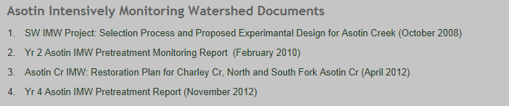

***There is additional information in the Recreation and Conservation Office’s PRISM database which you can access as READ-ONLY for this project #13-10***

***PRISM Project 13-1002 - $120,000***

***RCO contract with Lower Columbia River Fish Recovery Board for the Abernathy Creek IMW***

Success of the IMW project depends on the timely implementation of habitat restoration actions. The proposed work will generate final construction designs for 2 to 3 of remaining Abernathy Creek Phase 1 projects. This approach helps to speed restoration work by allowing project implementation to commence promptly once construction funding becomes available. It continues the advance design work previously funded by funds provided through the PSMFC.

Work began in last month and the LCFRB expects to complete design documents by the end of the year. The Technical Oversight Group (TOG) was reactivated. The group has met once to evaluate potential project sites to develop alternative concepts. Inter-Fluve, Inc. has been retained to develop to complete the designs. Letters have been sent to landowners for both public and private properties. Site reconnaissance has been delayed due to difficulties securing access permission from WDFW and WDNR. Given these delays it is likely completing the final designs will be extended to December 2013.

The TOG, including IMW Science Oversight Committee members and habitat restoration experts, will guide the design efforts. Project selection and design objectives with be guided by the IMW Restoration Treatment Plan. Restoration designs will be reviewed by the TOG and revised, as necessary, at the conceptual, 30% and 90% levels. The resulting shovel ready designs will be used to secure necessary permits and construction funding.

***There is additional information in the Recreation and Conservation Office’s PRISM database which you can access as READ-ONLY for this project #13-1002***