## **Skookum Valley Riparian Management**

## **RCO 24-1243**

## **Skookum Ranch-North Planting Site**

## **Scope of Work and Summary**

February 2024



**Site:** Skookum Ranch-North (Squaxin Island Tribe)

**Size:** 4 acres

**Category Proposed:** Stewardship and Maintenance

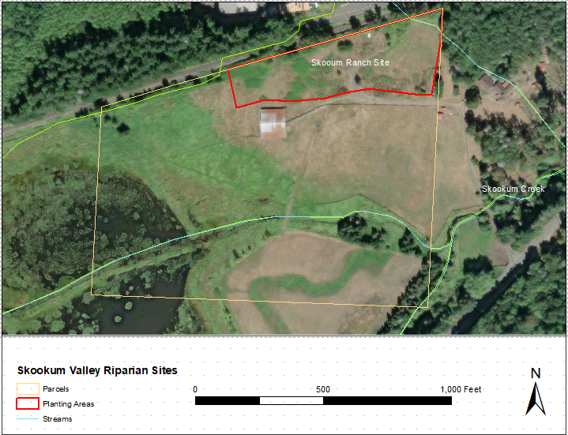

Figure 1. Skookum Ranch North Planting Area (in red) and site parcel.

**Description and Site Conditions:** The worksite is within the larger ‘Skookum Ranch’ property, a large site purchased by the Squaxin Island Tribe for conservation and restoration purposes. This work site is on the north end of the property and envelopes a 4-acre planting site which was planted with native trees in 2022-2023. This discrete part of the site is referred to as Skookum Ranch-North for the purposes of this proposal as distinct from the rest of the property and large-scale stream restoration treatments being included under other proposals.

Prior planting treatments in the work area are within the buffer of a seasonal stream that runs W/SW along the adjacent railroad tracks and included the installation of 1,400 trees, primarily Douglas-fir and big-leaf maple. Pasture grasses and opportunistic weeds including Himalayan blackberry, field bindweed, and others, dominate the understory and underlie the native tree plantings and continue to compete with the planted trees for moisture and coverage.

The planting area is upland in nature with a low summer water table and primarily upland vegetation communities, with the exception of the far west end of the site which begins to transition into wetland-edge areas.

The primary goal of this project is to conduct stewardship activities within the prior planting area including plant replacement, weed control, mulching, and general planting maintenance.

**Precipitation:** 60-70 inches per year

**Soils:**

Rd Rough mountainous land, Tebo soil material 11.2%

Wa Wadell gravelly loam, 0 to 5 percent slopes 88.8% Totals for Area of Interest

**Water Quality:** **None**. One Category 4a designation is listed on the Water Quality Atlas however the stream alignment is not accurate.

**Hydrology:** Seasonal surface flow occurs in winter through early summer in the channel along the adjacent railroad tracks however streamflow rarely or never spills onto the site. The primarily hydrologic influences in the planting area are seasonal precipitation, a high winter water table, and soil moisture in the dry season.

|  |  |
| --- | --- |
|  |  |
| Post-planting typical | Initial planting treatments 2022 |

**Goals and Objectives:** The primary needs on the site are plant replacement, weed control, mulching and general maintenance.

Goal 1 – Replace dead trees; Estimated 40% mortality = 560 trees.

Goal 2 – Reduce weed cover and reduce competition for moisture; target species include Himalayan blackberry, pasture grasses (*Agrostis* sp., *Festuca* sp., and others), field bindweed, and others.

Goal 3 – Improve soil and plant vigor with mulching and compost.

Objective 1 – Conduct site preparation with methods TBD which may include herbicide treatment, mowing, and/or mechanical removal of non-native species, sod scalping, placement of mulch and compost, and other methods.

Objective 2 – Install replacement native trees and shrubs in the work area.

* Estimated 560 trees @ 680/acre

Objective 3 – Conduct annual maintenance across the planting areas to include mowing, grass/weed control, browse control, mulching, and other methods, for 3 years.

**Conceptual Planting Plan:**

560 total plants/trees, to be field located and replace dead trees.

Douglas-fir, Big-leaf maple, small shrub component (Osoberry or others). Assumes 1-1 bare root 12-18”.

Stewardship/maintenance activities:

Mowing/trimming around trees 3-4 times per growing season, 3 years.

Mulching around trees, once.

Weed control to include mowing/trimming, mechanical removal, herbicide, 3-4 times per season, 3 years.