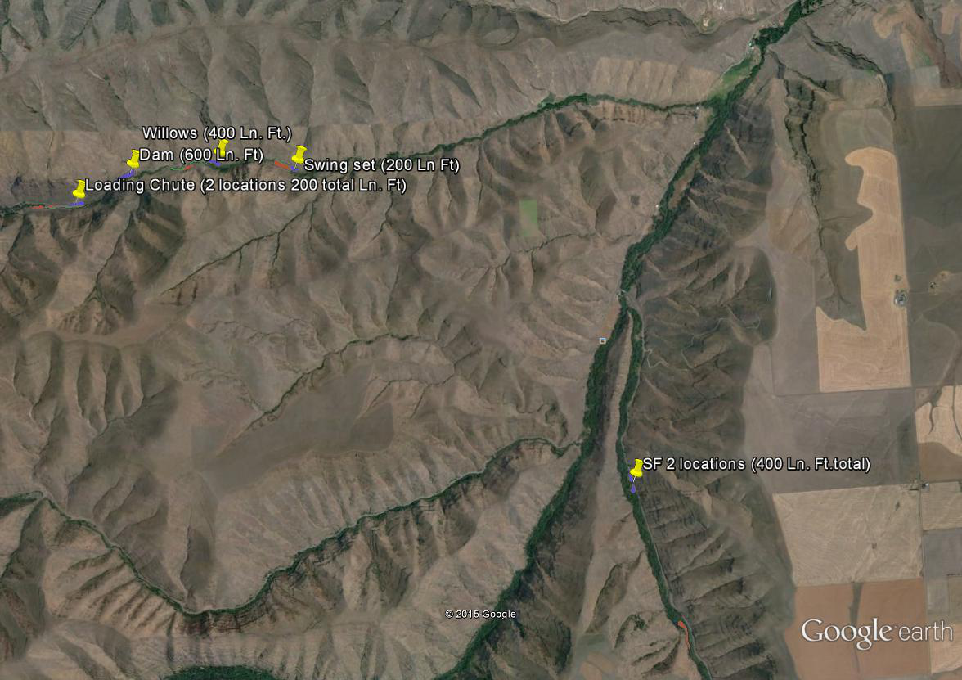  
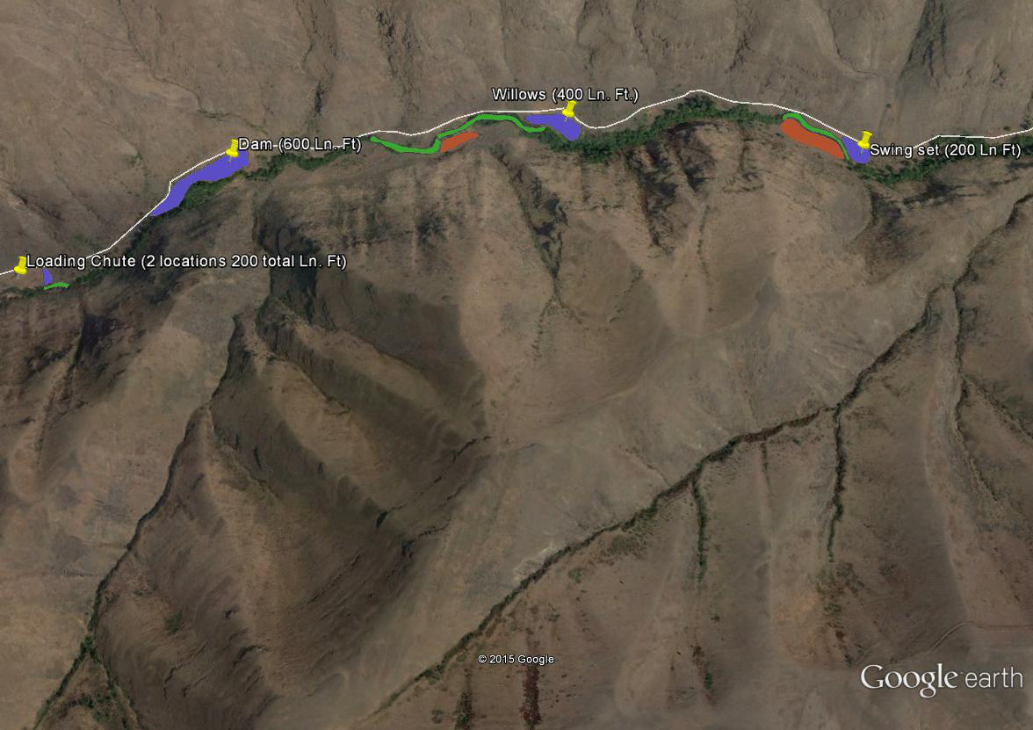

Charley Creek

South Fork Asotin Creek

Purple are the fabric planting locations

Orange is the scattered planting locations

Green is the cottonwood whip locations

Charley Creek

Purple are the fabric planting locations

Orange is the scattered planting locations

Green is the cottonwood whip locations

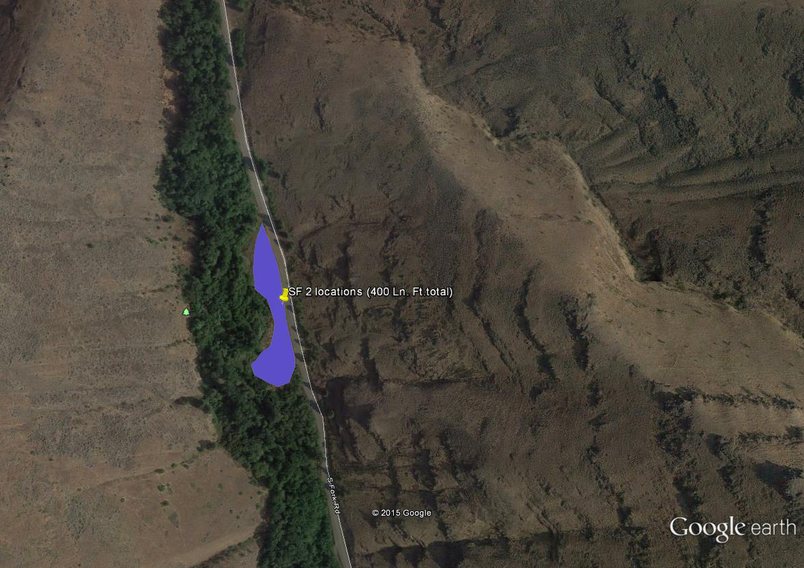

South Fork Asotin Creek