Asotin Creek Intensively Monitored Watershed: Summary of Restoration and Monitoring
January 1, 2015 – June 30, 2015 Progress Report
Stephen Bennett, Eco Logical Research Inc., Providence, Utah

Introduction
The Asotin Creek Intensively Monitored Watershed (IMW) is located in southeast Washington and began in 2008. The Asotin Creek IMW is determining the effectiveness of large woody debris treatments at increasing the productivity and capacity of Snake River Evolutionary Significant Unit (ESU) wild steelhead. Pre-treatment monitoring has been conducted from 2008 to 2012. The initial restoration phase began in 2012 and was finalized in October 2014. Effectiveness monitoring will continue until at least 2019. The following activities were completed during this reporting period:

- Monitoring
  - We maintained and downloaded two IMW water height gages and loaded these data into an IMW discharge database for use in analysis of habitat use and movement of both adult and juvenile steelhead.
  - We have completely updated our stream temperature database and used regression analysis to fill in missing data for the period 2008-2014 at all CHaMP monitoring sites and other strategic sites throughout the Asotin Creek watershed.
  - Field technicians attended CHaMP habitat and PIT tag mark/recapture training sessions in preparation for the field season (typically July 1 – Oct 15th).
  - Graduate thesis completed on the hydraulic and geomorphic effectiveness of LWD treatments (Camp 2015). Two manuscripts in preparation for publication.
  - Two mobile PIT tag surveys completed (January and March) at 12 fish sites to aid movement and survival assessments.

- Coordination and Planning
  - Proposed an follow-up restoration treatment (maintenance of existing structures and 2-4 km of new LWD treatments) to increase chances of detecting a treatment effect (this proposal has since been ranked #1 priority by SRSRB).
  - Coordinated with WDFW and Snake River Salmon Recovery Board (SRSRB) on all aspects of the IMW.
  - Developed a new Work Plan for the revised RCO budget.
  - Attended Data Symposium in Walla Walla, WA to present IMW results (March 17th).
  - Attended SRFB Monitoring Panel meeting to present findings of IMW (March 30th).
  - Attended SRFB Monitoring Panel meeting to respond to questions regarding the IMW progress.
  - Presented a DRAFT Revised Study Plan to the RCO Monitoring Panel of the monitoring results from (July 12).
  - Database management of discharge, temperature, fish, and habitat databases has been ongoing throughout the reporting period, and will continue.

- Upcoming Work
  - Regular summer and fall mark-recapture fish surveys at 12 permanent sites (Eco Logical Research Inc.) and 3 upper sites (WDFW)
  - Regular CHaMP surveys at 18 sites
  - Further data analysis including re-running survival analyses at the tributary and watershed scale using the Barker model approach, analysis and model building to assess the fish response to habitat restoration, and summary of habitat and biophysical data.

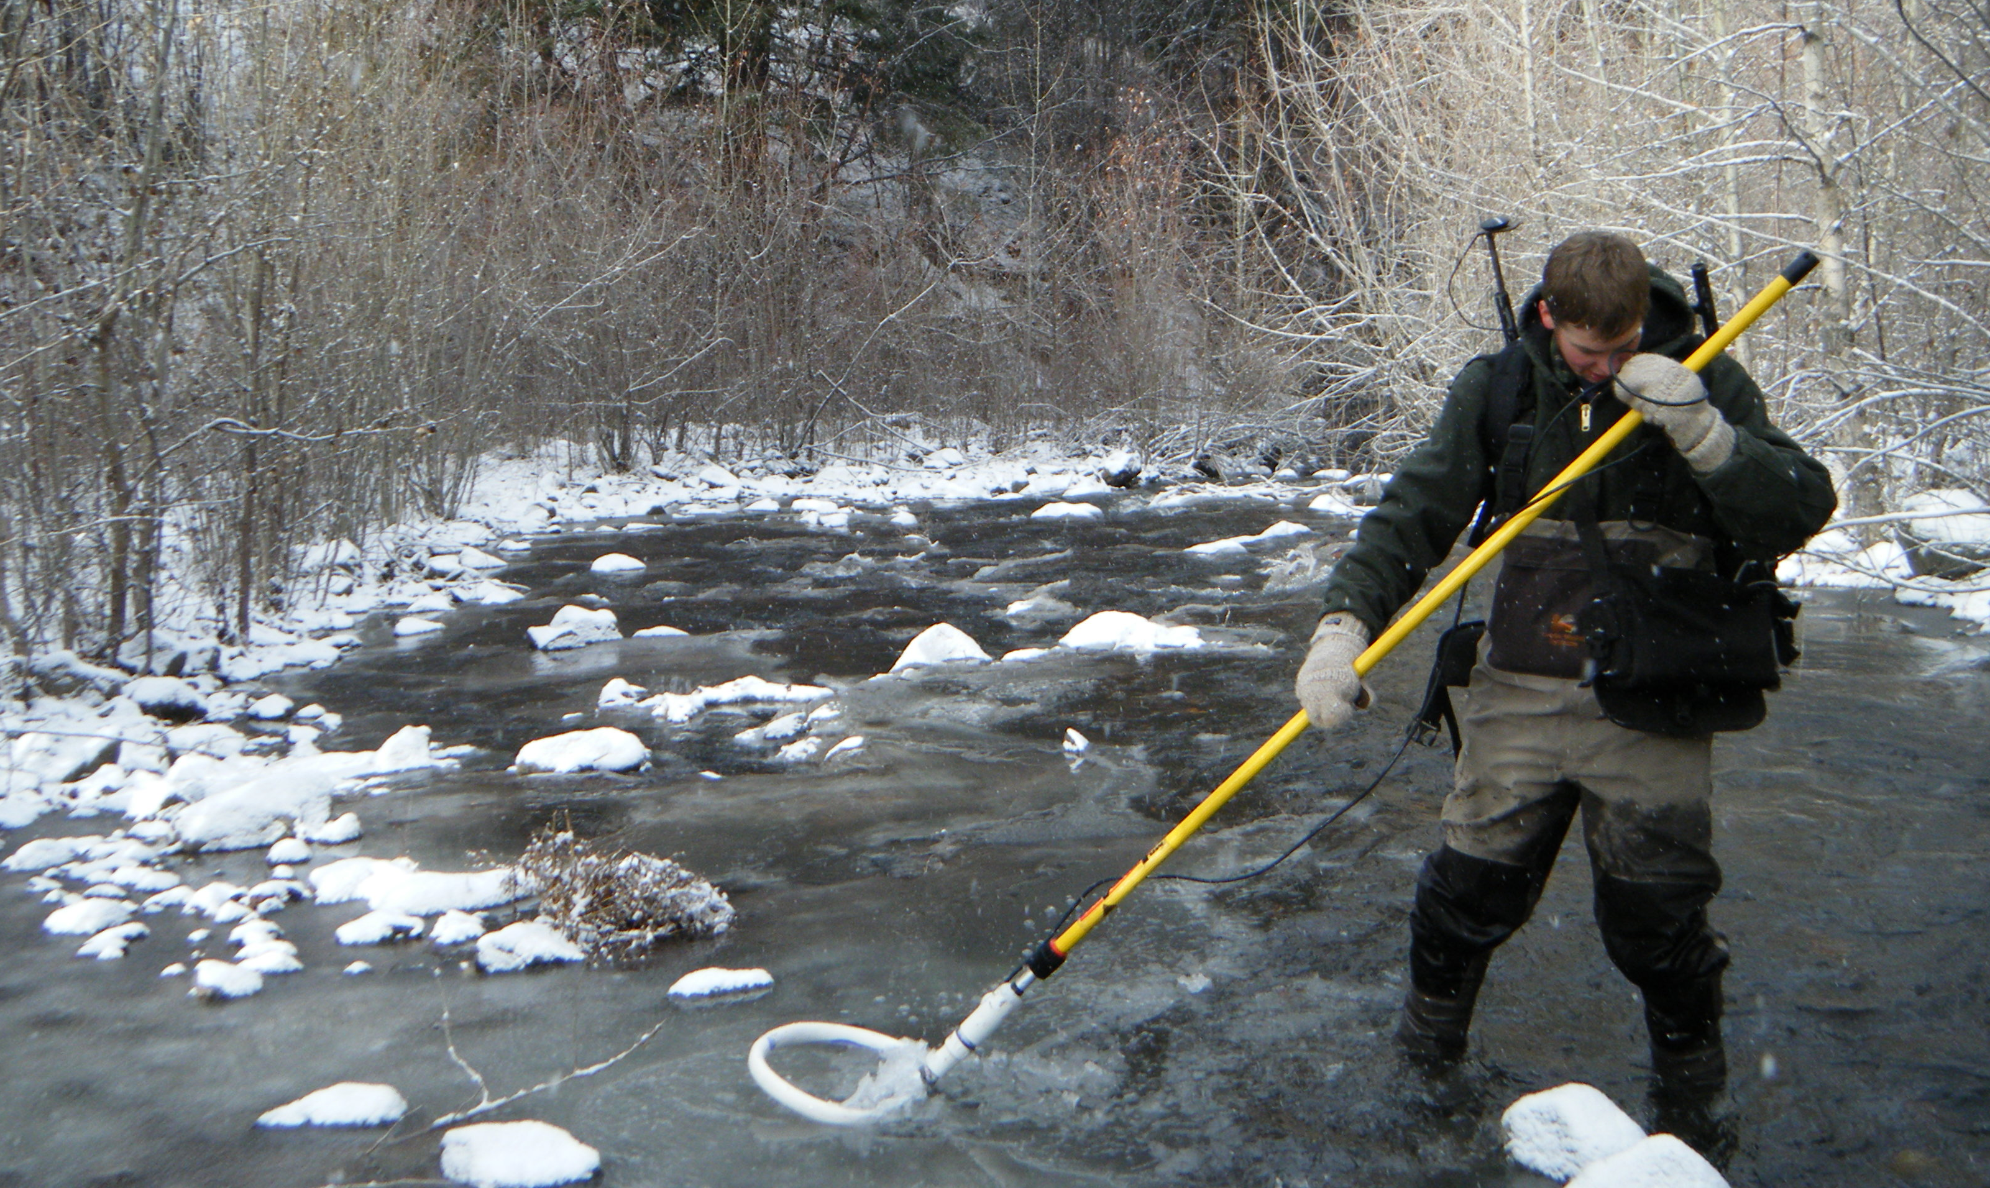

Winter mobile PIT tag survey using a mobile wand and data logger. Each PIT tag detection is recorded in the logger along with a GPS location and habitat unit where the fish was detected.

References

Camp, R. J. 2015. Short-term effectiveness of high density large woody debris, a cheap and cheerful restoration action, in Asotin Creek (Thesis). Utah State University, Logan, UT.

