Cann Bridge 2013 Monitoring Report

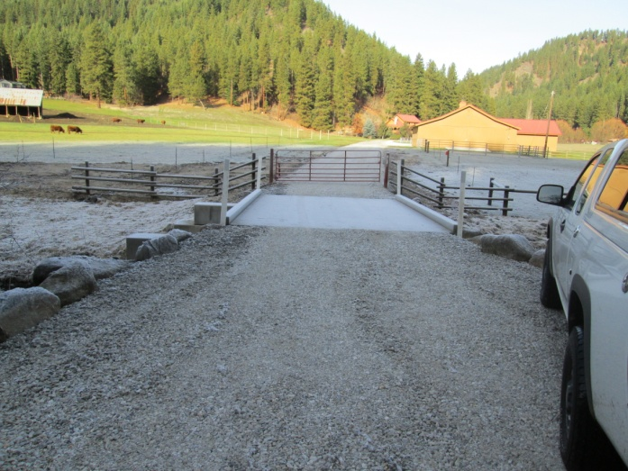

Prepared by: Chelan County Natural Resources Department

Adrienne Roumasset

**Introduction/Background**

The Cann Bridge project removed a fish passage barrier on Chumstick Creek river mile 8.59 as part of the Chumstick Barrier Removal project – a multi-agency partnership that removed all 30 Chumstick Creek fish passage barriers between RM 0.28 to RM 8.6 (26 culvert barriers and 4 irrigation dams) from 2001-2013. The Cann Bridge project was completed in 2012 and consisted of replacing a partial barrier culvert with a bridge, thus providing ESA listed salmonid species with complete access to upper reaches of Chumstick Creek.

Chumstick Creek is historical spawning and rearing habitat of steelhead, Bulltrout, and Coho salmon. The overall objective of the Chumstick Barrier Removal project was to reopen habitat and reinstate migration of these species into Chumstick Creek. The specific goals of the Cann Barrier removal project is to 1)replace the culvert with a concrete bridge to provide salmonids with access to reaches above RM 8.51 2) re-vegetate the work area to provide a diverse riparian habitat. The goal of monitoring Cann Bridge is to assess whether these goals are being met. Observations and data collected will be used to recommend adaptive management actions as needed to meet project objectives.

**Monitoring Methods**

CCNRD staff visited the site on June 5th, 2013 and August 16th, 2013 and estimated flow to be approximately 10 cfs and 3 cfs (baseflow) respectively during the June and August visits. Exact flow is unknown due to malfunctions with the DOE gage. Specific monitoring goals during the site visits were to 1) Document channel and bridge condition 2) assess the status of riparian revegetation. Fish passage through the three pit tag arrays in 2013 is also reported.

*Channel and Bridge Monitoring*

CCNRD staff established photo points post-construction in 2012. Pictures were repeated during the June 5th visit but lost due to a corrupted file, so only post-construction photos are available. CCNRD staff documented bridge condition and any erosion or deposition issues during the June 5th visit.

*Riparian Monitoring*

CCNRD staff performed stem counts throughout the planted area on August 16th 2013. The planted area was divided into northwest, southwest, northeast, and southeast quadrants (NE, SW, NE, SE).Total plants from the stem count were divided by total plants installed in 2012 and 2013 (available in planting plan) to calculate plant survival. Percent native shrub cover of each quadrant was visually estimated and invasive species were documented.

*Fish Passage*

A pit tag array near the mouth of Chumstick creek at north road (RM 0.28) has monitored fish passage into the creek since 2010. Two additional arrays were installed in March of 2013 to monitor adult fish passage at Sunitch creek (RM 5.3) and Merry creek (RM 8.82). 2013 fish detections are reported here.

*Channel and Bridge Monitoring*

CCNRD staff observed no structural issues with the bridge, bank erosion or sediment deposition around the project. Aside from an increase in riparian cover (see next section) no notable changes from post-construction photos were observed (Figure 1).

Figure 1. Post-construction photos, Fall 2012

 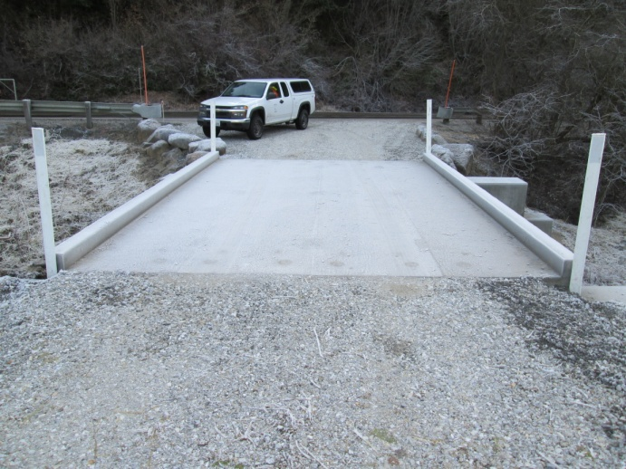

PP1 PP2

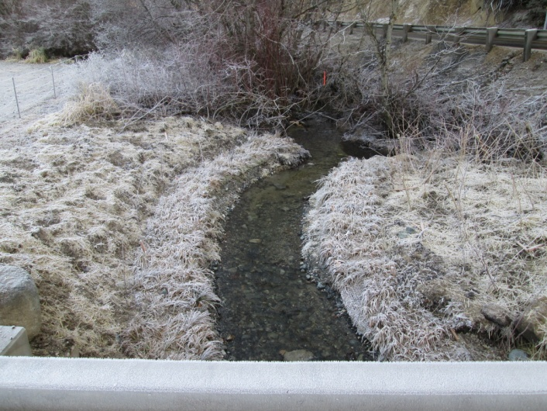 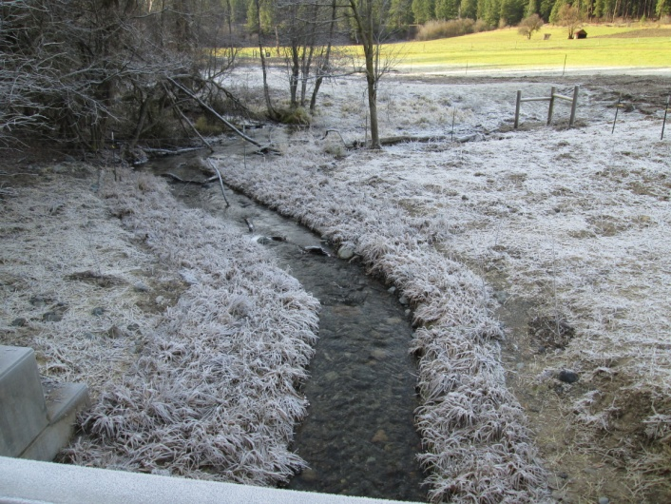

PP3 PP4

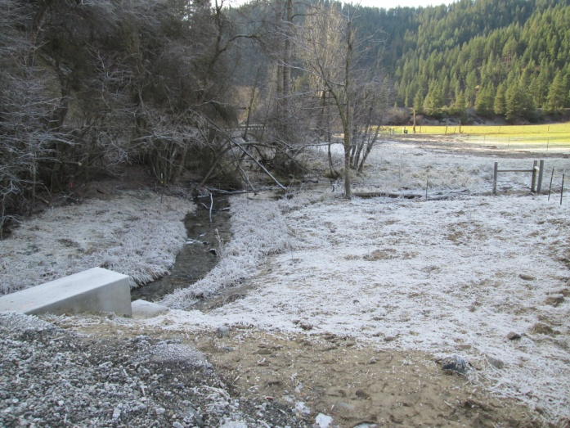 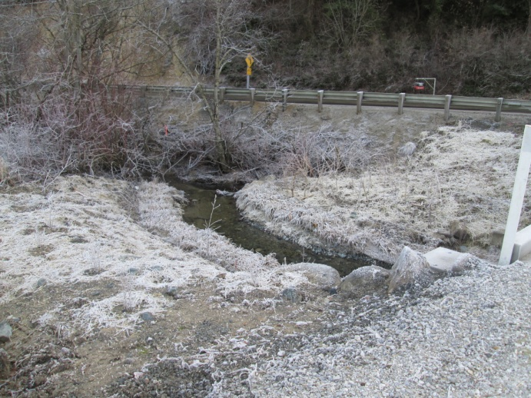

PP5 PP6

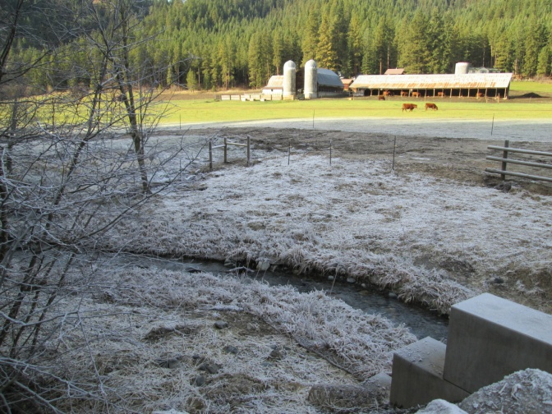

PP7

*Riparian Monitoring*

Totals from the stem count indicate a plant survival rate of 93 percent and average shrub cover of 23 percent (Table 1). Willows that were planted too high on the bank accounted for almost all of the observed mortality. Percent cover of sedge mats ranged from 70-100 percent.

Willow cuttings, dogwood, snowberry and alder are well established, growing fast, and providing good cover site wide. Areas of exceptionally high growth are in the SW quadrant (alder and dogwood near the creek) and the NE quadrant (willow stakes). Gaps in planting include a bare area between the bridge pillar and fence in the SW quadrant and lining the channel site wide (2-3 ft width swath) in the NE quadrant. Reed canary grass, an invasive species, lined the channel in the NW quadrant.

Table 1. Results from stem count on August 16th. Calculated plant survival = 178/192 *100 = 93 percent

|  |  |  |  |  |  |  |
| --- | --- | --- | --- | --- | --- | --- |
| **species** | **NW quadrant** | **SW quadrant** | **NE quadrant** | **SE quadrant** | **Total plants present** | **Total plants installed** |
| *Willow stakes* | 9 | 13 | 61 | 11 | **94** | 103 |
| *SYMPHORICARPOS ALBUS*- common snowberry | 11 | 10 |  | 4 | **25** | 25 |
| *ROSA WOODSII*- Wood's rose | 8 | 11 |  | 2 | **21** | 22 |
| *SAMBUCUS NIGRA spp. cerulea*- blue elderberry | 1 |  | 1 |  | **2** |  |
| *CORNUS SERICEA*- red osier dogwood | 3 | 3 | 2 | 3 | **11** | 12 |
| *ALNUS INCANA spp. tenuifolia-* mountain alder | 3 | 7 | 3 | 2 | **15** | 15 |
| *CRATAEGUS DOUGLASII*-Douglas hawthorne | 1 | 4 |  |  | **5** | 5 |
| *POPULUS BALSAMIFERA*- black cottonwood |  | 3 |  | 2 | **5** | 5 |
| ***totals*** | **36** | **51** | **67** | **24** | **178** | 192 |
| *% shrub cover* | 20 | 15 | 30 | 25 |  |  |

*Fish Passage*

Fish array data indicates that at least 2 wild summer steelhead migrated up RM 5.3 at Sunitch and 1 migrated to RM 8.82 at Merry (Cann Bridge is at RM 8.59). This represents 20 percent and 10 percent of the overall wild summer steelhead detected at North Road array located at the mouth of the Creek. Detections at fish arrays represent approximately 10 percent of the actual run.

Table 2. Adult salmonids detected at 3 fish arrays on Chumstick Creek in 2013

|  |  |  |  |
| --- | --- | --- | --- |
| **Species** | **North Road (RM 0.28)** | **Sunitch (RM 5.3)** | **Merry (RM 8.82)** |
| Wild Summer Steelhead | 11 | 2 | 1 |
| Hatchery Summer Steelhead | 9 |  |  |
| Hatchery Coho | 4 |  |  |
| Wild Spring Chinook | 2 |  |  |
| Hatchery Spring Chinook | 4 |  |  |
| **Total** | **30** | **2** | **1** |

**Conclusion/Recommendations**

Data from the fish array at Merry Canyon indicates the Baumann project is meeting the goal of opening up historical fish habitat to wild summer steelhead (Table 2). The bridge is structurally sound with no observed changes since post-construction in 2012. No bank erosion or sediment deposition was observed. Calculated plant survival was 93 percent, site shrub cover averaged 23 percent, and sedge mat cover ranged from 70-100 percent. Installed plants exhibit significant growth site wide.

Native shrub cover should be reassessed in 3-5 years before planting. Considered actions should be additional shrubs in the bare spot in the SW quadrant, and additional willow cuttings near the bank would to provide stream shade and fish cover. Changes to native and invasive species riparian cover, bridge integrity, and fish passage should continue to be monitored.