**Move it or lose it, King County tells Lake Sammamish homeowners over structures in trail corridor**

Jan. 15, 2020 at 5:32 pm Updated Jan. 17, 2020 at 10:35 am

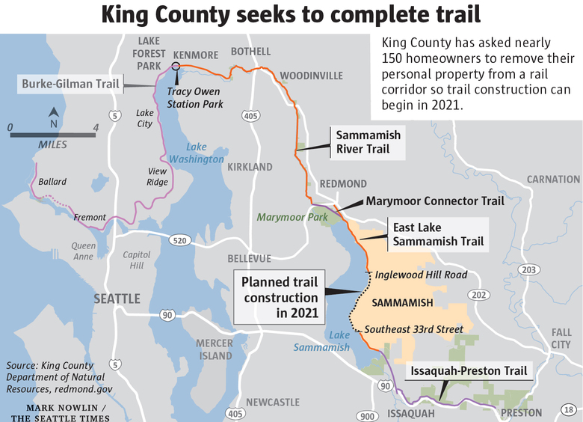

[](https://www.seattletimes.com/author/evan-bush)

By

[Evan Bush](https://www.seattletimes.com/author/evan-bush/)

*Seattle Times staff reporter*

King County sent [letters this week to nearly 150 homeowners](https://www.documentcloud.org/documents/6657214-King-County-draft-letter-to-homeowners.html) alongside Lake Sammamish with a pointed message: Move your personal property off a public right of way — or we will.

“They’re incensed,” said Reid Brockway, the acting president of the nonprofit Sammamish Homeowners, a neighborhood group of lakeshore owners. He called the letters “heavy-handed.”

The county in 2021 plans to pave a final section of the East Lake Sammamish Trail, which travels along a historic rail corridor lined by upscale homes.

Paving the railway’s final portion — which county officials have called “the missing link” — will connect Seattle’s Ballard neighborhood to Issaquah, giving cyclists, walkers and runners 44 miles of pavement to pound as it winds through Seattle and suburban Eastside communities.

“There are recreation opportunities, there are transportation opportunities and alternatives that are only possible if you have a completed trail,” said Katy Terry, a King County Parks deputy director. “It’s a real amenity to the region.”

The county also [filed a federal lawsuit Tuesday against several Lake Sammamish homeowners](https://www.documentcloud.org/documents/6657209-King-County-lawsuit-in-U-S-District-Court.html), taking another step in its decadeslong effort to clear way for the trail.

The lawsuit asserts that the land along the lakeshore and within a railway corridor is public land and that homeowners who have constructed docks, boat lifts, decks, walkways and fences there are trespassing.

The letters sent on Tuesday, and legal action, could be final steps in the project’s winding path toward achieving its vision for the trail. But it’s a vision that has been controversial and mired in several lawsuits over who controls the land.

The rail corridor at the center of this tangle of lawsuits dates back to the 1880s, according to the recent filing by King County.

Many homes along the corridor appraise for millions of dollars, according to King County property records, and the filing says their values rose when freight trains stopped using the tracks.

The county acquired the corridor in 1998, then pulled up the railway tracks before completing construction of an interim gravel trail in 2006, the filing says.

The trail along Lake Sammamish has been constructed in several phases. King County plans to begin its final phase in 2021 and replace a 3.6-mile gravel section along the corridor with an 14-foot-wide paved trail, between Southeast 33rd Street and Inglewood Hill Road.

King County sent letters Tuesday to homeowners with personal property along the trail corridor, directing them to remove landscaping or any structures by Sept. 30, according to a drafted letter provided by the county.

Some homeowners have built garages or gardens within the corridor, Brockway said.

Homeowners must tell the county by the end of March if they will move their personal property themselves or have the county remove it. The county will not charge to clear landscaping, but “may seek to recover all costs” for other items, the letter says.

Top of Form

Bottom of Form

“If they were not to remove it, then we would remove it as part of construction activities,” said Terry.

Separately, the county has filed a lawsuit against the owners of eight homes over shore lands along the trail corridor. The lawsuit claims that these homeowners have “used public lands without permission and without cost to enhance their homes and estates near Lake Sammamish by building and maintaining docks, boat lifts, cabanas, decks, walkways” and other structures.

The county is asking for these homeowners to get rid of these structures, pay for restoration and remediation of the land and pay rent for the “unauthorized uses.”

Area homeowners have sued several times over the trail and its railroad easement. Terry said by proactively filing a federal lawsuit over shore lands in the corridor, the county is taking a step to avoid further delays with the project.

“We are seeking clarity of ownership so it doesn’t slow down the project,” she said.

Most of the homeowners did not return calls Wednesday or declined to comment when reached by phone.

Justin Park, an attorney at Romero Park, who represents Patricia Harrell, one of the homeowners, said “she’s looking forward to negotiating with the county in good faith and hopes they can work something out,” before declining further comment.

Trail proponents say paving this final stretch of trail will fill a gap in the area’s regional trail system, providing options for green transportation with forthcoming connections to light rail, giving the public access to recreation and providing for the enjoyment of the lake’s natural beauty.

“On the trail, you are experiencing a little peace and quiet, a little bit of nature,” said Claire Martini, a policy manager for the Cascade Bicycle Club. “Having these connected corridors is critical for recreation” and “for folks on wheels who are trying to make trips in an increasingly congested region.”

But some homeowners are embittered and see the county’s efforts as taking what should be theirs.

Many homeowners along the rail corridor, which spans about 100 feet wide in most places, believed they had longstanding rights there, Brockway said.

[Homeowners in a 2018 Ninth Circuit Court of Appeals case](http://cdn.ca9.uscourts.gov/datastore/opinions/2018/08/03/16-35486.pdf) argued that when the county took over the corridor, the railroad easement should have been converted to a much narrower recreation easement, and that the remaining property, under state law, should revert to their control.

But the appeals court sided with the county, which argued that the federal Trails Act — the basis for converting railroads to recreational trails — preserves the entire railway easement for King County and the public.

The U.S. Supreme Court declined to hear the case on appeal.

“We’re stuck with that ruling, and the county has successfully been stealing our land,” Brockway said.

The developments Tuesday represent an escalation in a longstanding and complicated battle.

“Oh boy — here we go,” Brockway said, when he learned of the lawsuit.

***Evan Bush:****206-464-2253 or*[*ebush@seattletimes.com*](mailto:ebush@seattletimes.com)*; on Twitter:*[*@EvanBush*](https://www.twitter.com/EvanBush)*.*