Meadowdale Beach Park Restoration Study

Project # 20-1935

This project will evaluate the geomorphic and ecologic responses of the ESRP-funded Meadowdale Beach and Estuary Restoration Project, the first estuary embayment restoration project along the 52 miles of waterfront railroad in the Salish Sea. Improving understanding and metrics of project performance and system responses across several interconnected habitats will inform future design, siting and resilience of restoration investments.

**Project Proponent:** Todd Zackey - Marine & Nearshore Program Manager

Tulalip Tribes Natural Resources Department

[tzackey@tulaliptribes-nsn.gov](mailto:tzackey@tulaliptribes-nsn.gov)

(360) 716-4637

**Project Partners:**

Paul Schlenger - Principal Associate

ESA | Environmental Science Associates

[pschlenger@esassoc.com](mailto:pschlenger@esassoc.com)

(206) 601-1405

Ian Miller, PhD – Coastal Hazard Specialist

Washington Sea Grant

[immiller@uw.edu](mailto:immiller@uw.edu)

(360) 417-6460

Eric Grossman, PhD – Research Geologist

USGS/Western Washington University

[egrossman@usgs.gov](mailto:egrossman@usgs.gov)

(360) 650-2538

Frank Leonetti – Fisheries Biologist

Snohomish County Surface Water Management

[Frank.leonetti@snoco.org](mailto:Frank.leonetti@snoco.org)

(425) 262-2588

Elisa Dawson – Senior Planner

Snohomish County Marine Resources Committee (MRC)

[elisa.dawson@snoco.org](mailto:elisa.dawson@snoco.org)

(253) 215-8782

Joe Scordino – Volunteer Club Organizer/Retired NOAA Fish Biologist

Students Saving Salmon – Edmonds – Woodway High School Club

[joe.scordino@yahoo.com](mailto:joe.scordino@yahoo.com)

**Project Start Date: September 1, 2020**

**Project End Date: July 31, 2023**

Construction of the Meadowdale Beach and Estuary Restoration is set to begin in the Spring of 2021. Pre-restoration data needs to be collected before construction. Fiscal Year 2019 Tribal allocation of EPA NEP funds will be used to fund development of a QAPP and collect pre-restoration physical and biological data.

**Technical Information**

# Problem Statement

Numerous streams and embayments are impacted by the railroad that extends along 52 miles of the eastern shore of Puget Sound with another 73 miles within 200 feet. The Meadowdale Beach and Estuary Restoration (MBER) Project is the first restoration project of its kind that is restoring a creek estuary and working to restore natural processes to create sustainable habitat for juvenile salmon. This regionally significant restoration project presents a unique opportunity to investigate the geomorphic and ecological outcomes of the project. The proposed Meadowdale Beach Park Restoration Study will investigate the geomorphic and ecological effectiveness of the project. The proposed study will provide important information to guide future restoration designs, as well as key information documenting project benefits to stakeholders, funders, restoration practitioners, and the entire community.

To date, a strategic and viable approach to nearshore restoration along the railroad corridor in the Puget Sound has been elusive for a number of reasons, including:

* Difficulty implementing a nearshore restoration strategy that promotes natural process restoration for habitat functionality at the landscape scale
* Uncertainty about the site-scale and landscape-scale effectiveness and sustainability of restoration
* Having to retain economically important shoreline infrastructure
* Finding restoration sites with willing landowners

The Meadowdale Beach Park Restoration Study is in the unique position to help inform how to resolve some of these issues. The MBER Project[1] which is the focus of this study, will replace an undersized culvert with a railroad bridge and excavation of a 1.3 acre estuary upstream of the railroad. The restoration was designed to provide plenty of room for the estuary to adjust following construction and to expand as sea levels rise. The MBER project includes minimal monitoring of the estuary and plantings survival, but does not get at geomorphic or ecological effectiveness that informs whether meaningful restoration projects can be conducted along long stretches of continuously armored shorelines.

The proposed study is designed to collect geomorphic and ecological data to inform all future restoration projects along the railroad and other continuously armored sections of Puget Sound.

# Hypothesis Statement

This study will focus on the ecological and geomorphic changes resulting from the MBER project. The landscape scale implications of identifying an effective method and strategy to restore ecological function along the railroad corridor is significant for the recovery of the Puget Sound and ESA-listed salmon. However, before investing in an expensive strategy to open up embayments and stream mouths along the railroad corridor we need to understand if this type of restoration project is effective given its location (geomorphic constraints) and if it provides an ecological lift that benefits key species and ESA listed salmon. To do this we need to understand the processes (sediment dynamics) that form and maintain the embayment estuary and assess the ecological functions of the MBER project to determine if the ecological outcomes will contribute to Puget Sound recovery and whether this type of restoration is worth implementing more widely.

The MBER project seeks to restore the site to a state similar to its historical predevelopment configuration; however, infrastructural constraints (railroad embankment armoring) and watershed/stream conditions (increased peak flows and sediment delivery) at the site have altered the historic geomorphic equilibrium and there is uncertainty about what the restored geomorphic equilibrium will be. To inform the geomorphic response of the site following restoration, we will collect quantitative temporal and spatial data on the movement, distribution, and sorting of sediment to answer the following key questions:

1. How will the restored estuary landward of the railroad respond? Will it retain more of the sediment delivered from the creek (resulting in loss of lagoon/embayment habitat and reduced sediment flux to the beach), or will the widening of the current constriction lead to a pulse of sediment delivered to the shoreline in the project period, and higher annual delivery?
2. How will the beach waterward of the railroad respond? Will sediment be retained near to the project site or will it be transported away from the project site either alongshore or cross-shore? To what extent will changes in the flux and composition of sediment influence beach and creek mouth morphology, substrate composition and complexity. What are the associated spatial and temporal scales of transport and habitat response?

For the ecological component of the study, previous studies (Beamer et al. 2006 & Beamer et al. 2013) indicate that this type of system will be utilized by ESA-listed juvenile chinook and other fish species. We have based our hypothesis questions off of this work with the addition of looking into changes in prey availability for these fish. These questions are:

* + - 1. Post-restoration, will juvenile chinook utilize the estuary embayment landward of the railroad grade where they previously were not found?
      2. Post-restoration, will juvenile chinook and other juvenile salmon (coho, cutthroat) rear in the stream and estuary embayment?
      3. Will the restored estuary embayment fish assemblages be more diverse post-restoration than pre-restoration and as compared to an un-restored control site?
      4. Will fish prey availability increase at the restored site and/or be more diverse than the unrestored control site.

# Methods

#### Geomorphic Sampling approach

For the geomorphic component of this project we focus on when, where, how, and what type of sediment is eroded, transported, and deposited throughout the project area from the lower reach of Lunds Gulch Creek out to the shoreline/stream delta area and portions of the shoreline updrift and downdrift of the project site. The goals are to:

1) Track the movement of sediment within the stream-embayment system out onto the stream delta and shoreline and

2) Track the change in geomorphology and substrate composition through erosion, transport and deposition of sediment across the project site and along the shoreline.

Interpretation of the movement of sediment over time will provide insight into the dynamics between fluvial and coastal processes and what character and time the eventual geomorphic equilibrium the site will achieve, and whether the design and physical processes will maintain the embayment and shoreform as anticipated. Given the uniqueness of the MBER project we anticipate minor adjustments to our geomorphic data collection methods as we continue to pursue collecting and providing the most relevant data to inform restoration designs and strategies, e.g. we may find better substrate mapping techniques that better and align with forage fish egg survey work the Snohomish MRC is conducting. Study methods will be finalized in September 2020 as required by the pre-restoration matching grant (EPA NEP) funds to have an approved quality assurance project plan (QAPP) prior to any data collection.

#### Specific methods and technologies

We will employ a suit of methods to measure the sediment coming down the stream and into the embayment, measure changes in the depths of the embayment (sediment input from the stream), measure elevation changes on the beach (stream delta), map sediment changes post-restoration, and track tagged gravel.

To track the movement of sediment in the stream we will conduct surveys of the lower reach of the stream channel depths and widths and geomorphic units utilizing standardized methods utilized in Booth & Henshaw, 2000 twice a year.

We will also employ a novel approach of placing pit tagged gravel in upstream locations and tracking the tagged gravel as it is transported downstream utilizing a pit tag reader and potentially install an acoustic array to detect the gravel as it exits the stream into the embayment (Miller & Warrick, 2012). Scanning for pit tagged gravel across the site will be conducted quarterly to better understand the transport and deposition of gravel through the system.

A stream flow station will be set up to continuously monitor stream flow volumes for the duration of the study for potential correlation between sediment movement and flow volumes.

Embayment, stream channel, and shoreline transect and cross-section surveys will be conducted utilizing an RTK GPS to track changes in the elevation across the system and to track sediment as it moves into and out of the embayment and out into the shorezone.

Mapping of beach and delta substrate changes will be conducted twice a year utilizing UAS acquired aerial imagery and methods developed by the Skagit River System Cooperative (McBride et al. 2006).

Aerial imagery of the site will be acquired twice a year utilizing the Tulalip Tribes Ebee UAS it will be orthorectified and a digital terrain model (DTM) generated utilizing Pix4D software. This imagery will then be used in the mapping of beach substrate and track changes in the project site topography.

A time lapse camera will be deployed at the site to track changes along the shoreline and help identify associated geomorphic events (e.g., significant runoff, storm/wave impacts) to provide insight into the forces that modify morphology, substrate and overall habitat structure/availability.

The combination of data collected will allow us evaluate the extent and rates of sediment transport, retention and habitat response in different parts of the study area through the durations of the project period

#### Statistical analyses

The analysis of the geomorphic data collected will focus on estimating the volume and rate at which sediment is transported downstream into and out of the embayment to the shoreline/stream delta. We will explore whether large sediment transport events correlate with episodic climate events and at different tides. For the analysis of topography and grain size data we utilize methods outline in Warrick et al. 2019 and Gelfenbaum et al. 2015.

Additionally we will utilize the aerial imagery and time lapse camera footage to make qualitative observations about how the different processes (fluvial and coastal) interact and distribute sediment throughout the system.

### Ecological Sampling approach.

The ecological component of the study focuses on when, how, and where juvenile salmon and other fish species are using the site as compared to pre-restoration conditions and at a control site two kilometers north of the study site, Picnic Point Creek.

We will investigate the ecological benefits of the site by conducting fish and invertebrate sampling at the site pre-and post-restoration and at a nearby unrestored control site (Picnic Point Creek) for comparison of two years post-restoration and two years of data pre-restoration (data collected in 2018 and Spring 2021).

#### Specific methods and technologies

For fish sampling will employ two methods to collect fish samples.

1. Electrofishing techniques will be employed to sample the stream and intertidal channels at low tide. Sampling reaches will be established and discretely sampled utilizing methods outlined in Beamer et al. 2013. Fish collected will be identified to species with the first 25 of each species being measured. Any chinook or coho collected will be checked for adipose fin clips and coded wire tags (CWT) to determine if the fish are of hatchery origin. Caudal clip DNA samples will be taken to track individual chinook or coho residence time and river of origin.
2. A small beach seine will be used to collect fish samples in the marine waters adjacent to the site and in the embayment post-restoration during higher tides following methods established for pocket estuary fish sampling (Beamer et al. 2006). Fish processing will be the same as that employed for electrofishing sampling

Invertebrate sampling will consist of two different methods which best capture the prey field that juvenile salmon feed on, terrestrial insects and plankton four times a year.

Terrestrial insect sampled will involve the deployment of five fall out traps, at pre-determined sites within the embayment and stream mouth of the control site. Plankton prey samples will be collected using a neuston tow net which samples plankton near the water surface. Each individual sample will be placed in labeled sample jars and preserved in ethyl alcohol and sent to a lab to for species identification and enumeration.

Fish and invertebrate sampling will begin in February of each year, fish sampling will occur every two weeks until the end of June and four invertebrate samples will be collected during this period.

Discrete water quality data, dissolved oxygen, salinity, conductivity, and temperature, will be collected during fish and plankton sampling utilizing a multiparameter water quality meter. Additionally, a data logger to record temperature, depth, and conductivity will be installed in the embayment post-restoration to provide continuous water quality data.

#### Statistical analyses

To analyze the fish sampling results we will compare relative fish abundance and fish assemblages pre-and post-restoration and between the restored site and control site. If a sufficient number of DNA samples are collected from chinook and/or coho, we will have the samples analyzed to determine their river of origin and to see if we have recaptured the same individuals more than once. If so we will infer the residence time and growth rates of individual fish we have captured two or more times.

To analyze the invertebrate data we will compare terrestrial and planktonic assemblages between the project site and control site and if possible relative abundances to determine if the restored site has a greater number (density) of invertebrates (available prey) then the control site and if the restored estuary embayment has a more diverse assemblage of planktonic and terrestrial invertebrates.

### Coordination with other data collection efforts

We are working to coordinate our study efforts with existing data collection efforts taking place outside the scope of our study and on coordinating with these other efforts to ensure our work complements each other, avoid data redundancy, and increase efficiency.

1. Restoration implementation and performance monitoring will be conducted by a consultant to meet permitting requirements for the MBER project. The monitoring is very limited to investigate vegetation survival and estuary depth/velocity conditions (Anchor QEA 2017).
2. The Snohomish County MRC have already collected three years of seasonal forage fish and sediment sampling at Meadowdale Beach and Picnic Point and will continue this effort post-restoration.
3. A local high school club, Students Saving Salmon (SSS), has been conducting on going several carcass counts, water quality monitoring, and macroinvertebrate sampling for several years and plan on continuing this effort post-restoration. We will be working with SSS to include local students in the study and potential set them up to collect long-term data at the MBER site.

# Budget Narrative

We are requesting a total of $194,685 from ESRP for this proposed project, with an estimated 30.7% in match from FY19 EPA NEP grant funds which will be utilized to conduct pre-restoration sampling as part of this study prior to the beginning of this award. We developed our budgets for the project plan based on past similar sampling efforts.

### 1.0 Project Administration

Salary- $2,887

Fringe- $664

Salary and fringe for PM for project tracking, budgeting, and reporting.

Match- $2,219

Match is from salary and fringe costs for staff to manage FY19 EPA NEP grant which is the source of match for this grant.

### 2.0 Project Plan

Salary- $1,444

Fringe- $332

Salary and Fringe for staff do develop the required project plan.

Contractual- $1,200.00

Contracted Washington Sea staff will assist with project plan development specifically assisting with geomorphic methods write up

Match- $4,438

Match is from salary and fringe costs associated with the development of a QAPP for matching EPA NEP grant.

### 3.0 Wiki Content

Salary- $1,954

Fringe- $474

Salary and Fringe for Staff to create Content and upload to Project Wiki webpage

### 4.0 Data Collection and Processing (totals)

Salary- $69,247

Fringe- $16,999

Travel- $1,350

Equipment- $6,000

Supplies- $4,950

Contractual- $26,351

Match- $46,833

#### 4.1.1 Stream surveys

Salary- $7,535

Fringe- $1,856

Salaries and fringe for staff to conduct stream, embayment and beach surveys.

Travel- $100

Cost of 8 - 50 mile round trips in GSA vehicle at a rate of $0.25/mile .

Supplies- $200

Supplies budget for waders, wader boots and any stream survey supplies we may need e.g. hip chain, flagging etc.

Contractual- $2,965

Contracted Washington Sea staff will assist with geomorphic data collection and methods training, contracted WWU graduate student will assist with geomorphic data collection.

#### 4.1.2 Embayment transect surveys

Salary- $7,535

Fringe- $1,856

Travel- $100

Cost of 8 - 50 mile round trips in GSA vehicle at a rate of $0.25/mile

Supplies- $200

Supplies for embayment surveys, e.g. stadia rod.

Contractual- $2,965

Contracted Washington Sea staff will assist with geomorphic data collection and methods training, contracted WWU graduate student will assist with geomorphic data collection

#### 4.1.3 Beach transect surveys

Salary- $7,535

Fringe- $1,856

Travel- $100

Cost of 8 - 50 mile round trips in GSA vehicle at a rate of $0.25/mile.

Supplies- $200

Misc supplies for beach surveys.

Contractual- $2,965

Contracted Washington Sea staff will assist with geomorphic data collection and methods training, contracted WWU graduate student will assist with geomorphic data collection

#### 4.1.4 Tagged gravel tracking

Salary- $6,514

Fringe- $1,570

Salaries and fringe for staff to track pit tagged gravel across project site.

Travel- $300

Cost of 24 - 50 mile round trips in GSA vehicle at a rate of $0.25/mile.

Supplies- $850

Estimated cost of a of portable pit tag reading to track pit tagged gravel movement across the project site.

Contractual- $3,765

Contracted Washington Sea staff will assist with geomorphic data collection and methods training, contracted WWU graduate student will assist with geomorphic data collection.

#### 4.1.5 Aerial imagery acquisition (UAS flights)

Salary- $5,810

Fringe- $1,491

Salaries and fringe for staff to conduct UAS flight to collect aerial imagery of project site.

Travel- $100

Cost of 8 - 50 mile round trips in GSA vehicle at a rate of $0.25/mile.

Supplies- $200

Supply funds for aerial targert control points for drone flights.

#### 4.1.6 Sediment mapping and classification

Salary- $5,061

Fringe- $1,205

Salaries and fringe for staff to map and classify surface substrate across project site.

Travel- $200

Cost of 16 - 50 mile round trips in GSA vehicle at a rate of $0.25/mile.

Supplies- $200

Funds will be used for acquiring quadrats, and sediment sampling containers.

Contractual- $4,544

Contracted Washington Sea staff will assist with geomorphic data collection and methods training, contracted WWU graduate student will assist with geomorphic data collection.

#### 4.1.7 Time-lapse camera installation and maintenance

Salary- $2,024

Fringe- $482

Salaries and fringe for staff to install and maintain timelapse camera.

Travel- $50

Cost of 4- 50 mile round trips in GSA vehicle at a rate of $0.25/mile.

Equipment- $6,000

Supplies- $200

Supplies for misc installation items e.g. posts clamps, etc.

Contractual- $4,412

Contracted WWU graduate student will assist time lapse camera installation, maintenance, data management and processing.

#### 4.1.8 Stream flow logger installation and maintenance

Salary- $2,024

Fringe- $482

Salaries and fringe for staff to install and maintain water level data logger for determining stream flow rates.

Travel- $50

Cost of 4- 50 mile round trips in GSA vehicle at a rate of $0.25/mile.

Supplies- $500

Estimate cost for water level logger.

#### 4.2.1 Water quality data logger installation and maintenance

Salary- $1,664

Fringe- $399

Salaries and fringe for staff to install and maintain water quality data logger in restored embayment.

Travel- $50

Cost of 4- 50 mile round trips in GSA vehicle at a rate of $0.25/mile.

Supplies- $2,000

Cost of a Van Essen CTD Diver for logging water level, temperature, and salinity in restored embayment.

#### 4.2.2 Fish sampling

Salary- $12,244

Fringe- $3,017

Salaries and fringe for 3 staff to conduct fish sampling at the project site.

Travel- $150

Cost of 12 - 50 mile round trips in GSA vehicle at a rate of $0.25/mile.

Supplies- $200

Misc. supplies for fish sampling, buckets, measuring boards, dip nets etc.

Contractual- $4,737

Contracted ESA staff will assist with fish data collection.

#### 4.2.3 Invertebrate sampling

Salary- $11,302

Fringe- $2,784

Travel- $150

Cost of 12 - 50 mile round trips in GSA vehicle at a rate of $0.25/mile.

Supplies- $200

Cost for fallout trap bins, and sample jars.

### 5.0 Interim Results Analysis

Salary $1,954

Fringe $474

Salaries and fring for staff to conduct invertebrate sampling.

Contractual $7,619

Contracted ESA staff and Washington Sea staff will assist with interim data analysis.

### 6.0 Final Project Report

Salary- $5,061

Fringe- $1,205

Contractual- $18,672

Contracted ESA staff and Washington Sea staff will assist with Final report writing.

Match- $6,266

Matching funds for generating pre-restoration sampling results report from FY19 EPA NEP grant.

### 7.0 Final Project Presentation

Salary- $1,303

Fringe- $316

Contractual- $3,158

Contracted ESA staff will assist with presentation preparation and presentation delivery.

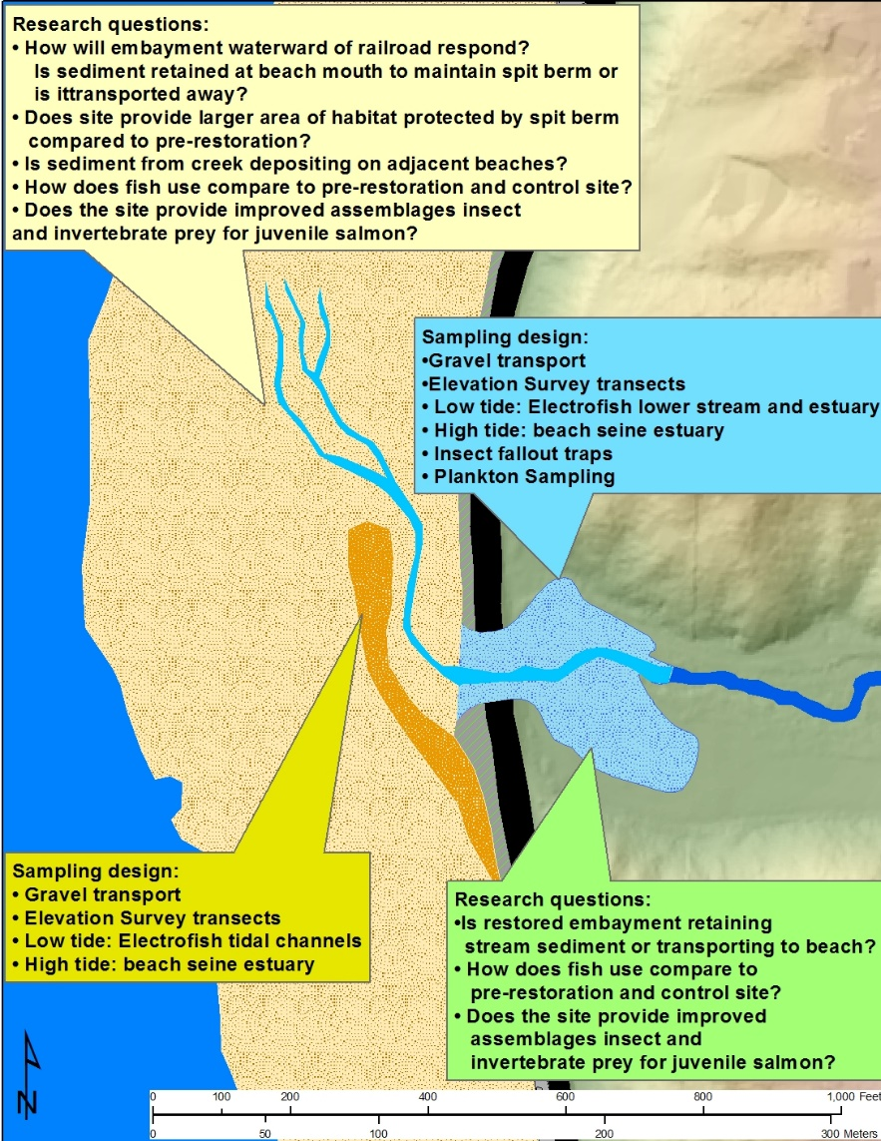

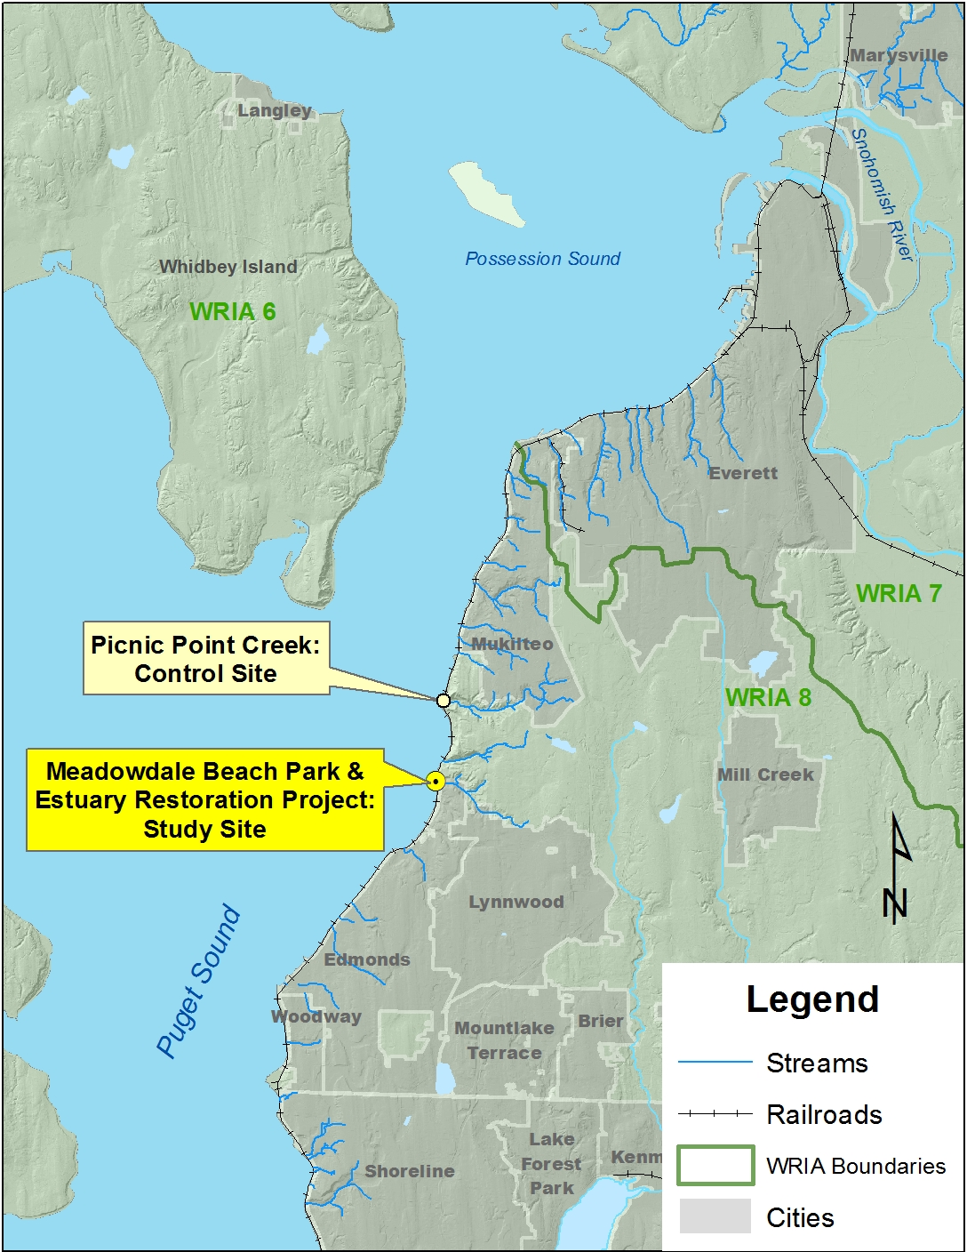

Figure 1. Project study site and control sites locations. Figure 2. Study site conceptual map showing proposed sampling methods and research questions.

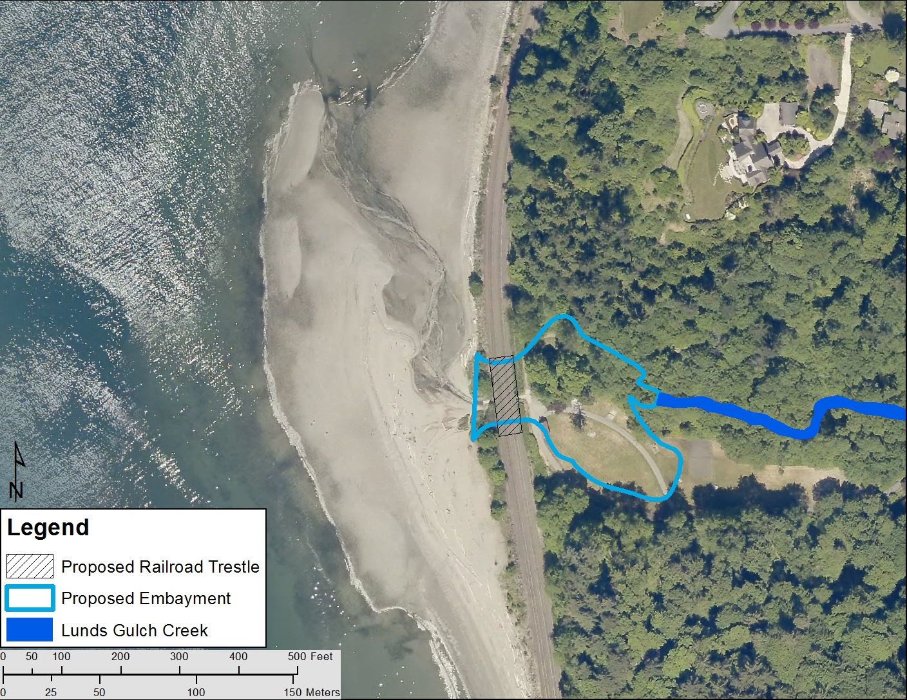

Figure 3. Project site existing conditions with proposed restoration overly

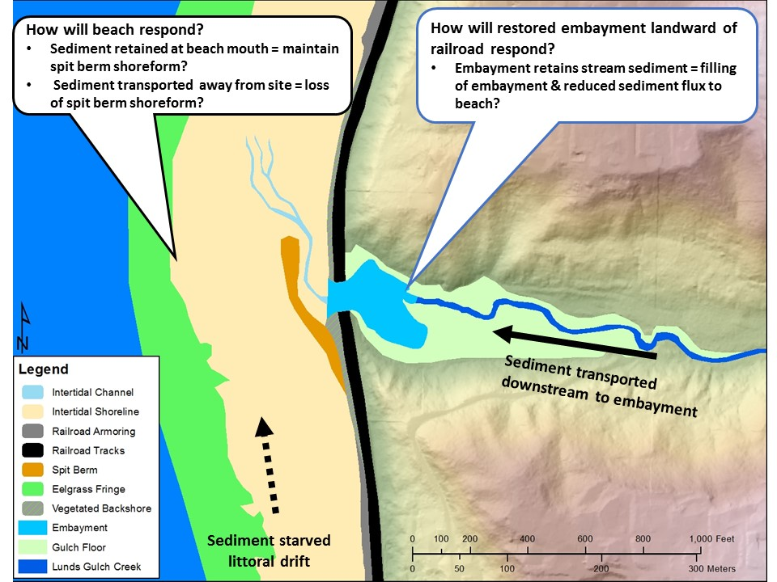

Figure 4. Restored site map with key study questions.

**Outputs and Outcomes**

# Task Description

Prior to the beginning this grant, EPA NEP funds will be used to conduct pre-restoration data collection and as match September 1, 2020 to July 31 2021

# Task 1. Project Management

Description: Project Management will include project reporting including PRISM reports, grant budget management, and assuring all grant requirements are met.

*Deliverables:*

*(1.1) PRISM progress reports (quarterly progress reports)*

*(1.2) PRISM final report - 6/30/2023*

# Task 2. Project Plan

We will develop a project plan that includes: (1) project goals and objectives, (2) scope and schedule for implementation and deliverables, (3) sampling plan and methods, (4) descriptions of factors affecting accuracy and precision of mapping products, (5) assessment of how the sampling plan will address these factors, (6) descriptions of staff roles and expertise, (7) product descriptions, and (8) estimated costs. This project plan will be completed during the initial phase of our project timeline and will include coordination with project partners and ESRP to develop a clear plan to address the desired project outputs.

Task 2.a. **(Match)** Restoration Study QAPP - Development and approval of a quality assurance project plan (QAPP) for all data collection methods that will be applied to all sampling efforts and data collection for the duration of the study.

*Deliverables:*

*(2.a.1) Pre and Post-restoration Monitoring plan – 9/30/2020*

*(2.1)Draft Project Plan – 8/31/2021*

*(2.2) Final project plan – 10/31/2021*

# Task 3. Create Wiki Page Content

We will develop and maintain a set of wiki pages that describe the project including:

• An effort page describing the project and links to any content published on the web.

• A workgroup page describing the project proponent.

• A document page for the final project report.

*Deliverables:*

*(3.1) Initial Wiki content – 7/30/2021*

*(3.2) Interim data summary to wiki and update – 10/1/2021-2023, 4/1/2022 & 2023*

*(3.3) Upload Final report to wiki and update wiki project pages to reflect – 6/30/2023*

*(3.4) Upload Final presentation to wiki - 7/31/2023*

# Task 4. Data Collection and processing

Data collection and processing will take place for the duration of the project and multiple data collection tasks will be collected during each site visit.

#### Task 4.a **(Match)** Pre-restoration data collection:

4.a.1 Stream Channel surveys x2 - Fall 2020 & Spring 2021

4.a.2 Beach Profile surveys x 2 - Fall 2020 & Spring 2021

4.a.3 UAS aerial imagery acquisition x 2 - Fall 2020 & Spring 2021

4.a.4 Beach substrate classification & mapping x 2 - Fall 2020 & Spring 2021

4.a.5 Fish Sampling – every other week February to July 2021.

Task 4. a.5.a Electrofish Lunds Gulch Creek & Picnic Point Creek

Task 4. a.5.b Beach seine shoreline adjacent to Lunds Gulch Creek & Picnic Point Creeks

4.a.6 Invertebrate sampling – 4 samples collected between February and July 2021

4.a.7 Pre restoration data QA/QC and processing

#### 4.1 Geomorphic data collection

4.1.1 Stream Surveys – conduct stream surveys twice annually for the duration of the project

4.1.2 Embayment transect surveys - conduct embayment surveys twice annually for the duration of the project

4.1.3 Beach transect surveys - conduct stream quarterly for the duration of the project

4.1.4 Tagged gravel tracking – survey tagged gravel at site quarterly and after episodic wing or rain event

4.1.5 Aerial imagery acquisition – Conduct UAS flights twice a year during low tides for the duration of the project

4.1.6 Sediment mapping and classification – map and classify site substrate twice a year using aerial imagery

4.1.7 Time lapse camera installation and maintenance – install and maintain time-lapse camera for duration of project

4.1.8 Stream flow logger installation and maintenance - install and maintain time-stream flow logger for duration of project

#### 4.2 Ecological data collection

4.2.1 – Temperature, salinity, & water level logger installation and maintenance – install and maintain water quality data logger in restored embayment

4.2.2 Fish sampling

4.2.2.1 Electrofishing sampling will be conducted every 2 weeks February through June 2022 and 2023

4.2.2.2 Beach seining sampling will be conducted every 2 weeks February through June 2022 and 2023

4.2.3 Invertebrate sampling

4.2.3.1 Fallout trap samples will be collected four times a year 2022 & 2023

4.2.3.2 Neuston plankton tow will be collected four times a year 2022 & 2023

4.3 Data QA/QC and processing

All data collected will be entered into a spreadsheet or database and QA/QC’d within two weeks of it collection or acquisition

*Deliverables:*

*(4.1) Synthesis of QA/QC’d data results*

*(4.2) Copies of all pictures and imagery acquired*

### Task 5. Interim Results Analysis

We will complete a preliminary analysis of data and results in an annual draft report every year of the study. The reports will include:

• A synopsis of the period of data collection for that year.

• Tabular summary of relevant parameters.

• Any statistical analysis or figures

• A brief discussion of any findings and anomalies.

Task 5.a. (**Match**) Pre-restoration sampling data analysis – 10/31/2021

*Deliverables:*

*(5.1) Two annual interim analysis reports*

*(5.a.1) Pre restoration monitoring analysis*

### Task 6. Final Project Report – 6/30/2023

We will deliver a draft and final learning project report that will address the subjects identified in the final Learning Plan and also include the following elements:

* A preferred bibliographic citation for the final report.
* An appendix providing a discussion of lessons learned and a bibliographic citation
* An appendix describing the final data
* An appendix describing the image archive provided

Task 6.a. (Match) Pre restoration study report

*Deliverables:*

*(6.3) Final data delivery – Final project data set, data dictionary and any revision to the sampling plan will be uploaded to PRISM. – 12/30/2022*

*(6.4) Image archive – Aerial imagery, site photos, and time-lapse imagery will be provided in a zipped format to ESRP. – 12/30/2022*

*(6.5) Upload of all deliverables to PRISM and wiki pages with final project findings. - 7/31/2023*

*(6.a.1) (****Match****) Pre restoration study report – 12/31/2021*

### Task 7. Final Project Presentation – 7/31/2023

We will provide a professional presentation of results via an ESRP-hosted seminar or webinar

*Deliverables:*

*7.1) Presentation Title, planned date and venue of the presentation – 6/30/2023*

*(7.2) Delivery of the presentation. – 7/31/2023*

*(7.3) PowerPoint - A copy of the PowerPoint uploaded to PRISM and to* [*https://salishsearestoration.org*](https://salishsearestoration.org)*. – 7/31/2023*



Figure 2. Task timeline, blue text and cells are tasks funded by EPA NEP grant funds and match for the ESRP Learning grant.

# Deliverables

1. A final report will be prepared that describes the methods and results of all data collection efforts. The report will include a discussion of the findings that is geared towards answering the geomorphic and ecological questions described in this proposal. In addition, the report will describe recommendations for future restoration efforts along the railroad, specifically related to design features that worked well and those that are not as successful. The report will include tables and figures for the study elements described below.
2. A summary of all tabular ecological and geomorphic data collected will be provided in a digital format to ESRP. If desired, all QA/QC’d data collected as part of the project will be provided to ESRP in a spreadsheet or database format. Summary statistics for fish sampling and invertebrate data will include, catch per unit effort (CPUE), relative abundances, and assemblages data. For the geomorphic sampling, all data will be summarized by site to clearly show if and what changes have occurred.
3. All aerial imagery and products derived from it will be provided to ESRP along with the accompanied metadata. Aerial imagery of the study site will be collected to access geomorphic changes to the site by mapping of sediment and creation of digital terrain models (DTM).
4. Stream channel, embayment, and shoreline cross-section and profile survey data will be plotted in graphs to show the changes at each transect over time and included in the final report and on the wiki page.
5. Post-restoration substrate classification maps and GIS data layers will be provided to ESRP. These maps and data layers will document changes in the surface substrate types and distribution over a two year period providing insight into what sized sediment is being transported to different areas across the site.
6. Time lapse photography and derived metrics of shoreline changes overtime, post-restoration will be provided to ESRP. This data will help document when significant transport of sediment occurs and allow us to correlate it with site conditions and processes e.g. tidal elevation, waves, stream flooding
7. Map and GIS layer showing movement of tagged gravel over time and associated metrics e.g. gravel size, distance traveled over time or during episodic event.
8. Continuous stream flow and water quality data from data loggers. Summary plots of stream discharge, embayment water levels, salinity, and temperature will be generated and delivered to ESRP and incorporated into the final report. QA/QC’d data will also be made available.
9. A short summary report detailing restoration recommendations and guidance for the restoration community. We are hoping to develop this with ESRP staff.

In addition to the report and associated deliverables, the study findings will be communicated via presentations an ESRP webinar, at technical conferences, and to restoration planning groups that are interested. Potential groups to present to include: Lead Entities, Snohomish MRC, Snohomish Technical group, and PSEMP Nearshore Working Group.

# Policy Impact

The desired policy outcomes of the Meadowdale Beach Park Restoration Study are to:

* Determine if estuary embayment restoration is a viable method to restore ecological and geomorphic functions and processes along stretches of continuous shoreline armoring, notably the railroad corridor.
* Inform a potential landscape scale strategy for restoring ecological function and connectivity along the waterfront railroad corridor/areas of continuously armored shoreline.

Working on restoration projects along the railroad is very expensive, but due to its existence along long stretches of shoreline, is widely considered necessary to recover Chinook salmon and Puget Sound health overall. The MBER is a regionally significant project because it is the first of its kind along the railroad in Puget Sound and seeks to restore natural processes at a site scale within a large constrained landscape. The MBER provides the opportunity to test the proof of concept that measurable ecological and geomorphic improvements can be reestablished along the waterfront railroad corridor and the purpose of this study is to help determine if this type of estuary embayment restoration is effective given the site constraints. This study can inform whether future restoration investments of this kind along the railroad will make meaningful contributions to recovery. In this way, the study will be used by decision-makers to inform future grant funding decisions. This study will also inform whether some aspects of the design were more (or less) effective and sustainable than expected. In this way, the study will inform the entire restoration community considering similar restoration on what is necessary to include and/or how to improve future restoration designs.

Given the prominence of the railroad as a stressor impacting conditions along the eastern shore of Puget Sound, working with BNSF is crucial. The study will be testing hypotheses that if correct will help justify the importance of the work to BNSF. Regional efforts are ongoing to establish a stronger dialogue with BNSF and the scientific investigation being proposed will provide a strong foundation for those discussions. Previously, all shoreline stream mouths between Nisqually and the U.S.-Canada border that are impacted by the railroad were prioritized for restoration based on benefits to salmon. This prioritization is available at <https://pugetsoundestuary.wa.gov/what-we-do/projects/habitat-projects/> (see Stream Crossing Prioritization along Puget Sound Shores with a Railroad). Currently, work is getting underway on a second phase focused on implementation planning. The Phase 2 work will include discussions with BNSF and restoration practitioners around the region, as well as developing conceptual restoration treatments at different types of sites. Insights from the proposed study will be very relevant and informative for this implementation planning work. Two members of the proposed study are involved in both phases of this effort and it is hoped that the results from this study will help further inform this effort.





**B. Budget Worksheet (XLS)** –

# C. Project proponent and partners qualification narrative

Todd Zackey

Todd is the Marine & Nearshore Program Manager for the Tulalip Tribes Natural Resources Department (TNRD) and will be the Project Manager (PM) and one of the Principle investigators (PI) for this study project. Todd manages the TNRD Monitoring and Research program and has over 17 years’ experience conducting research and monitoring in nearshore areas and estuaries. He has been managing Federal, State, and local grants for 18 years and oversees the Tribes’ Qwuloolt Restoration monitoring effort and the operation of two smolt traps monitoring juvenile salmon out migration in the Skykomish and Snoqualmie rivers. He has conducted several nearshore research and mapping projects and collaborated with colleagues from Federal, State, and County on multiple research projects including the Marine Survival Project and the system-wide monitoring of the Snohomish estuary. Todd has the experience and qualification to successful manage and complete the proposed Meadowdale Beach Park Restoration Study.

Paul Schlenger

Paul is a senior fisheries biologist with 22 years of experience who specializes in salmon biology, aquatic ecology, habitat assessment, and habitat restoration planning and design. He has extensive experience working in marine nearshore and estuarine environments, as well as in large and small rivers and lakes. Paul has a strong background in ecological assessment, and much of his work has focused on characterizing the ecological benefits of proposed restoration projects. This work has been conducted at the site scale to inform the development and evaluation of restoration alternatives, as well as at broader spatial scales to prioritize potential restoration and protection projects based on their ecological benefits. Paul has served as lead ecologist for numerous projects in river, floodplain, and coastal shoreline settings.

Ian Miller

Ian is a Coastal Hazards Specialist for the Washington Sea Grant program, where he uses applied research, outreach and science synthesis to build coastal community resilience to natural coastal hazards. He is also adjunct faculty at Peninsula College in Port Angeles, WA. His research interests include sea level, coastal geomorphology, sediment transport, biophysical interactions in the coastal environment and the application of these disciplines to management problems related to hazards and climate change. He also is interested in undergraduate education methods and pedagogy in the ocean and earth sciences.

Eric Grossman

Eric is a Research Geologist with the USGS Pacific Coastal and Marine Science Center who specializes in mapping, measuring and modeling coastal geology, geomorphology and coastal oceanographic processes. He leads the inter-disciplinary USGS Coastal Habitats in Puget Sound (CHIPS) Project and development of the Puget Sound Coastal Storm Modeling System (PS-CoSMoS) which together focus on studies of the benefits and impacts of sediment to coastal habitats and evaluating how climate and land use change are expected to influence coastal systems, habitat functions and availability, and ecosystem restoration outcomes.

Franke Leonetti

Frank works in local government at Snohomish County in the Surface Water Management division principally to provide information and input to management decision-making. He is a fisheries scientist by training and holds an M.S. degree from the University of Washington. Frank has more than 25 years’ experience working on salmon recovery planning and implementation, watershed assessment and aquatic habitat monitoring, including restoration project evaluation in streams, rivers, estuaries and Puget Sound nearshore.

Joe Scordino

Joe is a retired NOAA Fishery Biologist, has been monitoring water quality and conducting salmon surveys in Lunds Gulch Creek for over 3 1/2 years with students from Meadowdale and Edmonds-Woodway High Schools. He and students will participate in biological studies and contribute their stream monitoring data to the project.

# **E. Area of Potential Effect (APE) Map** (Image/Word document) – See EXAMPLE below.

NOTE: This attachment is only required if project includes ground-disturbing activities. Examples of learning project ground-disturbing activities include benthic sediment cores and data collection instrument installation.

We plan on very limited ground disturbance for this project and it will be limited to installation of rebar or posts on which to affix data loggers. Any activity of this type will not fall outside of the MBER project area which has an approved archaeological monitoring plan and unanticipated discovery protocol plan. Given the amount of excavation planned and material to be removed from the site we would expect any artifacts would be discovered prior to beginning of this grant.

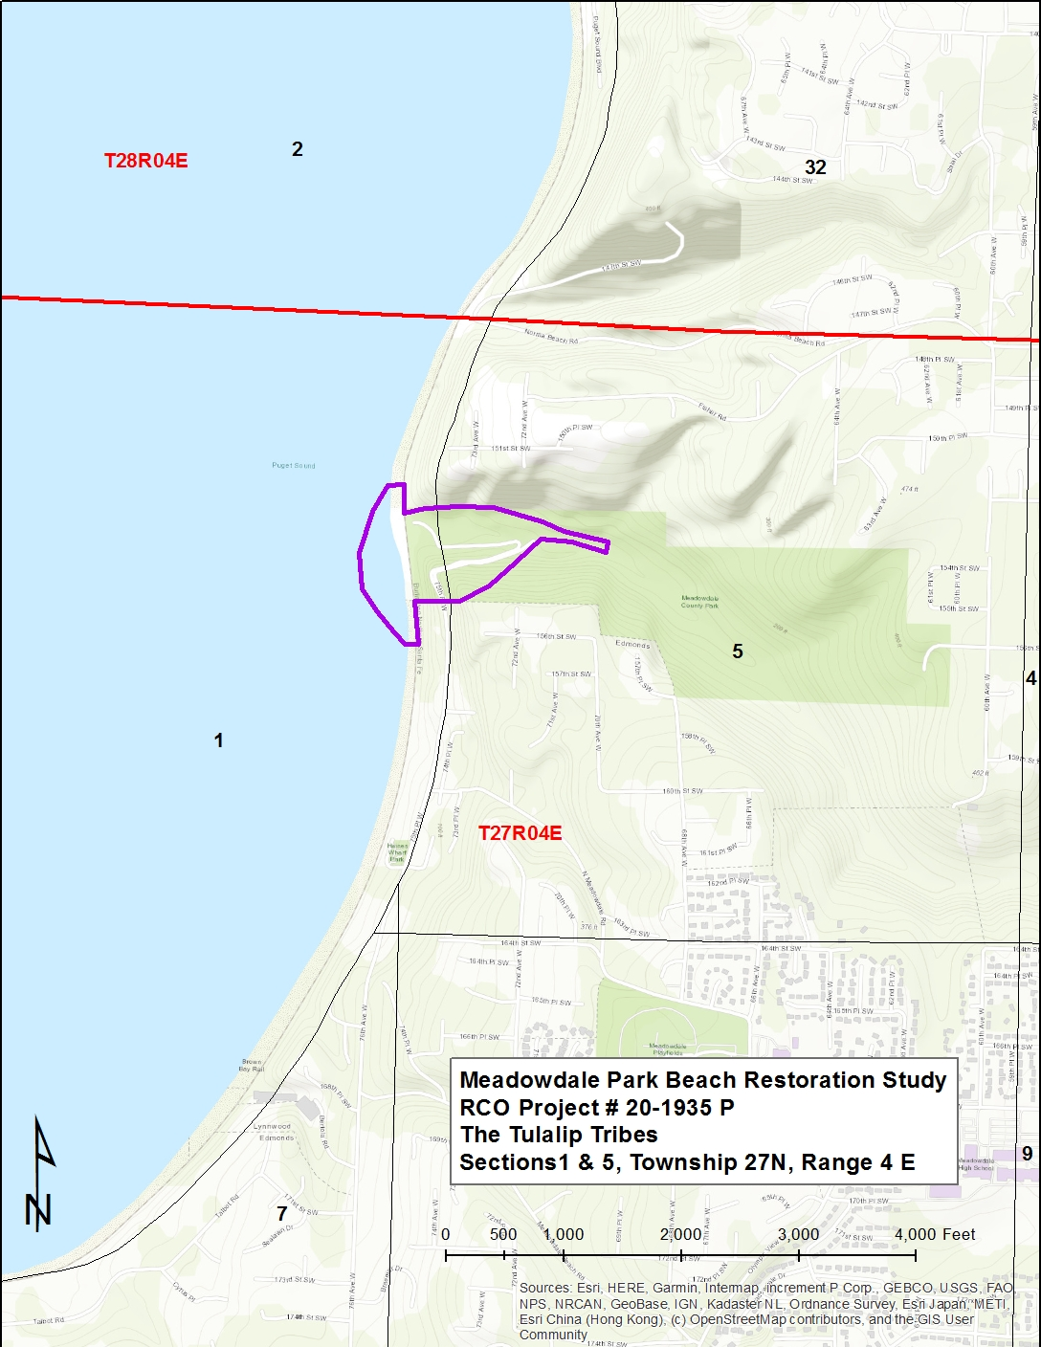

# References:

Beamer, E., A. McBride, R. Henderson and K, Wolf. 2003. The Importance of Non-Natal Pocket Estuaries in Skagit Bay to Wild Chinook Salmon: An Emerging Priority for Restoration. Skagit System Cooperative Research Department, La Conner, WA. http://www.cob.org/documents/pw/environment/restoration/pocket-estuary-report-beamer.pdf. Accessed March 27, 2013.

Beamer, E.M., A. McBride, R. Henderson, J. Griffith, K. Fresh, T. Zackey, R. Barsh, T. Wyllie-Echeverria, and K. Wolf. 2006. Habitat and fish use of pocket estuaries in the Whidbey Basin and North Skagit County bays, 2004 and 2005. Skagit River System Cooperative, La Conner, Washington.

Beamer, E.M., W.T. Zackey, D. Marks, D. Teel, D. Kuligowski, and R. Henderson. 2013. Juvenile Chinook salmon rearing in small non-natal streams draining into the Whidbey Basin. Skagit River System Cooperative, La Conner, Washington, December 3, 2013.

Booth, Derek B. and P. C. Henshaw. 2000. Rates of Channel Erosion in Small Urban Streams, Center for Urban Water Resources Management, Department of Civil Engineering, University of Washington. Seattle, Washington.

Gelfenbaum, G., Stevens, A.W., Miller, I.M., Warrick, J.A., Ogston, A.S., and Eidam, E. 2015. Large-scale dam removal on the Elwha River, Washington, USA: Coastal geomorphic change. Geomorphology (246) 649-668

McBride, A., K. Wolf, and E. Beamer. 2006. Skagit Bay Nearshore Habitat Mapping. Skagit River System Cooperative, La Conner, Washington.

Miller, I.M., and Warrick, J.A. 2012. Measuring Sediment Transport and Bed Disturbance with tracers on a Mixed Beach. Marine Geology 299-302, 1-7.

Warrick, J.A., Stevens, A.W., Miller, I.M., Harrison, S.R., Ritchie, A.C. and G. Gelfenbaum. 2019. World’s largest dam removal reverses coastal erosion. Scientific Reports, 9: 13968

1. Prism Project Numbers – 15-1056, 18-1259, 18-1504, 18-1505, 18-1507, & 18-1587