**PRISM contract/ project # 14-2229**

**INTERIM PROGRESS REPORT ADDENDUM FOR PSMFC July 31, 2015**

**Snake River region – Asotin Intensively Monitored Watershed (IMW) funded from PSMFC and supporting EcoLogical Research, Inc., in their ongoing monitoring program**

This project is a continuation of the Asotin Creek multi-year Intensively Monitored Watershed (IMW) monitoring project, focusing on three tributaries to the Asotin Creek in Southeast Washington, in the Snake River Salmon Recovery Region. The tributaries are: Charley Creek, North Fork Asotin Creek, and South Fork Asotin Creek. The purpose of the project is to link salmon and steelhead responses to specific mechanisms related to habitat restoration. The fundamental approach is to treat restoration as an experiment and concentrate a large restoration effort in order to increase the likelihood of detecting a population increase. This type of project will increase understanding of what restoration activities are most effective, demonstrate how changes in habitat influence survival of various life stages of salmon and steelhead, determine what magnitude of restoration is required to cause a significant population response, and ultimately provide information to better evaluate the efficacy of habitat restoration. The restoration effort is focused on summer run steelhead habitat. The funds for this grant award will focus on continuing the IMW effort in the Asotin. This phase of the contract included:

1) Continue baseline monitoring of 12 permanent sites for fish abundance and habitat condition;

2) Implement restoration treatment plan based on approval of the plan by the Regional Technical Team;

3) Monitoring a wide variety of response variables.

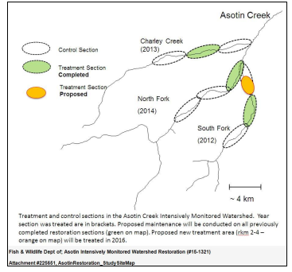

The current portion of this project continues through September 30, 2015. Anticipated support from PSMFC (as amendment to the existing RCO agreement) will result in a new monitoring contract with EcoLogical Research, Inc. (PRISM # 15-1443) commencing October 1 2015- September 30 2016.

It should be noted the Lower Columbia Salmon Recovery Region is supported by PSMFC, as well as the SRFB, in the Abernathy IMW complex. The SRFB also provides monitoring support for the Straits, Hood Canal and Skagit IMWs through Pacific Coast Salmon Recovery Fund support. (The Lower Columbia progress report for the current project, and scope and work plan for anticipated funds was forwarded).

Since the last progress report to PSMFC, a number of developments have taken place with relevance to this project in addition to the ongoing monitoring as approved in the work plan. In an earlier submission today you have been forwarded the contractor’s report. In addition, the Snake River Salmon Recovery region requested the Salmon Recovery Funding Board (SRFB) in late 2014, to consider funding monitoring of the Asotin IMW, as part of other SRFB monitoring efforts in western Washington.

The Salmon Recovery Funding Board approved in February 2015 to allow the WA salmon recovery regions to submit regional –based monitoring proposals. These projects had to address regional monitoring data gaps, be supported and certified by the local region, and be allowed up to 10% of the overall regional allocation. Other program criteria has also been established in this first year.

The Recreation and Conservation Office “entertained” the request by the Snake Region on behalf of the Asotin IMW to consider ‘eligibility’ of the Asotin IMW for monitoring support. At this time there are anticipated monitoring projects in the queue for review and determination by the SRFB Monitoring Panel for eligibility, and the subsequent awarding of monitoring contracts scheduled for the December 2015 SRFB meeting in Olympia. The Asotin IMW monitoring proposal is among them. Such monitoring support would leverage the PSMFC support. In addition, during a number of presentations of IMWs to the SRFB, a common theme has been the lack of restoration projects being implemented in the IMWs. This is partially due to the local lead entity process of prioritization of projects addressing limiting factors of local listed ESA salmon stocks, does not necessarily result in IMW treatments in those specific IMW basins. The SRFB decided in early 2014 to provide up to $2 million / year available for three years specifically supporting competitively submitted IMW restoration treatments. This year (2015) is the second of three years for such treatment support.

A SRFB Monitoring Panel was convened 13 months ago following an objective assessment of monitoring efforts. This assessment was performed and presented by Stillwater Sciences. A number of the processes in place now (i.e. monitoring panel development, regional monitoring eligibility, IMW treatment support, establishment of an adaptive management structure et.al.) all come from this report (URL) This monitoring panel is evaluating all monitoring efforts and have reviewed all SRFB-funded IMW study plans in Washington state, including the Asotin.

The Salmon Recovery Funding Board Monitoring Panel is scheduled to submit their reviews and comments of updated IMW study plans (including Asotin), the status and trends program performed by Washington Department of Fish and Wildlife (referred to as fish-in/fish-out) , as well as reach-scale project effectiveness monitoring performed by TetraTech, Inc. and bring recommendations to the SRFB in October 2015. Its other charges include reviewing, ranking and assisting in the prioritization of IMW treatments and monitoring proposals (including the Asotin IMW) for the SRFB consideration at their December 2015 meeting in Olympia.

Below is a “snip” of the Asotin progress report in PRISM for #14-2229 (can be viewed a s read-only)

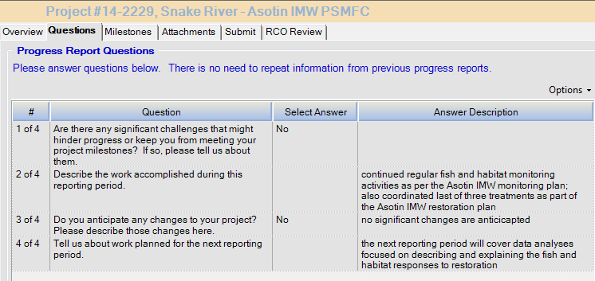

A PRISM “snapshot” of the Asotin project’s current contract can be viewed at:

<https://secure.rco.wa.gov/prism/search/projectsnapshot.aspx?ProjectNumber=14-2229>

Thank you for your attention and consideration in this interim report for the Asotin IMW.

***Keith Dublanica***

Science Coordinator

Governor's Salmon Recovery Office

(360) 902-2242

