Appendix A – Site photographs

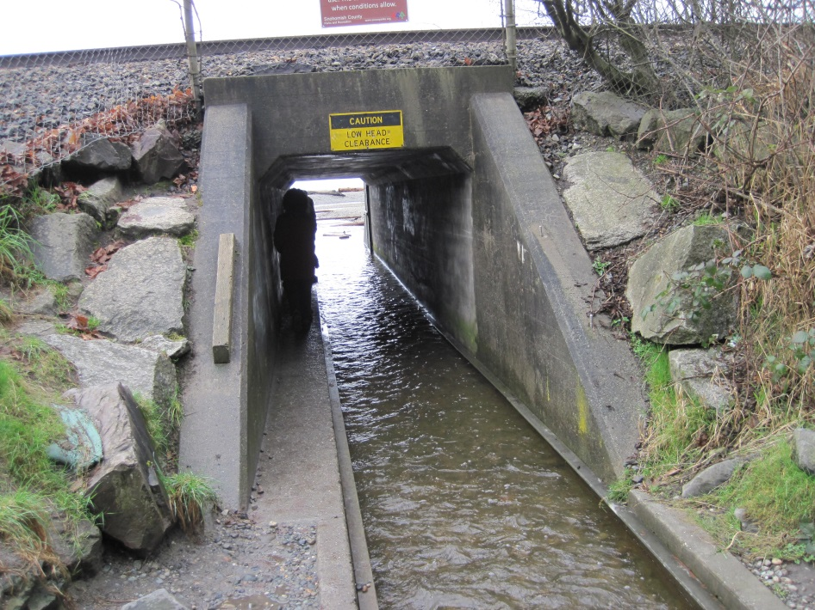

Photo 1 – Looking downstream through box culvert. Creek flows through concrete channel and park visitors access beach using narrow ledge next to creek

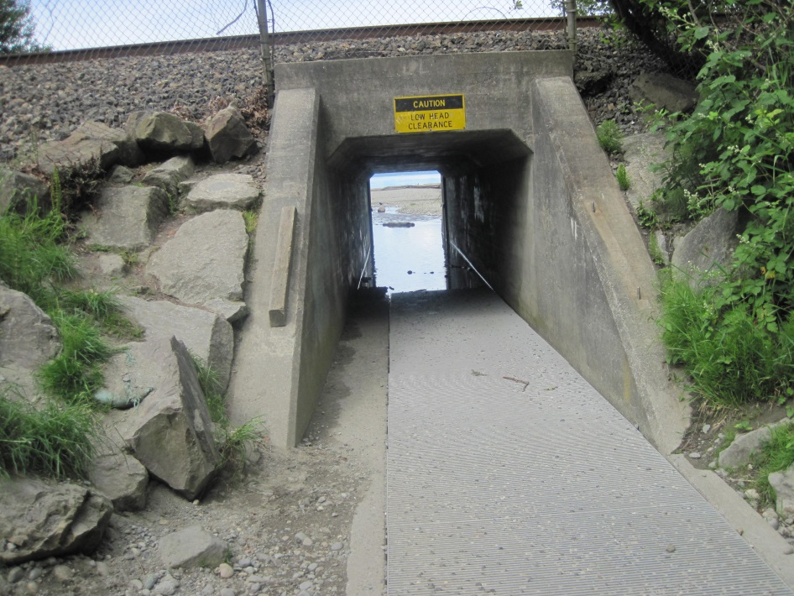

Photo 2 – Looking downstream through box culvert during summer when grates are placed over creek to provide wider walkway for park users. Downstream portion of grates is inundated

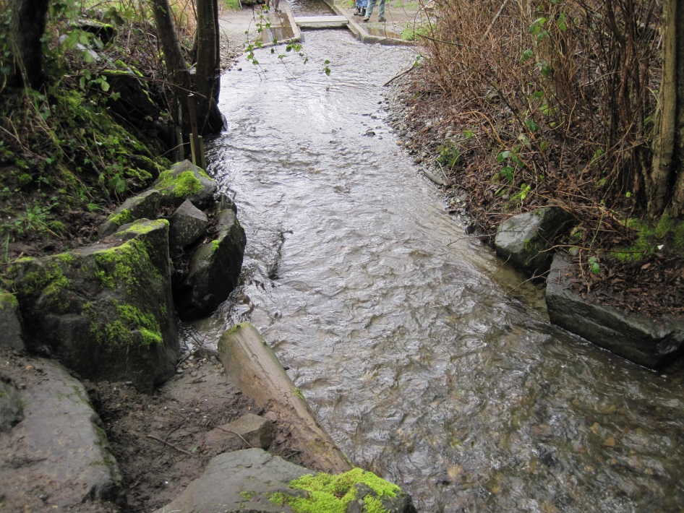

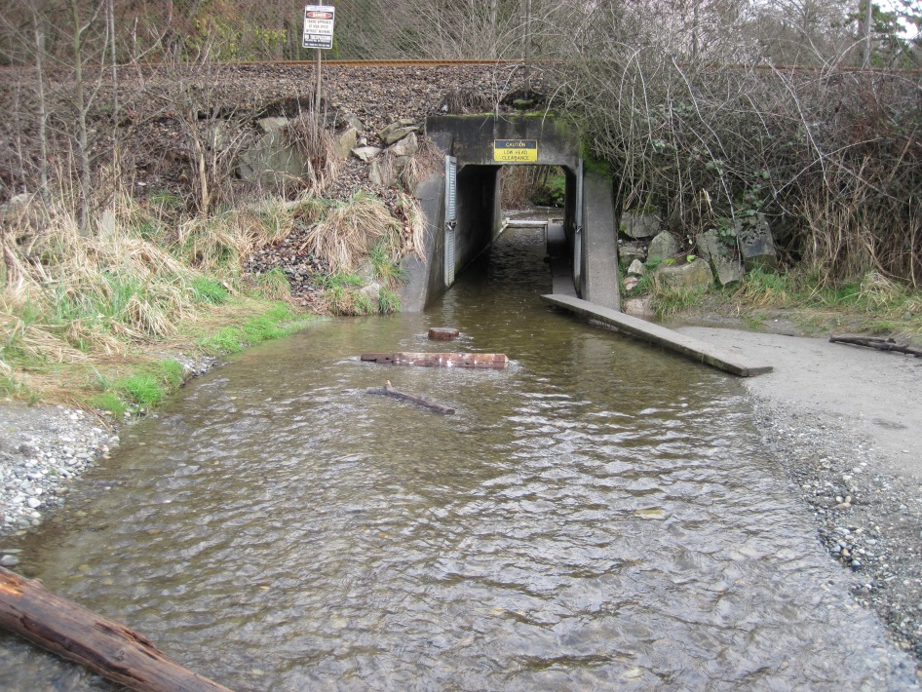Photo 3 – View of lower creek and concrete channel at upstream end of box culvert. Note the narrowing of creek as it is funneled into concrete channel.

Photo 4 – Looking upstream through culvert. Note that the creek more than doubles in width downstream of the culvert.

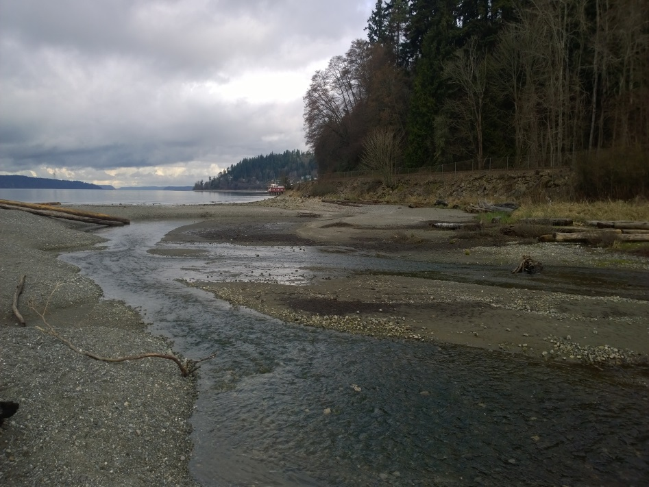

Photo 5 – Channel network in pocket estuary habitat waterward of the railroad crossing. b

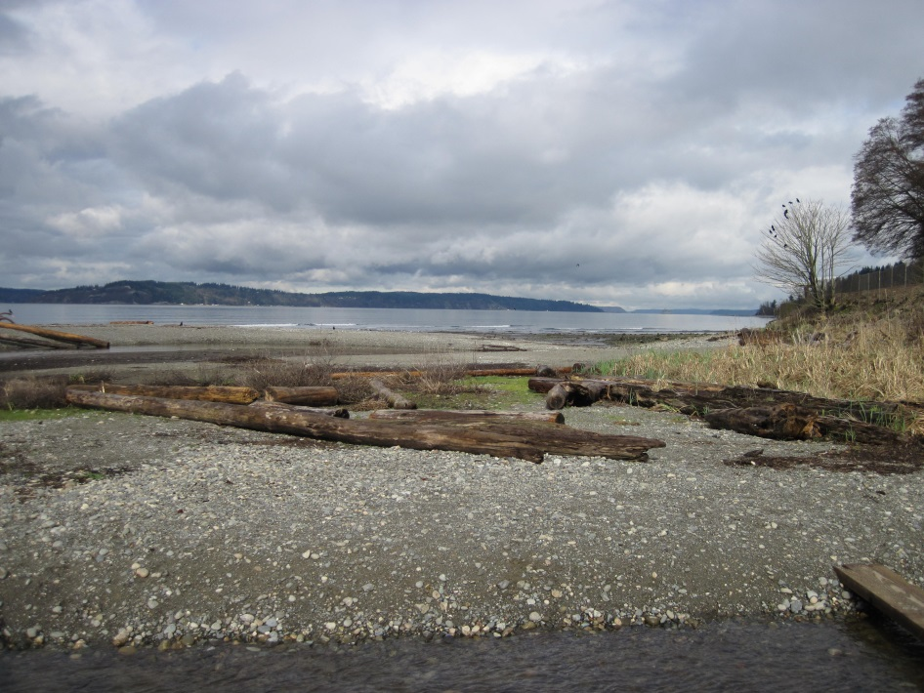

Photo 6 – Log accumulation, marsh vegetation and trees on delta waterward fo the railroad crossing.

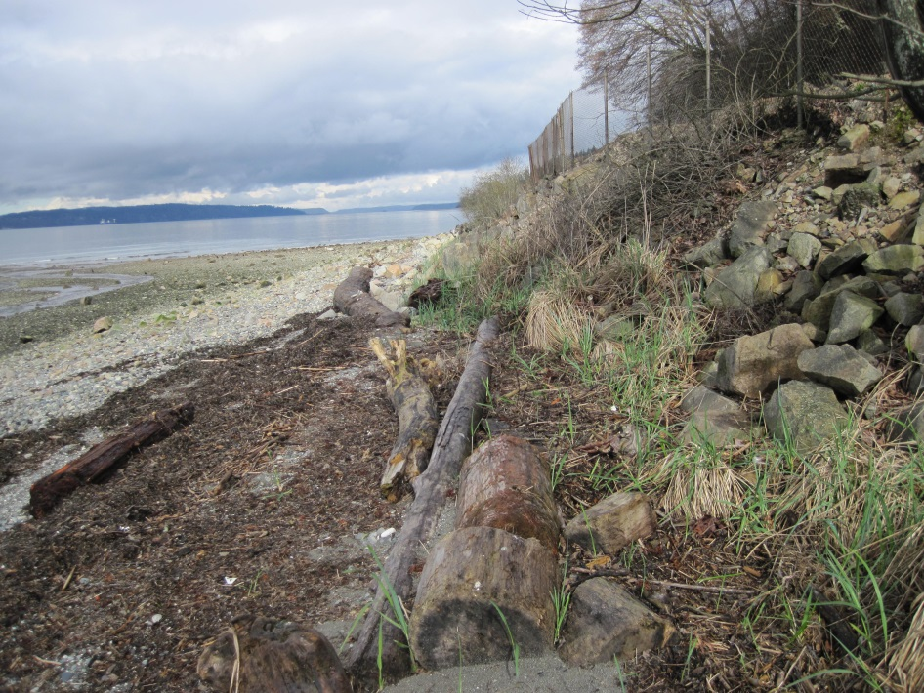

Photo 7 – Narrow fringe of vegetation in approximate location of new creek outlet proposed in Alternative 2.

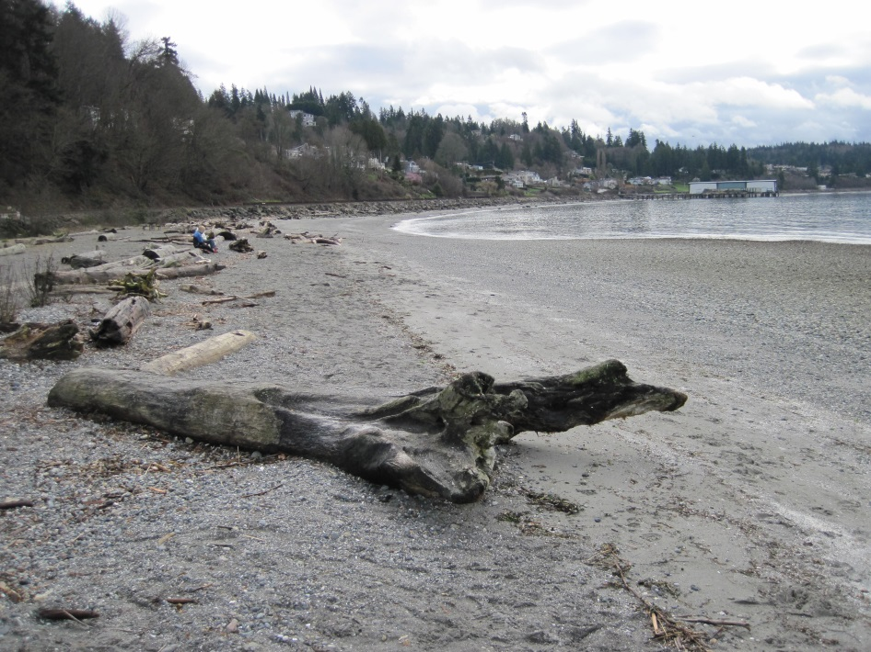

Photo 8 – View of delta looking south.

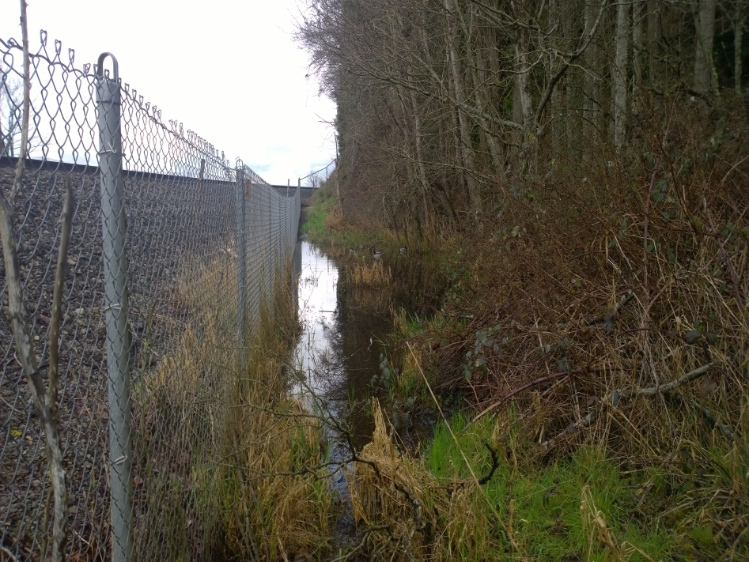

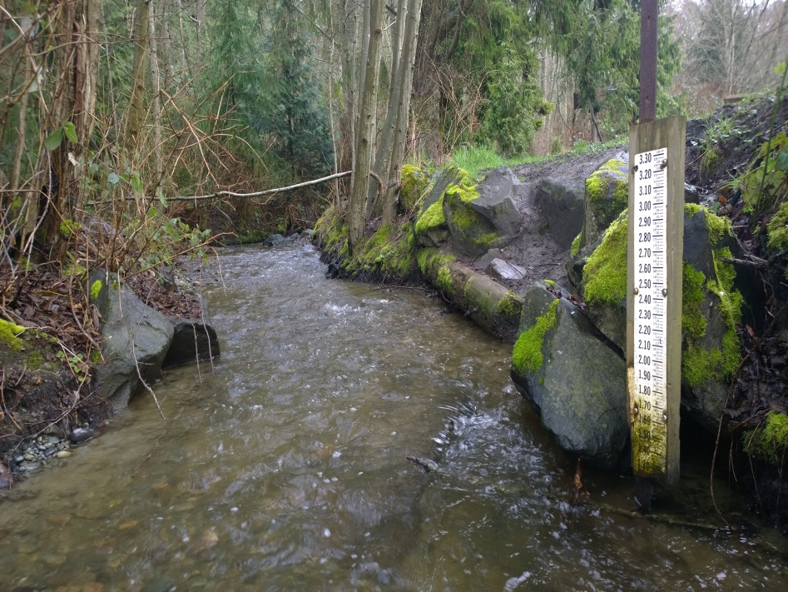Photo 9 – Small freshwater wetland adjacent to upstream side of railroad embankment. b

Photo 10 – Habitat in lowermost portion of Lund’s Gulch Creek. Rock and log bank armoring confine the width of the creek.

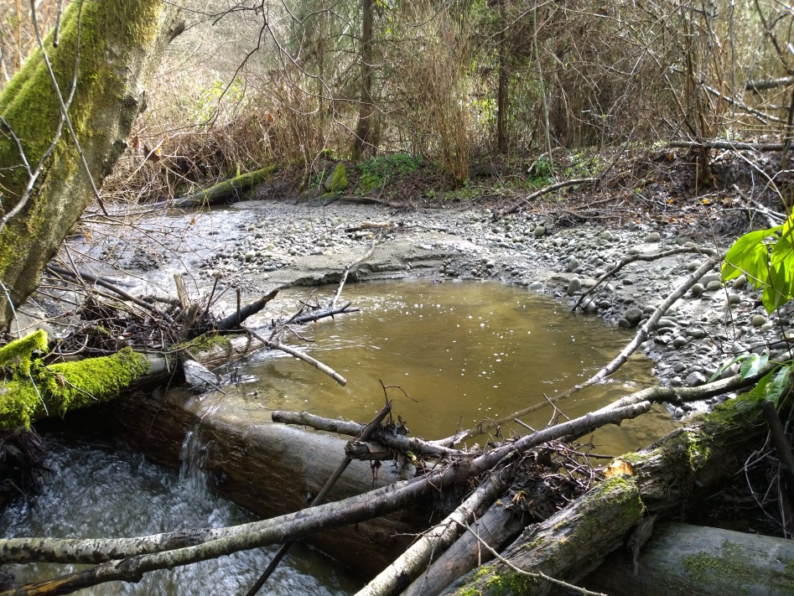

Photo 11 – Typical instream wood structure constructed to provide habitat. Structure forms a pool, but creek flows go over and under the wood to cause possible fish passage restrictions in certain flows.

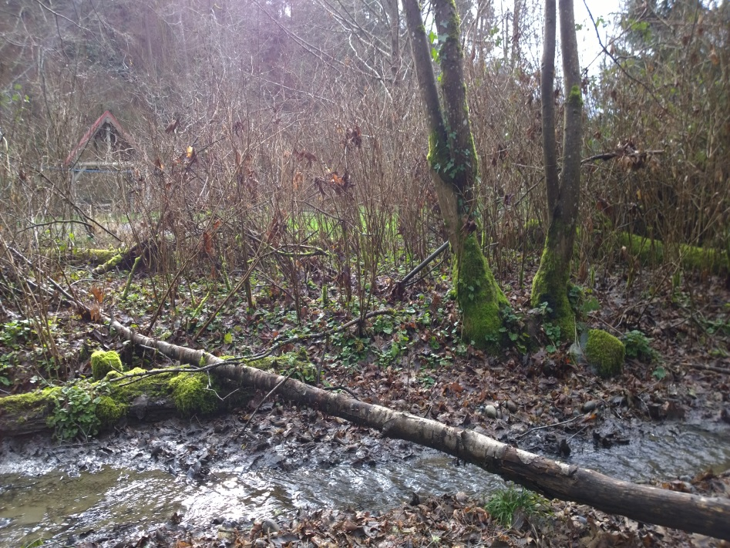

Photo 12 – Part of creek where water overtops the bank to flood lower park areas during storms. Also note narrow riparian corridor and lack of conifers.

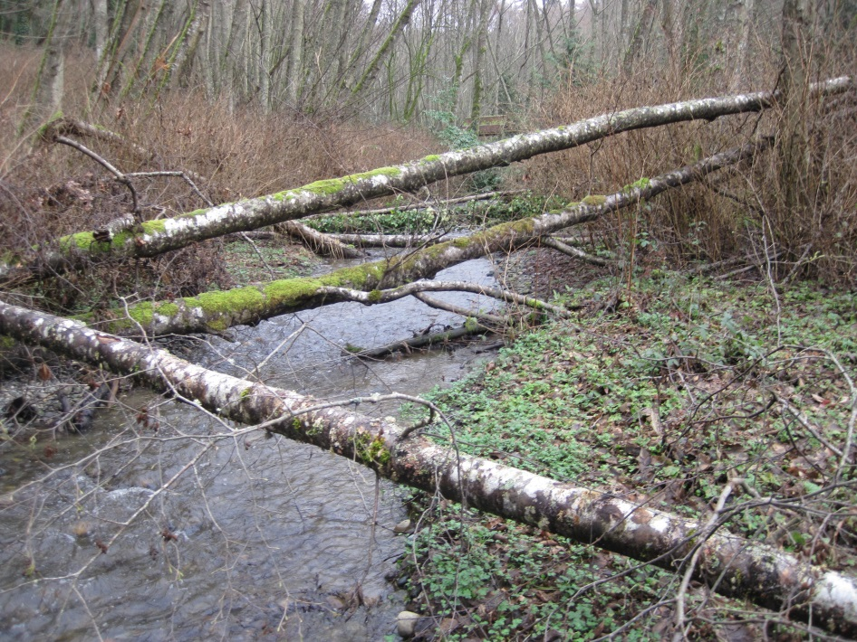

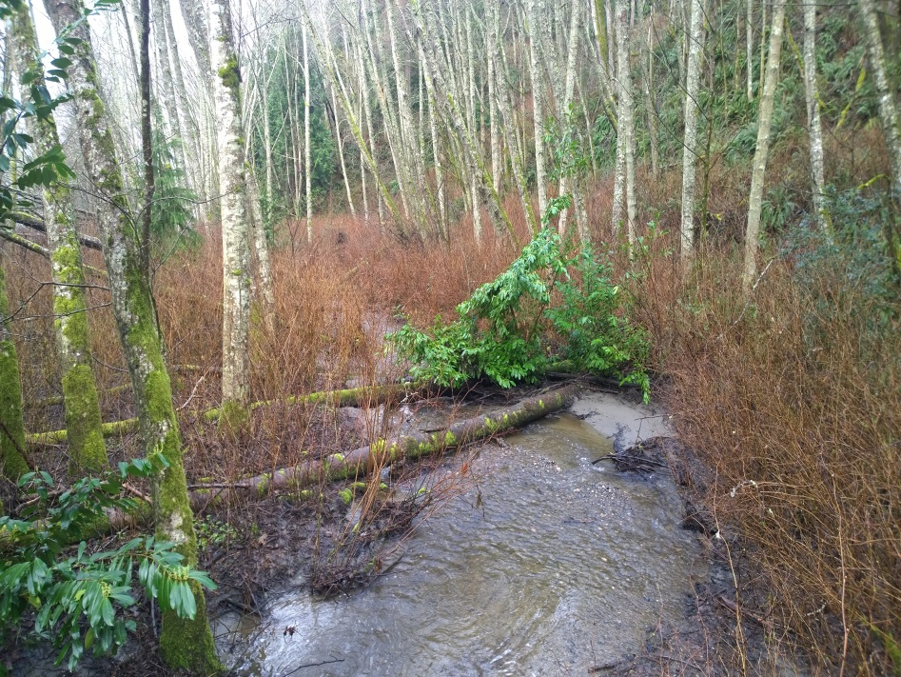Photo 13 – Typical habitat conditions in upper portion of project area. b

Photo 14 – Looking downstream at uppermost part of project area near Park Ranger’s House. Proposed restoration in this area is limited to riparian enhancement and improvements to instream wood structures that were previously installed.