CDLT will contract with the Cascade Columbia Fisheries Enhancement Group to design, create and install a signage kiosk at the site. The objectives for the signage kiosk are (1) to educate the public about the fish of the Icicle Creek; (2) to inform the public about the importance of protecting the habitat and how human use can affect the habitat; and (3) provide a locked bulletin board for the future property owner, the Washington Department of Fish & Wildlife, to post rules and periodic announcements. The project will also include funding acknowledgment and all project partners.

The kiosk will be similar to the one completed in 2012 at the Tall Timber Ranch on the White River (see photo below). The content of the signs will be similar, but with more emphasis on the human/habitat mix that is more prevalent at the Icicle Creek site. Plants may be included and installed with volunteer labor.

|  |  |  |
| --- | --- | --- |
| **Cost Estimate for Icicle River (Fromm Property) Signs** | | |
|  |  |  |
| Item | Description/Unit | Cost |
|  |  |  |
| Kiosk | similar to TT kisok (dimensions TBD) - includes materials and labor | $2,000 |
| Sign mounts | 2 powder coated sign mounts | $1,000 |
| Bullettin Board | Locking plexiglass and alluminum bulleting board (fishing regs, etc.) | $750 |
| Interp Signs | 2 interpretive signs (Icicle Overview, Salmon Lifecycle) 2'X3' | $700 |
| Graphic Designer | Layout, design, art, content | $3,000 |
| CCFEG | Project management (50 hrs @ $49) | $2,450 |
| Plants | 100 @ $4.50 native plants | $450 |
|  |  |  |
|  | **Total:** | **$10,350** |

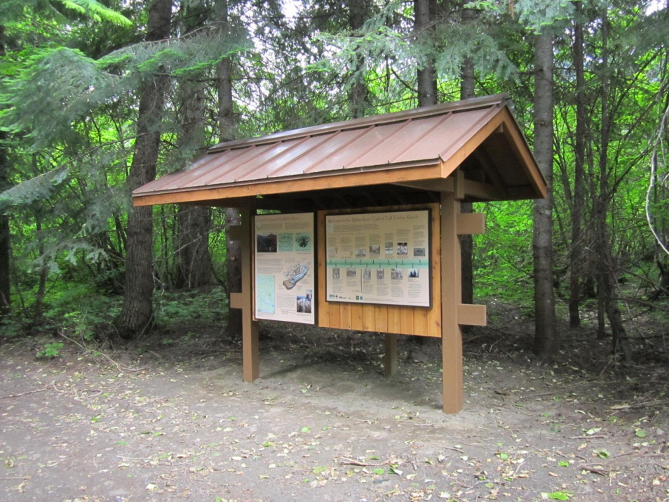

**Tall Timber Ranch Kiosk**