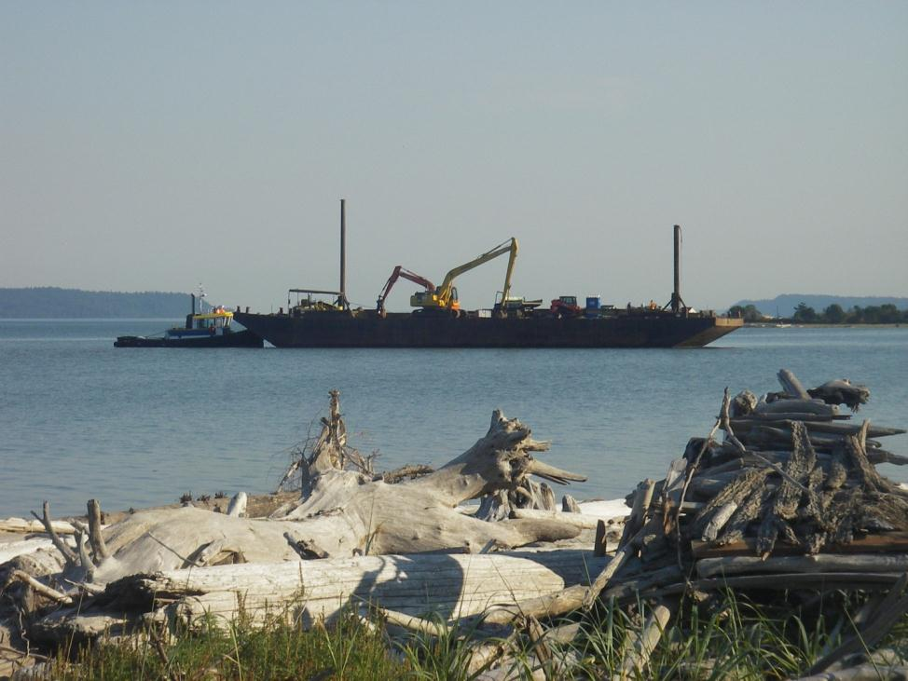

**Figure 1**. A barge carrying equipment to complete the Livingston Bay Pocket Estuary project arrives at the project site on September 17, 2012.

**South Levee Breach Repair**

**North Levee  
Modification**

**Tidal Channel Excavation**

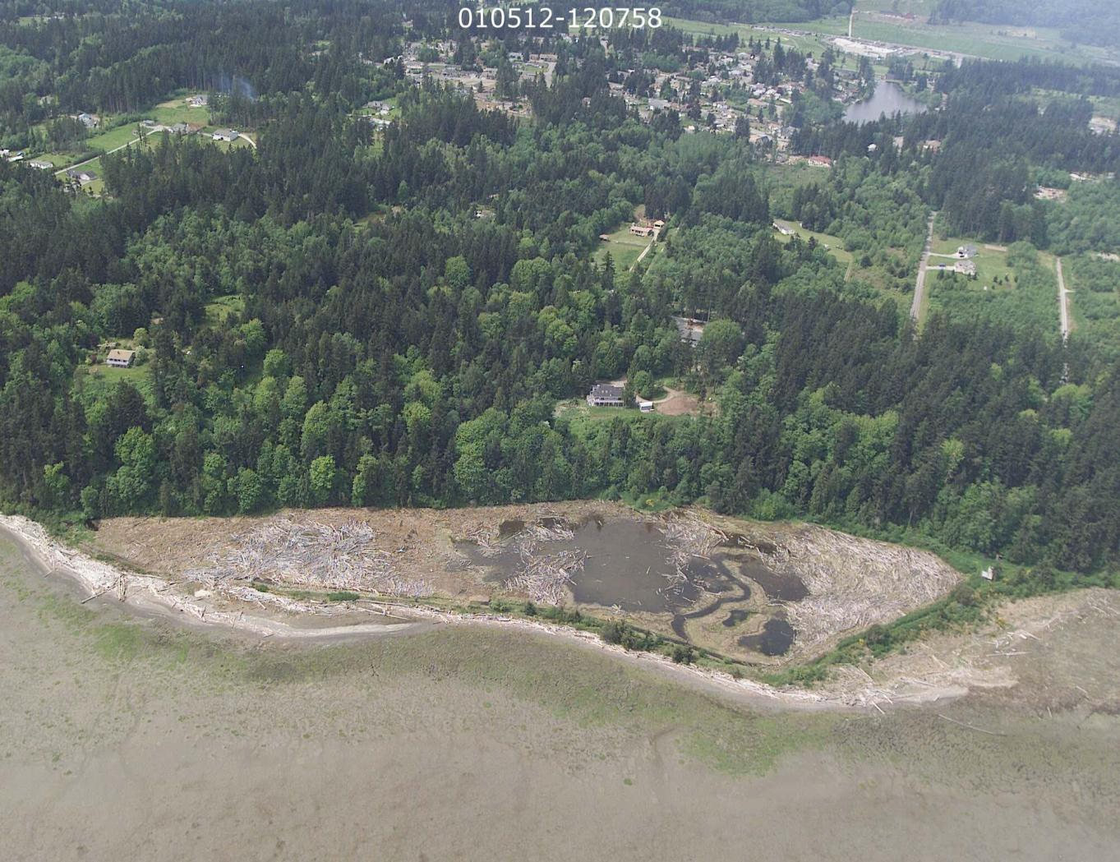

**North Levee Breach Area**

**Levee Crest Lowering**

**Tidal Channel excavation to connect to bay**

**Mobile home and shed demo**

**South Breach Repair to create natural beach berm**

**Wood relocation**

**Figure 2.** Conceptual design of restoration efforts (not to scale) showing various project elements.

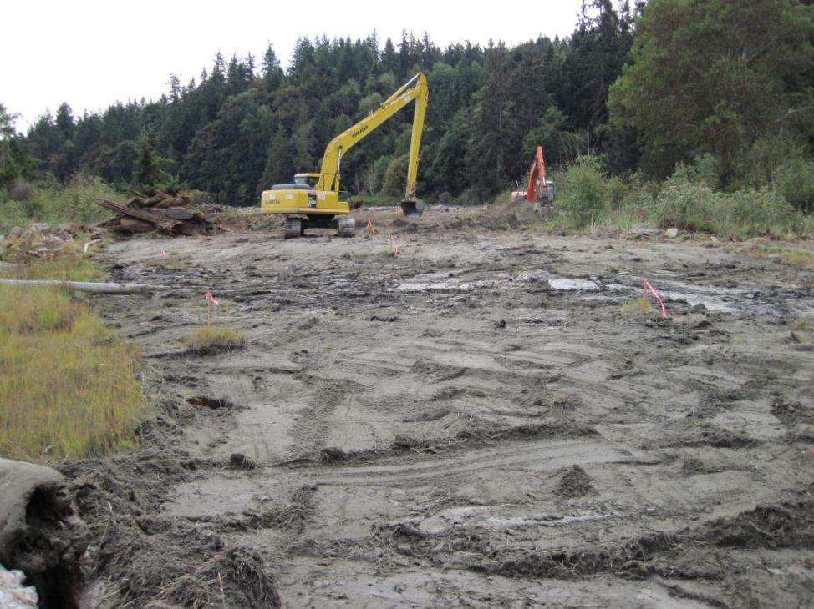

**Figure 3.** Photo shows clearing footprint for Tidal Channel Excavation and North Levee Breach. Photo is taken to the north of the pocket estuary along the new tidal channel footprint. The orange excavator is working on top of the levee at the location of the eventual North Levee Breach.

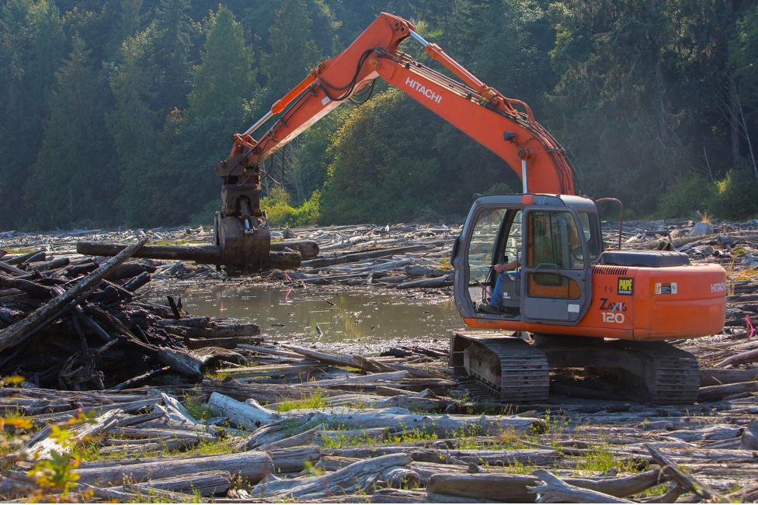

**Figure 4.** An excavator works inside the pocket estuary prior to breaching the north levee to relocate wood near the North Levee Breach and to aid the natural formation of channels inside the pocket estuary after restoration.

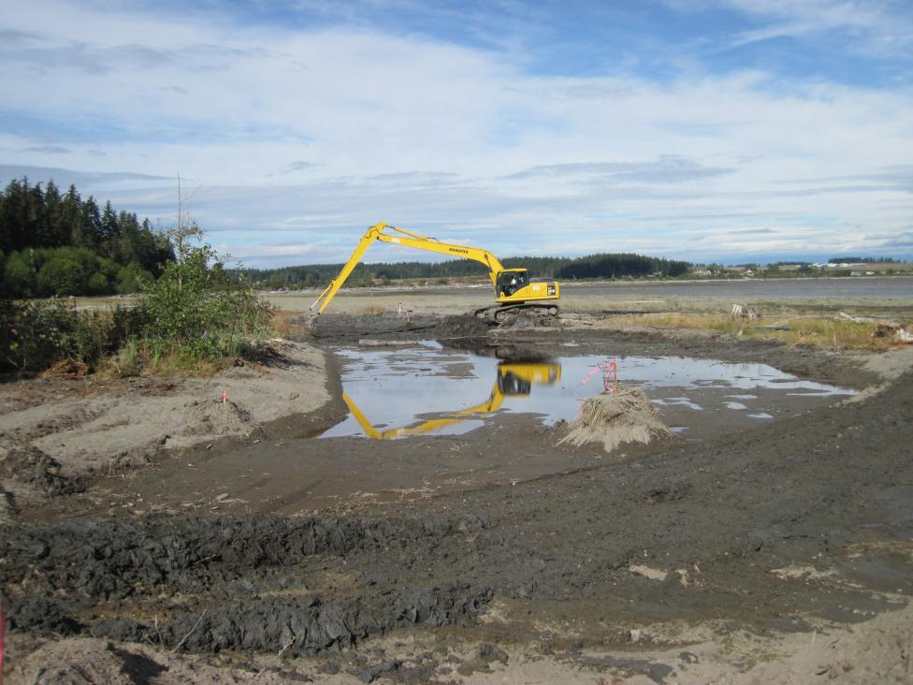

**Figure 5.** An excavator works to dig and shape the new tidal channel. Photo is taken from north levee at location that was eventually breached. Tidal channel was dug prior to North Levee Breach and excavation was done while tide was out.

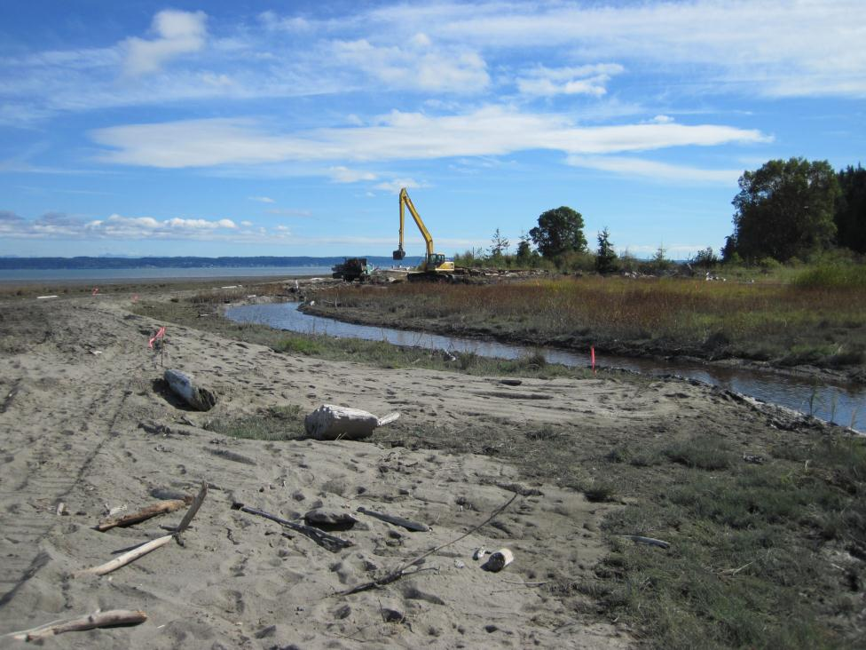

**Figure 6.** The new tidal channel can be seen as Tidal Channel Excavation work wraps up prior to North Levee Breach work. Photo taken from sand spit north of the pocket estuary.

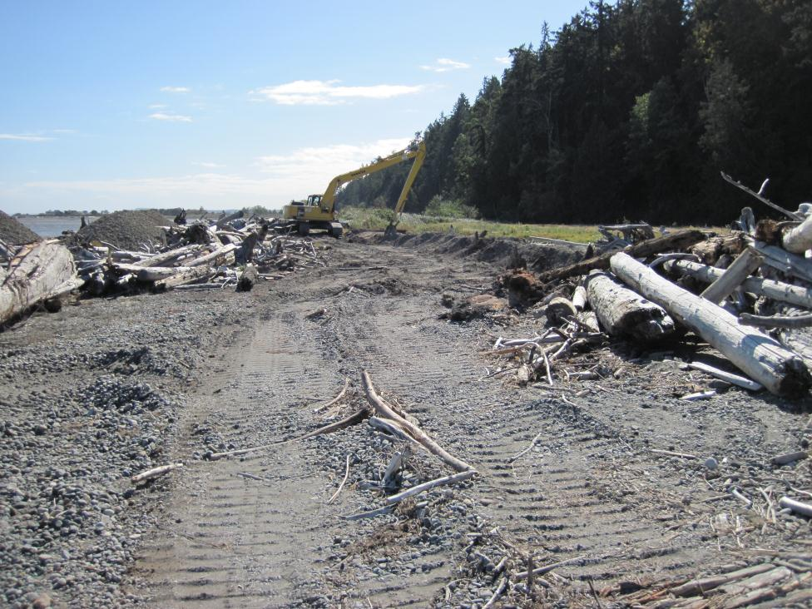

**Figure 7.** Photo shows area where South Breach Repair area has been cleared and fill material from Tidal Channel Excavation and North Levee Breach has been placed and is being shaped by excavator. Piles of imported rock material can be seen in the left portion of the photo. This rock was brought in by barge and matched with the size of existing rock on the beach.

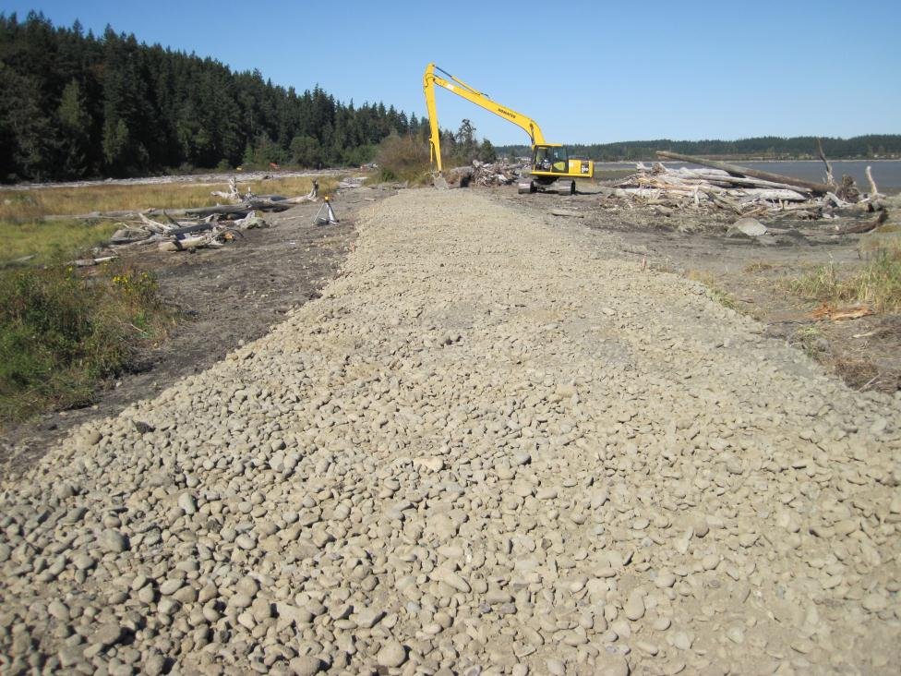

**Figure 8.** Photo shows work being completed at South Breach Repair area. Imported rock was placed on top and front slope of new berm/levee. Driftwood that had been cleared from the area was placed back at the front toe of the berm for a natural look and to offer protection to the berm.

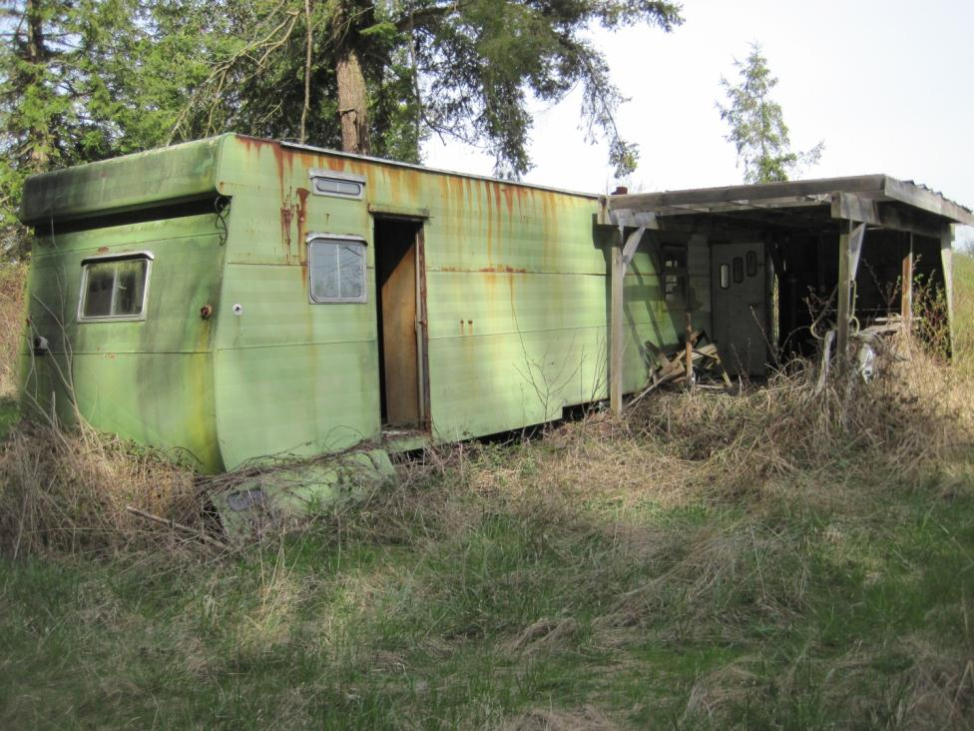

**Figure 9.** Photo shows mobile home that was demolished and removed from the site along with a wood shed and old pickup truck.

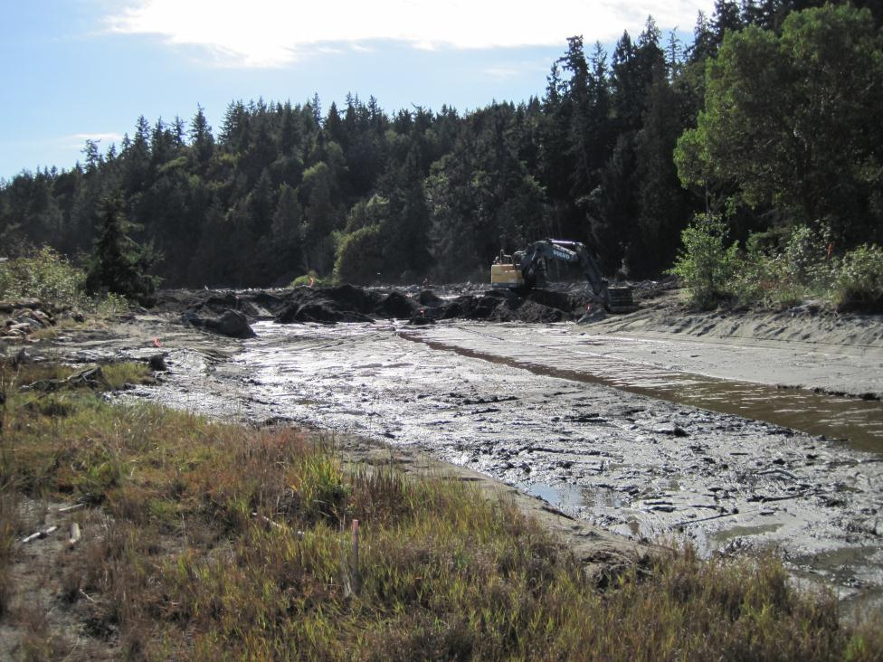

**Figure 10.** Photo shows excavator working to remove levee for the North Levee Breach work. Fill material was used for South Breach Repair but mostly placed at the upland area where mobile home and shed were removed.

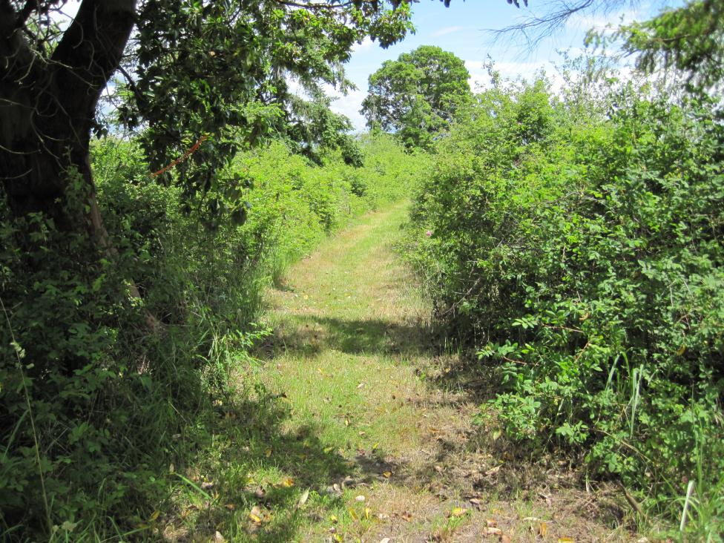

**Figure 11.** Photos shows North Levee Breach area in June 2012 prior to construction beginning. Note the Madrona tree in the distance on the north levee.

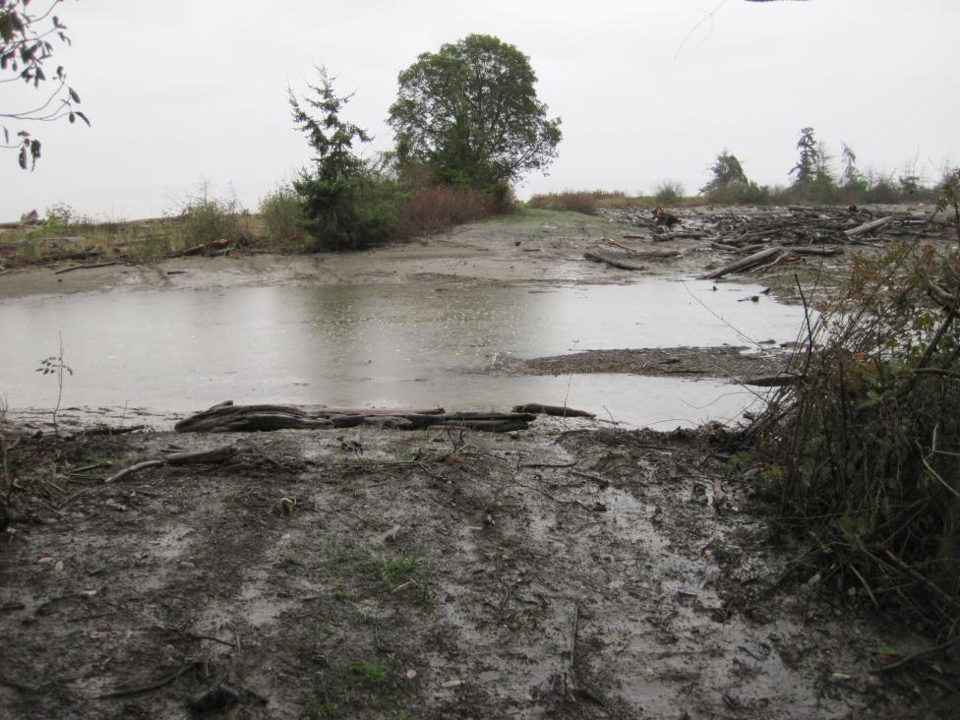

**Figure 12.** Photo taken at some location as Figure 11 photo and Madrona tree can be seen in distance. Photo was taken in December 2012.

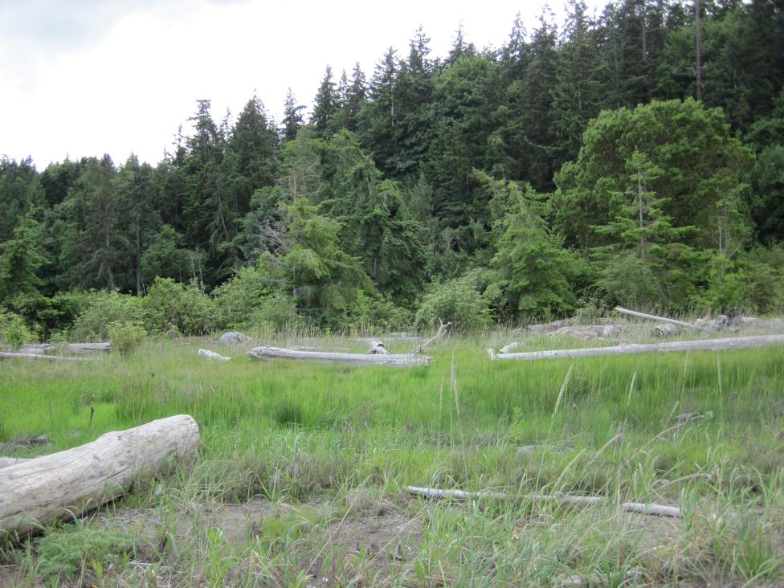

**Figure 13.** Photo taken of the North Levee Breach area. Photo is taken from the sand spit to the north of the pocket estuary. Note the tall Madrona tree in the right portion of the photo. Madrona trees stand on each side of the North Levee Breach area.

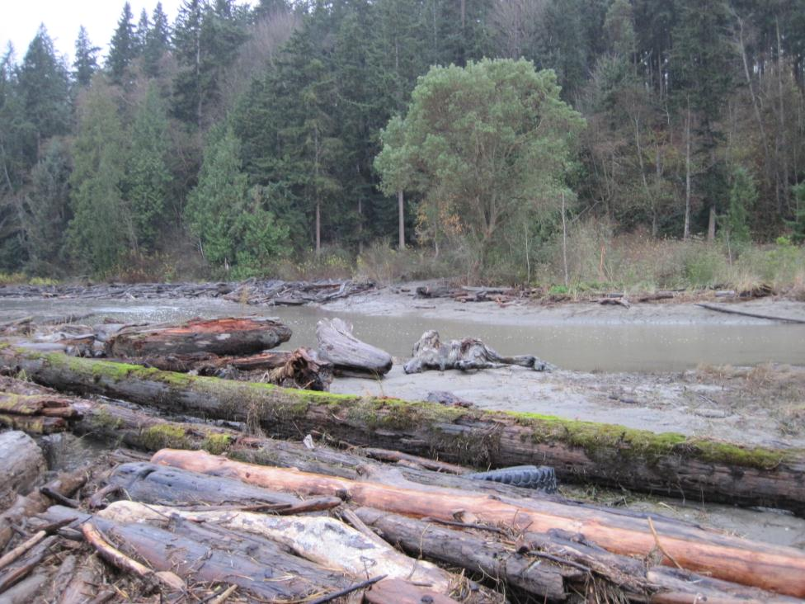

**Figure 14.** Photo is taken from the same point as photo in Figure 13. New tidal channel and North Levee Breach can be seen as well as the Madrona on the west side of the levee breach.

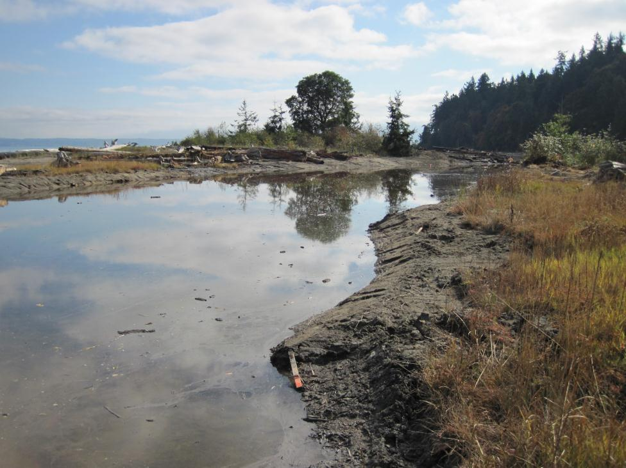

**Figure 15.** Photo taken along new tidal channel looking south towards the pocket estuary. This was one of the first higher tides to fill the channel and enter the pocket estuary after the North Levee Breach.

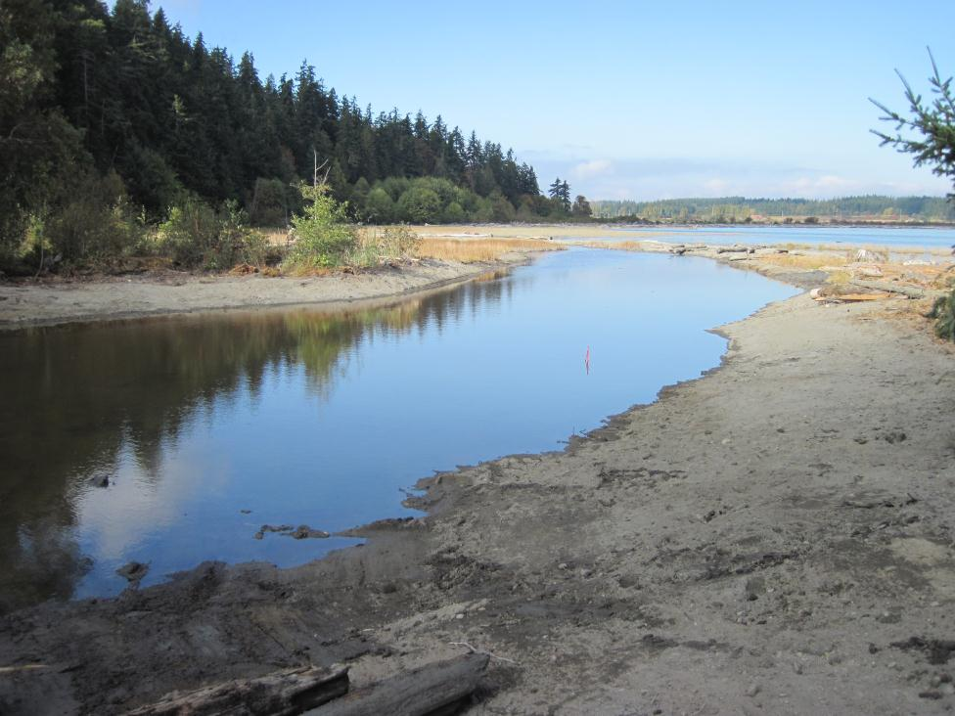

**Figure 16.** New tidal channel filled by an incoming tide. Photo taken from east edge of North Levee Breach. Compare with photo in Figure 5 that shows early excavation of channel.

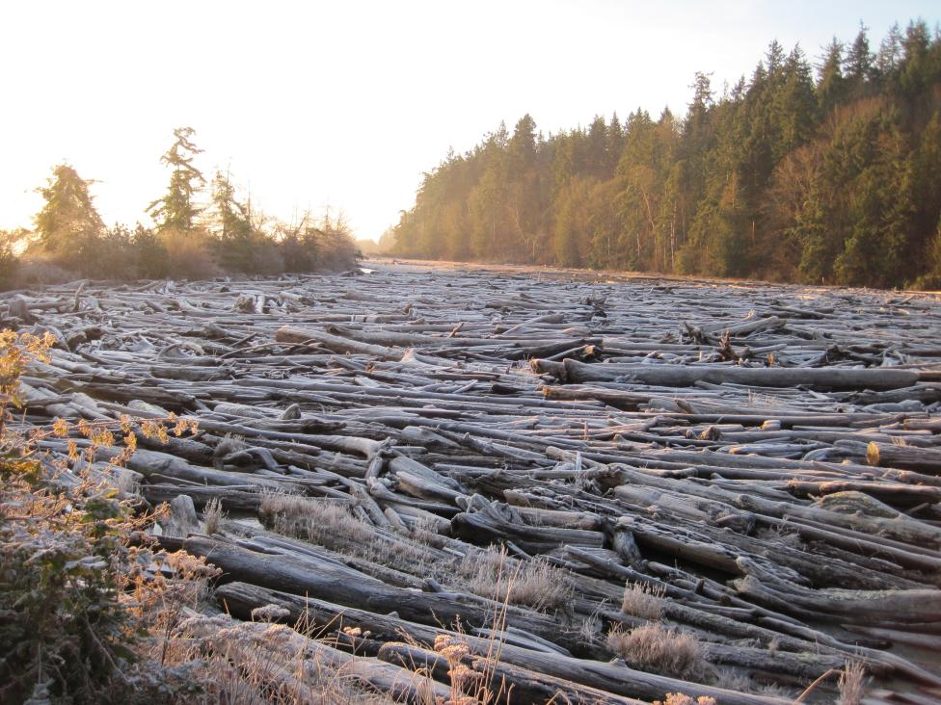

**Figure 17.** This photo was taken of the interior of the pocket estuary in January 2012 during a high tide event prior to project construction. Note the trees on the east levee in the left portion of the photo and note the general absence of water in the pocket estuary.

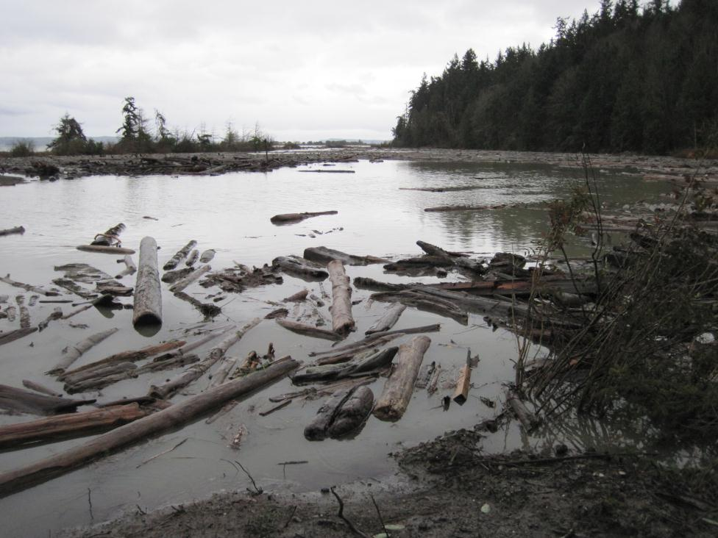

**Figure 18.** This photo shows the Livingston Bay Pocket Estuary in December 2012 during another high tide event, this time after project completion. The photo is not taken from exactly the same location as Figure 17 but you can note the same trees on the west levee in the left portion of the photo, marking the edge of the pocket estuary.