Baumann Bridge 2013 Monitoring Report

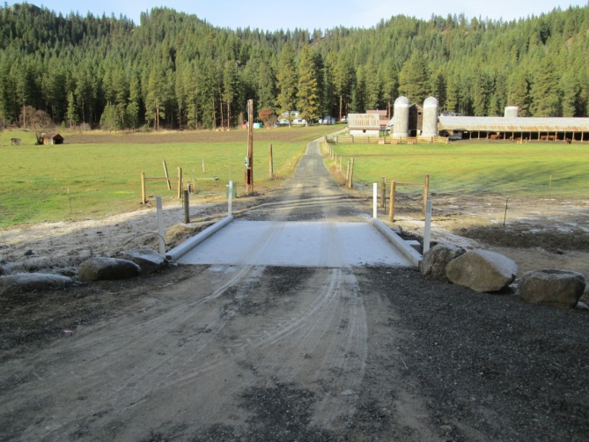

Prepared by: Chelan County Natural Resources Department

Adrienne Roumasset

**Introduction/Background**

The Baumann Barrier project removed a fish passage barrier on Chumstick Creek river mile 8.51 as part of the Chumstick Barrier Removal project – a multi-agency partnership that removed all 30 Chumstick Creek fish passage barriers between RM 0.28 to RM 8.6 (26 culvert barriers and 4 irrigation dams) from 2001-2013. The Baumann project was completed in 2012 and consisted of replacing a partial barrier culvert with a bridge, thus providing ESA listed salmonid species with complete access to upper reaches of Chumstick Creek.

Chumstick Creek is historical spawning and rearing habitat of steelhead, Bulltrout, and Coho salmon. The overall objective of the Chumstick Barrier Removal project was to reopen habitat and reinstate migration of these species into Chumstick Creek. The specific goals of the Baumann Barrier removal project is to 1)replace the culvert with a concrete bridge to provide salmonids with access to reaches above RM 8.51 2) re-vegetate the work area to provide a diverse riparian habitat. The goal of monitoring Baumann is to assess whether these goals are being met. Observations and data collected will be used to recommend adaptive management actions as needed to meet project objectives.

**Monitoring Methods**

CCNRD staff visited the site on May 29th 2013 and August 16th, 2013 and estimated flow to be approximately 25 cfs and 3 cfs (baseflow) respectively during the May and August visits. Exact flow is unknown due to malfunctions with the DOE gage. Specific monitoring goals during the site visits were to 1) Document channel and bridge condition 2) assess the status of riparian revegetation. Fish passage through the three pit tag arrays is also reported.

Channel and Bridge Monitoring

CCNRD staff established photo points post-construction in 2012. Pictures were taken at various locations on May 29th and at photo points on August 16th. However, the August photos were lost due to a camera malfunction so only post-construction 2012 and May 2013 photos are available. CCNRD staff documented bridge condition and any erosion or deposition issues during the June 5th visit.

Riparian Monitoring

CCNRD staff performed stem counts throughout the planted area on August 16th 2013. The planted area was divided into northwest, southwest, northeast, and southeast quadrants (NE, SW, NE, SE).Total plants from the stem count were divided by total plants installed in 2012 and 2013 (available in planting plan) to calculate plant survival. Percent native shrub cover of each quadrant was visually estimated and invasive species were documented.

Fish Passage

A pit tag array near the mouth of Chumstick creek at north road (RM 0.28) has monitored fish passage into the creek since 2011. Two additional arrays were installed in March of 2013 to monitor adult fish passage at Sunitch creek (RM 5.3) and Merry creek (RM 8.82). 2013 fish detections are reported here.

Channel and Bridge Monitoring

CCNRD staff observed no structural issues with the bridge, bank erosion or sediment deposition around the project (Figure 1 and 2). Aside from an increase in riparian cover (see next section) no notable changes from post-construction photos were observed (Figure 2).

Figure 1. Baumann Bridge photos

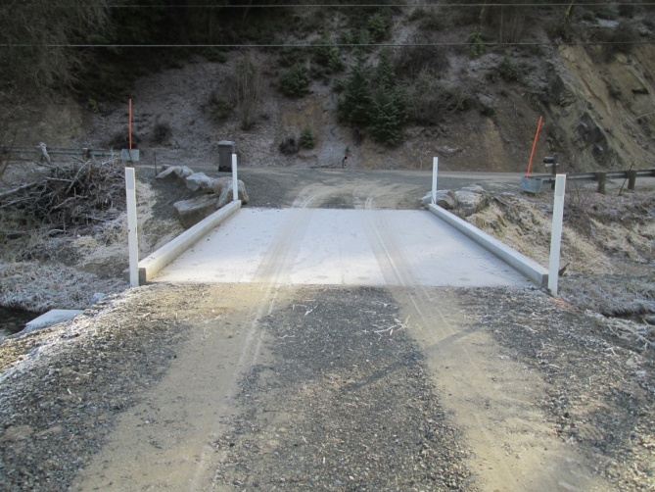 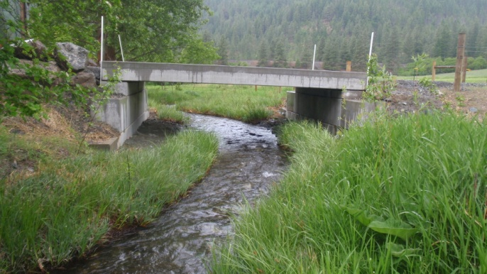

PP1, Post-construction 2012. PP2, May 29th 2013 issues

Figure 2. Channel photo points post-construction

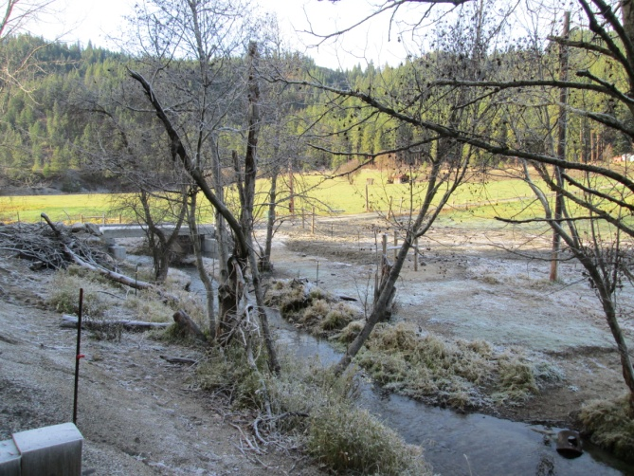 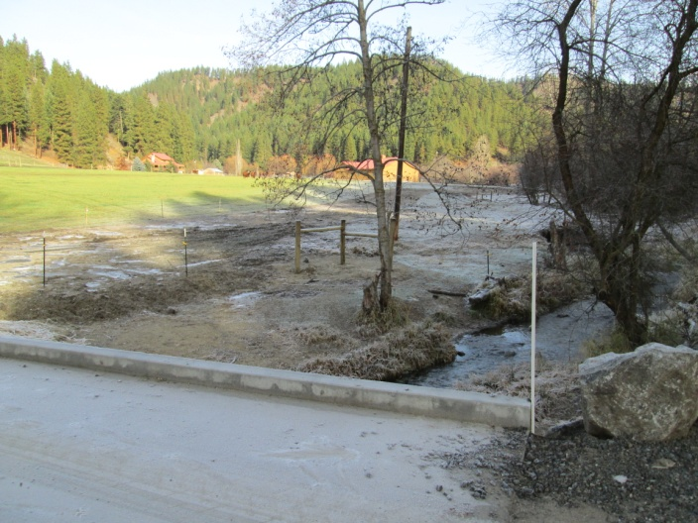

PP3 – no erosion or depositon issue upstream PP4 - no erosion or depositon issue downstream

Riparian Monitoring

Table 1. Results from stem count on August 16th. Calculated plant survival = 134/150 *100 = 89 percent

|  |  |  |  |  |  |  |
| --- | --- | --- | --- | --- | --- | --- |
| **species** | **NW quadrant** | **SW quadrant** | **NE quadrant** | **SE quadrant** | **Total plants present** | **Total plants installed** |
| *Willow stakes* | 11 | 44 | 5 | 14 | 74 | 80 |
| *SYMPHORICARPOS ALBUS*- common snowberry | 6 | 13 | 4 |  | 23 | 23 |
| *ROSA WOODSII*- Wood's rose | 3 | 8 |  | 4 | 15 | 15 |
| *CORNUS SERICEA*- red osier dogwood | 2 | 2 | 1 | 1 | 4 | 10 |
| *ALNUS INCANA spp. tenuifolia-* mountain alder |  | 6 |  | 2 | 8 | 8 |
| *CRATAEGUS DOUGLASII*-Douglas hawthorne |  | 10 |  |  | 10 | 15 |
| ***totals*** |  |  |  |  | 134 | 150 |
| *% shrub cover* | 10 | 20 | no data | 15 |  |  |
| *% grass cover* | 15 | 40 | no data | 20 |  |  |

Totals from the stem count from the August 2013 indicate a plant survival rate of 89 percent and shrub cover of 15 percent (Table 1). Willows that were planted too high on the bank accounted for most of the observed mortality. All plants were well established and shrub cover should increase with growth in subsequent years (Figure 3 and 4). Quadrant sedge cover ranged from 15-40 percent, with the NW and SW quadrants exhibiting 100 percent sedge cover near the water’s edge within the mat perimeter (Figure 5).

Figure 3. High plant survival in NW and NE quadrants

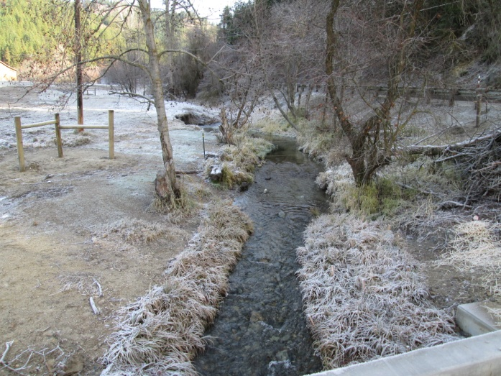 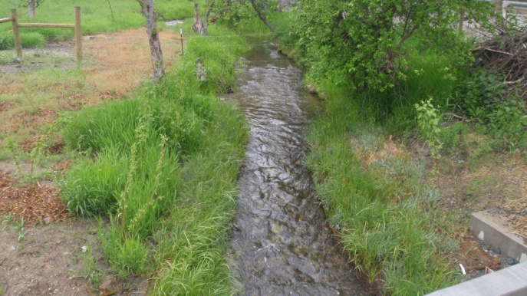

PP5, 2012 PP5, May 29th, 2013. Reed canary grass in NW quadrant

Figure 4. High plant survival in SE and SW quadrants

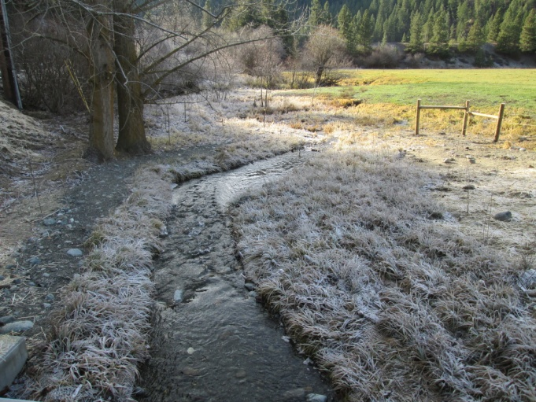 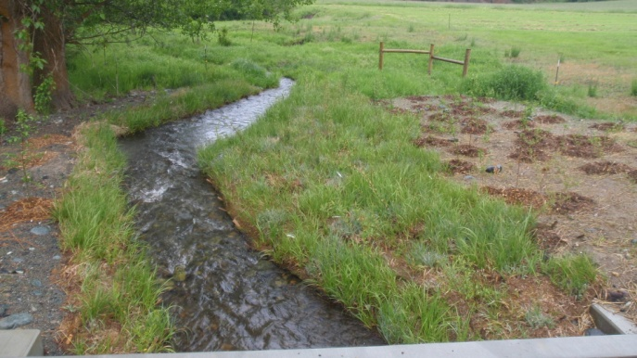

PP6, 2012 PP6, May 29th 2013. Large cottonwood supplies seed.

Figure 5. May 2013, SW quadrant 100% sedge mat cover

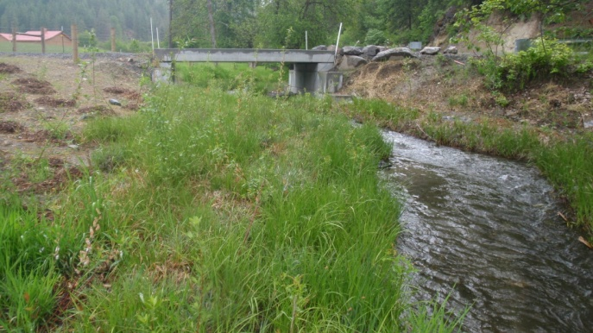

Natural regeneration of cottonwood, dogwood, and maple was also observed. Small cottonwood recruits were present in the SW quadrant due to a large cottonwood on the opposite bank (Figure 4). Dogwood and maple regeneration was present in the SE quadrant, along the south fence near the creek (dogwood), and on the steep embankment down from the guardrail (maple, Figure 6).

Figure 6. May 2013., SE quadrant- natural maple re-vegetation on embankment

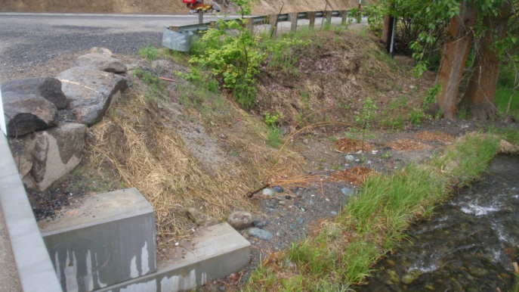

Reed canary grass, an invasive species, was present in a large patch along the creek in the NW quadrant (Figure 3, PP5). Some dogwood and willow were growing within and above it and will likely shade it out over time.

Fish Passage

Table 3. Adult salmonids detected at all 3 fish arrays on Chumstick Creek in 2013 and 2011 and 2012 detections at North Road.

|  |  |  |  |  |  |
| --- | --- | --- | --- | --- | --- |
| **Species** | **North Road 2011 (RM 0.28)** | **North Road 2012 (RM 0.28)** | **North Road 2013 (RM 0.28)** | **Sunitch (RM 5.3)** | **Merry (RM 8.82)** |
| Wild Summer Steelhead | 37 | 26 | 14 | 2 | 1 |
| Hatchery Summer Steelhead | 46 | 33 | 17 |  |  |
| Hatchery Coho | 8 | 7 | 4 |  |  |
| Wild Spring Chinook | 3 | 2 | 2 |  |  |
| Hatchery Spring Chinook | 4 | 0 | 4 |  |  |
| **Total** |  |  | **30** | **2** | **1** |

Fish array data indicates that at least 2 wild summer steelhead migrated up to RM 5.3 at Sunitch which is 3.2 miles downstream from the Baumann site (RM 8.51). One fish migrated 0.31 miles upstream of the site to Merry canyon. WDFW estimates that detections at fish arrays represent approximately 10% of the actual run due to the percentage of tagged fish. Based on those estimates, there may have been ~10 fish passing through the Cann site.

**Conclusion/Recommendations**

Data from the fish array at Merry Canyon indicates the Baumann project is meeting the goal of opening up historical fish habitat to wild summer steelhead (Table 2). The bridge is structurally sound with no observed changes since post-construction in 2012. No bank erosion or sediment deposition was observed. Calculated plant survival was 89 percent, site shrub cover averaged 15 percent, and quadrant sedge ground cover ranged from 15-40 percent. A patch of reed canary grass was observed in the NW quadrant that will likely be shaded out with time by adjacent willows and dogwood.

Although shrub cover is currently low, all plants are well established and should provide adequate cover with subsequent year’s growth. Thus, no additional plantings are recommended at this time. Changes to native and invasive species riparian cover, bridge integrity, and fish passage should continue to be monitored. . Photo points should be repeated in August and CCNRD staff should ensure the integrity of the picture file.