Burn-Johnson Family

Forest Management Plan ________________________________________________

Parcels 371112001000 & 371112002000

Waldron Island, WA

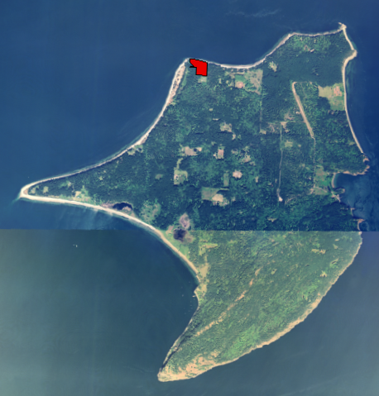

Prepared by

Rain Shadow Consulting, LLC

Carson & Samantha Sprenger

December, 2007

Table of Contents:

1. Purpose of Management Plan…………………………………………………………1
2. Goals and Primary Objectives……………………………………………………..….1
3. Legal Description and Location…………………………………………………….....2
4. Background and Land Use History …………………………………………………..4
5. Soil Description and Management Implications…………………………………......5
6. Stand Descriptions…………………………………………………………………..…6
7. Wildlife Habitat and Important Ecological Features……………………………….11
8. Forest Fuels and Fire Hazard Reduction……………………………………………11
9. Forest Health: Disease, Insects, and Invasive Species.……………………………..13
10. Management Recommendations and Suggested Timeline for Implementation…...16

List of Figures and Tables:

Figure 1. Location of forested parcels ……………………………………………...…. 3

Figure 2. Stands, driveway, and footpaths………………………………..………….. 4

Figure 3. Aerial photograph with stand boundaries…………………………………....9

Figure 4. Aerial photograph with location of ivy and spruce……………..………….14

Table 1. Legal description and location of parcels…………………..…………….……3

Table 2. Management timeline…………………………………………………….…....20

1. Purpose of Management Plan

This forest management plan was created to serve as the principal guiding document for the management of 9.87 acres of forest land owned by Christopher Terrigal Burn and Christine Johnson. It is the landowners’ intention to transfer their property into the Open Space Timber Land land use program. This plan has been developed to meet those requirements as well as to help the landowners become more informed stewards of their forest.

1. Goals and Primary Objectives

The overarching goal of the Burn-Johnson family is to improve the health, biological integrity, and native species diversity of the forest land on these parcels. By blending sound management with the periodic low-impact harvesting of timber, the landowners aim to pass on a healthy, vibrant forest to their future generations. They wish to engage their children in the management of this land as much as possible. Additionally, it is their hope that the management guidelines presented in this plan can serve to inspire and provide a resource for other family members who own forested acreage nearby.

Following is a list of primary objectives in support of the above stated goals:

1. Develop a better understanding of the different forest types growing on the property, their health, and long-term trajectory.
2. Use sustainable and low-impact logging techniques when harvesting timber.
3. Develop a better understanding of the threats to the forest posed by global warming, disease, and pests.
4. Promote forest stand structures that reduce hazardous fuels and minimize the risk of uncontrollable forest fire.
5. Support the local economy by marketing forest products locally whenever possible.
6. Locate and control non-native, invasive species.
7. Plan for the role of future generations by involving children in the decision-making process from the beginning.
8. Seek professional guidance in order to develop important tools for improving the health of the forest.
9. **Legal Description and Location**

The two parcels discussed in this plan are located on the northwest corner of Waldron Island, a non- ferry served island within Washington State’s San Juan Islands (Figure 1). Both parcels are under the same ownership and total nearly 10 acres (9.87; see Table 1).

Excluded from the Open Space Timber Land program is acreage that falls within a 200 foot shoreline buffer (Figure 3). and a 1 acre portion of land surrounding each residence. For computing the acreage associated with the shoreline buffer, the following formula was used:

Buffer acreage = 0.00459* 814.65 (linear distance of shoreline in feet)

Buffer acreage = 3.74 Acres

Though a 1 acre portion of land per residence is usually subtracted from the total acreage for this land use program, the single residence on the property is well within the 200’ setback. Therefore, no additional land should be excluded from the Timber Land program.

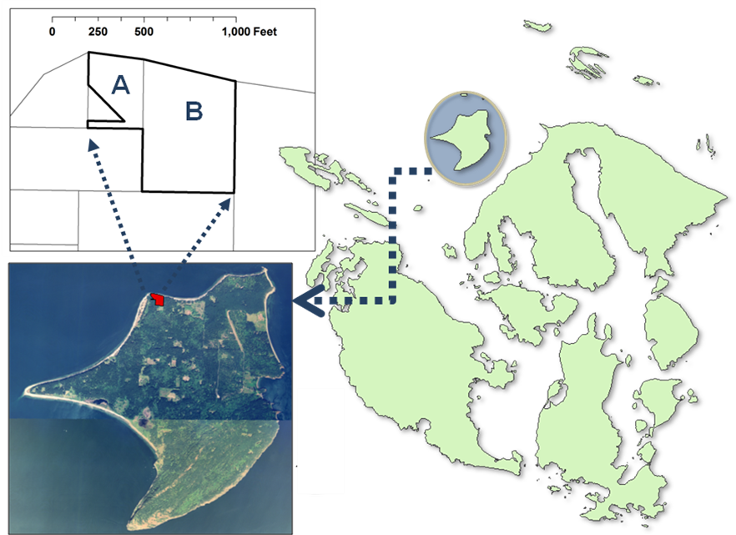

San Juan Islands

**Figure 1**. Location of parcels within the San Juan Islands, WA. Waldron Island is highlighted within the archipelago (upper right) and presented as an aerial photo (bottom left). In the upper left corner of figure (inset showing parcel boundaries), **A**. refers to parcel number 371112002000 and **B**. refers to parcel number 371112001000.

**Table 1**. Legal description and location of parcels.

|  |  |  |  |  |
| --- | --- | --- | --- | --- |
| **Parcel Number** | **Size**  **(Acres)** | **Current Land Use** | **Legal Description** | **Title Owner** |
| 371112001000 | 7.55 | Residential | E500' GL 5, EX CO RD | C. T. Burn |
| 371112002000 | 2.32 | Residential | PR GL 5 | C. T. Burn |

Vehicular access is currently available only for the smaller of the two parcels (37112002000). This driveway is accessed via a small network of shared private roads that eventually connects to an east-west running county road. A number of footpaths exist on both parcels and provide access to the northern half of the property as well as its eastern edge (Figure 2).

1. Background and Land Use History

Waldron Island totals about 2,900 acres (4.5 square miles). It is one of several “outer” or “non-ferry” islands among the San Juan Islands, with the nearest ferry-served island, Orcas, to the southeast. Waldron has no land line telephone service and no grid power. Passengers, mail, and small freight loads are handled by a number of island-based boat operators. Barge services are used for large loads such as vehicles, building supplies, bulk propane, and, occasionally, log export.

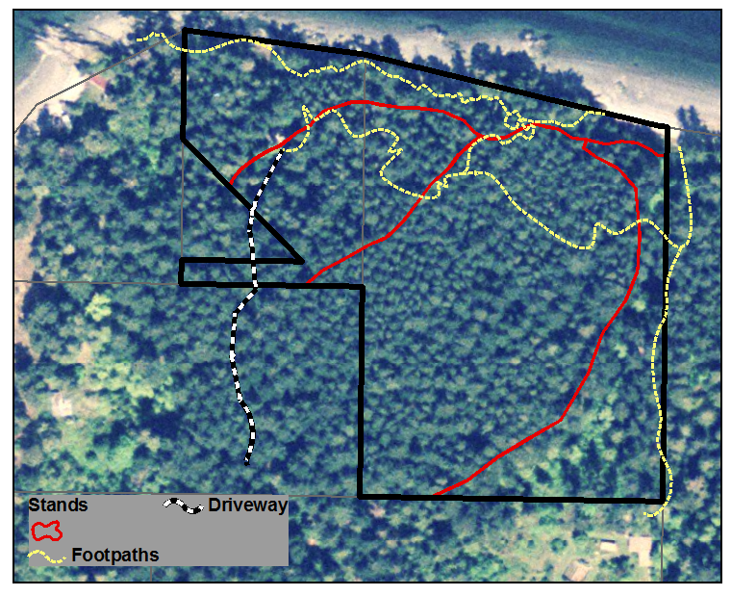

Figure **2**. Aerial photo overlaid with the boundary of the entire property. Forested stands, driveway, and footpaths are delineated.

Over the last century logs have been exported from Waldron by booming and barging. Waldron currently has three small, part-time sawmill operations which produce dimension lumber for local use. Surprisingly, the volume of lumber produced from these sawmills does not meet the local demand and, therefore, lumber is regularly imported. Almost all of the heated buildings on the island use wood fuel, and there is a small but steady market for firewood, which remains a locally produced product.

Much of Waldron Island was logged around 1900—if it had not already been cleared for farming and grazing by that time. The majority of the harvested timber was processed locally and sold as cord wood to feed the San Juan Island lime kilns. It was during this time that most of the easily accessible and merchantable timber was removed from Waldron.

The two parcels now under the ownership of the Burn-Johnson family were likely logged for cord wood around 1900. Remnant stumps from this logging (and possibly some homestead logging activity) can be seen scattered across the property. It appears that the land was logged quite heavily at this time due to the abundance of approximately 100-year old second-growth Douglas-fir (*Pseudotsuga menziesii*) trees.

These two parcels were once part of a much larger piece of land that was purchased by June and Farrar Burn in 1931. Subsequent logging on the Burn-Johnson parcels since the 1931 purchase has been very limited. A handful of trees were removed in the mid 1980’s when a small cabin was moved to the property. Additionally, one western red cedar (*Thuja plicata*) and a couple of Douglas-firs were cut from the site to provide lumber for this structure. More recently (in 2006) about 1,000 board feet of logs were removed near the house site in order to provide utility lumber and to increase solar exposure to the cabin.

1. Soil Description and Management Implications

According to the NRCS soil survey of San Juan County, this

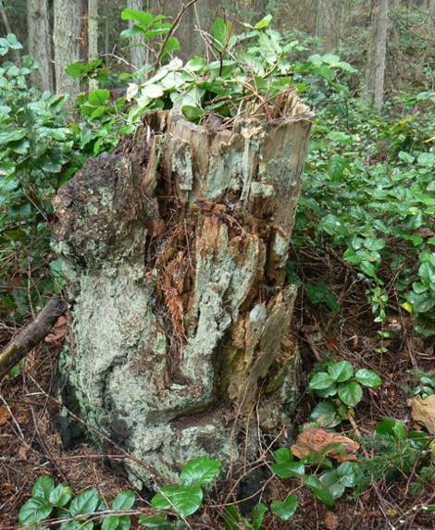

**Figure xx**. One of many enduring stumps scattered about the forest. This Douglas-fir tree was likely cut in the early 1900’s. Note spring board notch near base.



One of many enduring stumps scattered about the forest. This Douglas-fir tree was likely cut in the early 1900’s. Note springboard notch near base.

property contains only one soil type: Indianola loamy sand. Its full description is “Indianola loamy sand, warm, 3-15% slope.” This soil type is found on only 1.1% of property in San Juan County. It is derived from glacial outwash, which makes it significantly coarse in texture and, therefore, low in both water-holding capacity and fertility. Trees can root deeply in its sandy texture, though the anchorage may only be moderately good. This soil is better suited for the growing of trees than for farmland.

In terms of timber production, Indianola loamy sand is considered a *site class 3* for Douglas-fir (based on a scale of 1 to 5; 1 being the most productive sites and 5 the least.). The *site index* for Indianola soils is 140. This means that a typical Douglas-fir tree growing on this soil will be approximately 140 feet tall at 100 years of age.

Due to the coarse texture of the soil, and low degree of slopes on this property, the risk of erosion and compaction due to logging activity is relatively low. The steepest portion of the property occurs within the 200’ shoreline buffer zone, where no logging will take place. The remainder of the property exhibits little to no slope. If signs of erosion *were* to occur in areas where harvesting has taken place, the following action should be taken:

1. Apply 4-6” of straw to area to decrease surface runoff
2. Plant native species such as western red cedar and salal (*Gaultheria shallon*) to stabilize soil.
3. Decommission roads or trials crossing to affected area.

The coarse texture of Indianola soil (very little clay content) means that there is little concern of compaction during light, intermittent harvesting operations. It should be noted that there is a wet area in Stand 4 that is at a higher risk for compaction. However, this plan advises to do little to no harvesting operations in this portion of the property. If the landowners should ever want to carry out harvesting in this area, activities should be carried out in the dry season. Care should be taken when conducting any logging operations to avoid wet, saturated soils.

1. Stand Descriptions (See Stand Map, Figure 3)

**Overview**

The stands on this property are typical of dry, low-elevation sites in the San Juan Islands. Stumps present throughout the stands indicate that, around the time of early Euro-American settlement (circa 1880), the property was dominated by large Douglas-firs. Western red cedars were historically present as well but in smaller numbers. The shoreline was a place where a greater mixture of species would have been found. Lodgepole pine (*Pinus contorta*) and madrone (*Arbutus* *menziesii*) would have been common, along with stunted and windswept Douglas-fir. Hardwoods in these pre-settlement, mature forests likely played only a minor role because gaps in the forests large enough to allow for their regeneration rarely formed. However, moisture-loving hardwoods such as alder (*Alnus rubra*), maple (*Acer macrophyllum*), willow (*Salix* sp*.*), crab apple (*Malus fusca*), and sometimes aspen (*Populus tremuloides*) and cottonwood (*Populus trichocarpa*) would have been common along the edges of swamps and bogs.

Though no formal survey of pre-settlement forest conditions was conducted for these parcels, the following observations provide some clues. Evidence of large-scale windthrow (e.g., groups of similarly aged downed logs exhibiting a common orientation) was not apparent. However, the appearance of some recent wind damaged trees (and the fact that this parcel is fairly exposed to wind storms) indicates that storms play an import role in the local disturbance regime. The effects of wind storms will likely become increasingly apparent as stands continue to mature, self-thin, and develop more native stem and root rots.

From a historical perspective, although all of the major disturbance agents (i.e., wind, disease, fire, and insects) had important roles for most of the forest types found in the San Juan Islands, the historical disturbance regime was *dominated* by fire. From what is known of historical fires on Waldron, the historical fire regime for Douglas-fir forests on Waldron is best described as low severity. In essence, what this means is that fires tended to burn frequently (about every 5 to 20 years) and also caused relatively light damage—killing or damaging some small trees, shrubs, and herbs. Across Waldron Island evidence of past fire is abundant, and this property is no exception. There are numerous examples of fire scarred trees.

An example of fire scarred tree on the Burn-Johnson property. Despite the damage to the base of this cedar tree, it supports a healthy crown and may continue living for decades.

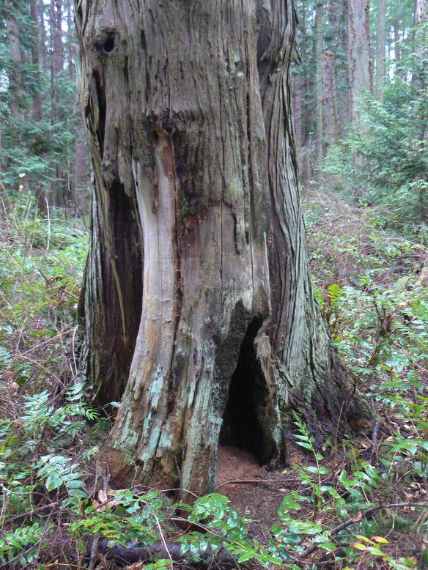

One particularly interesting and rare feature of this property is the presence Sitka spruce (*Picea sitchensis)*. Only two individuals were found (one tree and one sapling; Figure 4) and these are believed to be the only naturally occurring spruce on Waldron. Sitka spruce thrives in cool, wet places and can be found locally along the northern shoreline of Orcas Island as well as some scattered locations on Patos Island.

**Stand type 1:** (2 Acres)

This stand borders the entire length of the property’s shoreline, and is defined by its exposed, rocky edge to the north and its close proximity to the shore. Portions of this stand exhibit a strong north aspect and attain steeper slopes (~15%) compared with the rest of the property. The understory is composed primarily of salal and oceanspray (*Holodiscus discolor*)*.* The stand is comprised of a mixture of tree species which include: Douglas-fir, cedar, lodgepole pine, hemlock (*Tsuga* *heterophylla*), and grand fir (*Abies* *grandis*). A small handful of madrone and yew (*Taxus brevifolia*) are also present. The Douglas-fir range from slightly stunted to very twisted and wind sculpted. The latter are wonderful “character trees” and are a defining shoreline feature in San Juan County. Though not large, some of these firs are quite old and well rooted—an important factor in the stability of the soil on the shoreline.

Some of the cedars in this stand are young (<100 years) and of moderate size (<10” diameter at breast height or, “dbh”), indicating that cedars are successfully regenerating. There are also a good number of older cedars which exhibit signs of past fire, extensive woodpecker activity, and ornamented multi-topped crowns. Grand fir and hemlock occur throughout the stand in modest numbers and in a variety of sizes and ages. Neither of these tree species is considered long lived nor very rot resistant when compared with cedar and Douglas-fir. Thus, it is not surprising that few grand fir and hemlock appear to have attained an age much older than 100 years.

An interesting and unusual feature can be found at the east end of Stand 1 just up from the beach. Here lies a magnificent grove of crab apple which is reminiscent of an old orchard. Care should be taken to protect this possible artifact of Native American history, as some of the local archeological and ethnobotanical literature makes reference to the prized crab apple “orchards” that Coast Salish people tended in our area. Also present in this location, though a bit higher up on the bank, are a number of unusually large Douglas maples (*Acer glabrum var. douglasii*).

**Stand type 2:** (1.6 Acres)

Douglas-fir is the dominant tree species in Stand 2 and appears in two cohorts (age groups). The younger cohort of trees is estimated to be 95-100 years (based on increment core sampling of 3 trees), and the older cohort is approximately 250-300 years old (educated guess based on character and growth form as well as knowledge of old-growth Douglas-fir ages across Waldron). The older Douglas-firs are adorned with charred bark (a sign of at least one fire) near the base of the tree, as well as an occasional fire scar (a sign of two or more fires during the tree’s lifetime).

The size of the 95-100 year cohort averages about 14 inches dbh, while the average size of the larger cohort, though much more variable, is about 36 inches dbh. These two age groups of Douglas-fir compose roughly equal amounts of the total forest canopy space; though, because the younger trees are obviously smaller, they far outnumber the stems of the older group. Other stand components include a small number of scattered pole and sapling-sized cedars along with even fewer sapling-sized hemlocks.

Though it only encompasses less than 2 acres in size, this stand is a fine example of a second growth stand of Douglas-fir that shows numerous old-growth forest characteristics. Many of the old-growth elements considered to be ecologically important (down logs, older trees, snags, and multilayered canopy) are relatively well represented. If this stand is allowed to mature over the next 200 years, it will continue to develop increasing levels of complexity and likely provide a number of important ecological functions such as nesting and foraging habitat for eagles, woodpeckers, and other birds.

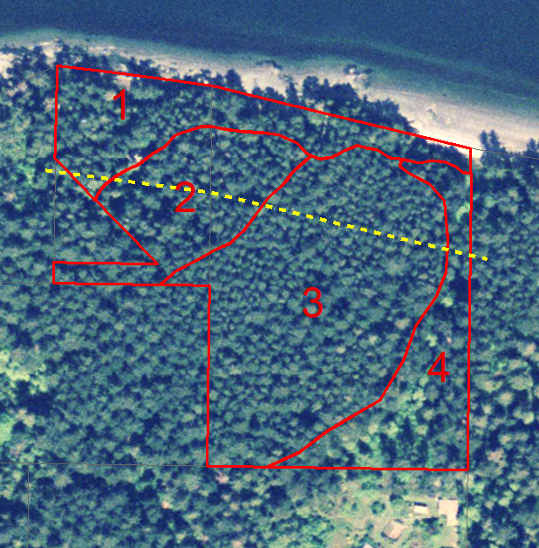

**Figure 3.** 2004 aerial photo showing the extent of the Burn-Johnson family property along with the four stand type boundaries and the location of the 200 foot shoreline buffer (yellow dashed line).

**Stand type 3:** (4.2 Acres)

Stand 3 is the largest of the four stands. It is comprised almost entirely of Douglas-fir, along with a minor component of cedar saplings. There is a towering collection of mostly straight and healthy saw-timber sized trees with a dense carpet of salal underneath. This stand is dominated by the 95-100 year cohort, though scattered throughout the stand are some older Douglas-firs—probably in the 150-200 year age range.

The majority of trees in the younger cohort range in diameter from 10 to16 inches dbh. The average tree diameter for the older age class is about 24 inches dbh. No sampling for volume was conducted, but it is estimated that the yield of standing saw timber would be in excess of 40 mbf (thousand board feet) per acre. The stocking level (density) of the Douglas-fir is close to 200 trees per acre (TPA), which is fairly high considering the size of the trees. This stand appears to be overcrowded and is showing early signs of suppression-induced mortality. Essentially, the trees are fighting for access to light, and many are beginning to decline in vigor. Some have already succumbed to the competition and died. An indication of an overcrowded stand is when the average percent live crown (percent of a tree’s height covered with live foliage) is less than 25%. Percent live crown was estimated on a number of trees in the younger cohort to be between 10-20%.

**Stand type 4:** (2 Acres)

Stand 4 has a relatively diverse mixture of conifer and hardwood trees with at least 2 different age classes of Douglas-fir and cedar. Grand fir occurs as a minor component, both as mature individuals and as small groups of saplings within or near gaps. Alder and maple make up the majority of the hardwoods, but some Douglas maples are also present. Greater concentrations of hardwoods are found near the southeast corner where the property borders a clearing. In this part of the property there are signs of frequent wind disturbance—probably related to its exposure to the south and the fact that this appears to be a fairly wet portion of the property (several patches of salmonberry and elderberry were located in this region).

This stand is defined by a multi-layered canopy, a good assortment of trees sizes and species, and also the type of spatial patchiness that is an important component of older, more complex forests. The large and mature (95-100 yrs) Douglas-fir in this stand are healthy and vigorous.

1. Wildlife Habitat and Important Ecological Features

A complete wildlife inventory was not completed for this plan; however, the following observations were made. The shoreline is a very active place for a number of wildlife species including eagles, shorebirds, and otters. The undeveloped portion of shoreline belonging to this property is fostering the development of large and enduring conifers as well as overhanging and fallen trees; two structural features that are critically important for both terrestrial and marine wildlife species.

The older forest conditions (present throughout all stand types but most apparent in types 2 and 4) include a number of high quality forage and nesting snags for cavity nesting birds. High quality snags for our region are defined as standing dead Douglas-fir or cedar trees larger than 16 inches dbh. These types of snags can remain standing for decades. Even more enduring are wildlife trees that contain portions of large diameter dead wood. Old-growth Douglas-firs and cedars (typically with multiple dead tops) are good examples of this. They are rarer but also very important due to their long expected life span. The most important management decision regarding the wildlife habitat will be the retention of the snags and large, down logs, old growth Douglas-firs, and old growth cedars.

1. Forest Fuels and Fire Hazard Reduction

Uncontrolled forest fire is a real threat for all forestland owners in San Juan County. Managing hazardous woody fuels along with providing vehicular access to key areas are two of the best ways to help prevent catastrophic wildfire.

Not all woody fuels are alike. In a typical Douglas-fir forest, much of what is considered “woody fuel” (essentially all woody biomass above ground) is not hazardous and does not warrant any management action. In general, the types of fuel to be concerned with are the following:

* **Fine fuels.** These are grasses, needles, and small twigs up to ¼ inch in diameter; all of which dry out very quickly and burn hot and fast. Fine fuels are most abundant on the edge of clearings and next to buildings.
* **Small diameter branches.** Material larger than fine fuels but less than 3 inches in diameter. This is usually the bulk of logging slash and blow downs. Once it dries out, it can be a major source of fuel in an unwanted wildfire. This is the fuel that, if it has accumulated to high levels, can feed fires enough to initiate the transition from surface fire to partial crown fire—an extremely dangerous situation.
* **Ladder fuels.** Ladder fuels are most commonly small live trees that grow underneath and close to mature trees, creating a continuous vertical arrangement of fuel from the ground into the canopy. Ladder fuels can also include: low sweeping limbs on mature cedars, dead trees, vines, and tall shrubs.

None of the stands surveyed contained excessive loads of hazardous fuels. However, when future management activities include the removal of trees, the slash that is produced must be properly dealt with in order avoid creating hazardous conditions. The following are standard methods used for treating slash and accumulated woody debris.

**Chipping** may be one of the fastest ways to treat slash in areas with easy access. A large chipper can handle full-length limbs and tops of trees efficiently. Chipping is most appropriate in areas close to roads or the edge of openings. The over-application of chips to the forest floor (smothering) should be avoided in areas other than short distances from roads and openings or mulching projects around individual trees.

**Burning** small slash piles during the wet season is an inexpensive and effective method of reducing fuel loads. Piles should be constructed during management operations, avoiding large layers of debris across the forest floor. Piles should be made early in the season to allow for partial drying and covered with tarps to facilitate clean hot burning. Piles should not be burned until the ground around them is saturated and weather conditions are cool and wet. Keep the size of the piles manageable (10-20’ in diameter) and within 100 feet of access roads.

Lop-and-scatter is a method of dispersing smaller sized slash throughout the forest in order to achieve rapid decomposition. Slash should be cut so that when it is scattered it lies as close to the ground as possible (within 8 to 12 inches of the ground). When properly done, this method can be an attractive as well as effective means of treating slash. If the cut slash is not adequately dispersed, or if too much material is applied to a particular area at once, this method can increase the fuel hazard.

Vehicular access to portions of the property could be improved. The driveway leading to the property is in rough shape and at places is quite narrow. At some point before any harvesting occurs, an access road into stand type 3 should be created.

1. Forest Health: Disease, Insects, and Invasive Species

Disease

During the most recent harvest, some rot was detected in both Douglas-fir and cedar. In both cases it was a native stem/heart rot (although the particular species was not identified). Older cedars in the San Juan Islands are particularly susceptible to native heart rot fungi. These pathogens infect individual trees and are not aggressive in terms of spreading to other trees. Some of the pathogenic fungi affecting Douglas-firs however, can be quite aggressive and are capable of spreading to other trees through root to root contact. These more aggressive root rots are associated with “pockets” of small groups of dying trees. No root rot pockets were discovered across any of the property’s four stands. Except for some signs of slow-moving decay fungi in the older trees, these stands appear to be quite disease free.

Insects

No major insect problems have been identified at this time.

Invasive Species

*English Ivy* (*Hedera helix*)

English ivy is, unfortunately, a common invasive species on Waldron Island. As it grows into the canopy of trees, increased light levels allow it to fruit—producing berries that are then spread by birds to new locations. English ivy has many detrimental effects on native vegetation such as 1) blocking out light to the host tree which can result in tree mortality, 2) adding excessive weight to the tree and thereby increasing the chance of stem breakage or the tree falling over, and 3) inhibiting native understory plant growth and reproduction. English ivy is also known to create an ideal refuge and bedding site for introduced rodent pests such as rats.

Twelve outbreaks of English ivy were located (Figure 4) while conducting an ecological inventory of these parcels (December, 2007). All of these outbreaks contained both prostrate (growing along the ground) and aerial shoots. The vigor and level of infestation of each of the outbreaks was mild to moderate and none of ivy was observed growing higher than 30 feet from the ground.

About half of the known and mapped ivy locations (7 of the 12) fall within the property borders, with the others in close proximity on adjacent parcels (Figure 4**)**. If no control measures are implemented on these outlying patches, they will continue to act as local seed sources, increase in size, and likely migrate onto the property. Therefore, it will be important to work with neighbors to effectively eradicate the ivy (or, at least, control its spread). Though the control of ivy can be labor intensive, it is imperative that action be taken soon while the outbreaks are of a manageable size. Rapid implementation of control measures will not only save trees and other native plants, but it will save time and money. Waiting for several years to control the ivy will be even more labor-intensive and costly.

There are three common approaches for controlling ivy: manually removing the plant (cutting vines and digging up all roots), applying herbicide, or a combination of the two. According to the Washington Department of Natural Resources, manual removal is the most effective method of control. One reason for this is that the thick, waxy leaves of ivy make it a poor target for herbicide treatment, as the herbicide can run off and affect nearby native vegetation.

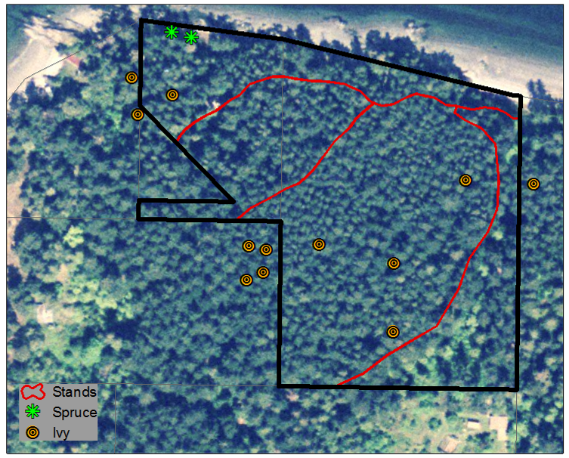

**Figure 4**. Map showing location of English ivy outbreaks as well as the only know Sitka spruce to occur on Waldron.

For manual removal of ivy on tree trunks, vines should be cut at ground level and then again at approximately 4-5 feet high to kill the growth in the upper portion of the tree. This is important in minimizing damage to the tree and to keep the ivy from producing berries. Manually remove the rooted vines from the trunk of the tree while trying not to damage the live tissues of the tree. (Gloves should be worn when removing ivy because the sap can cause a skin reaction with some people.) Removing ivy in the understory (rooted in the ground) should be done in the dormant season (late winter/early spring) when the moist soil makes it easier to remove roots. If resources do not allow for complete removal, begin by controlling the perimeter of the patch to inhibit the plant from spreading. Pile debris separate from compost and monitor. Ivy can easily resprout if it has contact with soil.

The Nature Conservancy acknowledges that there is no single best method for ivy removal, but a combination of manual digging and herbicide application has been found to be quite successful. As stated above, vines should be cut from the base of the trees followed by a cut stem application of herbicide on the larger vines. After an area of ivy has been hand dug, wait for the plants to resprout and then apply herbicide directly on the leaves. Herbicides that have been effective in ivy control are glysophate and triclopyr (found under a number of brand names; e.g. Roundup). An ideal time to apply herbicides is late fall or during warm winter days—when temperatures are above 55° F but most native vegetation is dormant. Any ivy removal strategy will involve ongoing monitoring and removal.

Aerial portion of one of the ivy patches. In this photo, the ivy is climbing up a Douglas-fir.

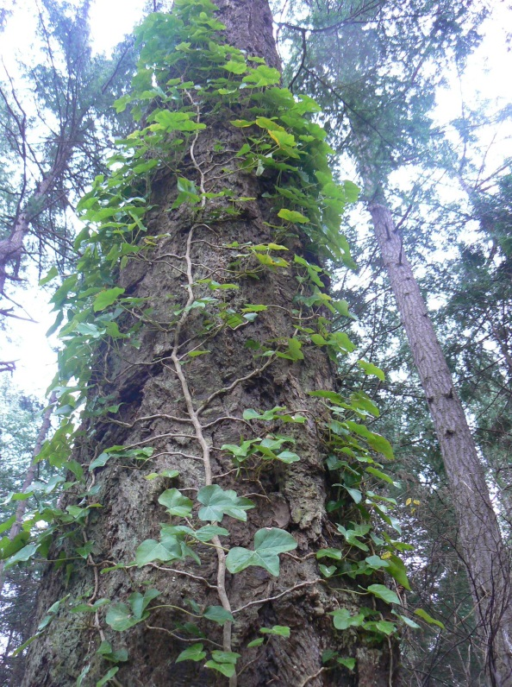

For more information on ivy removal, the following websites may be useful:

* San Juan County Noxious Weed Board: <http://sanjuan.wsu.edu/noxious/index.html>
* The Nature Conservancy’s invasive species website: H[TUwww.tncweeds.ucdavis.edu/control.htmlUT](http://www.tncweeds.ucdavis.edu/control.html)H
* DNR: H[TUwww.dnr.metrokc.gov/wlr/LANDS/weeds/pdf/english-ivy-control.pdfUT](http://www.dnr.metrokc.gov/wlr/LANDS/weeds/pdf/english-ivy-control.pdf)H
* Washington Arboretum: H[TUwww.depts.washington.edu/wpa/stewardship_archives.htm#ivyUT](http://www.depts.washington.edu/wpa/stewardship_archives.htm#ivy)H
* Washington Native Plant Society’s Ivy Out program: H[TUwww.ivyout.orgUT](http://www.ivyout.org)H

*Holly* (*Ilex aquifolium*)

No holly trees were found during this forest inventory; however, holly is a common occurrence on Waldron and it is highly likely that at some point it will show up on this property. Thinning activities may increase light levels and disturb soil which could facilitate the establishment and growth of holly. Holly is difficult to remove by cutting alone because it will resprout quickly. A more effective method of control is to cut the stem of the tree and apply herbicide to the stump. If herbicide use is undesirable, cutting should be done but will require ongoing maintenance of new growth. Small holly seedlings should be pulled manually when found.

1. Management Recommendations and Suggested Timeline for Implementation (See Management Timeline, Table 2)

**Stand 1**

As Stand 1 lies almost entirely within the shoreline buffer, management activities should be restricted to invasive species control and hazardous fuel reduction. Though most of the stand has only light to moderate levels of hazardous fuels (and is therefore not in any urgent need of management), some level of management should be done in the immediate vicinity of the residence. A buffer of 25 to 50 feet should be established around the structure. Within this buffer, shrubs should be trimmed low, dead branches removed, and trees pruned up to 10 feet from the ground. Treat the area closest to the structure and on the downhill side of the structure most intensively.

**Stand 2**

This stand should be allowed to mature and continue to develop old-growth characteristics. Too few old-growth Douglas-fir forests remain in the San Juan Islands and this stand has good potential to attain much of the form and function of what was once a common forest type throughout the islands.

Refrain from salvaging firewood and lumber from fallen trees, especially those that are big and old. Stand 2 is lacking in down, decaying logs and this feature has many important ecological functions. Among other things, down logs provide habitat for numerous invertebrates and a few species of amphibians as well. They hold moisture long into the dry summer months and also supply the soil with organic matter and humus.

**Stand 3**

Stand 3 is the best suited of the four stands for harvesting timber. The trees are tall, straight, and relatively slow growing, thus capable of producing high quality lumber. The ground is relatively flat and the soil is fast draining, therefore, the risk of erosion is very low. This stand is showing signs of stagnated growth and self-thinning (when trees in the stand begin to die due to overcrowding); a condition that will lead to an overall decline in tree vigor and health.

This stand would benefit most from a moderate-level thin of the smaller size classes within the next 5 years. Thinning should focus on the removal of Douglas-firs between 5 and 12 inches in diameter (dbh). The few trees that are below 5 inches are not competing heavily and will likely die, contributing to snags and down woody debris. The target density for the thinned stand should be about 125 TPA (not including cedar). The few cedar saplings that are present should be thinned to 10 TPA. All old-growth trees should be left standing.

Horse logging may be the most appropriate means of removing the timber. This system does not require wide skid roads and the smaller trees are an ideal size to be handled by horses.

The following contains some general information on thinning and how to go about assessing the need to thin:

Thinning is an important treatment for young stands and overstocked multi-aged stands. It is, however, grossly underutilized and underappreciated. Few good examples exist where well executed thinning has occurred.

Timely thinning increases growth and enhances overall stand health and vigor. It is a silvicultural application that concentrates volume production on those trees with the most desirable growth characteristics and, in the long term, improves the quality of the timber. Also, by removing trees with defects or insect and disease problems, stand health is improved. The remaining trees grow at a rate higher than would be possible in an unthinned condition. When combined with proper slash treatments, thinning can also greatly reduce the amount of hazardous fuels.

Thinning should be a priority in areas showing the greatest overall reduction in growth—stands that exhibit obvious signs of stagnation due to intense competition. The following three guidelines may be used to help assess which stands show signs of stagnation and should therefore be prioritized for thinning:

1. Stocking density in excess of 400 trees per acre;
2. Height to diameter ratio in excess of 100 to 1 (“spindly”);
3. Percent live crown less than 20%.

After the thinning has been completed for the stand, single-tree and small group selection will be the preferred method of harvesting timber. With these methods, there is more flexibility with the selection of trees to remove. In general, the largest and most vigorous trees should be retained while focusing the harvesting on the less vigorous and slower growing trees. The stand will support modest removals of timber immediately after the thinning is completed (<500 bf/acre/year). However, in order to capitalize on the gains in growth resulting from the thinning, it is advised to wait 10-15 years (~2017-2022) before much appreciable harvest occurs.

In the long-term, if Douglas-fir is to remain a dominant tree within this stand, methods of selective removal will need to focus on the establishment of new cohorts of Douglas-fir through the creation of larger and larger canopy gaps (up to ½ acre in size or larger). This means that harvesting methods will transition from the removal of individual trees to the removal of clusters of trees (following methods of *variable density thinning*—a silvicultural treatment often implemented to promote more naturally structured stands). These gaps will be needed to provide sufficient levels of light for Douglas-fir regeneration. Given the current age and structure of the stand, it is estimated that a good time to begin regeneration harvesting is when the stand approaches 200 years of age (roughly 100 years from now). At that time, managers will need to determine if natural regeneration is meeting minimum stocking levels or if planting may be required. Within gaps, seedling density should initially be high (> 500 TPA) to account for seedling and sapling mortality. If planting seedlings, make sure the seed source is of local origin (San Juan Islands).

**Stand 4**

This stand does not have as many large and old Douglas-fir trees, yet it contains the greatest diversity of tree species and tree ages of any of the four stands. It also exhibits the best example of periodic, but relatively frequent wind disturbance. The presence moister soil conditions, high tree and understory plant diversity, and a greater amount of coarse woody debris, make this stand a good candidate for minimal management. Beyond exotic species control (especially ivy as this stand contains the type of structure where ivy could really thrive), this stand should be allowed to mature and continue to develop old-growth characteristics.

**Table 2**. Management Timeline

|  |  |  |  |  |  |  |  |  |  |  |  |  |  |  |  |  |  |  |
| --- | --- | --- | --- | --- | --- | --- | --- | --- | --- | --- | --- | --- | --- | --- | --- | --- | --- | --- |
| **Activity** | **2008** | | | | **2009** | | | | **2010** | | **2015** | **2020** | **2025** | **2030** | | **2040** | **2050** | |
|  | W | Sp | S | F | W | Sp | S | F |  |  | |  |  |  |  | |  |
| GENERAL |  |  |  |  |  |  |  |  |  |  | |  |  |  |  | |  |
| Improve and maintain driveway |  |  |  |  |  |  |  |  |  |  | |  |  |  |  | |  |
| Cruise for and control ivy |  |  |  |  |  |  |  |  |  |  | |  |  |  |  | |  |
|  |  |  |  |  |  |  |  |  |  |  | |  |  |  |  | |  |
| STAND 1 |  |  |  |  |  |  |  |  |  |  | |  |  |  |  | |  |
| Maintain footpaths |  |  |  |  |  |  |  |  |  |  | |  |  |  |  | |  |
| Clear and maintain fire buffer around house |  |  |  |  |  |  |  |  |  |  | |  |  |  |  | |  |
|  |  |  |  |  |  |  |  |  |  |  | |  |  |  |  | |  |
| **STAND 2 and 4** |  |  |  |  |  |  |  |  |  |  | |  |  |  |  | |  |
| Cruise for and reduce ladder fuels |  |  |  |  |  |  |  |  |  |  | |  |  |  |  | |  |
|  |  |  |  |  |  |  |  |  |  |  | |  |  |  |  | |  |
| **STAND 3** |  |  |  |  |  |  |  |  |  |  | |  |  |  |  | |  |
| Commercial thin |  |  |  |  |  |  |  |  |  |  | |  |  |  |  | |  |
| Single-tree and small group selection |  |  |  |  |  |  |  |  |  |  | |  |  |  |  | |  |
| Cruise for and reduce ladder fuels |  |  |  |  |  |  |  |  |  |  | |  |  |  |  | |  |

**2012 Forest Management Plan Addendum**

**Harvest/Management Activities**

In 2010 ivy eradication was conducted across the entire property. All aerial ivy was cut and all root material was dug by hand.

In 2012, pre-commercial and commercial thinning was conducted in Stand 3. Approximately 30 trees from 8-14 inches in diameter were removed, totaling 1,800 board feet. This material was sold for firewood and generated $500.

In 2012 a new driveway and forest access road was installed on the property in order to improve access. This new road replaces the older driveway and creates a much improved route for hauling forest products.

**Annual Allowable Cut Calculation**

Based on soil productivity data from the Natural Resource Conservation Service, Northwest Natural Resource Group has calculated the annual sustainable harvest level for the Burn-Johnson parcel to be approximately 2 mbf/year.

**Monitoring**

Monitoring is an important component of the Burn-Johnson forest management plan for addressing safety concerns, invasive species, and overall forest health. The Landowners conduct an annual walk through inspection per year with a consulting forester. During these visits, the forester and landowner assess overall forest health with particular emphasis on invasive species. Other forest attributes that are observed include:

1. Yield of all forest products harvested.

2. Growth rates, regeneration and condition of the forest.

3. Composition and observed changes in the flora and fauna.

4. Environmental impacts of harvesting and other operations.

5. Costs, productivity, and efficiency of forest management.

In addition to these regular monitoring inspections, the landowners observe qualitative forest conditions during period walk through of the forest that are added to this management plan.

The following attributes will be monitored, at a minimum, via observations:

1. Impacts to trails, vegetation and water quality

2. Growth of newly planted seedlings

3. Presence of invasive species, in particular along forest access and haul roads and along margins of forest.

4. Wildlife

5. Snag and downed log recruitment

|  |  |  |
| --- | --- | --- |
| **Date** | **Observation** | **Note taker** |
| 6/9/12 | Recent thinning was well implemented, residual trees look good. Some material left for CWD recruitment, fuels cleaned up. Ivy very reduced. | C. Sprenger |
| 9/3/12 | New driveway work nearly complete. Well laid out and much improved access. Some woody debris from road work may need to be cleaned up (chipped or burned) to lower fuel hazard along sides of road. | C. Sprenger |
|  |  |  |
|  |  |  |
|  |  |  |
|  |  |  |
|  |  |  |
|  |  |  |
|  |  |  |
|  |  |  |
|  |  |  |
|  |  |  |
|  |  |  |
|  |  |  |

**THIS PLAN WAS PREPARED BY:**

**Carson B. Sprenger and Samantha Martin Sprenger**

**Rain Shadow Consulting, LLC**

**PO Box 107**

**Shaw, WA 98286**

**Phone: (360) 468-2548; Cell (206) 321-1592**

**E-mail:** H[TU**Carson@rainshadowconsulting.com**UT](mailto:Carson@rainshadowconsulting.com)H

H[TU**Sam@rainshadowconsulting.com**UT](mailto:Sam@rainshadowconsulting.com)H

**LANDOWNER’S CONTACT INFORMATION:**

**Christopher T. Burn & Christine Johnson**

**190 Lucero Way   
Portola Valley, CA 94028**