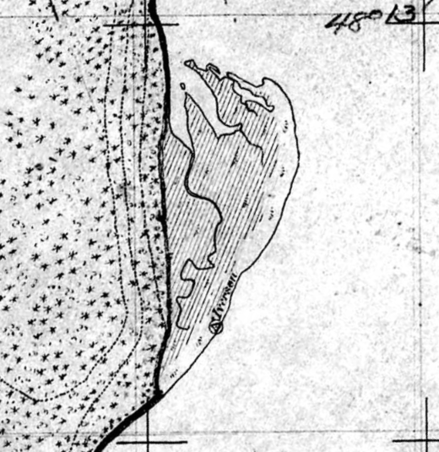

A clip from T-1755; Port Susan & Stillaguamish River, Wash. Terr., 1880

Puget Sound River History Project, University of Washington. <http://riverhistory.ess.washington.edu>