**Bear Creek Reach 6 Restoration Project, Phase II**

**Project 15-1059**

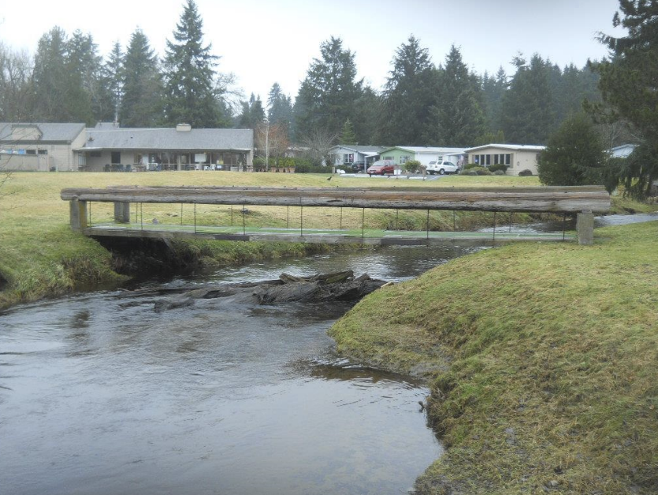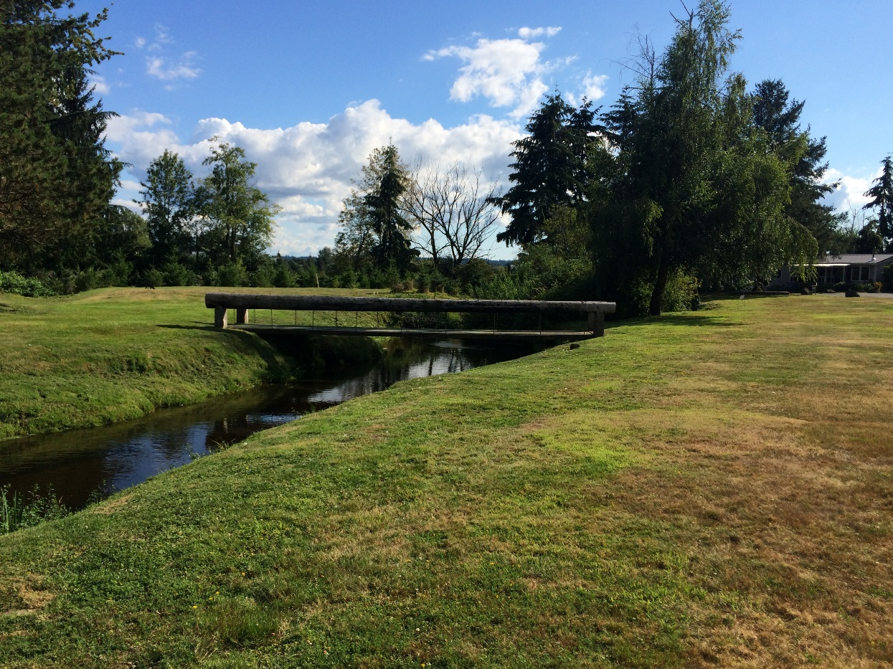8-8-2016

**Prepared by**

**Jay Kidder, P. E.**

Civil Engineer

Fisheries Biologist

***Chinook Engineering***

860 Windrose Drive

Coupeville, WA 98239  
360.678.4747

The technical material and data contained in this report were prepared under the supervision and direction of the undersigned, whose seal as a professional engineers licensed to practice as such in the State of Washington, are affixed below.

_________________________

Jay S. Kidder, P. E.

Civil Engineer

and Fisheries Biologist

*This document and the ideas and designs incorporated herein, as an instrument of professional service, is the property of* ***Washington State******RCO*** *and is not to be used, in whole or in part, for any other project without the written authorization of* ***Chinook Engineering***.***© Copyright 2016, Chinook Engineering, All Rights Reserved****.*

Table of Contents

Page Number

Introduction 5

Project Goals and Criteria 5

Site Description 5

Flows in Bear Creek 7

Hydrology 7

Hydraulics 8

Hydraulic Modeling 8

Preliminary Design Descriptions 10

Costs 11

Preliminary Cost Estimates 12

List of Figures

Page Number

Figure 1 The main section of the site showing low slope area. 6

Figure 3 Exceedence curve for Bear Creek at the Union Hill 02a gage for daily average flow 7

Figure 2 Estimated average daily return intervals for lower Bear Creek, Union Hill 02a Gage 7

|  |  |
| --- | --- |
| Chapter | Introduction |
| 1 |

Introduction

# Project Goals and Criteria

The goal of this project is to complete a final design for habitat restoration of the Reach 6 of Bear Creek. This is low in the Bear Creek stream system. The project under this grant includes the completion of a topographic survey, preliminary design and a final design to install restoration improvement elements.

The design when completed with this current funding request will be used for a future restoration project that will directly address priorities for Bear/Cottage Lake Creeks in the WRIA 8 Conservation Strategy for Chinook salmon (threatened), including protecting and restoring riparian vegetation and floodplain connectivity. This project will address these habitat-limiting factors by focusing design on: installing Large Woody Debris (LWD), re-vegetating the riparian buffer, increasing flood plain connectivity and re-establishing stream processes.

Restoration elements will be designed using the techniques and methods identified in the Integrated Stream Bank Protection Guidelines and the Stream Habitat Restoration Guidelines and other fisheries engineering restoration technology currently being used in the Puget Sound Basin.

# Site Description

The site is located at approximately River Mile 2.3 upstream on Bear Creek from the Sammamish River/Slough above Evans Creek. The project is located all within the property line of the Friendly Village neighborhood and is specifically located on the most downstream area of open ground that floods annually near the community swimming pool.

The grounds are all located between the most downstream property line of Friendly village and the vehicle bridge crossing Bear Creek on Snohomish Drive.

The downstream end of the work area is bounded by a log weir believed to be placed to prevent scouring of the stream bed to protect the sanitary sewer crossing under the stream at this location. The long profile of Bear Creek in this reach is approximately 0.77’/543’, S = 0.0014, 0.14%. The crown of the pipe of the sanitary sewer pipe is approximately 2’ below the top of the log and the stream bed upstream, and about even with the stream bed downstream of the log. This is very close to the streambed and will be strictly protected.

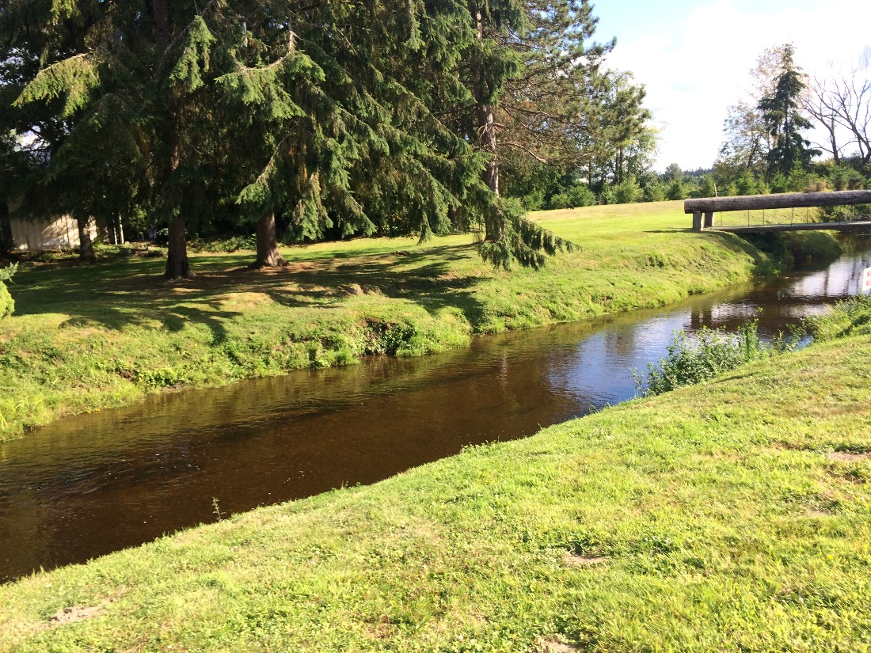

Figure The main section of the site showing low slope area.

Access to the site is from the Friendly Village neighborhood roads and specifically Snohomish Drive and Sealth Drive adjacent to the community swimming pool.

The site is open and easily accessed and includes room for staging equipment and materials for the construction.

|  |  |
| --- | --- |
| Chapter | Flow Analysis |
| 2 |

Flows in Bear Creek

# Hydrology

The nearest gage, King County Union Hill Road 02a, is located at approximately River Mile 1.3 and about 1 mile downstream of the restoration site on Bear Creek.

The exceedence curve of the daily average flow rate record is presented below and shows the 100 year flood to be approximately 1283 cfs at this location.

Specific return intervals are also shown using a best fit line with R=0.865

Figure Exceedence curve for Bear Creek at the Union Hill 02a gage for daily average flow

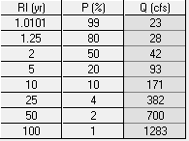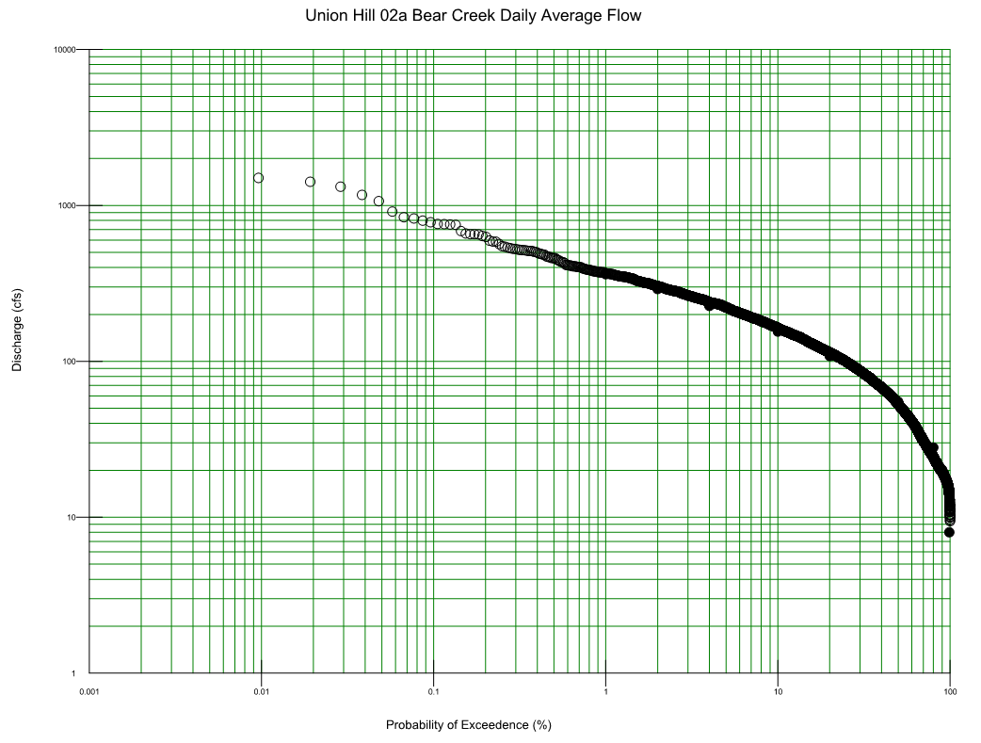

Figure Estimated daily average return intervals for lower Bear Creek, Union Hill 02a Gage

# Hydraulics

After the hydrology for the site is established, the hydraulic sizing of the stream restoration was begun. This is an iterative process that is completed during the final design phase.

Stream sizing of the preliminary bottom width and top width of the restored reach was established first by simply mimicking the existing dimensions. Plan formswere established in the conceptual design phase and included bend wavelength and radius of curvature.

This is seen in the table below and shows the averages found adjacent to the project. The radius of curvature used in the preliminary design is 75 feet. This conservative and will reduce streambank erosion seen now at the site.

Table Planforms found in Bear Creek adjacent to the project site.

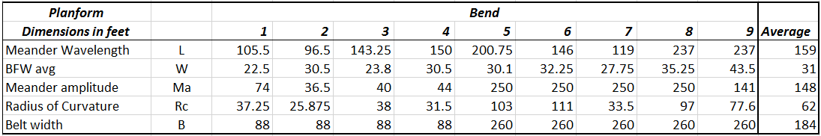Design of pools and riffles was accomplished using the bend count and setting each bend to associate with a pool as its exhibited in natural streams. Four pools were established and a stream profile was designed after this was complete.

The large wood (LWD) placed in the pools will help scour the fine sands and silt that are present in the reach. Riffles will scour in low water times and the pools will transport and scour during the 2 year and higher event flow rates. The LWD is anchored and will not float. The pools have the potential to aggrade during conditions that deliver sand to the reach. During the times of the antecedent leg of the hydrograph in which the sediment load is lower, the pools will tend to scour and transport sediment with the velocities increased around and through the LWD.

# Hydraulic Modeling

During final design hydraulic modelling of the project will be completed using the SRH two-dimensional model developed by the USBOR. This model will assist in the shaping and geometry of the final streambank and flood connection terraces. It will calculate water surface elevations, water velocities and sediment transport estimates. This model will be used to iterate geometries that will transport sediment during 2year flow events through the pools. Riffles will be sized using this technique as well and will provide for higher velocities and shallower depths and widths that are narrower to produce a natural stream channel.

|  |  |
| --- | --- |
| Chapter | Preliminary Design |
| 3 |

Preliminary Design Descriptions

The preliminary design of the of the stream restoration has been initiated in the August 3, 2016 drawing set. This is the first rendition of the geometry and layout. The constraints and criteria used are as follows;

1. Landowners interests
2. Sanitary sewer alignments and depth
3. Downstream shallow sanitary sewer location and log weir hydraulic control elevation
4. Four pools goal
5. Three riffles goal
6. Large wood complex structures full width of stream
7. Flood plain connectivity
8. Fish habitat for primarily rearing and some limited spawning sites

Initial layout and profiles are based on the completed topographic and bathymetric stream bed information for the site. This geometry is driven by the planforms and goals for the project.

Bends were established at approximately 75’ radii. The profile was modified to reflect riffles and pools coincidental with the horizontal plan. LWD is placed for habitat and sediment sorting. Floodplain terraces were placed on the two inside bends.

Upon receiving comments, we will iterate the alignment and wood placement as well as the channel width to depth ratios to first check flood elevations for no net rise. Then using the model, the channel final geometry is teased out of the anticipated results.

|  |  |
| --- | --- |
| Chapter | Costs |
| 4 |

Costs

Engineering Cost estimates will be completed in the next phase of design. These are preliminary design cost estimates. An estimate it should be treated as approximate and is completed before and after the final design is completed.

The quantity of materials is estimated using scale CAD drawings and are preliminary. Engineering and sales tax are included in both estimates.

The total construction delivery cost will be completed and reported below.

Preliminary Cost Estimates

Cost estimates follow.

Cost estimate page left blank at this time.