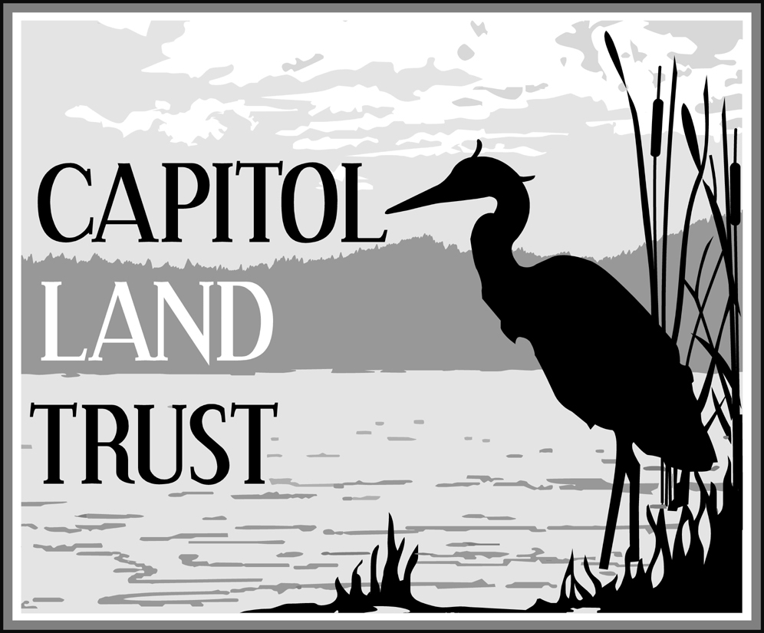

**Capitol Land Trust**

**Totten Inlet Estuarine Habitat Acquisition, project #09-1550A**

**Scope expansion request**

**August 20, 2010**

Capitol Land Trust (CLT) requests an expansion in scope for the Totten Inlet Estuarine Habitat Acquisition (project #09-1550A). CLT has the opportunity to purchase an additional 20-30 acres of forested wetland habitat adjacent to the current project site. As shown in the attached map, the landowner who owns the original 20-acre project site also owns the adjacent 40 acres of connected streams, wetlands, and associated forests. Due to declining property values, CLT has the opportunity to leverage existing funding to purchase additional conservation acreage.

The adjacent forested wetlands and streams are contiguous with, and similar to, the wetlands and streams on the original 20-acre project site. The same wetland types, riparian forest, streams and their important conservation values exist on the expanded conservation area. The wetlands on the adjacent forested parcel drain into the pocket estuary on the 20-acre project site. As contiguous and similar habitat to the original 20-acre project site, the expanded area is eligible for acquisition with SRFB funding.

CLT has engaged an appraiser, Stephen Shapiro, who is currently appraising the entire 60-acre property. Based on Mr. Shapiro’s appraisal, CLT will be able to specifically identify which portion of the 60-acres CLT may be able to purchase with existing funding, starting with the original 20-acre parcel and moving eastward to encompass as much of the additional wetlands and streams on the 40-acre parcel as possible.

Conservation of the adjacent 20-30 acres of forested wetland will provide additional protection of the estuarine and marine areas of the original project site. The interconnected mosaic of forested wetlands and small streams feed freshwater into the marine pocket estuary on the original 20-acre property. Protection of the adjacent riparian forest will filter sediments and moderate temperature in the forested wetlands and stream system, maintaining input of cool, clean water to the estuary. Protection of the site will create a dense shoreline and riparian forest that provides habitat-forming processes such as large wood recruitment, litterfall, and invertebrate drift into the estuary from the stream system and adjacent shoreline vegetation.

Conservation of the adjacent 20-30 acres of forested wetlands and streams will protect water quality by preventing sediment, toxic runoff, and septic pollution associated with development. One of the greatest threats to fish and wildlife habitat in Totten Inlet and on the site is the impact of increasing residential development in the surrounding watershed, including declining water quality from erosion and runoff caused by grading, building, and landscaping. Runoff from pesticide and fertilizers may cause accumulations of these materials in tideflats and in the shallow estuarine waters, and may detrimentally impact the invertebrate populations that provide food for fish, birds, and other wildlife. The increased protection afforded by this scope change is consistent with the same plans and priorities identified in the original grant application.

Expansion of the project scope will not affect CLT’s ability to acquire the original 20 acres proposed, it will instead allow CLT to increase the acreage conserved. This scope expansion will also not affect CLT’s ability to meet the milestone dates set forth in the original agreement. CLT is on track close on the acquisition by January 31, 2011, and complete the project by March 31, 2011. CLT originally set the purchase and sale agreement (PSA) milestone for July 31, 2010. This deadline has been delayed, but not as a result of this amendment request. CLT anticipates the appraisal will be completed by mid-September 2010, and therefore the PSA will be completed by the end of September or October by the latest.

The landowner has both the original 20-acre property and the adjacent 40-acre property listed for sale. The landowner has expressed an eagerness to sell the entire property to CLT specifically, but is highly motivated to sell and would accept a competing offer on the 40-acre parcel if we are unable to expand the scope of this project. The landowner is aware that the determination of what area CLT is able to purchase depends on an expansion of the original grant scope, as well as agreement on a purchase price based on appraised value.

The matching source for this grant is from the USFWS’ National Coastal Wetland Conservation Grant program. USFWS has already approved a scope expansion for this project to allow acquisition within the 60-acre area. The WRIA 14 Lead Entity supports this scope change. Attached is the letter of support from the WRIA 14 Lead Entity Coordinator. Approving this scope change will allow us to bring several hundred thousand dollars of additional federal money to provide better protection to the pocket estuary and overall nearshore habitat on this project site.

