P**ROJECT PROPOSAL – RESTORATION, ACQUISITION, AND COMBINATION RESTORATION/ACQUISITION PROJECTS**

**INSTRUCTIONS: Salmon Recovery Funding Board applicants must respond to the following items. Please respond to each question individually -- do not summarize your answers collectively in essay format). Local citizen and technical advisory groups will use this information to evaluate your project. Contact your lead entity for additional information that may be required. Limit your response to eight pages.**

**Submit information via the PRISM attachment process. Application checklists and attachment forms may be downloaded off the SRFB Web site at http://www.rco.wa.gov/srfb/docs.htm.**

**NOTE: Acquisition, Combination, Fish Passage, and Diversions and Screening projects have supplemental questions embedded within this worksheet. Please answer the questions below and all pertinent supplemental questions.**

**1) PROJECT OVERVIEW**

Explain your project overall and include the following elements:

a) List your primary project objectives, such as how this project will improve or maintain habitat conditions and habitat forming processes.

**Protect natural functioning riparian and side channel habitats from negative effects associated with development.**

**Project Overview: The Washington Department of Fish and Wildlife, in partnership with the Colville Tribe, intends to purchase fee title ownership, or conservation easements, from willing landowners along the middle reaches of the Okanogan River. This is a key reach that retains quality riparian characteristics and largely uninhibited floodplains. The project area represents the last naturally functioning section of the Okanogan, lying approximately between the towns of Riverside and Tonasket. The Okanogan is the northernmost anadromous fish-bearing tributary to the Columbia River. The project area supports spawning and rearing for steelhead and summer Chinook salmon, and supports reintroduction efforts for spring chinook. The project would protect natural riparian habitats, limited on the Okanogan, from potential negative effects of residential development. The project would also protect side channels and wetland sloughs from development. These off-channel features provide key habitats for many fish and wildlife species, including neotropical migratory songbirds, amphibians, anadromous fish and wetland mammals. Landowners on key parcels have expressed willingness to work with agencies and the Colville Tribe.**

b) State the nature, source, and extent of the problem that the project will address, including the primary causes of the problem, not just the symptoms. Explain how achieving the project objectives will help solve the problem. (Fish Passage projects and Diversions and Screening projects should refer to the supplemental questions later in this worksheet for further guidance on information to include in their problem statement.)

**The Okanogan River corridor is fast becoming a destination for new dispersed residential development. Many ranching families, and their successors, are under**

**pressure to sell out while the large blocks of land are still intact. Zoning rules in Okanogan would allow development close along the river, with the associated loss of riparian vegetation, bank protection (usually rip rap) and disturbances from human presence. This project would protect existing quality habitats. Long term, this portion of the Okanogan River offers one of the best opportunities for conservation in the entire Okanogan basin.**

c) Describe the fish resources (species and life history stages present, unique populations), the habitat conditions, and other current and historic factors important to understanding this project. Be specific--avoid general statements. Which salmonid species and life cycle stage(s) are targeted to benefit by this project?

**Federally listed steelhead utilize the McLoughlin Falls area for spawning and seasonal rearing (see attached PPt). Summer Chinook likewise use the area. Spring Chinook are being restored in the river by the Colville tribes, and sockeye pass through the area on their way to Lake Osoyoos. Protecting habitat complexity, both in and adjacent to the river would benefit all of these species. (Okanogan Basin Monitoring Report, Arterburn Colville Confederated Tribe, 2009)**

d) Discuss how this project fits within your regional recovery plan or local lead entity strategy (i.e., does the project address a priority action, occur in a priority area, or target priority fish species?).

**Protecting off channel complexity and riparian habitats are specifically identified priorities in the Habitat Work Schedule and the Okanogan River Implementation Plan for the Upper Columbia Recovery Plan. These plans reflect the biological priorities identified in the Biological Strategies of the Upper Columbia Salmon Recovery Plan.**

e) Has any part of this project been previously reviewed and/or funded by the Salmon Recovery Funding Board? If yes, please provide the project name and SRFB project number (or year of application if a project number is not available). If the project was later withdrawn for funding consideration or was not awarded SRFB funding, please describe how the current proposal differs from the original.

**Yes. McLoughlin Falls 2009, 09-1743**

When possible, list your sources of information by citing specific studies, reports, and other documents.

**2) PROJECT DESIGN**

a) Describe the location of the project in the watershed, including the name of the water body(ies), upper and lower extent of the project (if only a portion of the watershed is targeted), and whether the project occurs in the nearshore, estuary, main stem, tributary, off channel, or other location.

**The project area lies roughly between the towns of Riverside and Tonasket on the Okanogan River. Project target lands are centered on T36N R27E section 16. The project is within the only canyon portion of the Okanogan River in the United States.**

b) Describe the project design and how it will be implemented. Describe the extent of the project. Describe specific restoration methods and design elements you plan to employ. If restoration will occur in phases, explain individual sequencing steps, and which of these steps is included in this application. (Acquisition-only projects need not respond to this question.)

N/A

c) Describe the scale and size of the project or property(s) to be acquired, and its proximity to protected, functioning, or restored habitats. (Fish Passage only projects and Diversions and Screening only projects [i.e., not a combination] need not respond to this question.)

**Target Parcel: Wilson. 160 acres total. 90 acres of floodplain and riparian habitats (approx).**

**70 acres upland.**

**1.1 miles of Okanogan River (left bank only)**

**Adjacent to BLM, and Colville Tribal parcels (purchased for conservation). Across river from WDFW lands and other target parcels. Within key conservation focus area identified by WDFW staff and vetted w/ Okanogan County Commissioners.**

**See attached maps.**

d) Describe the long-term stewardship and maintenance obligations for the project or acquired land. For acquisition and combination projects, identify any planned use of the property, including upland areas.

**If lands are acquired and held in fee title by WDFW, land management and monitoring would become responsibilities of the wildlife area manager, likely the nearby Sinlahekin Wildlife Area. WDFW staff would take on the responsibilities for management.**

**PROJECT DEVELOPMENT**

e) List the individuals and methods used to identify the project and its location.

**WDFW and the Colville Tribe have had a long-standing interest in land protection in this section of the Okanogan River. It is considered part of north-south and east-west habitats essential for landscape connectivity for fish, and wildlife. Coordination and work on this area is occurring between various organizations in this area.**

f) Explain how the project’s cost estimates were determined.

**Recent appraisal work on nearby properties gave a good estimator value that will likely be reflected on these properties.**

g) Describe other approaches, opportunities, and design alternatives that were considered to achieve the project’s objectives.

N/A

h) Describe the consequences of not conducting this project at this time. Consider the current level and imminence of risk to habitat in your discussion.

**The Okanogan river valley is experiencing, considerable growth and development. In the Okanogan many people from Canada are buying land for home sites because it is cheaper in the US than in Canada, and the climate is mild.**

i) Describe any concerns about the project raised from the community, recreational user groups, or adjacent land owners, and how you addressed them.

**Ongoing concerns from local government are being addressed through coordination meetings and open communication. For example, on July 13, 2009, policy representatives from WDFW and the governor’s office met w/ Okanogan County Commissioners met and discussed WDFW land protection projects in Okanogan County. Similar meetings have occurred in 2010.**

j) Include a Partner Contribution Form, when required, from each partner outlining its role and contribution to the project. This form may be downloaded off the SRFB Web site. State agencies are required to have a local partner that is independently eligible to be a project sponsor. A Partner Contribution Form is also required from partners providing third-party match.

**The Colville Tribe is a potential partner in this project, however at the time of application WDFW plans to acquire the target parcel without partners.**

k) List all landowner names. Include a signed Landowner Acknowledgement Form (available on the SRFB Web site) from each landowner acknowledging their property is proposed for SRFB funding consideration. If a restoration project covers a large area and encompasses numerous properties, Landowner Acknowledgement Forms are not required. For sponsors proposing work on their own property, this form is not required. For multi-site acquisition

projects involving a relatively large group of landowners, include, at a minimum, signed

Landowner Acknowledgement Forms for all known priority parcels.

**Henry Wilson – Landowner Form Attached**

l) Describe your experience managing this type of project. List the names, qualifications, roles, and responsibilities for all known staff, consultants, and subcontractors who will be implementing the project. If unknown, describe the selection process.

**WDFW real estate and Wildlife staff, have extensive experience in working with real estate contracts and application of approved grant moneys. Ken Bevis has worked on several land protection projects. Scott Fitkin, WDFW Wildlife staff, has extensive land protection experience as well.**

**3) TASKS AND SCHEDULE**

List and describe the major tasks and time schedule you will use to complete the project.

**CONSTRAINTS AND UNCERTAINTIES**

Each project should include an adaptive management approach that provides for contingency planning. State any constraints, uncertainties, possible problems, delays, or unanticipated expenses that may hinder completion of the project. Explain how you will address these issues as they arise and their likely impact on the project.

**The key uncertainty revolves around the willingness of the target landowner to accept an offer from public moneys, based upon appraised values. Alternate parcels meeting the same resource objectives are adjacent, and could be targeted with these funds if Wilson is not completed. (See maps).**

**Supplemental Questions**

**4) PROJECTS INVOLVING ACQUISITIONS (Applies to both Acquisition-only and Combination Projects)– Answer the following questions**

a) Describe the type of acquisition proposed (e.g., fee title, conservation easement).

**Fee title**

b) Describe the habitat types on site (forested riparian/floodplain, wetlands, tributary, main stem, off-channel, bluff-backed beach, barrier beach, open coastal inlet, estuarine delta, pocket estuary, uplands, etc.), their size in acres, and quality. If uplands are included, explain why they are essential for protecting salmonid habitat. Describe any features that make the site unique.

**Wilson**

**160 acres total. 90 acres floodplain and riparian. 70 acres upland.**

**1.1 miles of Okanogan River (left bank only)**

**Adjacent to BLM and Colville Tribal parcels (recently purchased for conservation). Across river from WDFW and other target parcels.**

**Excellent side channel and mixed floodplain habitats, wetlands with cottonwood and willow habitats. Island and rare rapids. Site is very diverse, with floodplain lands transitioning directly into rocky, upland shrub steppe in a near-desert setting. Downstream portions are in pasture/hay fields with opportunity for restoration. An active railroad grade bisects the floodplain, with approximately 25 acres of floodplain east of the grade. Aerial photos from flood event indicate connectivity with floodplain (see attached PPt).**

**Located within key conservation target area**

b) State the percentage of the total project area that is intact and fully functioning habitat.

**Wilson –approx 30% in functioning riparian and side channel, 10% functioning floodplain agriculture, 15% partially functioning floodplain behind railroad grade, 45% in shrub steppe uplands. (See attached map in PRISM w/ breakdown of project lands).**

c) Explain the degree to which habitat on site is impaired and the nature and extent of required restoration. If the property is in the channel migration zone, is that function intact (i.e., do existing levees, riprap, infrastructure, or other features on this or nearby properties inhibit channel migration)? Describe the likely prioritization, timeframe, and funding sources for proposed restoration activities.

**Wilson – Riparian habitats on this property are in excellent shape with good vegetation on wetlands and side channels (photos below). Floodplain habitat in grass and pasture in good condition. Railroad grade cuts through part of floodplain, but has connectivity in flood flows. (See attached PPt). Future restoration projects (not part of this proposal) could entail better flood connection through railroad, upland habitat restoration and riparian plantings along river. The channel migration zone here is intact and functioning, with side channels and native vegetation.**

d) List existing structures (home, barn, outbuildings, fence) on the property and any proposed modifications. Note: In general, buildings on SRFB-assisted acquisitions must be removed. Refer to Section 2 of SRFB Manual 18 for information about ineligible project elements.

**Wilson – structures are old and would be removed before closing.**

e) Describe adjacent land uses (upstream, downstream, across stream, upland).

**Wildlife habitat, rangeland and limited residential use, esp. downstream from project**

**area. The project area is very wild.**

f) Describe why acquisition is needed. Explain why federal, state, and local regulations do not provide enough protection. State the zoning and Shoreline Master Plan designation.

**Okanogan County has limited restrictions on land uses. The current zoning in this area would allow 5 acre parcels, with exempt wells on each. Building setbacks from the river are established at 200 feet under current Shorelines rules, but these are currently being rewritten. Routine exemptions allow 50 foot building setbacks, which would be likely here. There is the potential for development and associated habitat degradation in this area. This is the last opportunity to protect large blocks of naturally functioning river on the Okanogan. It is a “Last Best Place”.**

g) If buying the land, explain why the acquisition of conservation easements to extinguish certain development, timber, agricultural, mineral, or water rights will not achieve the goals and objectives of the project.

**Wilson – Landowner wants to sell.**

h) For multi-site acquisition projects, identify all the possible parcels that will provide similar benefits and certainty of success and provide a clear description of how parcels will be prioritized and how priority parcels will be pursued for acquisition.

**Alternate parcels, Pariseau and Voelker, both on the west side of the river, would be proposed if the target parcel is no longer available.**

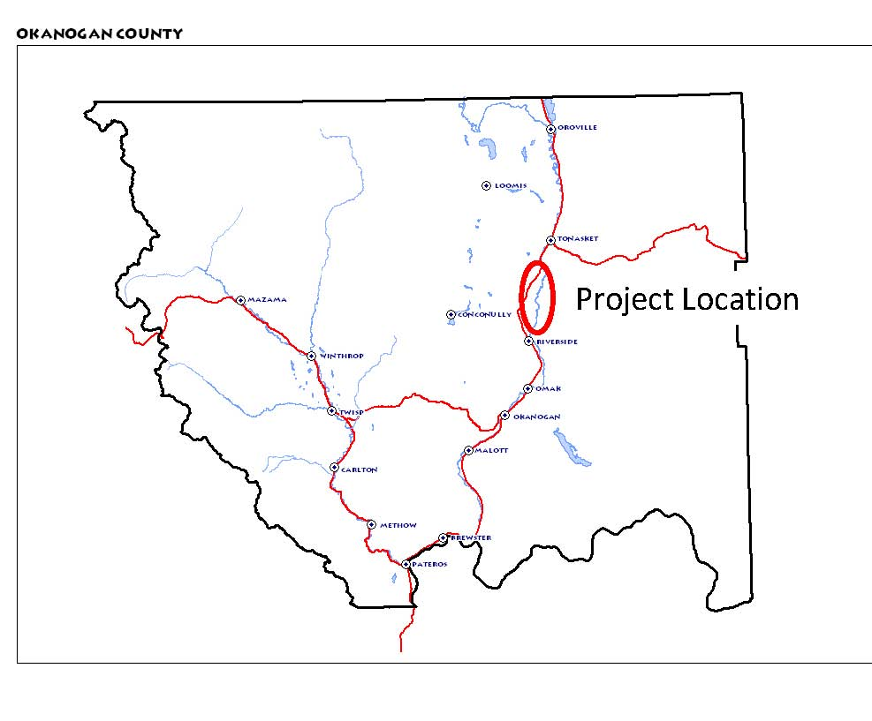

**McLoughlin Falls Project Locator**

**McLoughlin Falls Project Parcels**

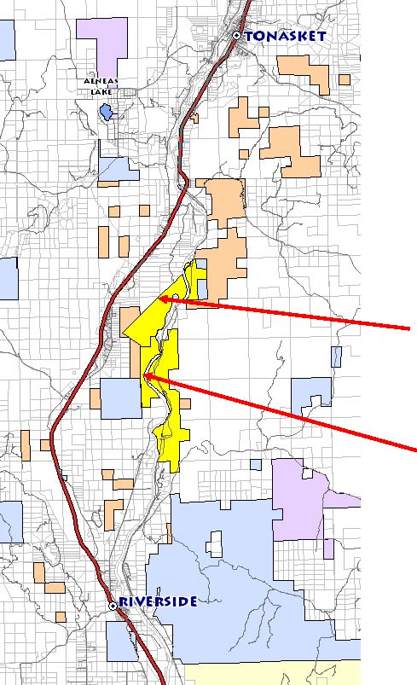

Alternates

**Wilson**

Alternates

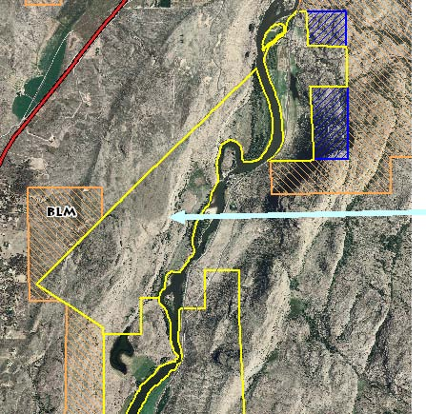

WDFW

BLM

Colville parcel

Par

**Wilson Parcel**

Alternate

[Type a quote from the document or the summary of an interesting point. You can position the text box anywhere in the document. Use the Text Box Tools tab to change the formatting of the pull quote text box.]

**McLoughlin Falls Project Area Photos**

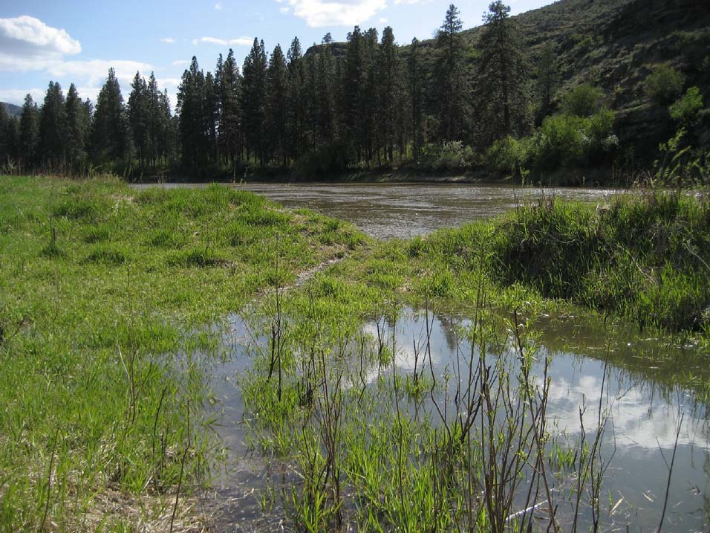

**Wilson property in foreground**

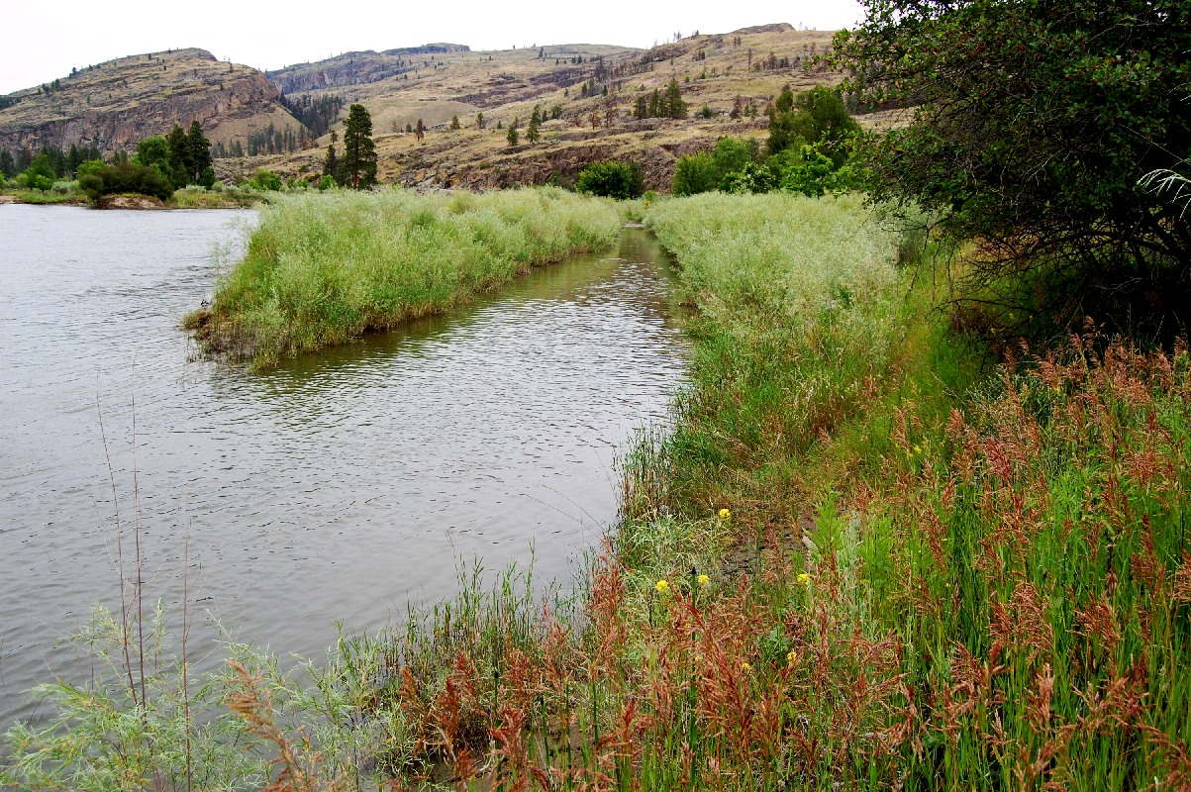

**Wilson Property**

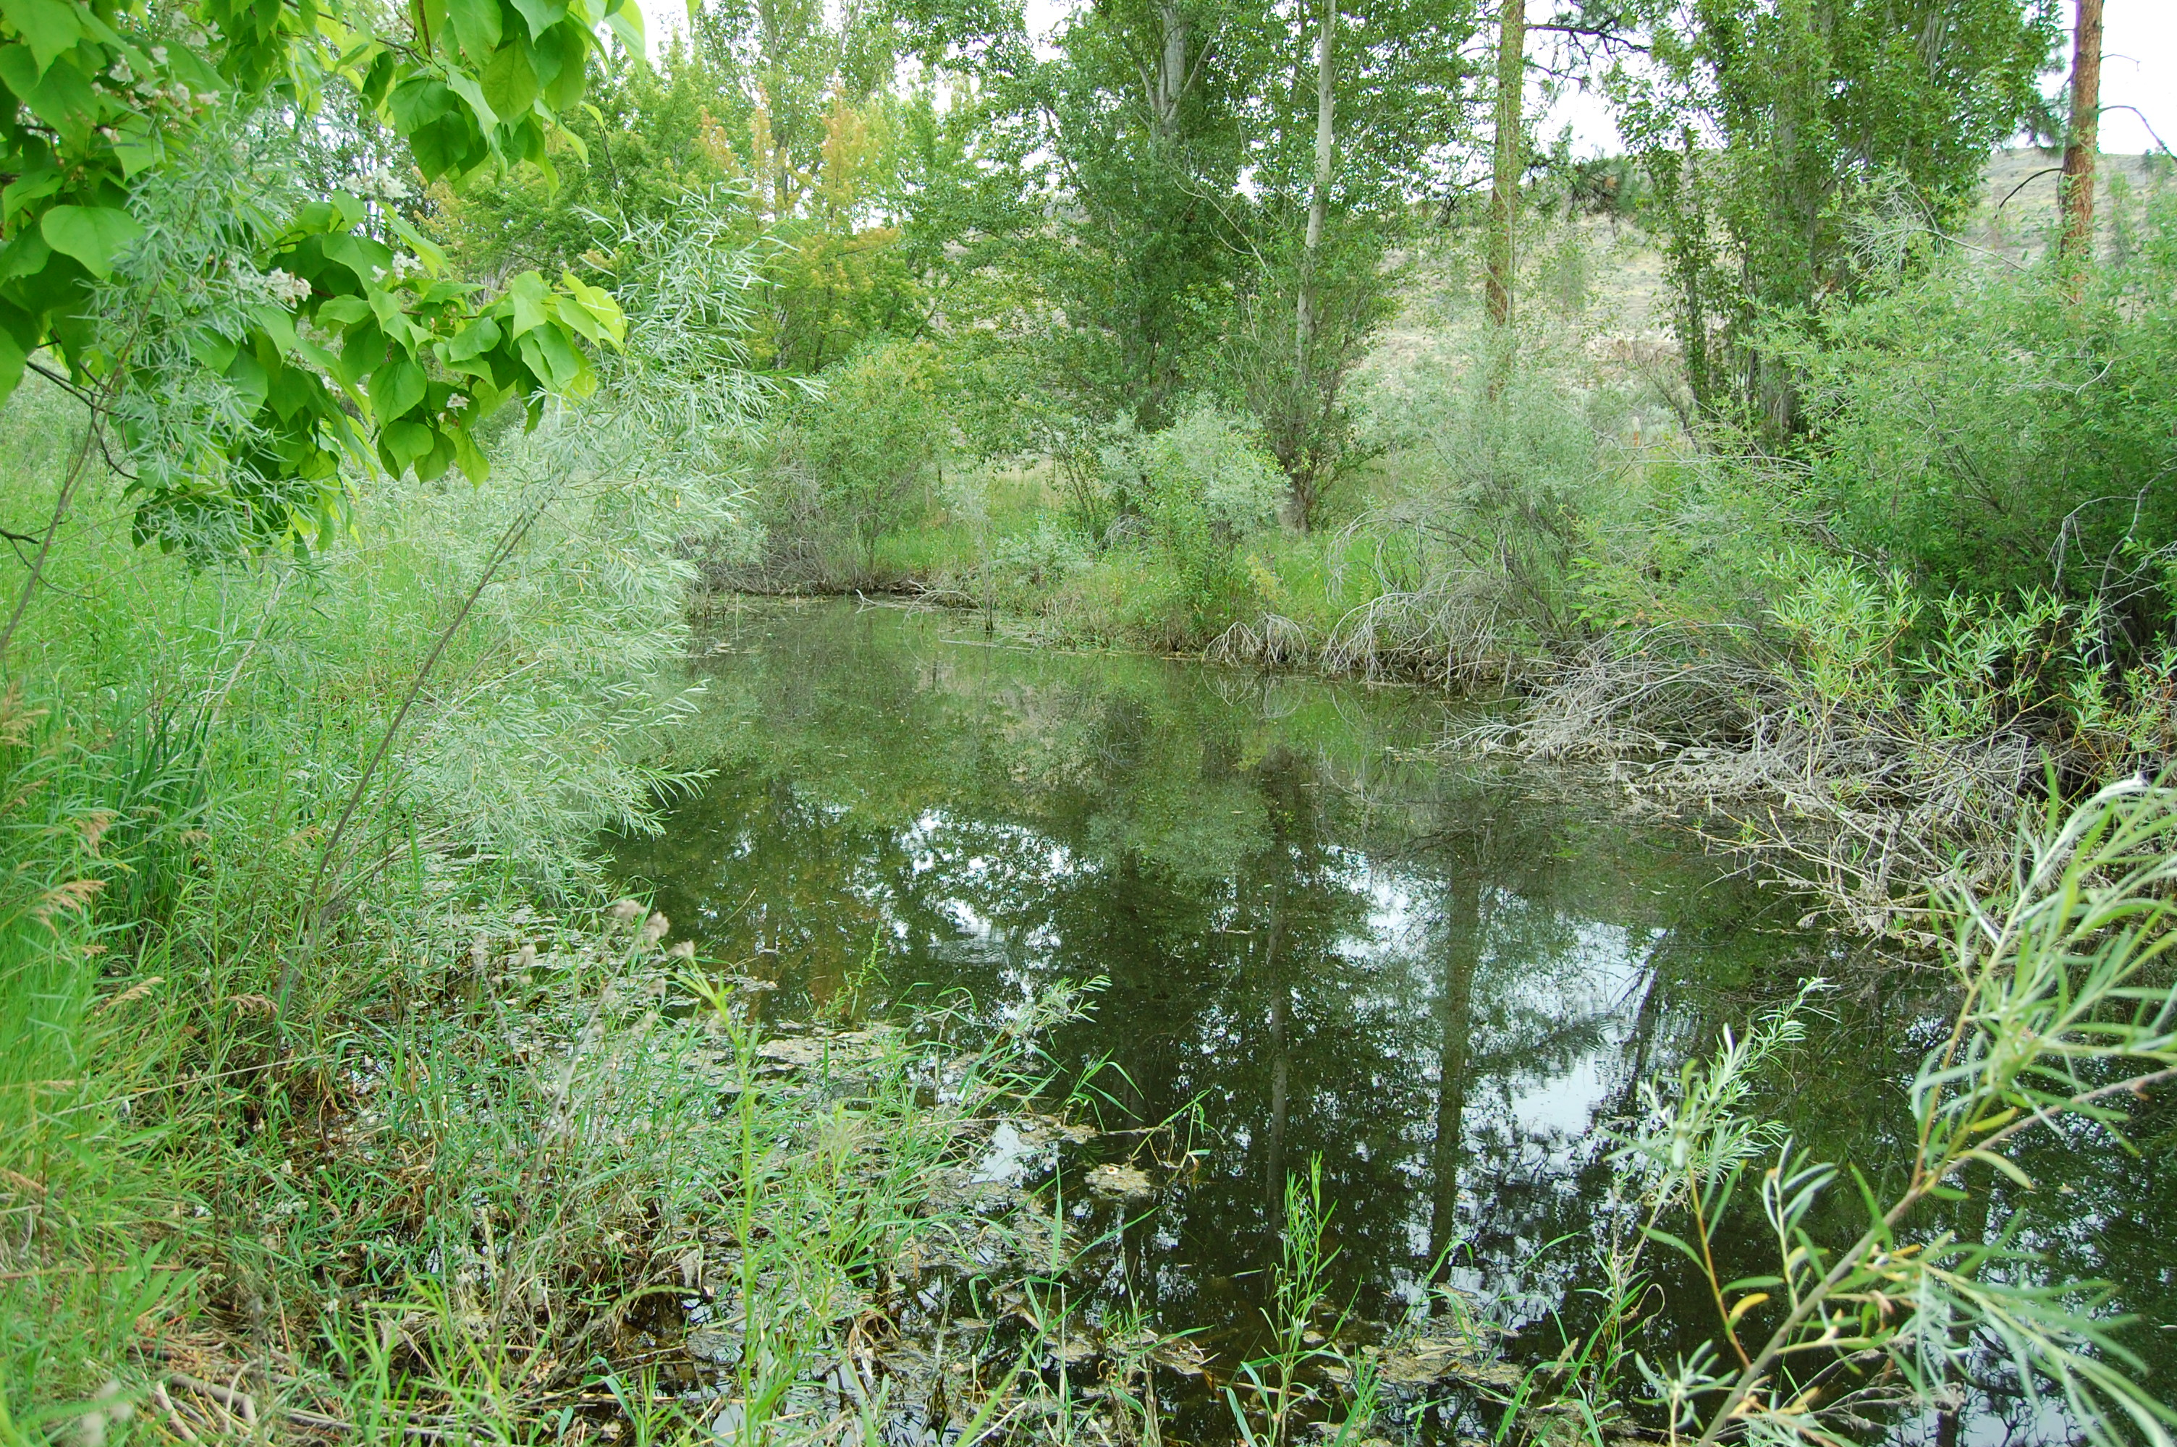**Wilson Property – Wetland side channel. Connected at high water.**

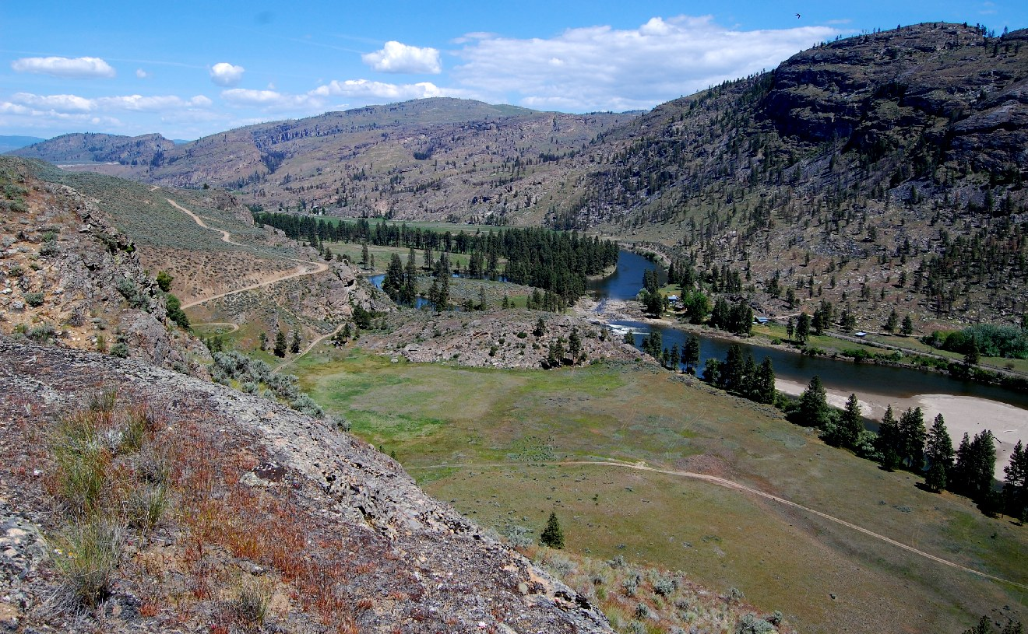

**McLoughlin Falls area, Wilson on far bank of Okanogan R. looking north into canyon area. Big landscape. “Last Best Place”.**



|  |  |  |  |  |
| --- | --- | --- | --- | --- |
| **Item** | **Cost/unit** | **Units** |  | **Donated/Other Source** |
| Acquisition |  |  | $400,000 | 2010 SRF Board |
| Acquisition |  |  | $100,000 | 2009 SRF Board |
| Acquisition |  |  | $600,000 | WDFW/ Sec 6 USFWS |
|  |  |  |  |  |