**Upper Chumstick Bridges: Pre-construction and one year after construction**

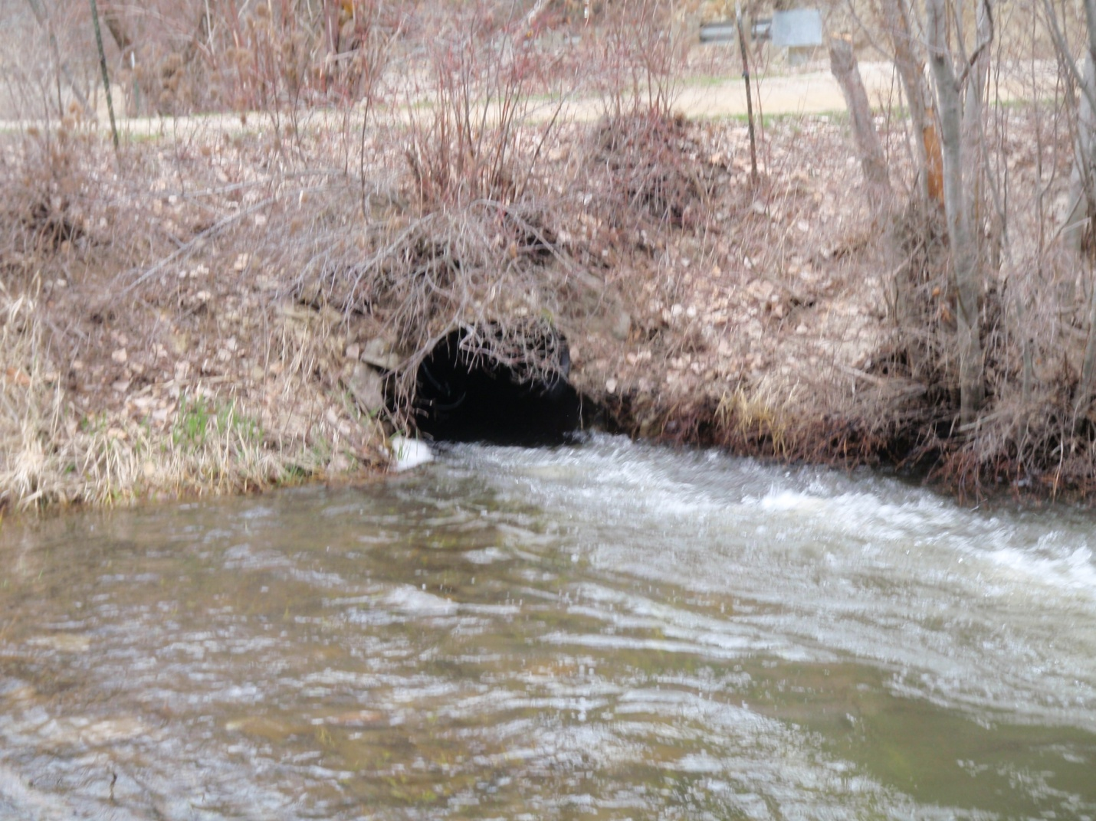

Cann culvert outlet 2010.

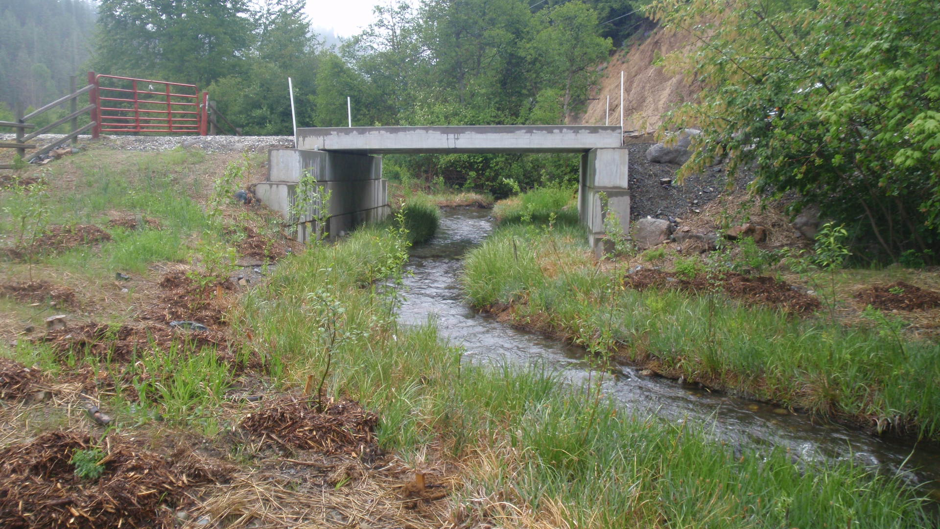

Cann bridge outlet 2013.

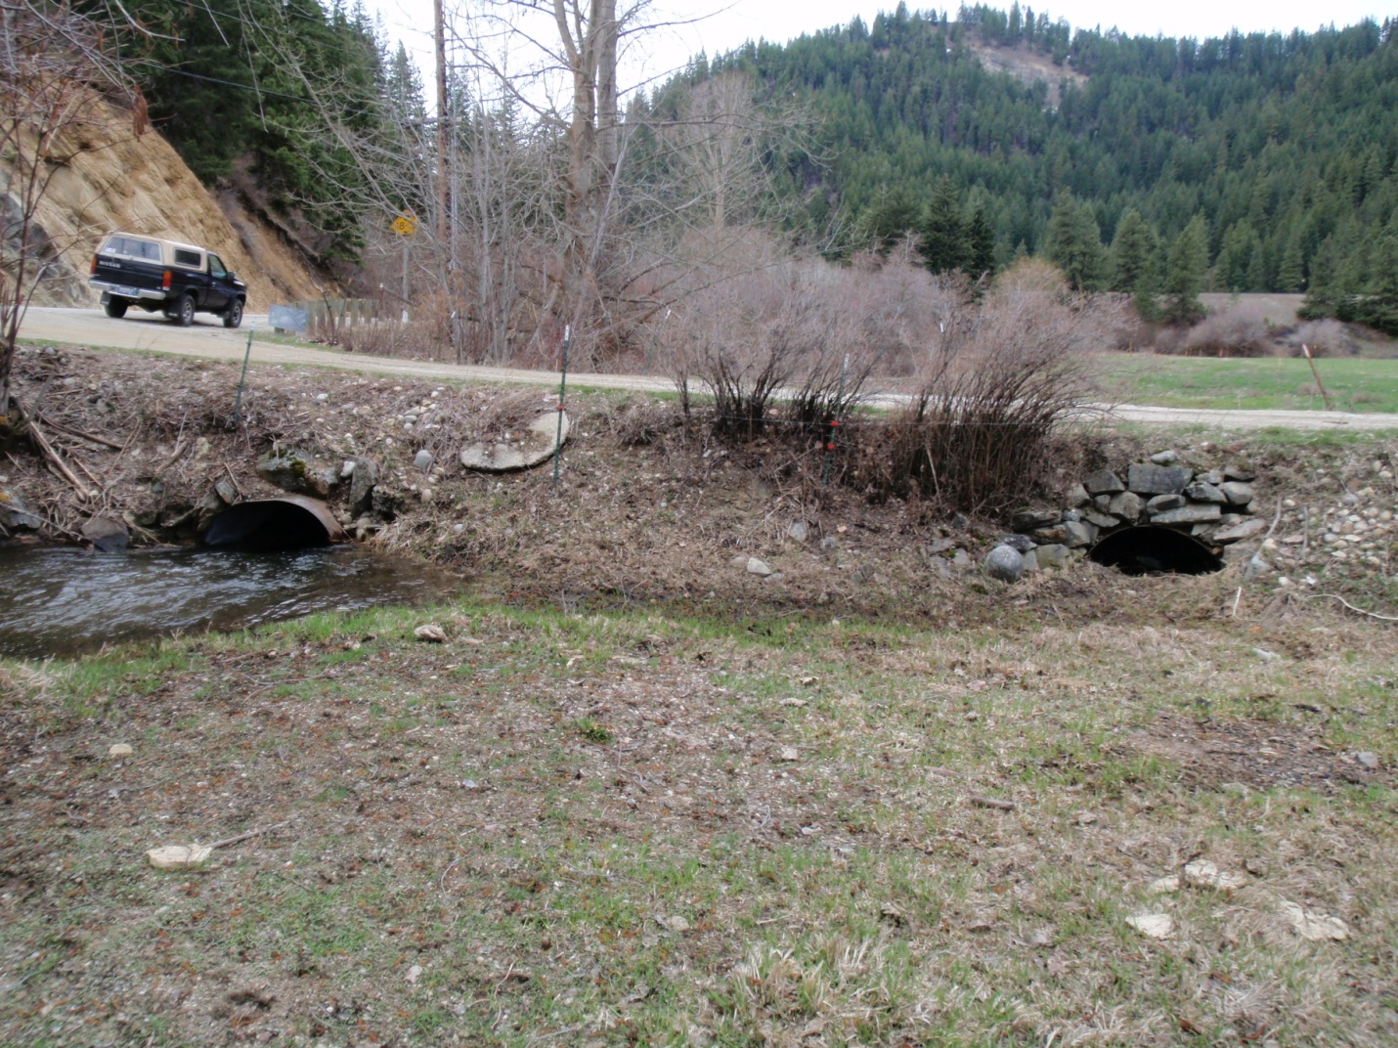

Baumann culvert inlet 2010.

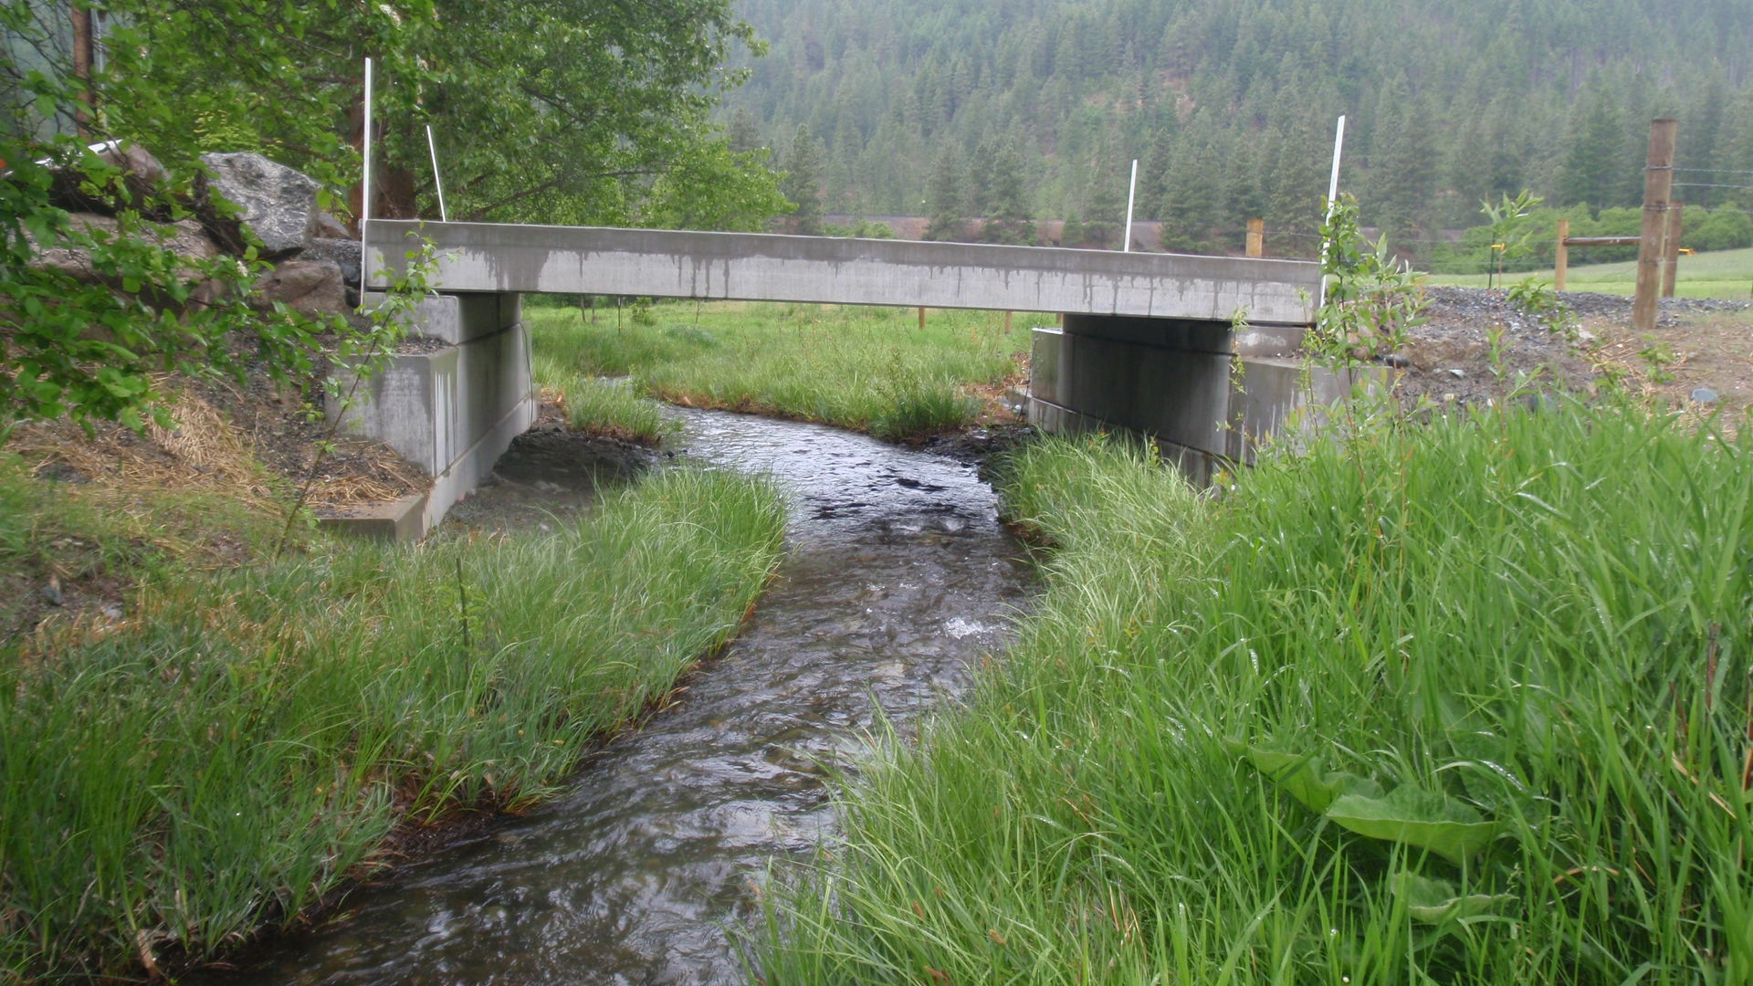

Baumann bridge inlet 2013.

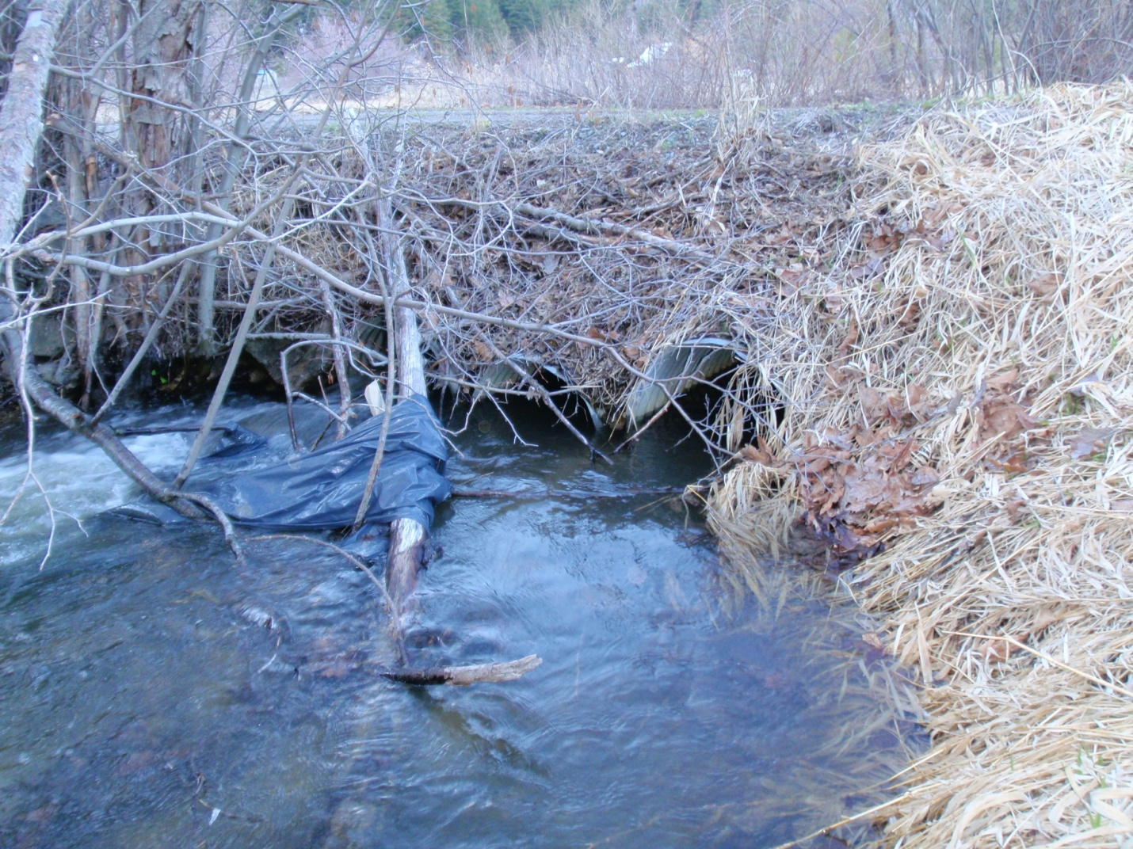

Ott culvert outlet 2010.

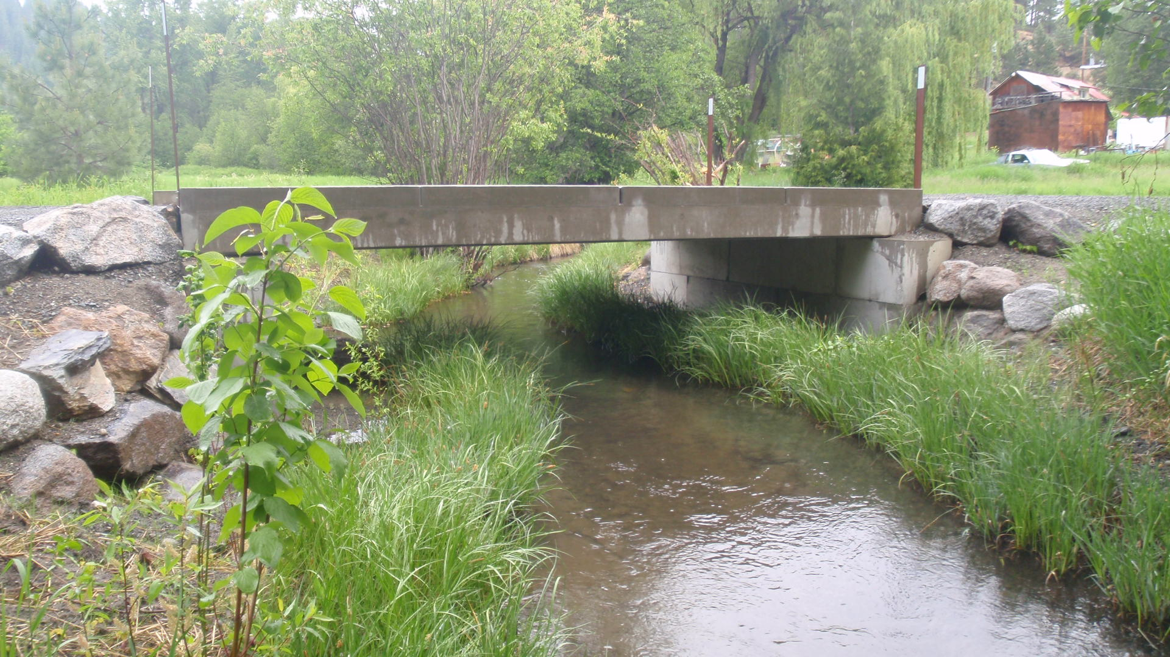

Ott culvert outlet 2013.