## **Skookum Valley Riparian Management**

## **RCO 24-1243**

## **River Mile 6.5 Site**

## **Scope of Work and Summary**

July 2024



**Site:** River Mile 6.5 (Squaxin Island Tribe)

**Size:** 10.4 acres

**Category Proposed:** New Planting, Annual Maintenance

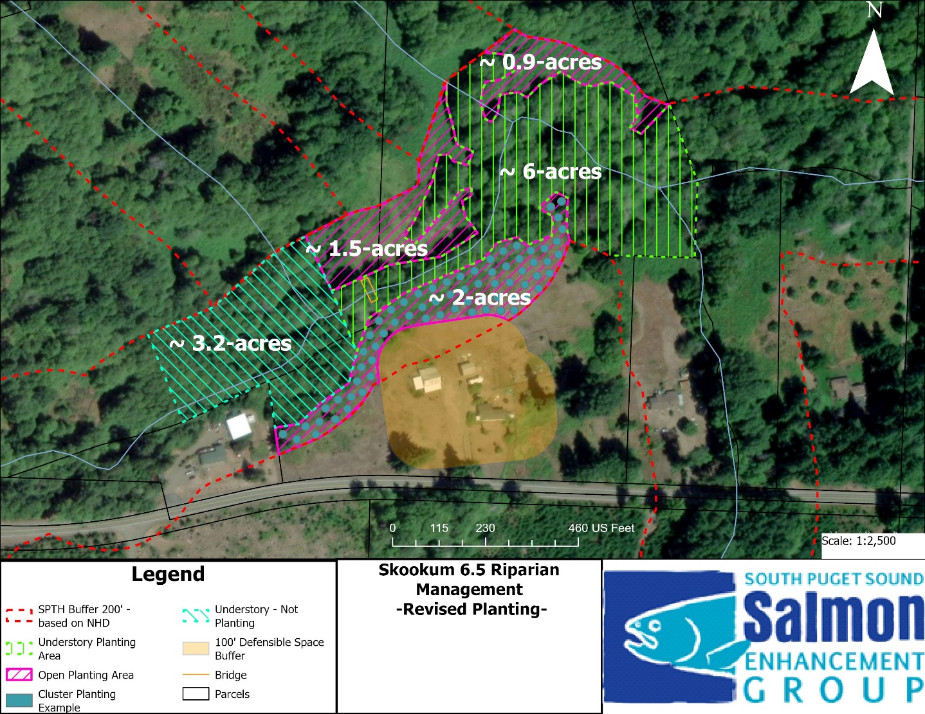

Figure 1. RM 6.5 Site work area separated into understory (green) and open area (pink) planting, with 200’ riparian buffer (red) and 100’ defensible space buffer around structures (orange). Western Understory (blue) not being planted in this project, the area has a substantial canopy cover, with largely native undergrowth (dominated by Salmon Berry).

**Description and Site Conditions:** The worksite is near River Mile 6.5 of Skookum Creek and spans two adjacent parcels owned by the Squaxin Island Tribe. The overall properties are fairly large and include a residence and associated outbuildings, extensive fields around the residence, and green spaces along Skookum Creek and the surrounding floodplain areas.

The Tribe has dedicated the stream corridor and surrounding floodplain areas to restoration and conservation and to that end a prior-funded stream restoration project (20-1090) is currently moving forward and will be constructed in summer 2024. Treatment types for the stream project will include the placement of several wood clusters and logs and side channel connection elements.

Within the proposed planting areas there are generally two zones- an existing riparian forest in mid-successional status, and more open areas dominated by non-native plants, especially blackberry and pasture grasses. Some pockets of native wetland vegetation communities are interspersed in both zones.

The primary goal of this project is to restore and enhance riparian conditions along Skookum Creek, as supplemental to the in-stream restoration occurring in 2024, which is to include site preparation, installation of native plants, weed control, and annual maintenance.

**Precipitation:** 60-70 inches per year

**Soils:**

Grove gravelly sandy loam, 0 to 5 percent slopes

Maytown silt loam, 0 to 3 percent slopes

**Water Quality:** Category 5 -303d for Temperature

**Hydrology:** Perennial surface flow is primarily found in Skookum Creek; intermittent tributaries provide surface flow from ~December through May; high groundwater tables associated with wetlands occur in portions of the planting areas. Newly accentuated side channels in this reach (from project 20-1090) provide increased access to substantial floodplains during higher flows in this reach.

|  |  |
| --- | --- |
|  |  |
| Blackberry control area and existing riparian | Open/grass area |

**Goals and Objectives:** The primary goals are to convert the open, grass and shrub dominated portions of the buffer to forest, remove large swaths of blackberry and plant with trees, remove or control non-native plants in the existing forest (holly and blackberry), increase the conifer component of the existing forest, and to conduct maintenance within all treatment areas for three years.

Goal 1 – Reduce cover of non-native plant species including Himalayan blackberry, holly, and pasture grasses (*Agrostis* sp., *Festuca* sp., and others).

Goal 2 – Convert open, grass or shrub dominated areas within 200’ of Skookum Creek to native forest. NOTE: A 100’ defensible space buffer has been added around the structures to accommodate tenant safety and climate change/fire danger realities.

Goal 3 – Improve the diversity and quality of existing riparian forest by under-plantings with coniferous tree species.

Objective 1 – Conduct site preparation with methods TBD which may include herbicide treatment, mowing, and/or mechanical removal of non-native species, sod scalping, placement of mulch and compost, and other methods.

Objective 2 – Install native trees and shrubs in the riparian buffer work area.

* ~4.4-acre open/grass area: plant spacing avg. 700/acre
* ~6-acre existing forest area: under plantings of conifers spacing TBD

Objective 3 – Conduct annual maintenance across the planting areas to include mowing, grass/weed control, browse control, mulching, and other methods, for 3 years.

**Conceptual Planting Plan:**

3220 total plants/trees

~ 4.4-acre grass/open zone: Clustered plantings in 20’ diameter circles with 15-20’ between circles and 20 plants per cluster at 5’ OC ~ 700 plants/acre, 200’ buffer.

Clustered planting is intended to make stewardship easier and less costly, make tracking easier, and promote diverse ecological function. The end goal would be that these circles eventually merge to form a forested mosaic. This does not significantly reduce the number of trees needed but is intended stewardship costs while increasing plant survival. These will also allow us to fit plantings to microhabitats, especially important in the open areas of the lower floodplains to the north. We will reserve a small amount of funding (and look to acquire future funds for continued maintenance) to help stitch together clustered planting with appropriate foliage later in the project, once clustered plots are established and less invasive maintenance is required.

Potential plant species: red alder, Oregon ash, grand fir, Douglas-fir, vine maple, bitter cherry, Western crabapple, Sitka willow, Scouler’s willow, Nootka rose. Assumes 1-1 bare root 12-18”.

~6-acre existing forest zone: Spacing as needed to add conifer component; estimated 25’ O.C. or ~ 420 trees.

Western red cedar, Western hemlock, Sitka spruce. Assumes 1-1 bare root 12-18”.

Mowing/trimming around trees 3-4 times per growing season, 3 years.

Mulching around trees, once.

Weed control to include mowing/trimming, mechanical removal, herbicide, 3-4 times per season, 3 years.