Ott Bridge 2013 Monitoring Report

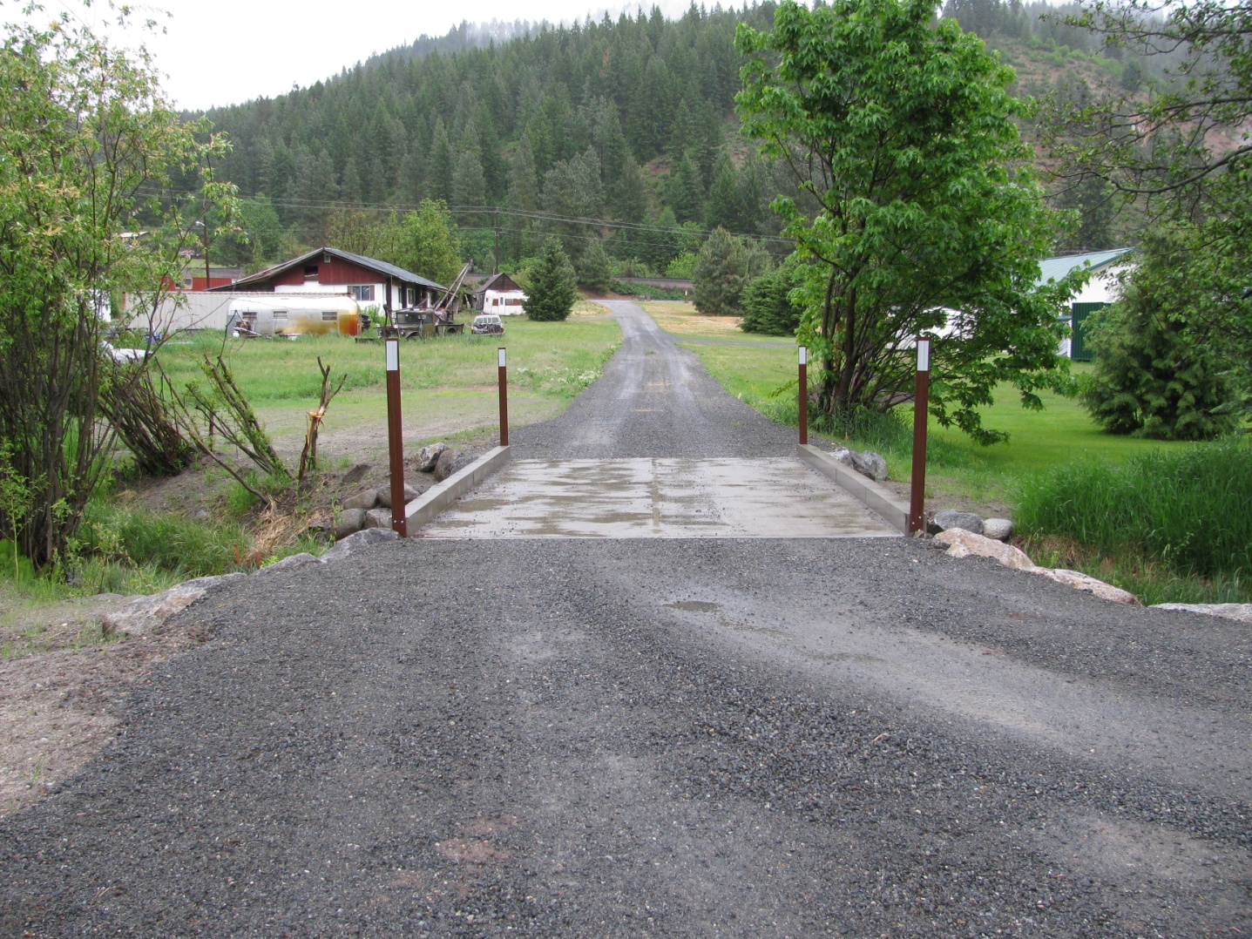

Prepared by: Chelan County Natural Resources Department

Adrienne Roumasset

**Introduction/Background**

The Ott Barrier project removed a fish passage barrier on Chumstick Creek river mile 8.23 as part of the Chumstick Barrier Removal project – a multi-agency partnership that removed all 30 Chumstick Creek fish passage barriers between RM 0.28 to RM 8.6 (26 culvert barriers and 4 irrigation dams) from 2001-2013. The Ott project was completed in 2012 and consisted of replacing a partial barrier culvert with a bridge, thus providing ESA listed salmonid species with complete access to upper reaches of Chumstick Creek.

Chumstick Creek is historical spawning and rearing habitat of steelhead, bulltrout, and coho salmon. The overall objective of the Chumstick Barrier Removal project was to reopen habitat and reinstate migration of these species into Chumstick Creek. The specific goals of the Ott Barrier removal project is to 1)replace the culvert with a concrete bridge to provide salmonids with access to reaches above RM 8.23 2) re-vegetate the work area to provide a diverse riparian habitat. The goal of monitoring Ott is to assess whether these goals are being met. Observations and data collected will be used to recommend adaptive management actions as needed to meet project objectives.

**Monitoring Methods**

CCNRD staff visited the site on May 21st, 2013 and June 5th, 2013 and estimated flow to be approximately 20 cfs and 10 cfs respectively during the May and June visits. Exact flow is unknown due to malfunctions with the DOE gage. Specific monitoring goals during the site visits were to 1) Document channel and bridge condition 2) assess the status of riparian revegetation. Fish passage through the three pit tag arrays in 2013 is also reported.

*Channel and Bridge Monitoring*

CCNRD staff took photos at established photo points during the May 21st visit during high flow. Pictures were compared to post construction (2012) to document general changes in channel geomorphology, bridge condition, and riparian cover. Any erosion or deposition issues were documented at low flow during the June 5th visit.

*Riparian Monitoring*

CCNRD staff performed stem counts throughout the planted area on June 5th 2013. The planted area was divided into quadrants – 2 on the left bank (A and B) and 2 on the right bank (C and D). A and C were upstream of the bridge and B and D were downstream (Figure 1). Plant survival and percent native shrub cover were visually estimated.

Figure 1. Quadrants for stem counts and shrub cover estimates.

**Flow**

*Fish Passage*

A pit tag array near the mouth of Chumstick creek at north road (RM 0.28) has monitored fish passage into the creek since 2010. Two additional arrays were installed in March of 2013 to monitor adult fish passage at Sunitch creek (RM 5.3) and Merry creek (RM 8.82). 2013 fish detections are reported here.

**Results/Discussion**

*Channel and Bridge Monitoring*

Photo points indicate that the Ott bridge functions as designed to provide fish passage. CCNRD staff observed no structural issues with the bridge, bank erosion or sediment deposition around the project (Figure 1). Coarse gravel ideal for steelhead spawning (approximately 0.25- 3.0 inch diameter) was observed at the upstream end of the bridge during the June 5th visit.

Figure 1. PHOTO POINTS Post Construction, 2012 (left photos) and May 21st, 2013 (right photos)

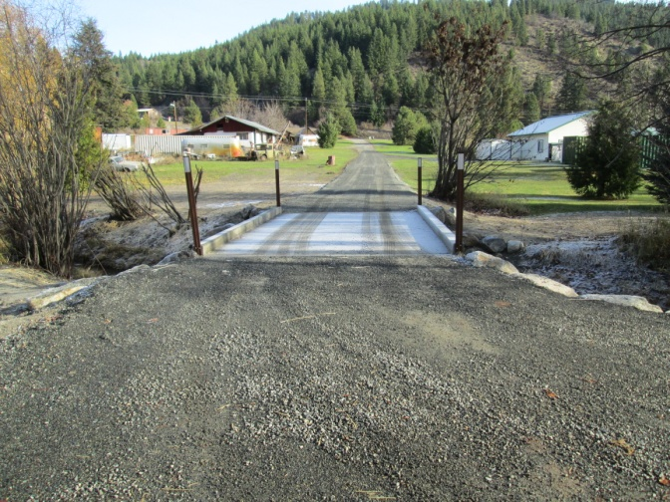 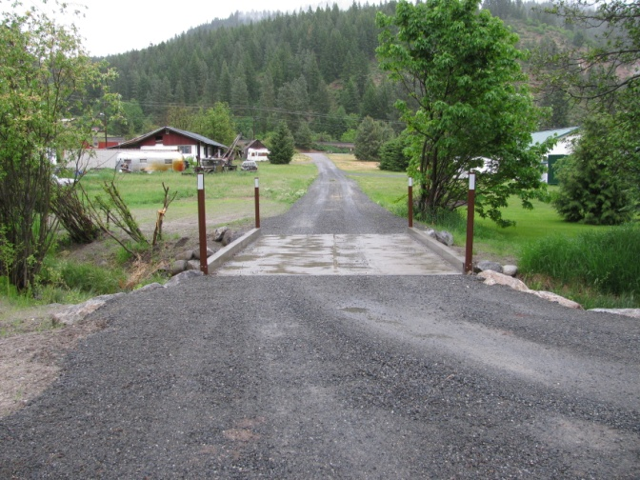

PP1

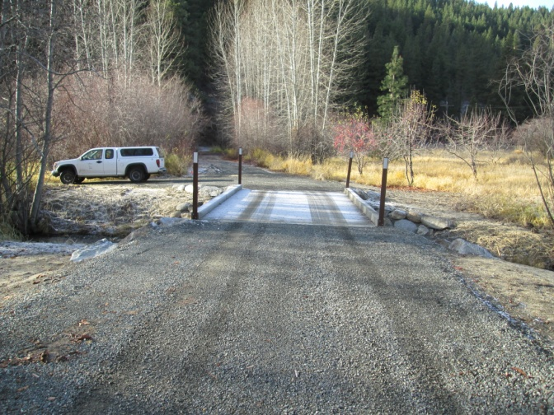 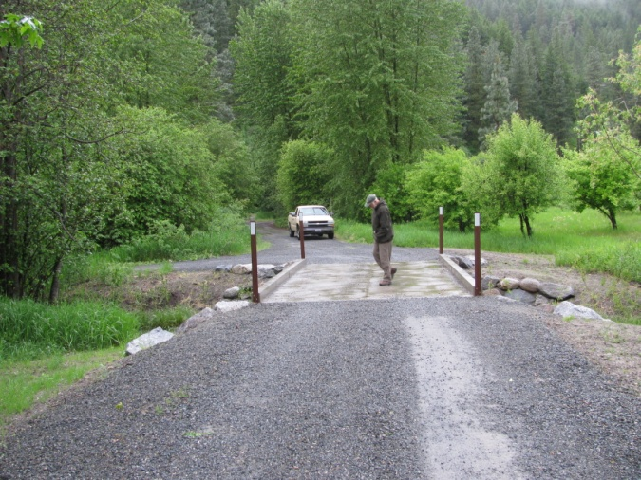

PP2

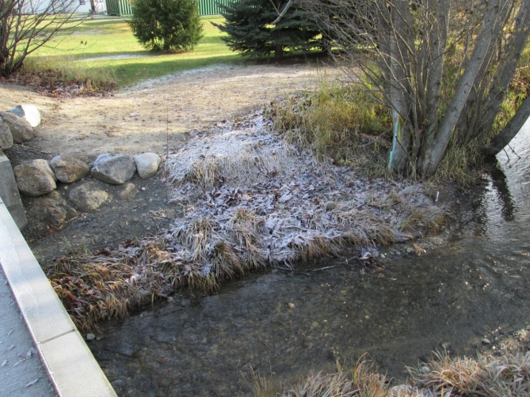 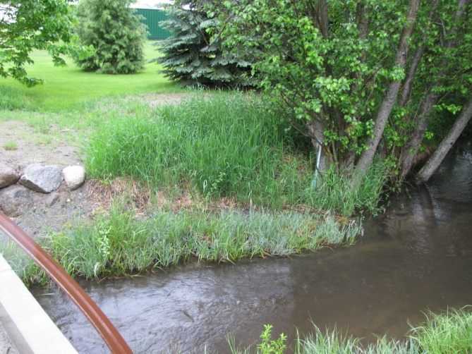

PP3

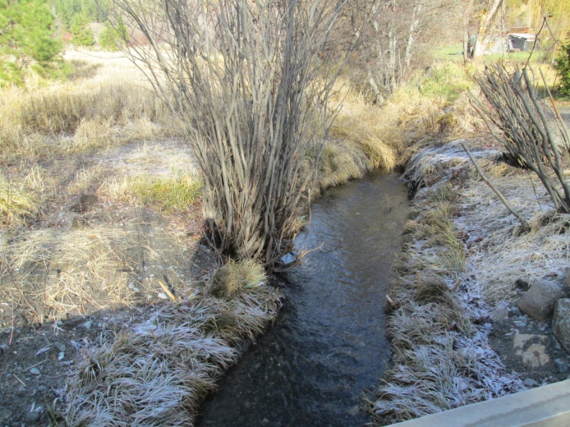 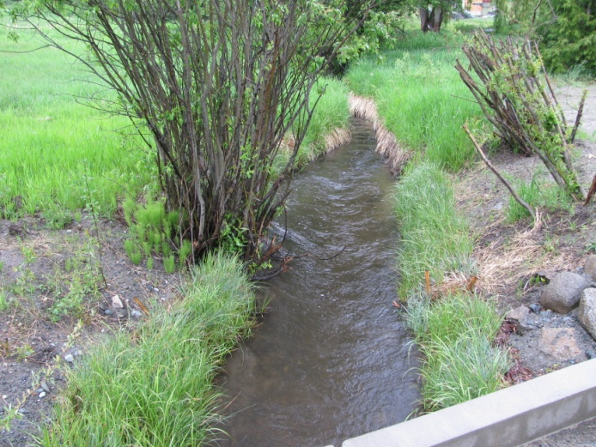

PP4

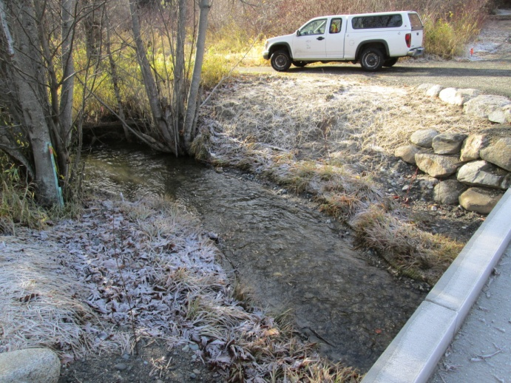 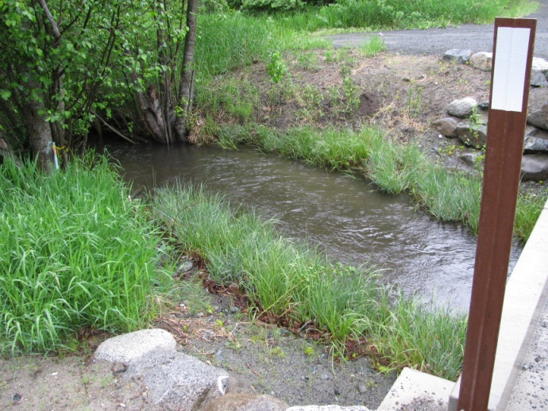

PP5

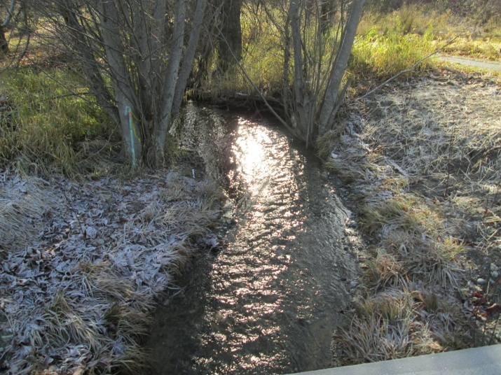 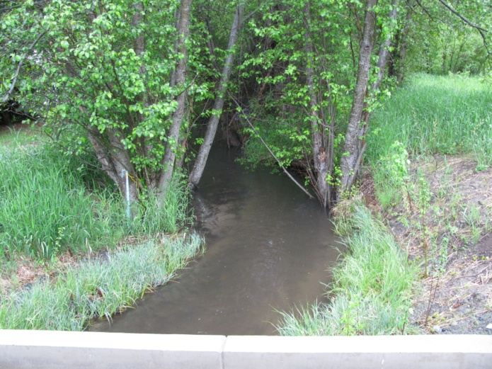

PP6

*Riparian Monitoring*

Table 1. Stem count on June 5th, 2013.

|  |  |  |  |  |
| --- | --- | --- | --- | --- |
| **Species** | **A** | **B** | **C** | **D** |
| *Willow stakes* |  |  | 4 | 3 |
| *SYMPHORICARPOS ALBUS*- common snowberry |  |  | 2 | 6 |
| *ROSA WOODSII*- Wood's rose |  |  | 2 | 4 |
| *SAMBUCUS NIGRA spp. cerulea*- blue elderberry |  |  |  |  |
| *CORNUS SERICEA*- red osier dogwood |  |  |  | 4 |
| *ALNUS INCANA spp. tenuifolia-* mountain alder |  | 2 | 2 | 1 |
| *CRATAEGUS DOUGLASII*-Douglas hawthorne |  |  |  |  |
| *ACER CIRCINATUM -* vine maple |  |  |  |  |
| Totals | 0 | 2 | 10 | 18 |

CCNRD staff estimated 20 percent native shrub cover site wide with a planted shrub survival of 95-100 percent. Shrub cover included 30 planted shrubs (table 1) and natural revegetation of willows (quadrant A about 4 feet from bank) and small maple recruits (quadrant D). Just downstream of the project is undisturbed forest (Figure 2, PP6) that provides stream shade adjacent to quadrants B and D during midday. The sedge mats have 95-100% cover in all quadrants and provide a 1-3 foot wide swath of sedge; no shrubs were observed in this area (Figure 2, PP 3-6. Other areas without any plantings include quadrant A and quadrant C above the rip rap.

*Fish Passage*

Table 2. Adult salmonids detected at 3 fish arrays on Chumstick Creek in 2013

|  |  |  |  |
| --- | --- | --- | --- |
| **Species** | **North Road (RM 0.28)** | **Sunitch (RM 5.3)** | **Merry (RM 8.82)** |
| Wild Summer Steelhead | 11 | 2 | 1 |
| Hatchery Summer Steelhead | 9 |  |  |
| Hatchery Coho | 4 |  |  |
| Wild Spring Chinook | 2 |  |  |
| Hatchery Spring Chinook | 4 |  |  |
| **Total** | **30** | **2** | **1** |

Fish array data indicates that at least 2 wild summer steelhead migrated up RM 5.3 at Sunitch and 1 migrated to RM 8.82 at Merry (Ott is at RM 8.23). This represents 20 percent and 10 percent of the overall wild summer steelhead detected at North Road array located at the mouth of the Creek. Detections at fish arrays represent approximately 10 percent of the actual run.

**Conclusion/Recommendations**

Data from the fish array at Merry Canyon indicates the Ott project is meeting the goal of opening up historical fish habitat to wild summer steelhead (Table 2). The bridge is structurally sound with no observed changes since post-construction in 2012. Steelhead spawning sized gravel was observed at the upstream end of the project. No bank erosion or sediment deposition was observed. Estimated plant survival was 95-100 percent, site shrub cover was 20 percent, and sedge mat cover was 90-100 percent.

Additional shrub plantings are recommended in quadrant A, quadrant C above the rip rap, and willow cuttings near bank within the sedge mats. Changes in riparian shrub cover, bridge integrity, and fish passage should continue to be monitored.