**Reid Harbor Conservation Easement**

**Stewardship Plan**

Salmon Recovery Funding Board

RCO-SRFB/PSAR #13-1354A

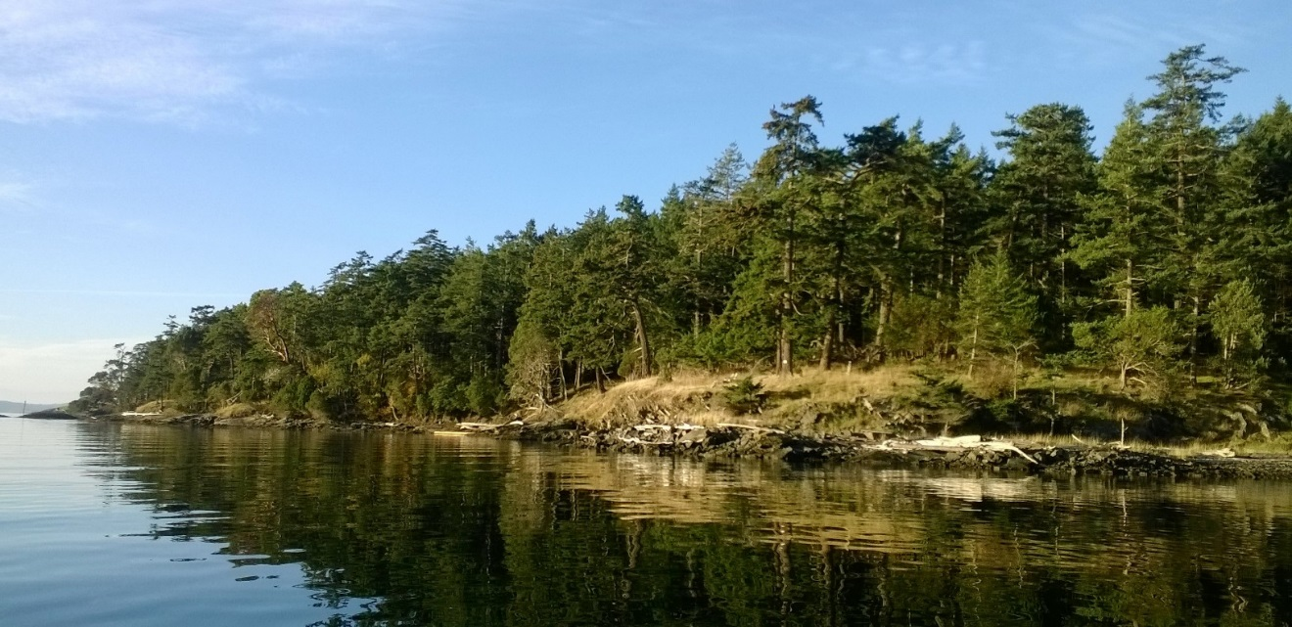

Background

Reid Harbor (North Star Preserve) Conservation Easement is a 61 acre parcel located on the southeastern shoreline of Reid Harbor on Stuart Island in the San Juan Islands in San Juan County, WA. The Property encompasses forested uplands lined by 4400 feet of natural shoreline. The Property contains a rocky medium bank shoreline and several pocket beaches which provide important marine riparian habitat for salmon and forage fish. The Property joins additional properties in Reid Harbor, including Stuart Island State Park, Trust Preserves and Conservation Easements, to provide conservation for 60% of Reid Harbor shoreline.

Land Use History

Stuart Island was actively used by Native Americans, primarily it is thought, as a summer camp area. The 1889 US Coast and Geodetic Survey map created by JJ Gilbert shows this property with a very similar structure as is found today, including a cleared area in the NW corner (with what looks like a large orchard which is gone today) while the remainder of the property is forested. Subsequently, the property was extensively logged, but has since been reforested to nearly its original extent.

Purpose – Landowner’s Goals

The purpose of the Conservation Easement is to preserve and protect the Conservation Values of the Property (ecological, natural shoreline, forest, scenic and open-space values) and to limit residential use of the Property to two (2) single-family residences and their appurtenant and accessory structures within two (2) Structures Areas on approximately 13.7 acres of the Property.

Relationship to Other Actions or Plans

The Property adds to existing shoreline conservation in Reid Harbor, totaling over two and one half miles (60%) of Reid Harbor shoreline.

Current & Desired Conditions

Current conditions and desired conditions are identical. The purpose of the Conservation Easement is to protect and preserve current natural conservation values as follows:

1. Fish Use and Habitat – The Property protects important natural shoreline habitat for endangered outmigrating juvenile Chinook salmon; juvenile chum and pink salmon; surf smelt; Pacific sand lance; and Pacific herring along 4400 feet of rocky shoreline with several pocket beaches. Eelgrass beds are present nearshore.
2. Riparian - The Property has a naturally vegetated shoreline with several pocket beaches considered important rearing areas for juvenile fish. Adjacent to the shoreline is forest fringed with grasslands. Douglas fir predominates, with grand fir, western hemlock, red alder, Pacific madrone, big leaf maple, Douglas maple, western redcedar, western juniper, willow and yew also present.
3. Hydrologic – The Property is primarily in a natural, undeveloped state. There are no documented wetlands. A man-made pond and small ephemeral stream draining the pond into Reid Harbor are located in Structures Area #1.
4. Soils and Soil Stability – The Cady-Rock Outcrop complex, a well-drained shallow soil interspersed with rock outcrops, underlies +/- 72% of the Property, including most of the forested area. The Whidbey-Hoypus complex, an assemblage of two moderately well drained and slightly deeper soils, accounts for +/- 25% of the land area and underlies the field and surrounding forest fringe. The Property is primarily in a natural, undeveloped state and supports natural sedimentation and unaltered shoreline erosional processes.
5. Upland - Adjacent to the shoreline is a fringe of grasslands that contain some native wildflower species and beyond that the Property is almost entirely forested. Sometime prior to 1949 the property was almost entirely logged and since then a fairly uniform Douglas-fir forest has re-established. While Douglas fir is the predominant species, others tree species found here include grand fir, western hemlock, red alder, Pacific madrone, big-leaf maple, Douglas maple, western redcedar, western juniper, willow and yew. While the forest and grassland structure of this area is relatively undisturbed, the understory has been greatly altered by the presence of feral Mouflon and domestic sheep and, in the recent past, a herd of feral cattle. While the understory has been kept open, the expected shrubs and forbs are still present, but in less density, these include ocean-spray, nutka rose, salal, tall and dull Oregon-grape, orange and hairy honeysuckle and buffalo berry. Also found in the forested area are a couple of scattered balds and a few remnant old-growth trees.
6. Public Use – The Property can be viewed by the public from Reid Harbor and conservation of its natural shoreline protects salmon and forage fish habitat for the benefit of regional fish and wildlife populations. There is no physical public access granted on the Property.
7. Cultural and Historic Resources – Reid Harbor was used by Native Americans as a summer camp area and a reef net fishing site is located just south of the Property.

Maintenance and Monitoring Schedule

The San Juan Preservation Trust will monitor the Property annually upon sixty (60) days prior written notice to the Grantor, with permission of the Grantor as to a mutually acceptable time and date not to be unreasonably withheld, for the purpose of making a general inspection of the land to assure compliance with the Conservation Easement. Annual monitoring reports are kept on file at The San Juan Preservation Trust.

Adaptive Management Plan

In the event of environmental change through time, issues will be addressed on a case by case basis as they arise.

Roles, Responsibilities, and Funding

Maintaining a good working relationship with the Property’s current and future landowners will be a high priority for management of the Conservation Easement. The

San Juan Preservation Trust has established a Stewardship Fund to cover legal or other expenses associated with enforcing the terms contained in the Trust's grant deeds of conservation easement. The Fund enables the Trust to take the actions necessary to uphold the intentions of the Grantors.

Constraints and Uncertainties

None are foreseen.

Attachment

North Star Preserve Easement Baseline Present Conditions Report