RCO Hazardous Substances Certification

The Whidbey Camano Land Trust, as the recipient of funding assistance specified in RCO Project Agreement #20-1461 titled Livingston Bay Protection and Restoration Planning does hereby give assurance that it does not know and has no reason to know that any hazardous substance, the release or threatened release of which has resulted in or contributed to the need for remedial action, was released or disposed of, in or at the Sherman property or properties that are included in the above-referenced Project Agreement. The Whidbey Camano Land Trust further warrants that it has obtained representations and warranties concerning the environmental condition of the property from the seller and has inspected the property to the scope and extent described in the attached (check applicable):
- Environmental Site Assessments per American Society for Testing and Materials (ASTM) standards
- All Appropriate Inquiries per U.S. Environmental Protection Agency standards, or
- RCO Property Assessment Checklist [provided in Appendix M].

_______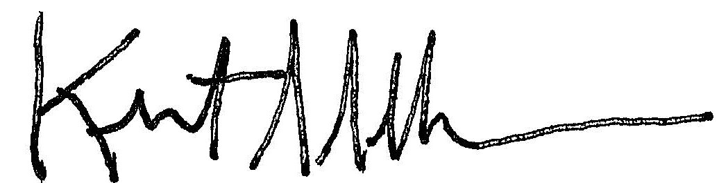__________________________________
Signature of Project Sponsor
__Conservation Director___________________________________________
Title
____September 5, 2024____________________________________________
Date

“Manual 3: Acquisition Projects,” Appendix L

