Correction Analysis Form

Site Information (measurements in feet)
Project Name: George Davis Creek Fish Passage  East Lake Sammamish Parkway Culvert Replacement Project |  | PRISM Project #: |  | Date: 6/21/18
Bankfull Width (outside influence of culvert): 9 ft. |  | Utilities Crossing: Yes No Unknown
Road Fill at Culvert Invert (Top): 8 ft. |  | Road Width: 56 ft. (38 paved)
Road Description/Condition (mainline, spur road, driveway/access): Arterial, two-lane with 8-foot paved shoulder/bike lane each side, good pavement condition.

Evaluator Information
Evaluator Name: Danika Globokar |  | Affiliation: City of Sammamish, Assoc. Stormwater Engineer
Mailing Address: 801 228th Ave SE |  | City: Sammamish | State: WA |  | Zip: 98075
Telephone: 425-295-0516 | FAX: | Cell: 425-531-1282 | E-mail: dglobokar@sammamish.us

Upstream Habitat/Channel Description
Channel Slope (outside of culvert influence): 6% |  | Re-grade Potential (streambed US – streambed DS in feet): 6 ft.
Dominant Substrate: Sand (<1/5”) Gravel (1/5”–3”) Cobble (3”-12”) Boulder (>12”) Bedrock
Additional Upstream Information, Habitat Description, Other Site Conditions or Concerns, Including Potential Re-Grade Impacts Relative to Channel Stability And Habitat: An existing, in-line sedimentation pond and high-flow-bypass diversion structure are located at the upstream entrance of the culvert under East Lake Sammamish Parkway. Upstream of the Parkway, an existing, in-line sedimentation pond and high-flow-bypass diversion structure are located at the culvert entrance. The channel 100 to 200 feet upstream of East Lake Sammamish Parkway is lined with non-native vegetation including ivy and Himalayan blackberry in backyard areas. This transitions farther upstream into a wooded ravine with in-stream wood and primarily native vegetation. Upstream, gravel-dominated substrate includes rounded cobbles and a few small rounded boulders. A concrete weir exists about 400 feet upstream which poses an additional barrier. Its removal or modification to allow fish passage is proposed by a separate fish passage grant application.

Downstream Habitat/Channel Description
Channel Slope: 6% (outside of culvert influence)
Additional Downstream Information, Habitat Description, Other Site Conditions or Concerns:
Additional fish passage barriers occur downstream under the East Lake Sammamish Trail, East Lake Sammamish Shore Lane, and connected piping extending downslope from the Shore Lane across two private properties and beneath structures. The correction of these barriers is proposed by King County and the City of Sammamish, respectively.

Correction Options and Preferred Alternative

Options to Consider – Provide up to Three Site-Appropriate Correction Alternatives.
Option 1: Replace the existing, 60-inch CMP culvert which crosses East Lake Sammamish Parkway with a 12-16-foot-wide box culvert along the same alignment. De-activate and remove an existing high-flow bypass diversion structure and an associated small pond which has been serving as a de-facto sediment pond. The channel profile would be designed and modified as appropriate to be compatible with a short, upstream, reconstructed channel section and the new culvert. The new upstream channel will include gravel substrate, log structures, and native riparian vegetation to replace existing non-native vegetation. The downstream channel alignment would remain in the same general alignment as its current configuration.
Option 2: Similar to Option 1, except changes to the culvert angle and channel at the downstream end would direct the channel northward between the Parkway and trail. Other related King County and City of Sammamish-led culvert and stream channel modifications would then direct the channel through new fish-passable culverts under the East Lake Sammamish Regional Trail and East Lake Sammamish Shore Lane north of the present locations by approximately 200 feet. The stream channel would then connect to Lake Sammamish through a new channel section across a to-be-acquired property several parcels to the north of the existing stream mouth. (Corresponds with Option 2 for the Shore Lane crossing. FBRB #10a)
Option 3: See Figure below for a depiction of the stream alignment under this alternative. George Davis Creek would be re-routed beginning several hundred feet upstream of East Lake Sammamish Parkway to cross the Parkway at a new location, at some distance to the south of its present location. Several residential driveways would also need to be crossed with new fish-passable culverts. The downstream channel would continue to the south, before crossing the East Lake Sammamish Regional Trail. The trail crossing would be designed and implemented by King County. No crossing of East Lake Sammamish Shore Lane would be needed under this alternative. The creek would connect to Lake Sammamish at a new mouth location across an undeveloped shoreline area (as shown). (Corresponds with Option 3 for the Shore Lane crossing. FBRB #10a)
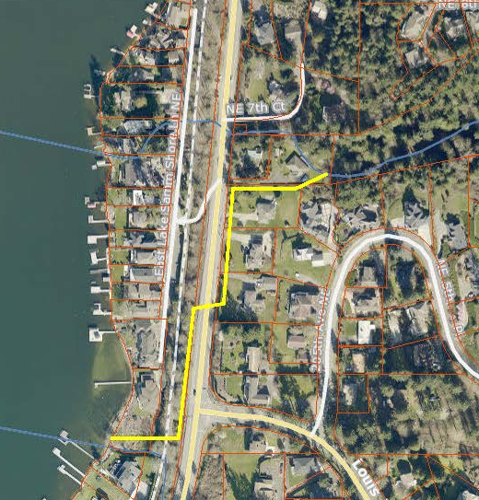
Alternative 3, Southwest Alignment, is shown in yellow.

Option 1 is the preferred, or default, alternative since it lies along the existing stream alignment at the current crossing location. The City has separately financed and contracted a feasibility study in order to determine the best and most cost-effective course of action, which will make George Davis Creek upstream of East Lake Sammamish Parkway readily accessible to kokanee and other salmonid fish. For whichever overall alternative is eventually selected, crossings at the Parkway, the Trail, and East Lake Sammamish Shore Lane will be coordinated to be along the same channel alignment. There would be little difference for the actual crossing alignment of the Parkway between alternatives 1 and 2 – the differences would occur primarily at the trail crossing and below, associated with related projects and actions.

Alternative 3 is an ambitious concept that could provide a significant increase in productive habitat for kokanee and other salmonids by providing a meaningful increase in stream length at a near-ideal gradient for providing spawning and rearing habitat. However possible disadvantages include problematic disruptions in sediment transport due to reduced gradient, narrow buffers, a need to remove existing vegetation along the Parkway and trail, high costs associated with overall project size and extensive grading, needed permissions from owners of property along the way, additional driveway crossings, and other technical feasibility considerations.

Cost Estimates
Rough Cost Estimate* - Attach Detailed Cost Breakdown Using the Appropriate Cost Estimate Template, Provided Separately.
Option 1: $ 353,500 (cost breakdown in cost estimate spreadsheet)
Option 2: $ 400,000
Option 3: $ 600,000
*This is a rough approximation of project costs; actual costs may vary depending on specifications identified during final project design.

Correction Analysis Form Instructions

Site Information
Project Name – This is the landowner’s last name followed by the creek name. If more than one site per landowner is evaluated on the same creek, designate each site with a letter, e.g. Franklin – Boulder Creek A.
PRISM Project Number – This will be provided by PRISM database.
Bankfull Width – The stream width measured perpendicular to flow at the stage at which water begins to overflow into the active flood plain. Bankfull width requires a floodplain or a bench not present in many channels. In those cases, use ordinary high water. Ordinary high water is where the regular stream flow makes a line on the bank marking soil or vegetation with a character distinct from that of the abutting upland. Also defined as the lowest point at which perennial vegetation grows on the stream bank. Enter the average of several bankfull width measurements taken up and/or downstream of the culvert, outside the influence of the culvert.
Utilities Crossing – Include any water, gas, phone or electrical utilities at the crossing to be affected by project construction.
Road Fill at Downstream End – Measure height of material from top of culvert to top of fill at downstream end.
Road Width – Measurement should include shoulders.
Road Description/Condition – Provide a brief description of the road surface, use, condition, etc.

Evaluator Information
Provide contact information for the people completing the Correction Analysis Form.

Upstream Habitat and Channel Description
Channel Slope – This is measured outside of the culvert influence.
Re-grade Potential – Subtract the downstream streambed elevation from the upstream streambed elevation at the site.
Dominant Substrate – Identify the size category most prominent in the substrate.
Additional Information – Provide any additional upstream information that may be important to the project.

Downstream Habitat and Channel Description
Channel Slope – This is measured outside of the culvert influence.
Additional Information – Provide any additional upstream information that may be important to the project.

Correction Options and Preferred Alternative
Options to Consider – The purpose of this section is to provide the sponsor some guidance on the intended fix. Most small forest landowner projects should be relatively straightforward; however each site is different.
Preferred Alternative – Describe the recommended correction and site-specific concerns to be addressed during design and construction.

Cost Estimates
Rough cost estimate – Provide estimated costs for correction options listed above. Costs should be based on cost estimate templates, provided separately, for culverts, bottomless arch culverts, and bridges. Attach the corresponding completed template for each estimate. These represent approximate costs; actual costs may vary depending on specifications identified during final project design.

