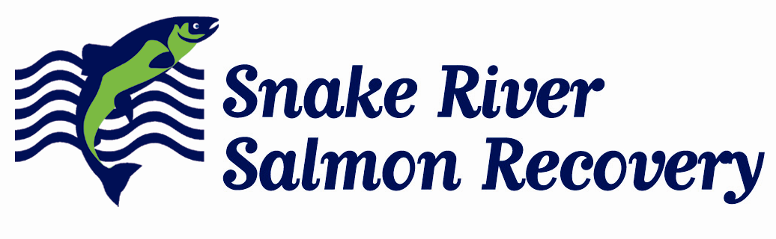
410 B East Main phone: 509.382.4115
Dayton, WA 99328

www.snakeriverboard.org

Date: 8/8/16

Memo: Project Sponsorship and funding shortfall, Asotin IMW Monitoring YR10, Project 16-2101

Project Sponsorship and Background: The Snake River Salmon Recovery Board (SRSRB) received funds to develop and implement an Intensively Monitored Watershed (IMW) in the Snake River Salmon Recovery Region of the state of Washington in 2009. A primary goal of IMW projects is to determine the effectiveness of specific restoration actions on increasing salmonid production. Specifically, the Asotin Intensively Monitored Watershed (IMW) project was proposed as a minimum 10 year project monitoring the effectiveness of a large wood treatment on increasing salmonid production.

Eco Logical Research Inc. (ELR) was hired through a competitive bid process to develop the IMW experimental and monitoring design with the support and input of the Snake River Regional Technical Team (RTT), and coordinated by the Snake River Salmon Recovery Board (SRSRB). ELR was contracted to provide the following:
- coordinate the selection of an IMW location in southeast Washington,
- identify factors limiting freshwater production in the selected watershed
- develop an IMW experimental design and work plan for the selected IMW basin(s),
- develop a set of hypotheses to test regarding the efficacy of restoration
- estimate the future annual costs of monitoring,
- coordinate a peer review of the draft experimental design and work plan,
- develop a data management system,
- collect initial baseline (pre-treatment) fish and habitat data, and
- document all data sources used in the development of the IMW.

The funding for the IMW has historically come from the Pacific States Marine Fisheries Commission (PSMFC) and the National Oceanic and Atmospheric Administration (NOAA) and been allocated through the Washington State Recreation and Conservation Office (RCO). Over time the level of funding has decreased and we have sought other funding sources to maintain the project. Additional funding had been allocated through the Salmon Recovery Funding Board (SRFB) process in 2015 and again in 2016. However, private consultants and contractors are not eligible to be a primary project sponsor on a SRFB project. For the 2015 project (#15-1321), the Washington Department of Fish and Wildlife (WDFW) was the primary sponsor to satisfy SRFB eligibility criteria who then went through the process of contracting with ELR to complete the work under that grant – they were not interested in serving as the project sponsor for the project in 2016 due to cost and effort.

To simplify the reporting and eliminate the costs associated with using a project sponsor to contract with ELR for the 2016 phase of the project, we sought to allow ELR to be the project sponsor. The Asotin IMW Monitoring project is inherently different in that it is a 10+ year monitoring project. Originally, the SRSRB held the first SRFB PSMFC monitoring contract and through a competitive bid process selected ELR Inc. as the contractor for the 10 year project. In this case, the grant agreement and funding timeline did not align with the project term – the project is a 10+ year project and funding has been allocated on a yearly or biennial basis. Funding has been harder to find and harder to secure each year. Last year alone we coupled four funding sources together to make the project budget mostly whole. For each funding agreement, a painstaking process has been undertaken to align contracts and satisfy contractor selection criteria even though the project is ongoing and the contractor had already been selected. This also creates a reporting burden consequently increased expense. Finally, one of the major benefits of the Asotin IMW has been the collaboration and partnership that have worked to implement restoration actions while also coordinating monitoring efforts. Reviews of the monitoring program have provided positive feedback with regard to the coordinated effort that has allowed for the project to successfully reach YR10. This coordination has been a result of partners and collaborators working with ELR as the project lead. Transitioning to another project lead would not be a wise use of public funding nor provide the highest scientific rigor. The Asotin IMW Monitoring project is at a critical point with restoration actions will be completely implemented in 2016. Funding sources are dwindling as the initial 10+ year study plan is just now getting to the point where real post-implementation data is being collected and analyzed. Coordination and the prudent use of funding has never been more important to realize the goal of the project.

Through due diligence on RCO’s part, it was determined that the best path forward was to find an eligible project sponsor for the funding allocated through the SRFB. The Asotin County Conservation District (ACCD) was approached as a potential project sponsor and agreed to serve in that role. The ACCD is a natural project sponsor for the project having intimate knowledge of the Asotin Basin and having successfully completed multiple projects in the watershed, some in coordination with ELR.

Budget Shortfall: The budget and scope of work for the Asotin IMW Monitoring YR 10 (#16-2101) was developed with the thought that ELR would be the project sponsor – this is also the reason for the project application and supporting materials written from the perspective of ELR. With the change in sponsorship, ACCD required project management and oversight within the budget. Some additional cost savings were identified and additional funds secured through PSMFC, but an approximate $2,300 shortfall remains. Unless additional funds are identified to complete the full scope of work identified for the project, a small amount of data analysis will be removed from the project.

John Foltz
Program Coordinator
Snake River Salmon Recovery Board

