

Cascade Creek Preserve

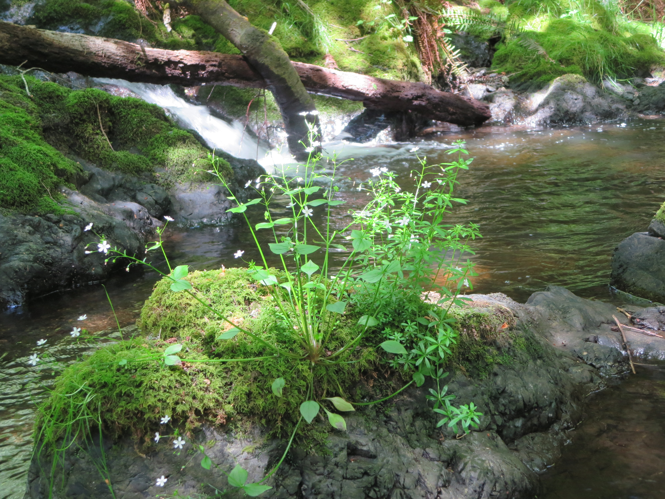

Draft Stewardship & Management Plan
October 2015

Adopted by the Land Bank Commission:
Approved by the SJ County Counsel:

San Juan County Land Bank
350 Court St. #6
Friday Harbor, WA 98250
360-378-4402

Stewardship Goal

The Land Bank’s stewardship goal for the Cascade Creek Preserve is to protect and maintain a healthy, functional riparian corridor and associated uplands for use by Chinook, Chum and Coho salmon, and Cutthroat trout.

Cascade Creek Preserve
Stewardship & Management Plan

Table of Contents________________________________

I Introduction .……………………………………………………………………… 4

II Ecological Resources……………………………………………………………….. 5
A. Objectives………………………………………………………………………. 5
B. Stewardship Tasks……………………………………………………………… 6
C. Monitoring Protocols…………………………………………………………... 7

III Public Access ………………………………………………………………..…… 8

A. Objectives……………………………………………………………………. 8
B. Stewardship Tasks……………………………………………………………. 9
C. Monitoring Protocols ………………………………………………………… 10

Appendix A: Site Map…………..……………………………………………………… 12
Appendix B: Summary of Use Restrictions…………………………………………… 13
Appendix C: Priority Habitats and Species……………………….……………………. 14
Appendix D: Budget…………………………………………..…………….………… 15

I. Introduction_________________________________________________

Cascade Creek Preserve protects the freshwater outflow at the head of Buck Bay - a healthy tidal estuary currently used, in part, as an oyster farm, and where the Land Bank and San Juan Preservation Trust have shore and tideland conservation lands. From its outlet into the bay, Cascade creek passes under a bridge on Point Lawrence Road which was upgraded in 2011 to facilitate passage of salmonids and unimpeded tidal exchange. The riparian corridor above the bridge is quality salmon habitat for 300’, and includes natural gravel beds, woody debris, native vegetation, and a stand of mature conifers along the drainage and throughout the contiguous upland buffer.

The total watershed area of Cascade Creek is roughly 2,750 acres, of which approximately 1,800 are protected in Moran State Park. While the Cascade Creek preserve is a small fraction of the whole, the lower creek is clearly one of the most critical areas in the watershed. Stewardship of the preserve will ensure careful protection and care of 1,200 feet of the watershed and secured water rights which provide year-round, high quality stream flow.

The purpose of this Stewardship Plan is to provide long-term management guidelines. Two management themes provide a framework for discussing the stewardship of Cascade Creek Preserve: 1) protection of the creek, and 2) allowance for site-appropriate educational, research and public access uses. This plan devotes a section to each of these themes, with sub-headings detailing objectives, stewardship tasks and monitoring protocols. Objectives describe the long-term vision for the resources and uses in each section, while Stewardship tasks outline specific actions that lead toward the achievement of that vision. Monitoring protocols provide the methods to measure progress towards reaching and maintaining our stewardship objectives. Appendices to the plan include a site map, a summary of use restrictions, a list of priority habitats and species, references, and a financial analysis.

While this plan attempts to be as descriptive as possible, stewardship is an adaptive process that must respond to changing environmental and social conditions. The rising population and increased development of San Juan County will put new pressures on Cascade Creek over time. Through vigilant monitoring and regular internal review, the Land Bank will evaluate the effectiveness of our stewardship policies and priorities, and update or revise the plan as necessary.

II. Ecological Resources_________________________________________

Cascade Creek is one of the few remaining salmon spawning streams in San Juan County. The lower creek corridor is in relatively pristine condition with 300 feet inhabited by salmon cutthroat trout.
The lower stream corridor is excellent salmon spawning habitat for Coho and Chum salmon and Sea run coastal cutthroat trout (Boessow, DFW, 2007). It also provides high quality foraging habitat for juveniles of these species and Chinook salmon as well (Boessow, DFW, 2007). The presence of each of these species in the Creek has been documented by at least two studies (Boessow, DFW, 2007; Glasgow, WFC, personal communication). In addition, numerous studies have demonstrated the importance of freshwater streams to foraging salmon species, especially Chinook (Beamer, et al., 2013; Nelson and Temple, 2005). Protection of the stream corridor and adjacent uplands will help ensure the existing structure and function of this system remains intact.
Additionally, the 23.95 acre preserve has a forested buffer of mature, conifer-dominated Puget lowland forest. In-stream water rights for year-round flow to the creek have been secured, and along with the bridge replacement, vastly improved passageway to Buck Bay. Careful stewardship of this critical parcel is integral to insuring viable salmonid habitat into the future.

The Land Bank holds habitat protection as the paramount goal of its stewardship program. Maintaining an area’s ecological health will also preserve its scenic and open space character. Public access, where appropriate, is designed to minimize impacts on the property’s ecological resources. If future monitoring reveals that impacts are not being controlled, public access may be restricted or discontinued. The objectives and tasks outlined below serve as guidelines for protecting the ecological qualities Cascade Creek Preserve, and appropriate public access.

II. A. Objectives

- To maintain the fish-bearing habitat qualities of Cascade Creek Preserve in good condition.

- To encourage and improve the understanding of the property’s natural systems through conservation, education, and research.

II. B. Stewardship Areas and Tasks

1. Priority Habitats and Species:
Protection of habitat, especially for Chinook, is the number one priority for WRIA2. As one of the three remaining fish-bearing streams in San Juan County with juvenile Chinook documented, this species is a management priority.

Stewardship tasks to protect priority habitats and species include:
- signage denoting use restrictions for habitat protection and restoration
- designing and directing public use away from sensitive areas
- regular monitoring of impacts from human and natural processes
- continued monitoring for the presence of other priority species

2. Water Resources

Protection of the flow and quality of water in the Cascade Creek Preserve is a high priority.
Tasks will include:
- Monitoring and controlling erosion
- Decommissioning existing rough roads and converting them to trails or vegetated open space areas
- Working with up-stream neighbors to reduce introduction of pollutants
- Maintaining native vegetation buffers
- Addressing changes in flow due to natural disturbance

3. Vegetation Management

Fire suppression, logging and other human activities have impacted plant communities and patterns of succession throughout San Juan County, including, to some extent, Cascade Creek Preserve. In some cases, species or whole communities can be lost without management intervention. While plant communities at the Cascade Creek Preserve do not currently appear to be threatened, vegetation management can still be an important management tool. Through monitoring and consultation as necessary, the Land Bank will assess the health of the Preserve’s plant communities and the need for management action.

5. Fire Management:

The absence of a natural fire regime in forest systems can lead to the build up of combustible materials over time, increasing the risk of a major wildfire event. The Land Bank may consider specific management actions to reduce the threat of wildfire at Cascade Creek Preserve. Such actions may include:
- thinning or removal of hazardous vegetation
- use restrictions during times of peak fire danger

6. Invasive Species:

The spread of invasive species ranks second only to habitat loss as a threat to global biodiversity. The Land Bank puts a high priority on controlling populations of invasive species on its properties. Known “Class B & C” invasives at Cascade Creek Preserve include tansy ragwort (Senecio jacobaea), herb Robert (Geranium robertianum) and travellers’ joy (Clematis vitalba).
Specific actions may include:
- monitor and control known noxious and invasive species
- monitoring for new occurrences
- work with neighboring landowners to control spread of invasives

7. Education and Research:

The Land Bank will encourage a deeper understanding of all of Cascade Creek Preserve’s ecological resources through cooperation with students, scientists and interest groups, including university and post-graduate researchers. Education and research activities will be conducted on the preserve with written permission only.
Specific activities may include:
- guided natural history walks
- conservation education field trips
- interpretive signage

8. Use Restrictions: (see Appendix B for a complete list)
- Collection of botanical, zoological, geologic or other specimens prohibited except on a written permission-only basis for scientific or educational purposes
- Pedestrian access only, limited to designated trails
- Dogs must be leashed
- Day use only
- No hunting or fishing
- No rock climbing

II. C. Monitoring Protocols

Monitoring protocols must be designed to answer specific management questions. At Cascade Creek Preserve, such questions will be developed over time as critical stewardship issues come into focus. The Land Bank follows several policies that will help identify these issues and develop appropriate protocols. As a requirement of access to Land Bank Preserves, researchers must share the results of their studies and make data available for management purposes. On-going studies are encouraged, as they can provide an excellent monitoring protocol in their own right. In the case of Cascade Creek, periodic fish inventories will help track population trends. The Land Bank also develops ecological assessments for all of its fee-owned properties. These documents are updated regularly through field visits by Land Bank staff and others. Additionally, volunteer stewards file reports on activities and condition of Land Bank properties. Finally, photographic monitoring is a regular part of Land Bank baseline documentation and stewardship. Updated regularly, photographs from set points provide a continuous history of a property and help set a framework for the limits of acceptable change.

III. Public Access______________________________________________

Public access for low-intensity recreation is an element of the Land Bank’s mandate. Cascade Creek Preserve has potential for such access, but it must be designed to minimize impacts on the land’s ecological & scenic qualities. As at all Land Bank preserves, the benefits of access must be balanced against its risks, with the caveat that it may be discontinued if visitor impacts prove unmanageable. The following objectives and stewardship tasks serve as a guideline for establishing appropriate levels of safe, low impact public access at Cascade Creek.

III. A. Objectives

To maintain the possibility for safe, low-intensity recreational access that does not detract from its aesthetic and ecological qualities.

To protect the land’s natural resources and ensure that each visitor has a quality experience.

III. B. Stewardship Tasks

1. Level of Use:

Maintaining an appropriate level of use is the essential element in protecting Cascade Creek Preserve outstanding natural and scenic character. The Preserve will face increasing use pressures over time from the rising population of Orcas Island and the demand for recreational areas by both residents and visitors. Use can be controlled in a number of ways, from restrictions and signage to the availability of parking. The Land Bank will draw from a variety of tools to monitor and control use levels at Judd Cove Preserve, as outlined below under Monitoring Protocols.

2. Safety:

Hiking, nature viewing and other low-intensity recreational activities all include a certain level of danger, but the Land Bank will make every effort to reduce the risk of injury to visitors at Cascade Creek Preserve. Stewardship tasks to enhance public safety may include:
- signage encouraging visitors to stay on maintained trails
- directing visitor use away from hazards
- utilizing fencing and barriers as needed

3. Trails:

A loop trail at Cascade Creek Preserve will showcase the property’s habitat diversity and allow for passive enjoyment of the forest and creek. The trail surface will remain largely as is (unpaved dirt), but with additional care to maintain/plant native vegetation and prevent erosion. Potential trail problem areas with high potential for failure will be upgraded or relocated. Management guidelines related to trails include:
- directing trails away from sensitive ecological and cultural areas
- directing trails away from property boundaries
- directing trails away from safety hazards

4. Commercial Use:

Commercial use is defined as the use of a property by any group or individuals engaged in a for-profit business operation. Such operations include whale watching tours, sightseeing tours, bicycle tours, guided hiking trips, etc. Land Bank policy generally prohibits commercial use of its preserves, but does consider proposals and historical uses on a case by case basis, provided that such activities do not adversely impact the conservation value of the property. No commercial use currently exists at Cascade Creek Preserve.

5. Disabled Access:

Terrain at the Cascade Creek Preserve may prohibit universal access, but the Land Bank will consider disabled access options in any public access plans.

6. Parking and Other Facilities:

A parking area that can accommodate two vehicles may be installed in an area already disturbed and currently used as a driveway. No toilets or other facilities are planned for this site.

7. Maintenance:

Maintenance at Cascade Creek Preserve will include trail care, seasonal mowing if needed, invasive species control, litter pick-up and the care of signs and parking area. These activities will be conducted by Land Bank stewardship staff, with assistance from volunteers.

8. Enforcement:

Signage and contact from Land Bank staff and volunteers is used to educate visitors about use restrictions at all preserves. When necessary, enforcement actions are carried out through cooperation with the San Juan County Sheriff’s office. The need for patrols at Cascade Creek Preserve will be evaluated as patterns of use develop. Night checks of Land Bank preserve parking areas are incorporated into sheriff’s department routines.

9. Boundary and Trespass Issues:

The Land Bank will take steps to discourage the public from trespassing on private land neighboring Cascade Creek Preserve. At the request of neighbors or at the Land Bank’s discretion, signs will be placed along property lines identifying the end of public land and discouraging trespass. Additionally, trails on the preserve will be routed away from property boundaries, will utilize topographic features to direct pedestrians, and where necessary, will install fences to demark property lines. Having a strong and consistent policy regarding public use being limited to on-trail use only has proved a powerful message to preserve visitors at other sites.

10. Volunteer Stewards:

The Land Bank will establish a network of interested neighbors and citizens to serve as Volunteer Stewards for the Cascade Creek Preserve. Stewards will help the Land Bank meet its stewardship goals through regular visits to the property to observe its condition and level of use, and may also be involved in maintenance, invasive species control.

III. C. Monitoring Protocols

As noted under Ecological Resources, monitoring protocols need to be designed to answer specific questions. In terms of public access, the most important issues are the level of use and the impact that use is having on the area’s cultural, scenic and natural resources. Protocols for particular impacts will be developed as use patterns become clear, but level of use can be monitored continually.

1. Level of Use:

A minimum of twice weekly monitoring will provide stewardship staff with information on levels and patterns of use at Cascade Creek Preserve. Initial data collected will act as a baseline. Increases in use or impacts will trigger a management review.

Management responses to inappropriate uses may include:
- restrictions on hours of use
- seasonal or permanent closure
- Additional signage and/or increased staff presence

Appendix A: Site Map__________________________________________

Appendix B: Summary of Use Restrictions_________________________

The following use restrictions will be in effect for Cascade Creek Preserve. They will be posted on site and mentioned in literature describing the Preserve.

- No camping
- No fires
- Daytime use only
- Dogs must be leashed
- Pedestrian use on designated trails only
- No horses
- No bicycles
- No motorized vehicles
- No rock climbing
- No hunting or discharge of firearms
- The use of metal detectors is prohibited
- No collection of botanical, zoological, geologic or other specimens except on a permission-only basis for scientific or educational purposes
- No collection of historical or archaeological artifacts except on a permission only basis for scientific or preservation purposes
- No commercial use

Appendix C: Priority Habitats and Species________________________

Definitions for Priority Habitats, Areas and Species are based on the Priority Habitats and Species Manual, published by the Washington Department of Fish and Game, with some adjustments for local conditions. A comprehensive ecologic inventory will be conducted at the Cascade Creek Preserve within the first year of Land Bank ownership.

Priority Areas:
- Critical Habitat Area for Puget Sound Chinook salmon (Oncorhynchus tshawytscha)

Priority Species:
- Pileated woodpecker (Dryocopus pileatus) – candidate for state listing
- Columbia black-tailed deer (Odocoileus hemionus columbianus) – state recreationally important species

Notes:
- While recreationally and commercially important species receive status under the Fish & Wildlife list (i.e. Columbia black tail deer), they may not be as high a management priority as the more rare and sensitive species.
- The Magnuson-Stevens Fishery Conservation and Management Act (Magnuson-Stevens Act) requires federal fishery management plans to describe the habitat essential to the fish being managed and describe threats to that habitat from both fishing and non-fishing activities. In addition, in order to protect this Essential Fish Habitat (EFH), federal agencies are required to consult with the National Marine Fisehries Service (NMFS) on activities that may adversely affect EFH. The Pacific Fishery Management Council manages the fisheries for coho, chinook, and Puget Sound Pink Salmon and has defined EFH for these three species. While the EFH needs of all these species at each life stage is considered as a whole, the EFH for the Pacific coast salmon fishery is broad, covering freshwater, estuarine, and marine environments.

Appendix D: Site Enhancement and Maintenance Budget

The following is an analysis of anticipated future stewardship costs for the Cascade Creek Preserve categorized as annual, 5-year, and 10-year expenses as required by the Land Bank’s enabling legislation. (Note: No 10-year expenses other than annual preserve management and maintenance are anticipated, though if need arises, there would be costs associated with seasonal toilet facilities.)

Projected Annual Preserve Management Costs:

Trail maintenance, mowing, weed control, monitoring*: $6,500
(Anticipate 25 – 30 volunteer hours per year at this site)

Site Enhancement (completed first year of ownership):
Ecological Inventory & riparian management plan $2,000
Signage $ 950
Benches 450
Trails 1,250
Parking area 1,500
Fencing 4,000
________
$10, 150

*includes staff time

