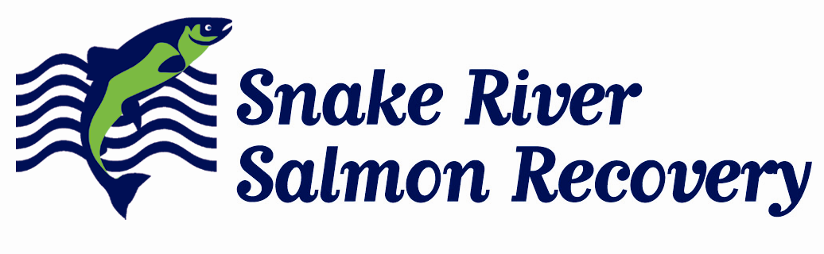
410 B East Main phone: 509.382.4115
Dayton, WA 99328

www.snakeriverboard.org

Date: 8/3/2015

Memo: Intensively Monitored Watershed Certification – Asotin Intensively Monitored Watershed Restoration, Project 15-1321

Snake River Salmon Recovery Board (SRSRB) staff have worked with Washington Department of Fish and Wildlife and the coordinator of the Asotin IMW, Ecological Inc., to develop the Asotin IMW Restoration project proposal. The location and methods for the treatments developed are a direct recommendation from the IMW implementation team and fit the IMW treatment.

Therefore, the SRSRB certifies that to our knowledge the proposed project contributes to and will not negatively affect ongoing data collection and salmon restoration efforts within the Asotin IMW.

John Foltz
Program Coordinator
Snake River Salmon Recovery Board

