April 28, 2015

Kittitas Conservation Trust
205 Alaska Ave
Roslyn, WA 98941-0428
Attention: Mitch Long, Project Manager
David Gerth, Executive Director

Subject: Gold Creek Conceptual Restoration Design Memo

project background
The Kittitas Conservation Trust (KCT) has identified the lower 3 miles (mi) of Gold Creek above Keechelus Lake near Snoqualmie Pass as a candidate location for habitat restoration (Figure 1). The primary objectives of the Gold Creek Restoration Project (Project) are to restore perennial flow and improve instream habitat for threatened Gold Creek Bull Trout (Salvelinus confluentus). The hydrologic, hydraulic, habitat, and geomorphic conditions within the project reach have been assessed to better understand the causal mechanisms contributing to seasonal dewatering, and the associated impacts to Gold Creek Bull Trout. These findings will be used to develop conceptual designs that meet the primary objectives of the Project by restoring natural geomorphic and hydrologic processes.
Existing information relevant to the Project has been reviewed and compiled to guide the assessments and conceptual design development. This information was used to describe the existing knowledge base related to the Project, and to identify key data gaps that needed to be resolved to define the problems effecting Lower Gold Creek (NSD 2013a). Hydrologic monitoring studies in 2013 and 2014 described hydrologic conditions related to seasonal dewatering (NSD 2013b, NSD 2014a), and geomorphic assessment (NSD 2014b) documented historic conditions, disturbances and current conditions of the valley. All of these studies identified the Gold Creek gravel pit (Pond), historic channel widening, Helis gravel pit (Pond), and the buried drainage system on the eastern floodplain as potential contributors to dewatering. This technical memo presents the conceptual restoration designs developed to address these contributors to dewatering, which will focus on restoration of the natural geomorphic processes that once sustained a healthy population of Bull Trout in Gold Creek.

Assessments completed
Hydrologic monitoring during the summer of 2013 and 2014 was conducted to evaluate the spatial and temporal character of dewatering in Gold Creek, and to determine the mechanisms contributing to seasonal dewatering in the creek (NSD 2013b, 2014a). This monitoring included several surface water gages in Gold Creek and in Gold Creek and Helis Ponds, and multiple groundwater wells in the adjacent eastern floodplain. Visual observations of the extent of dewatering in the creek we recorded bi-weekly to more accurately determine the spatial extent of dewatering during the monitoring season. The findings of this monitoring revealed that dewatering in Gold Creek initiates near RM 1.5, and progresses up and downstream to near RM 2 and RM 1, respectively (Figure 1). A second dewatering reach emerged during the 2013 monitoring season between RM 0.5 and 0.66, however this reach remained wetted throughout the 2014 monitoring season (NSD 2013b, 2014a). While this reach maintained flow throughout 2014, shallow water depths were observed that act as a barrier to adult fish migration upstream. Several summer rainfall events occurred during 2014 monitoring season that re-wet the creek, in contrast to the 2013 season during which a prolonged dry period more typical during the summer occurred that increased the duration and extent of dewatering in Gold Creek. The groundwater wells revealed the orientation of Gold Creek Pond relative to the valley axis induces a lateral groundwater gradient away from the creek up-valley from the Pond. This lateral gradient drives groundwater toward the eastern side of the valley. The water surface elevation (wse) of Gold Creek Pond is held relatively constant by discharging into the outlet channel, joining Gold Creek near RM 0.55, effectively passing groundwater from up-valley of the Pond downstream to RM 0.55 considerably faster than would occur through the subsurface without the Pond (Figure 1). The large size of the Pond also moderates water levels. The 27-acre pond occupies 78% of the valley bottom. The combination of drawing groundwater away from Gold Creek and reducing the groundwater elevation up-valley of the Pond was identified as the greatest contributor to seasonal dewatering in the creek.
The geomorphic assessment (NSD 2014b) describes the historic condition of Gold Creek, historic alterations within the valley, and how disturbances have led to the current degraded condition. Prior to human alteration, Gold Creek was a wood-forced anastomosing channel with a mature forested riparian corridor. The large trees that once lined the channel banks created a dynamically stable channel, with tree recruitment forming and maintaining instream habitat conditions. The mature riparian forest prevented over-widening of the creek as trees recruited into the channel resulting from bank erosion helped to deflect flows away from the eroding bank, limiting continued widening and providing a stable surface for the floodplain to regenerate. Logging in the valley after the 1940’s cleared much of the large trees lining the channel banks that provided stability to the channel. Dramatic channel widening (90% increase in channel width) and avulsions immediately following logging has resulted in a much less stable channel and loss of instream wood limiting critical habitat (pools, cover) in the creek (NSD 2014b). The current over-widened channel increases the infiltration capacity of the channel bed, reduces channel depths over the range of flow conditions, and the channel thalweg freely migrates across the unvegetated active floodplain, preventing the establishment of riparian cover. The loss of instream wood and resultant channel destabilization was identified as the primary limiting factor to habitat conditions in Gold Creek (NSD 2014b).

CONCEPT DESIGN DEVELOPMENT
The conceptual restoration designs were developed to meet the restoration objectives to restore perennial flow and improve instream habitat for threatened Gold Creek Bull Trout (Salvelinus confluentus). The hydrologic (NSD 2013b, 2014a) and geomorphic (NSD 2014b) assessments informed the development of the conceptual restoration designs by identifying the contributors to the current degraded condition of Gold Creek, and providing recommendations to restore geomorphic and hydrologic processes.
Historic disturbances within Gold Creek valley have altered natural geomorphic processes and hydrologic conditions, resulting in degraded habitat conditions. The cumulative impact of these disturbances has resulted in an over-widened channel lacking instream complexity and cover, which dewaters annually for a significant reach during the summer months. The proposed conceptual restoration designs developed focus on the primary contributors to seasonal dewatering (Gold Creek Pond) and degraded instream habitat conditions (due to historic logging and resultant destabilized channel) (NSD 2013b, 2014a, 2014b). These impacts have diminished Gold Creek Bull Trout populations by creating a migration barrier (due to the channel dewatering), and a loss of instream habitat (due to channel widening, loss of pools and cover). Restoring each of these limiting factors is critical, and of equal importance, to increasing Gold Creek Bull Trout populations.
Implementation of restoration actions will need to be sequenced based on the need for restoration, available funding, stakeholder input, and availability of material for construction. Restoration of Gold Creek Pit (Pond), and instream habitat have been identified as the highest priority actions to address the limiting factors to Gold Creek Bull Trout. Implementation sequencing should begin with these restoration efforts, followed by subsequent restoration actions identified. Continued monitoring of groundwater wells, surface water stations, and locating dewatering extents through the summer months, will be critical to evaluating the performance of restoration actions as they are implemented. The findings of this monitoring will be essential to inform adaptive implementation of the proposed restoration actions based on project performance throughout construction and available funding for additional work.

GOld Creek Pit Restoration
Based on a second year of surface and groundwater monitoring (NSD 2014), it is clear that the Gold Creek gravel pit (Pond) is the major contributor to seasonal dewatering of Gold Creek. This annual dewatering of the creek occurs during the summer months, when Gold Creek Bull Trout are attempting to migrate upstream to spawn. This barrier to upstream migration periodically re-waters when dry during summer rainstorms, and fish have been observed migrating upstream during this time. However these re-wetting events are short-lived and fish become stranded in the few remaining pools as the creek again dewaters. More often than not these pools completely dry up, resulting in mortality.
The primary influence of the pond is to lower groundwater elevations on the eastern side of the valley relative to the western side, modifying the natural gradient of flow toward the eastern floodplain and away from Gold Creek. In addition to modifying flow direction, the pond decreases groundwater elevations up to 10-ft from what would be their natural elevation. Both of these influences of the pond are a result of the orientation and size of the pond relative to the valley.
Gravel extraction for construction of I-90 began in Gold Creek valley by 1970, forming a 27-acre pit, extending 1530-ft up the valley (between RM 0.75 - 1.15). This large footprint relative to the size of the valley has accentuated the hydrologic effects of the Pond relative to other gravel extraction pits of similar size but in much larger valley bottoms. Several options were considered at Gold Creek Pit (Pond) to restore perennial flow to Gold Creek. In all options considered, recreational opportunities would be maintained or potentially improved upon. These options included:
- Completely fill the Pond and outlet channel, restore site to historic forested wetland complex
  - Restore tributary access to Gold Creek
- Partial fill starting in the northeastern corner to re-orient the pond perpendicular to the valley axis
  - Reduce lateral (west – east) gradient of groundwater up-valley of the Pond that currently draws groundwater away from Gold Creek
- Raise inlet to the Gold Creek Pond outlet channel, increasing the water elevation of the Pond
  - Raise groundwater elevations surrounding the Pond
- Relocate the outlet channel upstream at northwestern corner of Pond
  - Decrease the length of dewatered channel, restore perennial flow to lower dewatered reach (between RM 0.5 – 0.66)
  - Potential to raise inlet elevation relative to current elevation, increasing groundwater elevations surrounding the Pond
- Fill outlet channel completely, increasing the water elevation of the Pond
  - Pond levels would fluctuate seasonally, similar to Helis Pond
  - Pond elevations are currently 10+ feet below groundwater at northern end of the Pond
    - Unlikely they would be restored to this level by plugging the Pond
  - There is currently only 2-3 feet of “freeboard” at the picnic area at the southwestern corner of the Pond. Any rise greater than that will result in the Pond spilling into the channel, potentially catastrophically.
Based on the potential for restoring perennial flow to Gold Creek, and the cumulative habitat benefits, the option selected for restoration of the Gold Creek Pit (Pond) is to convert the valley back to the forested wetland complex that was present prior to excavation of the pit. Restoration of this gravel pit back to the historic forested wetland complex includes several elements (Figure 2 and 3):
- Filling of the Pond back to the historic floodplain elevation creating wetland mosaic
  - using fill material of similar size to that removed
  - compacting fill material to a similar density of the adjacent native floodplain
- Lowering berms surrounding the pond back to the historic floodplain elevation
  - use material to fill the pond
- Removing riprap, bridges, culverts, roads, or other artificial barriers to channel migration
- Filling the outlet channel
  - using fill material of similar size to that removed
  - compacting fill material to a similar density of the adjacent native floodplain
- Establishment of new tributary alignment
- Remove existing trail and establishment of new ADA compliant trail around/through restored area
- Establishment of new picnic and parking area
- Planting of native vegetation appropriate for ecotone to be established (wetlands, streamside, floodplains)
- Abandon existing Bureau of Reclamation groundwater well
These proposed actions would restore the historic groundwater and hydrologic conditions present prior to gravel extraction, addressing the primary contributor to seasonal dewatering of Gold Creek. The floodplain elevation immediately north of the Pond was projected down to the floodplain elevation between the outlet channel and parking area, to estimate the historic floodplain elevation through the Pond (Figure 4). Based on this projection, an estimated 1.2 million cubic yards (CY) of fill material is needed to fill the Pond to the historic floodplain elevation. It is estimated that because the proposed restoration will include low-lying wetland complex areas (Figure 3), the amount of fill required will be less than 1.2 million CY. The berms surrounding the Pond (Figure 2) contain approximately 180,000 CY of fill that can used to fill the Pond. Material used to fill the Pond could be of any size and shape for the deeper portions of the pit, with the upper 10 – 15-ft of fill material being of similar range of sizes/grading and shape (rounded) and compacted to a similar bulk density of the adjacent undisturbed floodplain immediately north of the Pond.
The quantity of fill needed may require identification of multiple sources and take several construction seasons to place. Phasing of fill placement should prioritize filling the northeastern corner of Gold Creek Pond first, to better align the up-valley margin of the Pond with the axis of the valley and eliminate the cross-valley groundwater gradient drawing water from Gold Creek.
Floodplain Forest areas proposed would be composed of conifer species assemblages similar to that of the adjacent upland floodplain (Figure 3). The Forested Wetland Complex areas would support a mix of conifer and deciduous tree assemblages, surrounding smaller isolated and connected seasonal wetlands areas (Figure 3). Beaver dams could be incorporated into the grading of these wetland features to mimic the habitat complexity present in a similar setting on the western floodplain near RM 1.1 (Figure 1, 4). Larger more extensive emergent wetlands (Wetland Complex, Figure 3) are proposed similar to that found on the western floodplain near RM 2.2 (Figure 1) and at Mardee Lake (Figure 4). These varied ecosystems will not only restore the hydrologic regime, but also provide habitat for a wide variety of birds, amphibians, invertebrates, insects, fish, and mammals.
Several tributary drainages once flowed through the floodplain where the pit was excavated, and a critical part of restoration will be to re-connect these drainages to the creek. The proposed tributary channels (Figure 3) will convey cool water through the restored wetland complexes as they traverse the floodplain toward Gold Creek. This will provide excellent rearing opportunities in these restored channel and connected wetlands, including over 1 mile of tributary channel and 29 acres of forested and emergent wetland complexes (Figure 3).
Recreation developed at the Pond will be maintained by relocating facilities to allow natural geomorphic processes to occur unimpeded in the restored area. Where these facilities will be relocated, or what new facilities will include, will be evaluated with input from USFS, permitting agencies, and local stakeholders. To reiterate that recreational amenities will be maintained in some form, a potential trail alignment and new facilities are shown on the concept design (Figure 3). The proposed conceptual design (Figure 3) presents an option for relocating recreational facilities within Gold Creek valley. A new ADA compliant trail is shown to follow the eastern valley wall, providing an overview of the restored area, then drop down into the restored area traversing the various ecosystems. The trail could be an elevated boardwalk through the restored wetland areas, with new bridges fully spanning the new tributary channel alignments (Figure 3). The parking area, restrooms, and picnic area are all shown to be relocated to the southeastern corner of the restored area (Figure 3). Interpretative signage could be included along the proposed trail to provide pubic education about the Gold Creek Bull Trout restoration project.
The proposed restoration actions at Gold Creek Pond are primarily on US Forest Service property, however they extend onto adjacent private property (Figure 2 and 3). The parcel boundaries on Figures 2 and 3 are from Kittitas County and are approximate locations. A detailed land survey of parcel boundaries should be conducted prior to developing more detailed restoration designs to ensure all potential project stakeholders are identified.
It is anticipated that further coordination with project stakeholders, identifying design and construction funding, and locating potential sources of fill material, will delay restoration at the pit for several years. Implementation may need to be phased to fit with funding and material availability, requiring a thoughtful approach to how construction sequencing should be designed. These details will be determined as the process is moved forward leading up to construction.

Gold Creek Restoration
The finding of the geomorphic assessment (NSD 2014b) highlights the role of channel destabilization from historic logging of the riparian corridor contributing to habitat degradation in Gold Creek. The over-widened channel has resulted from a loss of large riparian trees that once were recruited into the channel as the channel banks eroded. These large trees formed key pieces in the channel that trapped sediment and mobile wood, which over time helped to stabilize the channel by partitioning shear stress and reducing further bank erosion. This dynamic equilibrium allowed for wood and sediment recruitment into the channel while providing a much more narrow and multi-thread channel with habitat and hydraulic complexity from instream wood. Key to restoring habitat quantity and quality in Gold Creek is to narrow the current over-widened active channel, increase the number to channel flow paths where possible, and increase wood loading and frequency of large logjams. Wood can be the foundation to restoring a reinforced floodplain along Gold Creek, providing bank strength until riparian trees mature. This approach uses a matrix of trees that are partially buried into existing gravel bars and exposed in the channel, restoring a narrower channel similar to the historic Gold Creek. These restorative actions will provide much needed off channel rearing habitat and increase pool frequency with cover. These habitat features are critical to supporting all life history stages of Gold Creek Bull Trout, and are currently lacking in lower Gold Creek. In addition to increasing instream complexity, narrowing the channel width will reduce the duration of dewatering by decreasing the infiltration area and creating a deeper channel for any given discharge.
Due to the dewatering that occurs within the proposed project reach, it is recommended that implementation of instream restoration actions be performed prior to restoration of Gold Creek Pit (Pond). Because restoration of Gold Creek Pit (Pond) will introduce perennial flow to the creek within the reach, there are significant ecologic and financial benefits to restoring the creek beforehand to allow working in the dry. This will not only provide construction cost savings as little to no water management (pumping, diversions, crossings, isolation, etc.) or fish exclusion will be needed, but will also reduce risk to Gold Creek Bull Trout. This population begins migrating up Gold Creek during late summer, the same time construction activities would likely be permitted to occur. Working prior to introducing perennial flow (restoration of Gold Creek Pit) will reduce risk to this critically low population as the creek will be dewatered and fish will not be present in the reach.
Given the length of channel impacted, targeted restoration of the most significantly over-widened reaches and those with the most impaired habitat conditions should be prioritized (Figure 5). The project reach was divided into 3 phases, with Phase I being the highest priority reach. The Phase I reach (between RM 1 and 2.1) (Figures 6 and 7) was selected as the highest priority reach for restoration as it includes the most over-widened channel sections (NSD 2014b), completely dewaters seasonally, and contains the initiation point of dewatering in the creek (NSD 2013b, 2014a). Phase II (between RM 2.1 and 2.5) (Figure 7) was selected as the second highest priority reach for restoration to complete restoration within the dewatered reach of the channel and accelerate the natural recovery that has started in this uppermost reach. A significant portion (0.5-miles between RM 0.4 and 0.9) of Gold Creek is on private property through the Phase III reach, and will require consultation with the landowner. The Phase III reach (between RM 0 and 1) (Figures 5 and 6) was selected as the lowest priority reach because of this pending landowner agreement, and to accommodate future restoration actions planned by the USFS at the frontage road bridge and causeway. The frontage road bridge is proposed to be widened, similar to the recent I-90 bridge replacement just downstream. This restoration action will open a considerable portion of the floodplain to channel migration, possibly changing the intent, types, and locations of instream restoration design elements.
Key to restoring a narrower channel is the creation of a hardened floodplain along the margins of the current channel to mimic the historic role large recruited trees and resultant logjams once provided (Figures 5-7). The hardened floodplain would be composed of a matrix of large timber of varying width and lengths, constructed on gravel bars and partially to completely backfilled and planted with native vegetation (Figure 8). Vertical and inclined posts, combined with backfilling, will provide structural stability to the roughened floodplain. Logs along the margin of the roughened floodplain structure will project into the channel at varying lengths to roughen the edge with the channel (Figure 8). The hardened floodplain will function by:
- Limiting bank erosion and further widening of the active channel
  - Hardened floodplain to be constructed along channel banks without large riparian trees along their margin to limit erosion into these areas
  - Moving banks inward from both sides of the channel to reduce channel width
    - Decrease average channel width from 119-ft to 50-ft
  - Creation of stable islands in the channel
- Roughen exposed gravel bars to promote formation of new floodplain (area protected from channel migration)
  - Extend structure from current bank across adjacent gravel bars
  - Partitioning of shear stress due to roughened floodplain will reduce sediment transport capacity, and will fill-in and further bury wood over time creating new floodplain
  - Material excavated for new channel flow paths to be used to completely to partially backfill roughened floodplain
  - Planting native vegetation on roughened gravel bars
    - Native shrub species on partially backfilled areas
    - Native tree and shrub species on completely backfilled areas
Excavation of new channel flow paths are proposed at several locations (Figures 5-7) to restore an anabranching planform, increase edge habitat availability, and to maintain flow conveyance lost from narrowing the channel during formative flow events. The proposed new channels are located in low-lying floodplain areas that Gold Creek historically occupied, limiting the quantity of excavation required. Material excavated will be used to partially backfill roughened floodplain areas adjacent to the excavation. Any trees cleared to construct new channels will be incorporated into other restoration elements of the project (roughened floodplain, engineered wood placements).
To restore instream habitat within the creek, 111 engineered logjams (ELJs) are proposed along the lower 2.5-mile reach of Gold Creek (Figures 5-7). The locations of these structures are intended to maximize habitat benefits by:
- Forcing and maintaining pools with cover (111 pools)
- Deflecting flows into constructed and side channels
- Contribute to channel stability by partitioning shear stress
- Creating hydraulic and habitat complexity (fast and slow, deep and shallow water all in close proximity)
- Localized sorting of sediment sizes due to hydraulic complexity
The dimensions of the proposed ELJs are approximately 40-ft in width and length, mimicking the size of functional and stable natural wood accumulations observed in the channel (Figure 8). The proposed ELJs are constructed with a core of structural logs partially embedded into the channel and arranged to induce a desired hydraulic and geomorphic effect. Each structure includes a large volume of smaller (racking) logs packed on the upstream end and flanks of the structure to provide complex interstitial cover for fish, and additional stability to the structure by forcing scour away from the structural core. Long-term stability is maintained as the structure recruits mobile wood moving down Gold Creek during larger floods. Structure heights are designed to be near the flow depth during the 2-year flood to maximize geomorphic function. Final elevations and locations will be optimized during the design phase through the evaluation of proposed hydraulic modeling.

Helis pond restoration
Restoration of Helis Pond, an artificial pit excavated in the summer of 1996 as a source of gravel for resurfacing roads, and construction of a flood diversion structure (berm) to protect the community from flooding (Bennett 2007). Following excavation, a trail was built around the new pond, with a footbridge over the outlet channel. The outlet channel drains Helis Pond during the spring until around mid-June (based on observations in 2013), when the pond drops below the inlet to the outlet channel as groundwater starts to decline. The surface elevation of the pond was found to be above the elevation of flowing water in Gold Creek across from the pond throughout the year (NSD 2013b, 2014a). However similar to Gold Creek Pond, Helis Pond may be drawing water from Gold Creek at the upstream end of the pond near RM 2. This location in Gold Creek is where the maximum extent of dewatering was observed during monitoring in 2013 and 2014 (NSD 2013b, 2014a). A more detailed local monitoring study should be conducted in Gold Creek and Helis Pond to better understand the exchange of groundwater and surface water between these features. This more detailed monitoring would sever to focus restoration needs and strategies at Helis Pond. Due to these uncertainties, restoration of Helis Pond is considered lowest priority of all the restoration actions proposed, and any proposed actions will need the full support of Forterra and the SkiTur community prior to implementation. Any proposed actions will require maintaining the flood benefits from the flood diversion structure (berm) constructed in 1996 to the SkiTur community downstream.

DRAInage line restoration
An 8-in buried drainage line was identified during field surveys at manhole locations along Snowshoe Lane and Gold Creek Road. The locations of the manholes and the pipe invert at each manhole were recorded to create a map of the drainage line connecting the manholes and its elevation (Figure 9). The invert elevation of the drainage line was compared to the water surface elevation (wse) at groundwater well locations adjacent to the pipeline to evaluate if the pipe lies above or below groundwater during the summer months. WSE was compared at GW 4 and GW 8 (NSD 2014) during the summer months, and was found to be 1 to 3-ft below the elevation of the drainage pipe. Groundwater elevations are close to 3-ft below the pipeline on its northern end, but are closer to the pipeline further south along the alignment. Water was observed flowing in the drainage pipeline at Manholes 1, 9, and 8 during the summer months, indicating that the invert is below groundwater elevation at the lower end of the drainage pipe. The pipe terminates into a drainage ditch discharging directly into Gold Creek Pond from Manhole 8.
This drainage system appears to function mostly during the winter and spring months when groundwater elevations are at their highest, but continues to function at the lower (southern) end into the summer months when the creek is dewatering. No documentation pertaining to the rational for constructing the drainage line, or when it occurred, was found. However, given its location we conclude that it is related to the planned development of the parcel of land immediately to the north and east of the drainage line, with several roads entering the parcel that have subsequently been overgrown. Offshoots from the drainage line extend into the parcel, lending further evidence that draining this plot of land for development was the purpose of installing the drainage pipe.
Because the drainage line has flowing water when dewatering of the creek occurs, we proposed filling and sealing the pipe and manholes at the lower end (approx. 1320 ft of pipe) (Figure 9). To minimize the impact to adjacent landowners and their property from seasonally high groundwater levels (winter and spring), the upper end of the drainage line will not be modified. Sealing the lower end of the drainage line will prevent artificially moving groundwater from upstream of Gold Creek Pond directly into the Pond at a much faster rate than if traveling through the floodplain. This will help to raise groundwater elevations during the summer months to lessen the extent and duration of dewatering in Gold Creek. These actions should be conducted in conjunction with the restoration of Gold Creek Pond as the two are hydrologically linked.

Limitations
We have prepared this report for Kittitas Conservation Trust, their authorized agents and regulatory agencies responsible for the Gold Creek restoration project. Within the limitations of scope, schedule and budget, our services have been executed in accordance with generally accepted practices for river and wetland restoration in this area at the time this report was prepared. The conclusions, recommendations, and opinions presented in this report are based on our professional knowledge, judgment and experience. No warranty or other conditions, expressed or implied, should be understood.
We appreciate this opportunity to be of service to Kittitas Conservation Trust for this project and look forward to continuing to work with you. Please call if you have any questions regarding this report, or if you need additional information.

Sincerely,
Natural Systems Design, Inc.

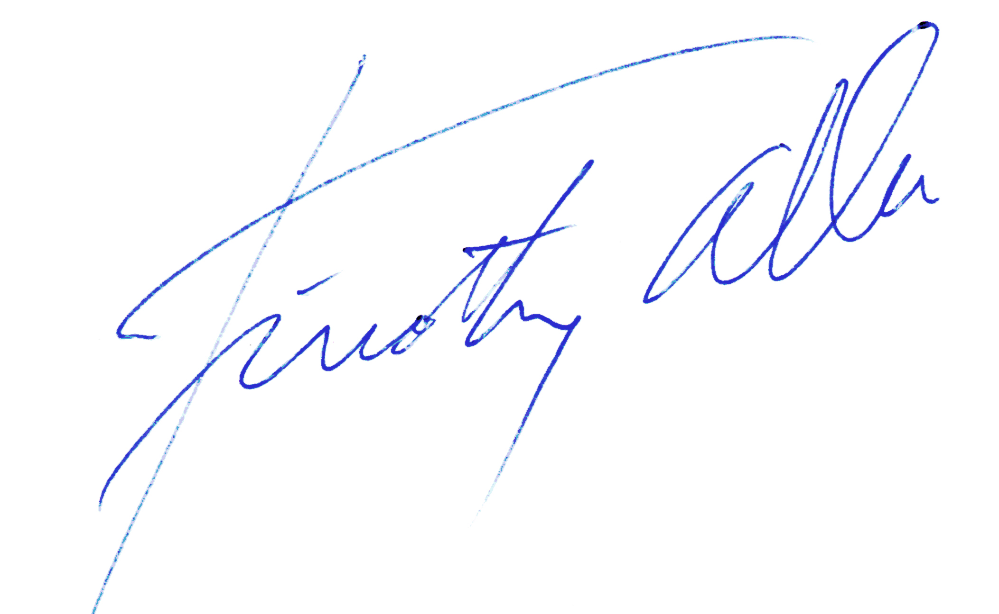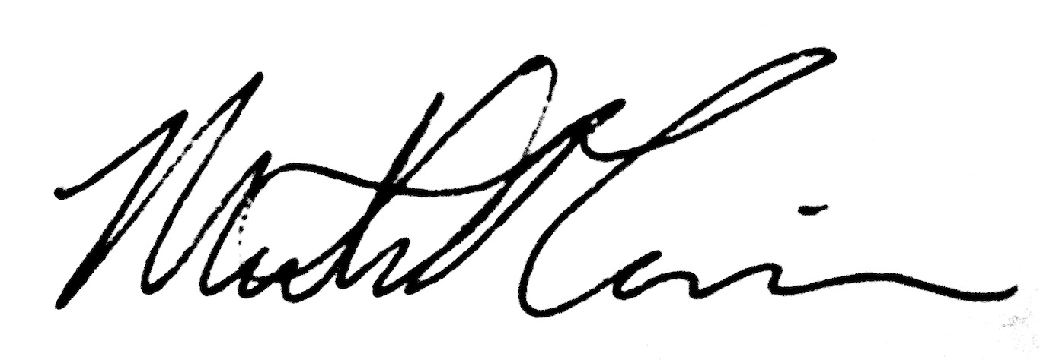
Tim Abbe, PhD, PEG, PHG Michael Ericsson, MS, PG
Principal Geomorphologist Geomorphologist
Washington Hydrogeologist #1151 Washington Geologist #2942

Attachments:
Figure 1 – Project reach map
Figure 2 – Gold Creek Pond Restoration Actions
Figure 3 – Gold Creek Pond Restoration Concept Design
Figure 4 – Gold Creek Pond Restoration Profile and Reference Photos
Figure 5 – Gold Creek Restoration Actions (Map Index & Downstream Section)
Figure 6 – Gold Creek Restoration Actions (Middle Section)
Figure 7 – Gold Creek Restoration Actions (Upstream Section)
Figure 8 – Gold Creek Restoration Reference Photos
Figure 9 – Drainage Line Restoration Design

references
Bennett, J. 2007. The Spirit of Ski Tur Valley. Xlibris Corporation.
Natural Systems Design, 2013a. Gold Creek Habitat Assessment & Conceptual Design Task 1: Data Inventory & Data Gap Analysis. Unpublished report prepared for Kittitas Conservation Trust.
Natural Systems Design, 2013b. Gold Creek Hydrologic Assessment Memo. Unpublished report prepared for Kittitas Conservation Trust.
Natural Systems Design, 2014a. Gold Creek 2014 Hydrologic Assessment Memo. Unpublished report prepared for Kittitas Conservation Trust.
Natural Systems Design, 2014b. Gold Creek Geomorphic Assessment Memo. Unpublished report prepared for Kittitas Conservation Trust.

