November 19, 2013

Subject: Synopsis of 2013 Gold Creek Bull Trout Spawning Activity and Nature of Habitat Used

project background
The Kittitas Conservation Trust has identified the lower 6.8 miles of Gold Creek above Keechelus Lake as a candidiate for habitat restoration to: 1) restore perennial flow through a seasonally dewatered reach within this segment, and 2) improve instream habitat for threatened Gold Creek bull trout. The bull trout that presently utilize Gold Creek are all that remain of a once more abundant population native to the original pre-dam Lake Keechelus. In 1998, owing to seriously reduced numbers, the U.S. Fish and Wildlife Service listed the entire upper Columbia River Distinct Population Segment of bull trout, including the Lake Keechelus/Gold Creek population, as threatened under the U.S. Endangered Species Act.

In my earlier report dated August 16, 2013, I compiled all available information on the life history and ecology of the Keechelus/Gold Creek bull trout population, as well as everything available from previous stream habitat assessments on the physical nature of the habitats these fishes utilize during those parts of their life cycle spent in the creek. In this addendum report, I provide a synopsis of this year’s Gold Creek bull trout spawning activity along with new information about the sites they selected for spawning.

methods
Washington Department of Fish and Wildlife (WDFW) personnel conduct bull trout spawning surveys annually in several tributary streams in the upper Yakima River Basin, including Gold Creek, using a redd count protocol originally developed in the Flathead River Basin of Montana (Shepard and Graham 1983), but modified and refined for use in Washington watersheds (Bonar et al. 1997). For the Gold Creek survey, the stream was divided into lower and upper segments, each of which was walked by teams of experienced observers three times over the course of the bull trout spawning season. For 2013, the lower segment extended from RM 0.1 (access road overpass; see map, Fig. 1) to RM 4.0 (downstream edge of the major 2008 avalanche chute). The seasonally dewatered reach of Gold Creek lies within this segment. The survey’s upper segment extended from RM 4.0 to the feature labeled Gold Creek Falls (Fig. 1) at approximately RM 6.6. The first pass was made October 2, the second pass October 15, and the third and final pass October 24. The teams counted every new redd they observed on each pass, and recorded their GPS coordinates. They then placed flagging to alert observers on subsequent passes so that redds would not be double counted. The redd counts from each pass were then added to obtain a cumulative total for the year.

For 2013, the teams were also asked to record descriptions of the Hydraulic Habitat Units (so-called by Barta et al. 1994 and Shellberg et al. 2010) where each redd was sited. Hydraulic Habitat Units (hereafter, HHU or HHUs) are defined as microhabitat-scale features where localized stream power is reduced sufficiently during bedload-moving flows for scour to be minimized and the egg pockets excavated by spawning bull trout most likely to remain undisturbed. Both Barta (1994) and Shellberg et al (2010) listed the following features as HHUs:
- gravel pockets immediately downstream of one or more flow obstructions such as boulders or LWD pieces (i.e., in the approximately triangular-shaped zone of slower water that forms immediately below such obstructions);
- gravel pockets immediately upstream of one or more such obstructions (i.e., in the “cushions” of slower water that form immediately above such obstructions);
- gravel pockets surrounded by such obstructions;
- riffle crests in gravel riffles (a riffle crest is defined as the shallowest continuous line of gravel across the channel closest to where the water surface becomes continuously riffled, i.e., near or at the upstream entrance to the riffle [Armantrout 1998]);
- lateral gravel bars;
- side channels.
This level of localized spawning habitat analysis is new, and only bull trout spawning streams west of the Cascade crest were studied during its development (Shellberg et al 2010). Its use in Gold Creek is, to our knowledge, its first application anywhere east of the Cascade crest.

results

conditions ENCOUNTERED in gold creek DURING THE UPSTREAM MIGRATION PERIOD

The seasonally dewatered reach of Gold Creek went dry this year on or about July 29th over a length extending from RM 1.41 to RM 1.68. Dewatering extended upstream and downstream from there, reaching upstream to RM 2.0 and downstream to the Gold Creek Pond outlet over about the next two weeks. If the onset of the bull trout spawning migration occurred about mid-July, as it always has in the past (Craig 1997; Wissmar and Craig 1997; James 2002; Meyer 2002) and if it proceeded on its normal schedule, then more than half of the 2013 migrants ascended past the dewatered reach to upstream holding locations in the approximately two weeks before dewatering began. Later migrants would have been blocked and obliged to hold in waters below the outlet of Gold Creek Pond.

On September 22-23, a rainstorm occurred that was heavy enough to re-water the dry section of the creek for 24 hours. Then, four days later, a much heavier and prolonged rainstorm spanning the September 27-29 period restored surface water flow in the channel for the rest of the season and allowed free upstream access to all remaining migrants.

One additional observation: the WDFW team surveying the upper segment of Gold Creek reported a new (winter of 2012-2013) avalanche chute that reached the channel about 200 feet downstream from the feature labeled Potential Natural Passage Barrier at RM 5.7 in Fig. 1. This avalanche did not block the stream, but did deposit new LWD in the channel.

2013 REDD COUNTS AND LOCATIONS
No redds were observed anywhere in Gold Creek on the October 2 pass; all spawning in the creek in 2013 occurred after October 2.
Between October 2 and October 15, bull trout constructed seven redds, three in the lower segment of the creek and four in the upper segment. Between October 15 and October 24, five additional redds were constructed, three in the lower segment and two in the upper segment. The total redd count for 2013 was twelve, up by five from the 2011 and 2012 spawning seasons. The locations of these redds are mapped in Fig. 1 below.

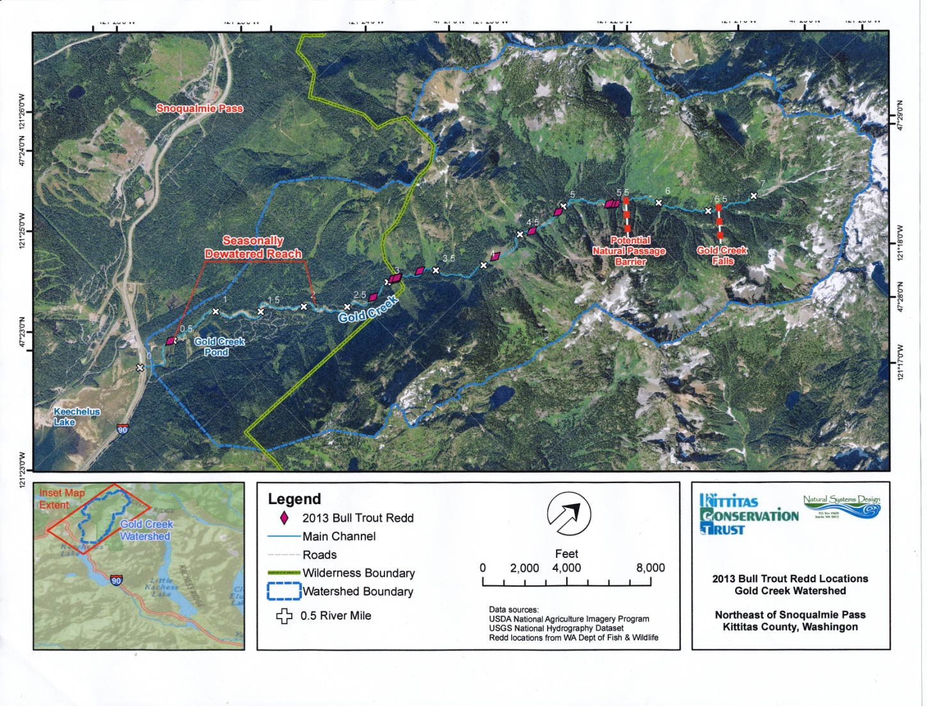
Figure 1. Bull trout spawning sites, Gold Creek, 2013

Of particular note for 2013 is that bull trout chose two areas in particular to aggregate their redds, one in the RM 5.5-5.6 vicinity where three redds were constructed in close proximity to one another. This is very close to the area where the reported new avalanche chute deposited new LWD in the channel.

The other area was located at or just above RM 3.0 (three redds, two at the same GPS position), near where the boundary line for the Alpine Lakes Wilderness crosses Gold Creek. There is nothing in the survey field notes to suggest why the bull trout should have aggregated here. However, this is about where the valley widens and the overall stream gradient decreases from 2-4 percent to around 1 percent or so, which would make this a natural deposition reach for sediments being transported downstream. Perhaps this has simply become a more gravel-rich area that was attractive to bull trout spawners in 2013 where it wasn’t in 2011 or 2012 when no aggregation of redds occurred (only one redd here in both 2011 and 2012).

CONFORMANCE OF REDD SITES WITH SHELLBERG/BARTA HHUs
The recent publication by Shellberg et al. (2010) presents evidence that bull trout may select spawning sites for their stability against bedload scour in streams such as Gold Creek. Although Gold Creek itself was not one of their study streams, Shellberg et al. (2010) found that bull trout spawning in streams of a like nature on the west side of the Cascade crest consistently selected redd locations in the same HHUs that Barta et al. (1994) had earlier identified as places where gravel deposits were least likely to move during bedload-moving flow events.

To test if this might be the case in Gold Creek as well, we made a one-day reconnaissance of the creek in July of this year. We found that gravel deposits at the GPS locations where bull trout spawned in 2012 were associated with Shellberg/Barta HHUs, even though it was not possible to discern where the redds themselves had been located that long after the spawning season. Results from the 2013 redd survey, where the teams described the locations of every new redd observed, reinforce this earlier findings and confirm that spawning bull trout did indeed select HHUs for excavating their redds. The results were as follows:

- Two redds were sited in gravel pockets immediately upstream of LWD obstructions.
- Two redds were sited in gravel pockets immediately downstream of boulder or LWD obstructions.
- Two redds were sited in gravel pockets surrounded by boulder or LWD obstructions.
- Three redds were sited on or slightly upstream of riffle crests. A photo of one site described as slightly upstream showed a pool that spilled out into a riffle. The redd was in the pool tailout several feet upstream of the actual riffle crest.
- Three redds were sited on or at the edge of lateral gravel bars.

The only HHU not used by bull trout in 2013 was the side channel HHU, possibly owing to the lack of access to side channels, or their absence from the stream, in 2013. In the past, a side channel that existed between RM 4.0 and RM 4.3 along the east bank of the stream saw extensive use each year by spawning bull trout, and was one of the highest-density spawning reaches identified in the stream (Craig 1997; Wissmar and Craig 1997). That side channel was obliterated by the major avalanche of 2008 (Reiss et al. 2012).

The Shellberg/Barta HHU assessment provides useful new insights into the selection of spawning sites by Gold Creek bull trout that should be useful in guiding instream habitat restoration activities as the project nears completion. Its use should be continued in 2014 and beyond.

conclusions
A total of twelve bull trout redds were recorded in Gold Creek for 2013. This is an increase of five redds over the 2011 and 2012 periods.
All bull trout redds were sited in Hydraulic Habitat Units described by Shellberg et al. (2010) and Barta (1994). The only type of HHU not used by Gold Creek bull trout in 2013 was the side channel HHU, a heavily-used HHU in the past, possibly owing to the lack of access or absence of such units in the creek in 2013.
The Shellberg/Barta HHU assessment provides useful new insights into the selection of spawning sites by Gold Creek bull trout, and should be continued to gather more data in 2014 and beyond.

Sincerely,

Natural Systems Design, Inc.

Patrick C. Trotter, Ph.D.
Senior Fishery Biologist

references
Armantrout, N.B. 1998. Glossary of aquatic habitat inventory terminology. American Fisheries Society, Bethesda, MD.
Barta, A.F., P.R. Wilcock and C.C.C. Shea. 1994. The transport of gravels in boulder-bed streams. Pages 780-784 in G.V. Cotroneo and R.R. Rumer, editors. Hydraulic Engineering ’94, Proceedings of the 1994 Conference. Vol. 2. American Society of Civil Engineers, New York, NY.
Bonar, S.A., M. Divens and B. Bolding. 1997. Methods for sampling the distribution and abundance of bull trout/Dolly Varden. Washington Department of Fish and Wildlife, Inland Fisheries Investigations, Resources Assessment Division, Report RAD 97-05. Olympia, WA.
Craig, S.D. 1997. Habitat conditions affecting bull trout, Salvelinus confluentus, spawning areas within the Yakima River basin, Washington. Master’s thesis, Central Washington University, Ellensburg, WA.
James, P.W. 2002. Population status and life history characteristics of bull trout in the Yakima River basin, final report. Submitted to U.S. Bureau of Reclamation, Upper Columbia River Office by the Department of Biological Sciences, Central Washington University, Ellensburg, WA.
Meyer, W.R. 2002. The effects of seasonal de-watering on three age classes of bull trout, Salvelinus confluentus. Master’s thesis, Central Washington University, Ellensburg, WA.
Reiss, K.Y., J. Thomas, E. Anderson and J. Cummins. 2012. Yakima bull trout action plan. The Yakima Bull Trout Action Plan Working Group, Yakima, WA.
Shellberg, J.G., S.M. Bolton and D.R. Montgomery. 2010. Hydrogeomorphic effects on bedload scour in bull char (Salvelinus confluentus) spawning habitat, western Washington, USA. Canadian Journal of Fisheries and Aquatic Sciences 67: 626-640.
Shepard, B.B. and P.J. Graham. 1983. Fish resource monitoring program for the upper Flathead Basin. Flathead River Basin Environmental Study, EPA Contract No. R008224-01-4. Montana Department of Fish Wildlife and Parks, Kalispell, MT.
Wissmar, R.C. and S. Craig. 1997. Bull trout spawning activity, Gold Creek, Washington. University of Washington, Fisheries Research Institute Report FRI-UW-9701, Seattle, WA.

