November 5, 2013

Kittitas Conservation Trust
205 Alaska Ave
Roslyn, WA 98941-0428
Attention: Mitch Long, Project Manager
David Gerth, Executive Director

Subject: DRAFT Gold Creek Habitat Assessment Memo

project background
The Kittitas Conservation Trust (KCT) has identified the lower 6.8 miles (mi) of Gold Creek above Keechelus Lake near Snoqualmie Pass as a candidate location for habitat restoration. The primary objectives of the Gold Creek Restoration Project (Project) are to restore perennial flow through the lower 6.8 mi of Gold Creek, and improve instream habitat for threatened Gold Creek Bull Trout (Salvelinus confluentus). The hydrologic, hydraulic, and geomorphic conditions within the project reach will be assessed to determine the causal mechanisms contributing to seasonal dewatering, and the associated impacts to Gold Creek Bull Trout. These findings will be used to develop conceptual designs that meet the primary objectives of the Project by restoring natural geomorphic processes.
Existing information relevant to the Project has been reviewed and compiled to guide the assessments and conceptual design development. This information has been synthesized to describe the existing knowledge base related to the Project, and to identify key data gaps that need to be resolved to meet the objectives of the Project (NSD 2013). This technical memo describes the current hydrologic and hydraulic conditions within the Project reach, and how they contribute to seasonal dewatering in Gold Creek.

PROJECT REACH
Gold Creek drains a 14.3 mi² (9,122 acre) watershed in the Cascade Mountain range, flowing for approximately 8 miles before entering Keechelus Lake near Interstate 90 (Craig 1997, Wissmar & Craig 2004, USFS 1998). The drainage basin ranges from 2,507 to 6,933 feet (ft) above sea level (total relief of 4,426 ft.) (Wissmar & Craig 2004) with an average annual precipitation of 87.6 inches (in) and mean temperatures ranging from 33 – 52 degrees Fahrenheit (Western Regional Climate Center 2013). The lower reach of Gold Creek (river mile (RM) 0 – 1.85) is a low-gradient (1%), braided channel flowing through a broad, alluvial valley of highly-permeable sand and gravel (USFS 1998, Collins 1997). The average bankfull width in this reach is 160 ft and the valley is 500 ft wide in some areas, reducing tributary inputs of sediment and large woody debris (LWD) to Gold Creek (Collins 1997). The middle reach (RM 1.85 – 3.1) is more confined, with average bankfull and valley widths of 50 and 100 ft, respectively (Collins 1997). This reach averages a 3% gradient, and is composed of pool-riffle segments dominated by cobble and boulders (USFS 1998, Collins 1997). The upper reach (RM 3.1-7.1) is a high-gradient (5%) channel of step-pool segments underlain by boulders and bedrock (Collins 1997). The upper reach is moderately confined, with an average bankfull width of 40 ft and a mean valley width of 100 ft. Fish passage is impeded by a bedrock cascade segment and a waterfall at RM 5.3 and 7.1, respectively (Craig 1997, Collins 1997). Stream discharge measurements in lower Gold Creek range from 12.3 cfs in mid-August to 19.9 cfs in late September and a peak flow of 331 cfs was measured in mid-June (Thomas 2001). In recent years, channel dewatering in the lower and middle reaches has been observed between mid-July and late September (Craig 1997, Mayo 2003).

habitat assessment
The bull trout that presently utilize Gold Creek are all that remain of a once more abundant population native to the original, smaller, pre-dam Lake Keechelus. Although there are only anecdotal accounts and no official numbers, bull trout—at that time believed to be Dolly Varden charr, Salvelinus malma—were said to be plentiful in the pre-dam lake (see for example Bickel 1908). Here in the Pacific Northwest, bull trout did not come to be recognized as such until 1978 (Cavender 1978), and only since 1982 have they been acknowledged by the State of Washington as the species actually present in Lake Keechelus (Mongillo and Faulkoner 1982). In 1998, owing to seriously reduced numbers, the U.S. Fish and Wildlife Service listed the entire upper Columbia River distinct population segment of bull trout (including the Lake Keechelus/Gold Creek population) as threatened under the U.S. Endangered Species Act.
Redd counts, available for every year since 1984 (Fig. 1), have served as surrogate estimators of spawning population strength for Gold Creek bull trout. These counts show that this population is especially small, and has been for some time. Such populations are at high risk of extirpation from chance events alone, such as wildfire or, say, an ill-timed, ill-placed major landslide or avalanche. Such an event, in this case an early spring avalanche in 2008 that occurred near RM (River Mile) 4, completely covered about a quarter-mile section of Gold Creek with snow, ice, large wood debris, rock, and earth. Initially it was feared this blockage would have a catastrophic impact by preventing the fish from reaching preferred spawning sites and reproducing successfully. Although that did not happen (Reiss et al. 2012), recent observations do suggest that the core areas selected by the bull trout for holding and spawning locations may indeed have been affected. I discuss this further later in this report.

Figure 1. Gold Creek yearly redd counts, 1984 through 2012, data from Washington Department of Fish & Wildlife Summary Stock Report.

bull trout life cycle
Gold Creek bull trout follow what is referred to as an adfluvial (aka lacustrine or lake-dwelling) life cycle, meaning that they spend most of their lives foraging and growing in the lake environment of Keechelus Reservoir but migrate into Gold Creek for the purpose of reproduction. Adults that survive the rigors of spawning return to the reservoir—and so do their progeny after spending the first 1 to 3 years of their juvenile lives in the creek. The progeny become sexually mature and ready to spawn themselves for the first time at age 4 or 5 after a year or two of foraging and growth in the reservoir, and can spawn every year thereafter, although many of the adults do not do so in successive years and remain in the reservoir throughout the years that they skip. Adfluvial bull trout can live to age 10 (occasionally to age 12), and over that span of time can grow to more than 30 inches in length and to weights of 20-plus pounds. The Washington State angling record is a 35-inch, 22.5-pound bull trout caught in the nearby Tieton River in 1961, and a fish estimated to be 30 inches in length was photographed in Gold Creek by a Forest Service snorkeler back in 1992 (Fig. 2). However, most migratory bull trout will generally run smaller and weigh in the 3 to 12 or perhaps 15 pound range.
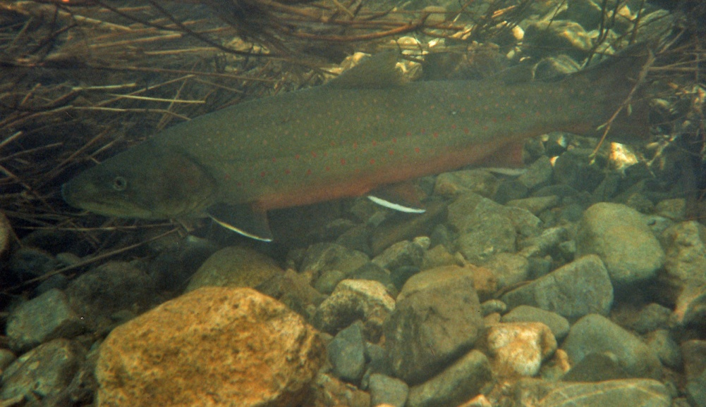
Figure 2. A 30-inch (estimated) bull trout photographed in Gold Creek in 1992. U.S. Forest Service photo courtesy of Snoqualmie Ranger District, Mt. Baker-Snoqualmie National Forest.
An important aspect of the bull trout life cycle is the requirement for cold water temperatures throughout. All of the fishes in our project area could be considered coldwater species, but the bull trout’s life cycle requires a colder temperature regime than any of the others. They migrate into the coldest headwater tributaries where they spawn in the fall when water temperatures drop to 46º F (8º C) or lower. The optimal temperature for development of the deposited eggs to hatching is about 39º F (4º C), but the embryos can readily endure the even colder water temperatures that occur over the course of the winter in streams such as Gold Creek. When foraging and growing in the lakes or when holding in the headwater streams prior to spawning, adult bull trout prefer water temperatures in the 50 to 54º F (10-12º C) range, as do juvenile bull trout during their first 1-3 years of summer rearing in their natal streams. Bull trout will rarely be found in waters where the summer temperature exceeds 59 to 60º F (about 15º C).
Bull trout are fall spawners, but in adfluvial populations the majority of the adults may enter natal tributaries in mid-summer, about two months prior to the initiation of actual spawning (Fraley and Shepard 1989). This is true in Gold Creek as well, where observers have consistently reported the first of the migrants in the stream about the second or third week of July (Craig 1997; Wissmar and Craig 1997; James 2002; Meyer 2002). The majority of the upstream migrants enter between mid-July and mid-August (James 2002) and move quickly upstream to holding pools in the same general segment of the creek where they will later spawn, beginning in early to mid-September. Researchers studying Gold Creek bull trout holding and spawning behavior in the 1993, 1994, and 1996 seasons (Wissmar and Craig 1997; Craig 1997) found that in those years the fish homed to a segment about 1.7 RM in length, extending from roughly RM 4 to RM 5.7. More recent observations (since 2008) make it clear that the core segment for holding and spawning has lengthened in a downstream direction, and now extends from roughly RM 3 to RM 5.7. The few migrants that enter the creek later would likely home to this same core segment, were it not for the dewatering of a downstream segment adjacent to the Gold Creek Pond, that in some years may extend as much as 2 miles upstream from the Pond outlet (Reiss et al. 2012). This also occurs around mid-August most years and blocks any further upstream migration.
I base my remark that the blocked fish would likely continue upstream if they could on two observations made by researchers in the field. In mid-September of their 1994 field season, Wissmar and Craig (1997) reported that a heavy rainstorm re-watered the channel briefly and the bull trout isolated below the Gold Creek Pond outlet at the time took advantage and passed upstream quickly. Meyer (2002) made a similar observation of late-arriving bull trout moving rapidly upstream during a short-duration re-watering event that occurred in September, 2001. But in most years the channel remains dewatered until the rains of later-autumn commence, which typically does not occur until the bull trout spawning period has concluded in Gold Creek.
The evidently strong fidelity to holding pools in a specific core segment of the stream is another life history trait that Gold Creek bull trout share with other adfluvial populations. Although not true for all such populations (Pratt 1992; McPhail and Baxter 1996), those that do share this trait exhibit strong homing fidelity not only to their natal tributaries, but also to natal reaches within these tributaries and sometimes even to specific holding pools and spawning sites that they return to year after year for as many times as they spawn (Hogan and Scarnecchia 2006; Starcevich et al. 2012).
The early studies of Gold Creek bull trout suggest that they too exhibited strong fidelity to specific spawning sites. Figure 3 (from Craig 1997, his Fig. 9), is a map of Gold Creek bull trout redd locations in 1996, the year with the highest return of spawners so far recorded (51 total redds; 102 returning adults using the formula, redd count x 2 = spawning population size [Wissmar and Craig 1997; William Meyer, WDFW, personal communication May, 2013]). By far the highest densities of redds were observed at just two sites, one a 1st-order spring-fed side channel near RM 4.2 (Reach 5 in Fig. 3) and the other a short upwelling reach in the immediate vicinity of the Silver Creek confluence at RM 4.9 (within Reach 6 in Fig. 3). Bull trout spawners congregated in these same two locations as well in 1993 and 1994 (Wissmar and Craig 1997), both years of lower spawner numbers. Figure 3 also shows that the fish will spread out and use other sites to build redds when large numbers of spawners crowd the preferred sites. In 1996, the spreading was mostly upstream to spawning sites between the mouth of Silver Creek and what has been classified in stream surveys (USDA Forest Service 1992, 1993) as a bedrock cascade at RM 5.7. Bull trout are capable of ascending past this feature, but few do. Over all years of record, bull trout have spawned only infrequently upstream of this feature (Reiss et al. 2012).
Figure 3 also shows that bull trout blocked by dewatering from migrating upstream will indeed spawn in the stream segment downstream from the Gold Creek Pond outlet, and even in the dewatered reach of Gold Creek (Reach 3 in Fig. 3) once water is flowing in the channel again. But all of this spawning activity takes place in October, late in the spawning season, and not until water temperatures in these segments drop to 46º F (8º C) or lower, which they do not normally do until around the 19th or 20th of October (Goetz 1994; Craig 1997; Thomas 2001; Meyer 2002). The Gold Creek Pond outlet was built to be a spawning channel, but bull trout have seldom (if ever) used it as such. It is, however, used each year by the introduced kokanee that inhabit Lake Keechelus, which typically enter the creek in September and October.
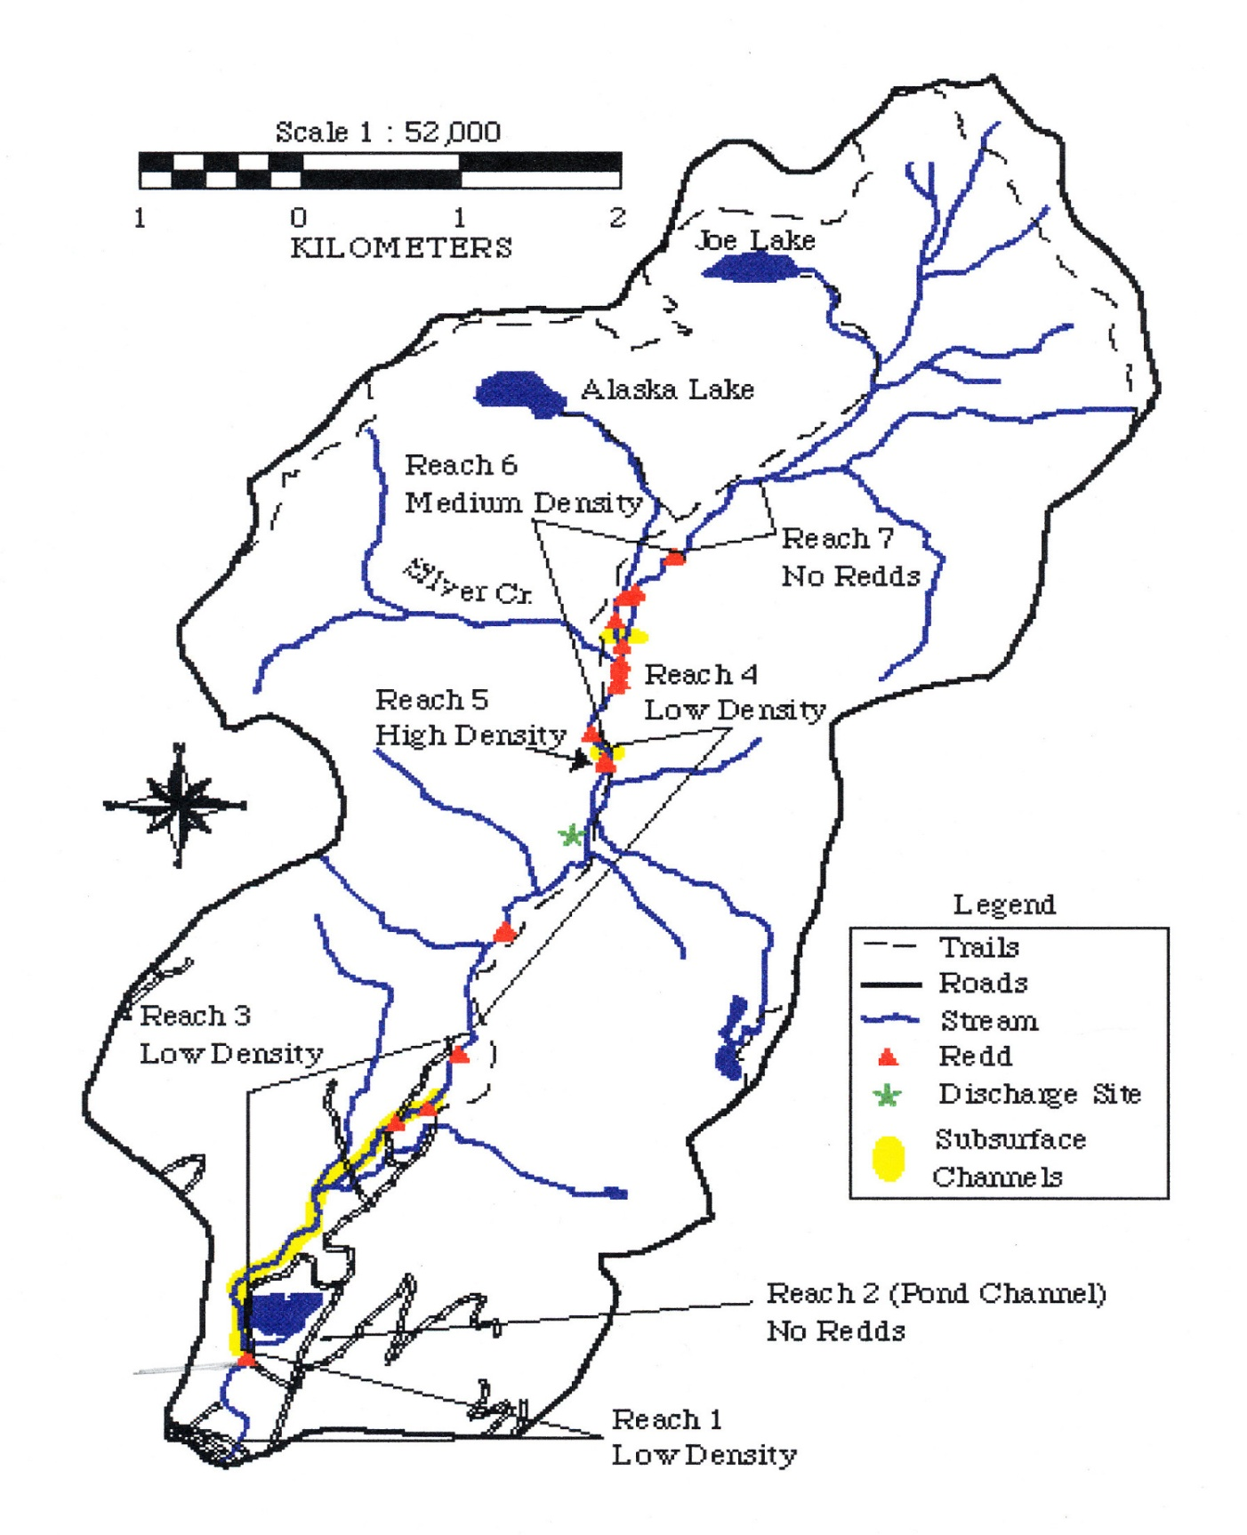
Figure 3. Bull Trout Spawning Locations, Gold Creek 1996. From Craig (1997).
Beginning in 2008, in addition to simply counting the bull trout redds in Gold Creek, the spawning survey teams began recording the GPS locations of the redds they observed. We have mapped these locations for 2008 and also for the two most recent years, 2011 and 2012, in Figures 4A, 4B, and 4C below. Comparing these maps with those from the earlier years of study, it is clear that some changes have occurred in the holding and spawning preferences of Gold Creek bull trout. The recent maps show that at least some of the site fidelity reported in the 1993-1996 period has been relaxed, with adult bull trout now holding and spawning further downstream than in those earlier years. The bull trout have not abandoned spawning in the reach between RM 4 and RM 5.7 where they congregated before, but more spawning has been occurring in the reach between RM 3 and RM 4 in recent years, whereas that reach of stream was all but bypassed in the earlier years.
It is tempting to suggest that this downstream shift in holding and spawning locations was brought about by the major avalanche that occurred in the early spring of 2008. That event completely covered about a quarter-mile section of the Gold Creek channel near RM (River Mile) 4 with snow, ice, large wood debris, rock, and earth. Although bull trout migration and spawning was not impeded that summer and fall, the debris deposited in the channel was surely moved and redistributed downstream by the action of the moving water, creating new habitat units and conditions suitable for the bull trout further downstream. Although we cannot state this with certainty, owing to the lack of data for the 12- to 15-year gap between the 1993 to 1996 studies and the beginning of redd mapping in 2008, this is, nevertheless, one plausible explanation for the differences shown in the two sets of maps.

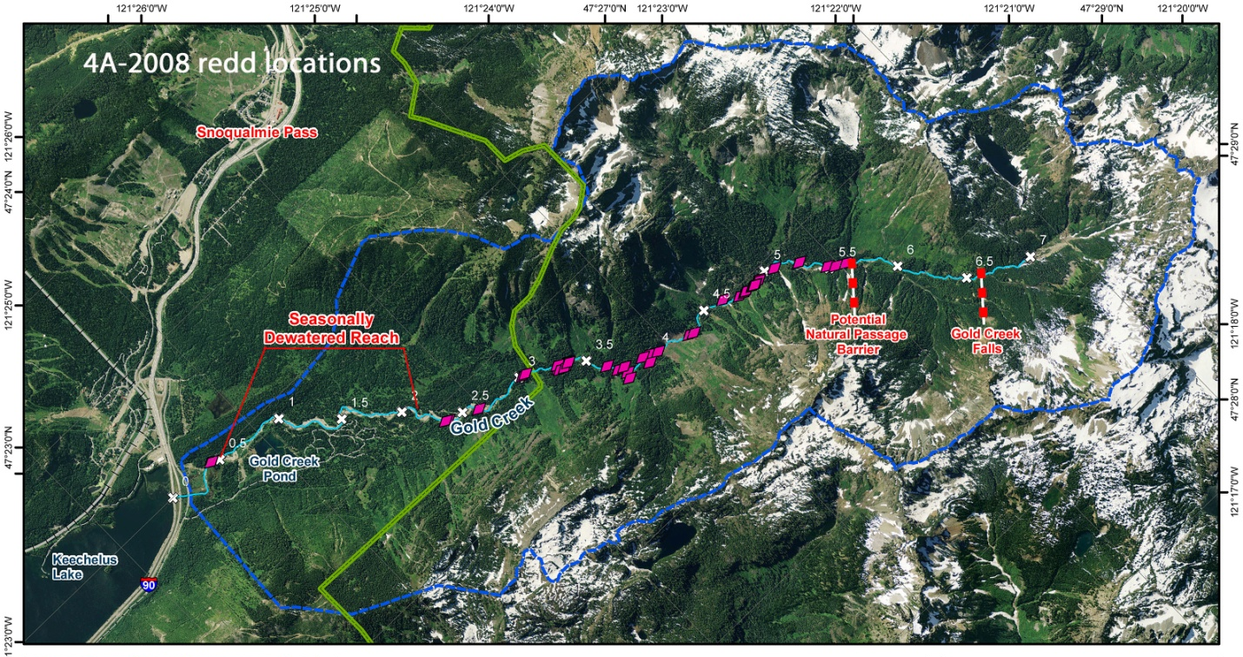

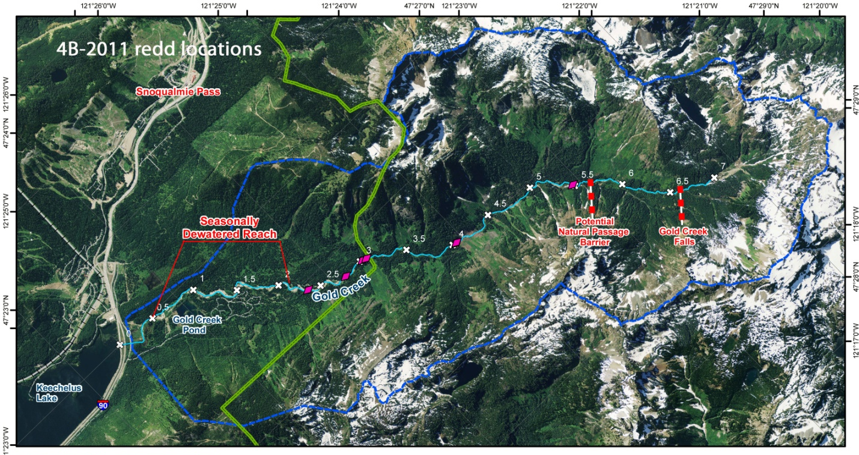
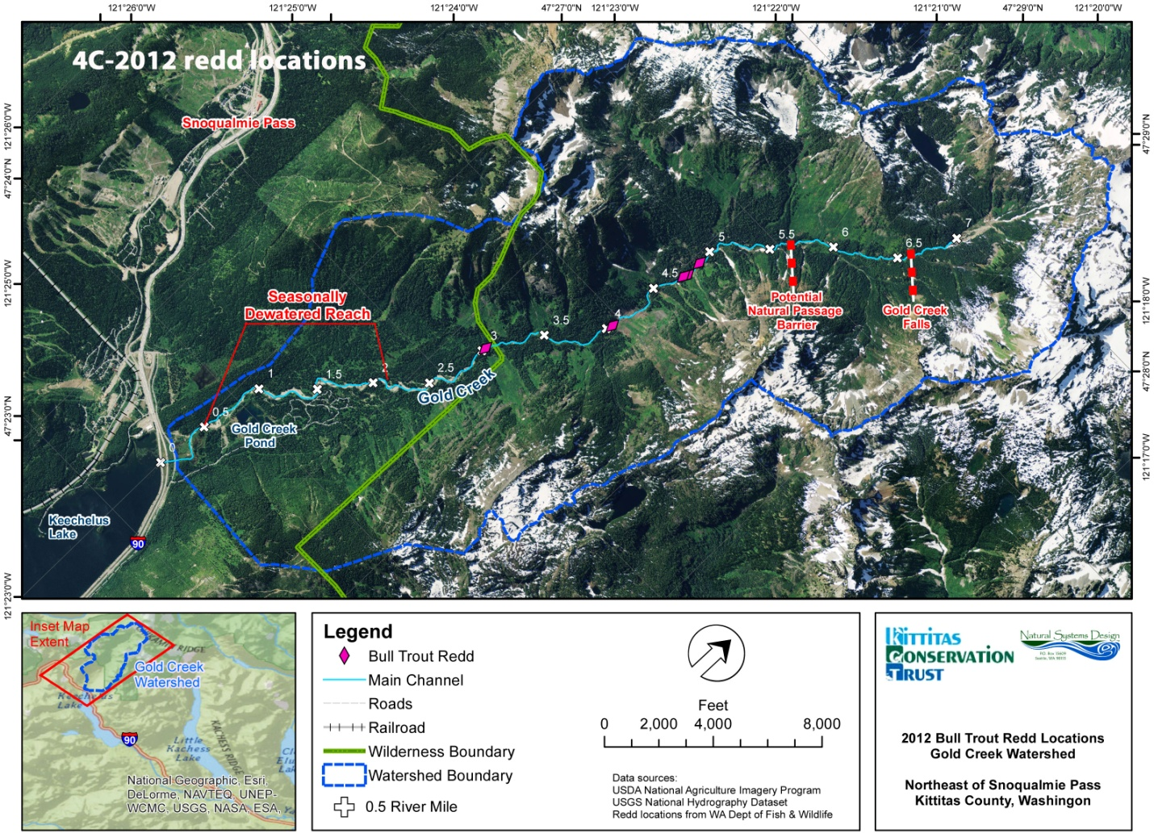
Figure 4. Bull trout redd sites, 2008 (4A), 2011 (4B), and 2012 (4C).
Post-spawn adult bull trout begin moving downstream soon after they have completed their spawning (Wissmar and Craig 1997), in order to recover condition in the lake environment of Keechelus Reservoir. The rigors of spawning are hard on these fish, and if their downstream migration is stalled, as happens in Gold Creek when dewatering persists too long into the fall, it can add to the stress they are under and can lead to their demise...the longer the dewatered state lasts, the greater the post-spawning mortality (Wissmar and Craig (1997).
Craig (1997) monitored spawning activity in upper Gold Creek throughout the fall of 1996 and, with the aid of a thermograph, he also recorded daily water temperatures for the period July 20, 1996 through April 28, 1997. First spawning activity occurred on or about the 15th of September that year, peak spawning activity occurred on or about October 5th, and no new redds were seen after October 7th. Using his water temperature data and a reported value of 392 accumulated CTU (Celsius Temperature Units) to hatching (Gould 1987; Fraley and Shepard 1989), he estimated that hatching of the deposited eggs occurred on or about the 22nd of April after about 199 days of incubation. Because his thermograph was removed shortly thereafter, he did not estimate a date for emergence of the fry. I projected the trend line for the last month of his temperature measurements forward in time, and used the reported value of 635 accumulated CTU to emergence of fry from the gravels (Fraley and Shepard 1989) to estimate that the fry should emerge on or about the 2nd of June after another 40 days of alevin development within the gravels.
Bull trout fry are only about 1 inch (23-28 mm) in length upon emergence and at this size, are not strong swimmers. They move immediately over to the stream edges where they find quiet water in edge niches and backwaters. They will feed and grow in these edge habitats for most of their first summer. When they reach about 2 inches (50 mm) in length, they begin to disperse from the stream edges in search of deeper pool habitats with concealment cover where they will continue to forage and grow, and then spend their overwinter months concealed within the bottom substrate.
Goetz (1994), James (2002), and Meyer (2002) have each reported on the movements and habitat use of young-of-the-year and older juvenile bull trout in Gold Creek. In the spring and summer months, these fish disperse throughout the stream, with the exception of the outlet from the Gold Creek Pond and the Gold Creek mainstem downstream from the Pond outlet. These two reaches may be avoided because of their elevated summer water temperatures, which are often at or above the 59 to 60º F (15º C) preference level of the species (Thomas 2001; Meyer 2002). Juvenile bull trout have been observed in the Gold Creek Pond itself, however, but always at the northern end of the pond where cold springs discharge. They also use the mainstem reach that dewaters (when water is present in the channel, of course), and often have been found stranded in residual pools when dewatering occurs, especially the age-1 fingerling-sized juveniles. They could survive in those pools provided they have sufficient depth and substrate for concealment and are continually refreshed with a flow of cold subsurface water and hyporheic invertebrate organisms for food, but probably not otherwise.
Age-1 and older juvenile bull trout are, like the adults, bottom dwellers and substrate-oriented. They utilize pools and deeper glides that provide concealment cover such as crevasses, interstitial spaces, large woody debris, undercut banks, and even the “bubble cover” generated by water falling into plunge pools or where riffles and cascades discharge into pools or glides (Fig 5). They also may use the deeper pockets within pocket water habitat units when pools and glides are scarce (Wydoski and Whitney 2003).
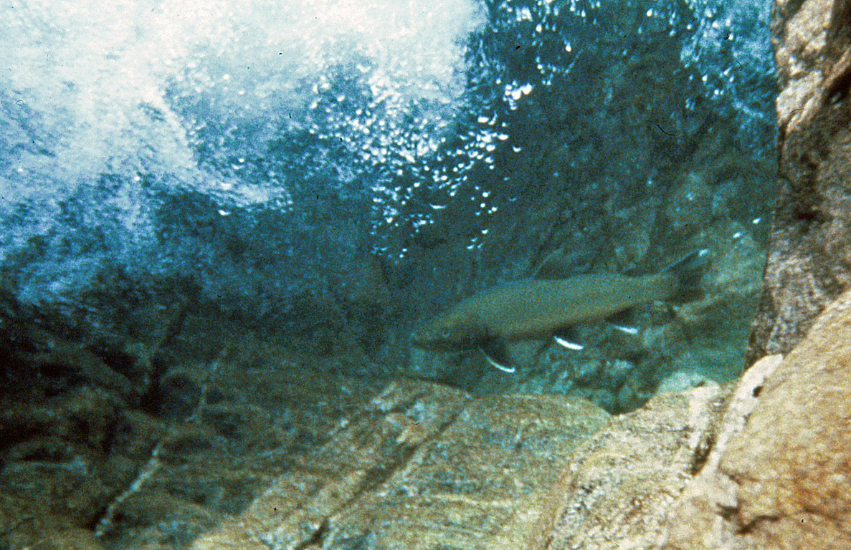
Figure 5. Bull trout beneath bubble cover. Photo courtesy of Alan Johnson, Natural Systems Design.
Juvenile bull trout tend to remain within concealment cover in their preferred pools and glides during the daytime, but are much more active and wide ranging at night. Goetz (1994) published an electivity index chart for juvenile bull trout in Gold Creek (Fig. 6) showing that during the daylight hours they select pool and glide habitat units in mainstem reaches and demonstrate a strong, virtually complete avoidance of side channels. But at night, their aversion to side channels disappears. At night they select both pool and side channel habitats for foraging. They do not totally abandon the glides at night, but use them only in proportion to their availability in the reach.
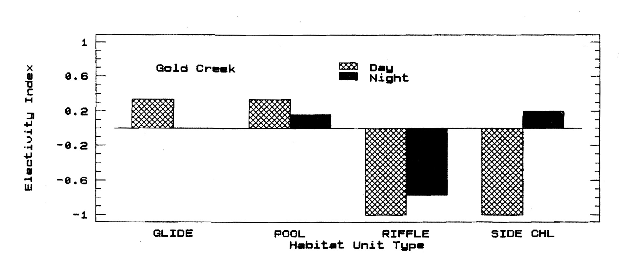
Figure 6. Electivity index for habitat units utilized by age-1 and older juvenile bull trout in Gold Creek. The index varies continuously from +1 (strong selection) to -1 (strong avoidance). From Goetz (1994).

In general, outmigration of adfluvial juvenile bull trout to take up their cycle of foraging and growth in lakes is volitional and could take place anytime throughout the spring, summer and fall seasons. James (2002) found that juvenile outmigration in other Yakima basin populations occurs in the late summer and fall, but he was unsuccessful in tracking downstream movements of either juveniles or adults in Gold Creek. I suggest that outmigration of juveniles from Gold Creek is likely to take place either in the spring and early summer or in the very late fall, owing to 1) the dewatering of the segment adjacent to Gold Creek Pond in the late summer-early fall months, and 2) the elevated water temperatures that prevail downstream from the Pond outlet during late summer-early fall (Thomas 2001; Meyer 2002).

REACHES AND CHANNEL UNITS
Stream surveys to classify the morphological and physical aspects of Gold Creek stream segments, reaches within segments, and instream habitat units within reaches (Bisson et al. 1982) were completed by the U.S. Forest Service during the 1992, 1993, and 1996 field seasons (US Forest Service 1992, 1993, 1998) and by Plum Creek Timber Company in 1997-98 (Plum Creek Timber Co. 2002). The Forest Service surveys of 1992 and 1993 followed an early version of Rosgen’s stream classification protocol (Rosgen and Silvey 1996), whereas the Forest Service 1996 and Plum Creek surveys followed the State of Washington’s Watershed Analysis protocol (Washington Forest Practices Board, various dates). In addition, physical aspects of the instream habitats actually selected and utilized by bull trout in Gold Creek were examined by Craig (1997) and Wissmar and Craig (1997, 2004) for pre-spawn and spawning adults, and, as described above in the Life Cycle Section, by Goetz (1994) and Meyer (2002) for age-0 and ages 1-3 juveniles.
With regard to the adult bull trout that enter Gold Creek on their pre-spawning migration, available evidence indicates that the majority of these fish move up the creek quickly, past the reach that dewaters in late summer, to holding pools and eventual spawning sites in a segment of stream that now extends from about RM 3 (just below the Wilderness boundary at RM 3.05) upstream to RM 5.7. The Washington Watershed Analysis protocol characterized this core segment as “variably confined” with gradients in the 2% to 4% range (Plum Creek Timber Co. 2002). One Forest Service survey defined three reaches within this segment and another a year later defined four reaches, both using the Rosgen protocol. Other field workers, using their own criteria, have broken this segment down into more, or fewer, reaches as they saw fit to meet their own research objectives. I chose the Forest Service’s three-reach delineation for Table 1 below, where I summarize the reach-scale attributes of this core segment as recorded in the early stream surveys.
In considering these attributes, it is important to remember that regardless of the protocol used, a stream survey gives only a snapshot of the state of its segments at the time of the survey, and the most recent of these surveys of Gold Creek, completed in 1998, is 15 years old now. The stream has been described as naturally flashy, in the sense that the channel responds rapidly to springtime snowmelt runoff, summer rainstorms, rain-on-snow events in late fall and winter, and frequent mass wasting off the steep side slopes, with a migrating stream channel constantly readjusting to maintain equilibrium (USDA Forest Service 1992, 1993; Wissmar and Craig 1997; Meyer 2002). Therefore, it is only to be expected that reach-scale changes, as well as changes at the instream habitat unit level within reaches, have occurred in that time that would change the snapshot presented in Table 1.
Rosgen reach type | B3 | C3 | B3
Reach length | RM 3 to RM 3.9 | RM 3.9 to RM 5.3 | RM 5.3 to RM 5.7
Overall reach gradient | 3.8% in 1st 0.4 mi.,  2.9% in last 0.6 mi. | 2.7% | 2.7%
Width:depth ratio | >12 | >12 | >12
Entrenchment ratio | 1.4-2.2 | >2.2 | 1.4-2.2
Sinuosity | >1.2 | >1.2 | >1.2
Pool:riffle:glide ratio | 2:5:1 | 1:5:1 in main channel  2:3:1 in side channels | 1:6:1
Substrate | Cobble dominant,  small boulders,  good loose gravel. | Cobble dominant,  good gravel in both main channel and side channels. | Bedrock, boulder, cobble, less gravel.
Other observations | A stair-stepped reach with good deep pools. | Evidence of channel migration.  Evidence of past mass wasting events.

Table 1. Reach-scale attributes of the Gold Creek stream segment utilized by adult bull trout during the pre-spawn and spawning periods of their life cycle.
Of more enduring significance for the bull trout may be factors at the reach-scale, the individual habitat unit level, and even at the microhabitat scale that are not included in stream survey protocols but the fish themselves signal are important. In his study of spawning locations in bull trout tributaries of the upper Yakima basin, including Gold Creek, Craig (1997) found that the numeric density of redds in spawning reaches was best predicted by a stepwise regression model containing three reach-scale variables: 1) overhead canopy cover measured at the thalweg, 2) water depth at the thalweg, and 3) water velocity at the thalweg. The highest redd densities occurred within reaches with greater than 54% overhead canopy cover, mean water depths of 25.4 cm (10 inches), and mean water velocities of 42.5 cm/sec. (1.4 ft/sec.). These reaches were highly constrained as well, with a mean channel constraint value of 2.3, which Craig (1997) calculated by dividing mean bankfull width by mean wetted width at the time of spawning. He also noted, evidently without studying them in greater detail, that several 1st order spring-fed side channels, including the one he singled out as his Reach 5 in Gold Creek (see Fig. 3; our RM 4.2), also had high densities of redds.
At the scale of the individual habitat unit, Wissmar and Craig (1997) recorded the habitat units (pools, riffles, or glides) selected by spawning females for constructing their redds in 1993 and 1994, in both the mainstem reach near the mouth of Silver Creek, and the spring-fed side channel near RM 4.2. They later published their results (see Wissmar and Craig 2004) in the form of habitat unit availability and electivity charts that I reconstructed in Figure 7 below. In the main channel, riffles were the most abundant habitat type available but were avoided by spawning bull trout in favor of pool and glide habitat units. On the other hand, electivity for riffles was high in the side channel. No redds were established in pools or glides in either year in the side channel.

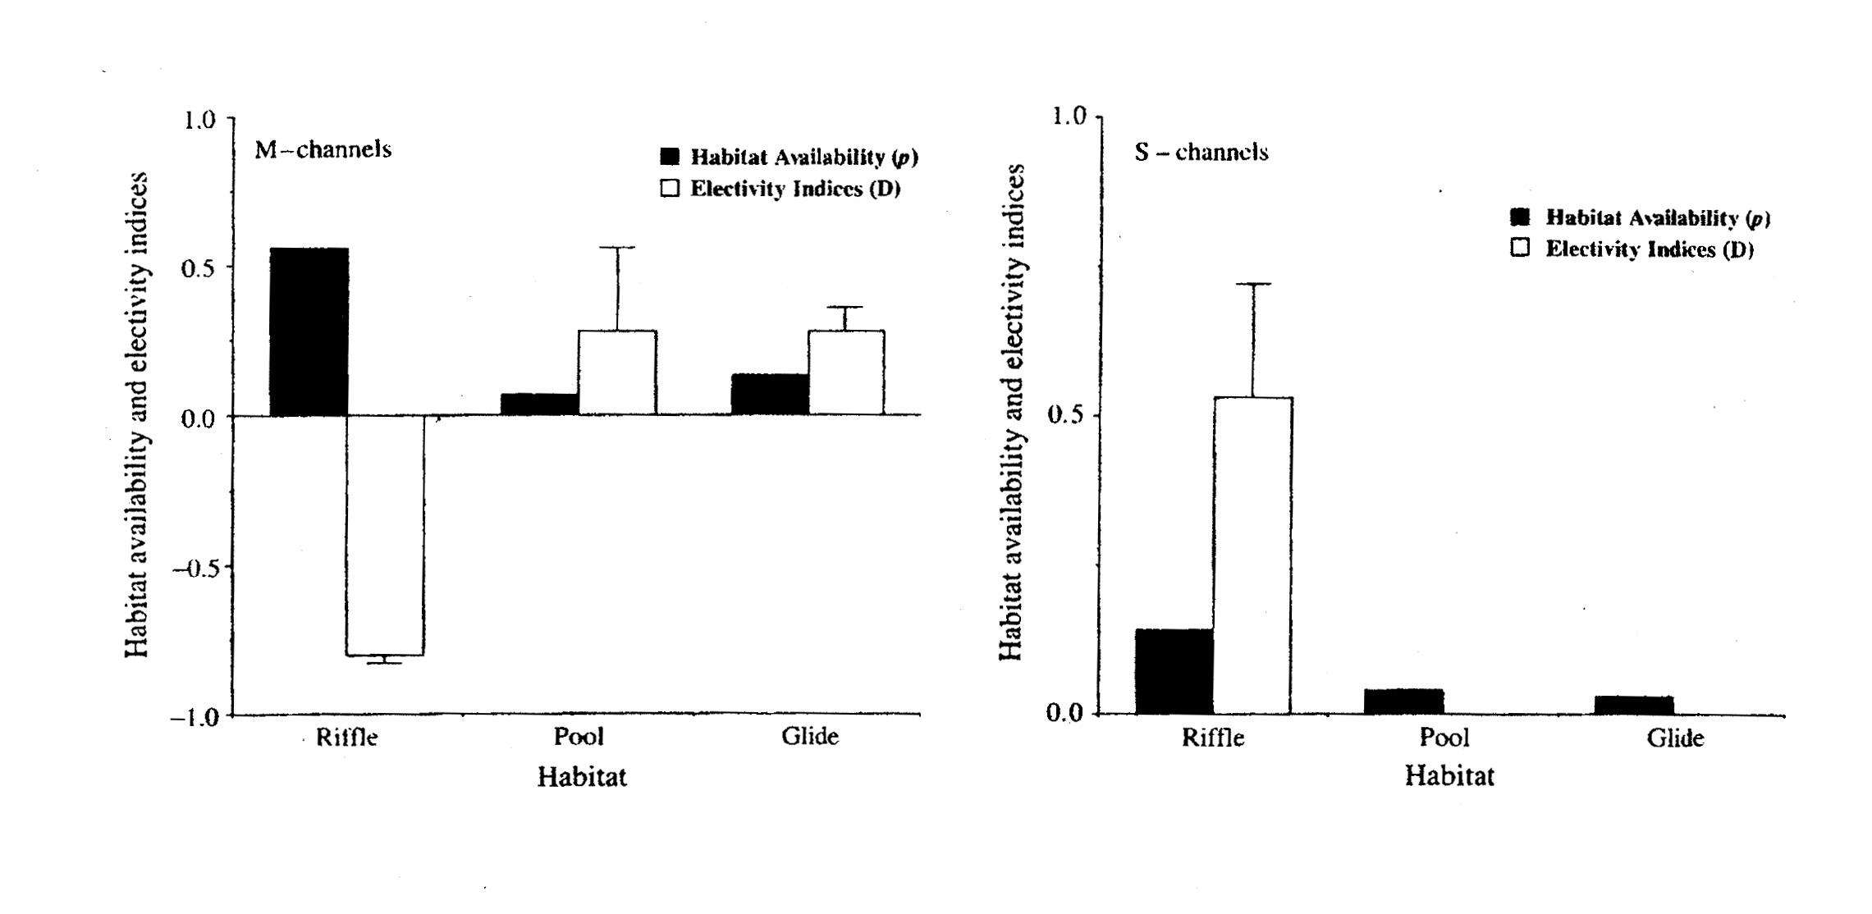
Figure 7. Habitat unit availability and electivity indices for bull trout redd locations in Gold Creek main channel (M) and side-channel (S). Electivity indices vary continuously from -1 (strong avoidance) to +1 (strong selection). From Wissmar and Craig (2004).
Selected habitat units had these additional features (Wissmar and Craig 2004):
- mean channel gradients ranging from 0.9 to 2.4 percent, steepest for riffles in the side channel and lowest for pools in the main channel reach.
- Wetted widths ranging from 15.4 to 23.3 ft. (4.7-7.1 m), narrowest for riffles in the side channel.
- Gravel substrates in abundant combination with instream cover elements such as LWD, boulders, and water turbulence.
- Abundant overhead canopy cover.
In addition to his work on the reach-scale factors that accounted for the highest densities of redds in spawning reaches, Craig (1997) also made several microhabitat-scale measurements at the redds themselves in 1996. Wissmar and Craig (2004) published similar measurements made in 1993 and 1994. Among these were gravel size, area disturbed by redd construction, egg burial depth, mean current velocity at redd locations, and mean tailspill depth. Although some of these measurements might be considered more as descriptors of redd morphology than microhabitat properties, I have included the entire array in Table 2 below.
Parameter Measured | Values Recorded
Gravel size | Mean pebble diameter 1.35-1.6 inches (Wissmar and Craig 2004).  Fredle Index 1.6 (Craig 1997).
Area disturbed by redd construction | 17.2-25.8 sq. ft. (Wissmar and Craig 2004).  6.67 sq. ft. (Craig 1997).
Egg burial depth | 4-8 inches (Craig 1997).
Mean current velocity | 0.3-0.5 ft./sec. at redd location (Wissmar and Craig 2004).  1.15 ft./sec. at tailspill (Craig 1997).
Mean tailspill depth | 5.3 inches (Craig 1997).

Table 2. Redd characteristics and microhabitat properties at bull trout redds in high-density spawning reaches, Gold Creek.
One important physical element missing from all of the studies highlighted above is upwelling. Indeed, upwelling has been shown to be a key factor influencing bull trout redd location in other basins within the species range (Baxter and McPhail (1999); Baxter and Hauer 2000). But, aside from a mention by Wissmar and Craig (1997) that the principal main-channel spawning reach used by bull trout in 1993 and 1994 was an upwelling reach, there appears to have been no further consideration of upwelling as an important selection factor for redd location by Gold Creek bull trout.
A fairly recent publication by Shellberg et al. (2010) presents evidence that bull trout may also select spawning sites for their stability against bedload scour in streams such as Gold Creek. Although Gold Creek itself was not one of their study streams, Shellberg et al. (2010) found that bull trout spawning in streams of a like nature on the west side of the Cascade crest consistently selected redd locations in the same hydraulic habitat units that Barta et al. (1994) had earlier identified as places where gravel deposits were least likely to move during what would be classified as bedload-moving flows in the stream channel as a whole. Both Barta et al. (1994) and Shellberg et al. (2010) listed these hydraulic habitat units as places where localized stream power is reduced sufficiently, even during bedload-moving flows, for scour to be minimized and, according to Shellberg et al (2010), bull trout egg pockets most likely to remain safe from scour:
- gravel pockets immediately upstream of one or more obstructions (LWD structures, boulders);
- gravel pockets immediately downstream of one or more obstructions (LWD structures, boulders);
- gravel pockets surrounded by obstructions (LWD structures, boulders);
- riffle crests in gravel riffles (a riffle crest is defined as the shallowest continuous line of gravel across the channel closest to where the water surface becomes continuously riffled, i.e., near or at the upstream entrance to the riffle [Armantrout 1998]);
- side channels;
- lateral gravel bars.
Because this kind of localized habitat analysis is new, it has not been applied to Gold Creek bull trout spawning site selections. But it could provide valuable new insights into the process, and could easily be incorporated into the existing monitoring protocol. At present, Gold Creek bull trout monitoring consists of walking the stream three (sometimes four) times a year during the spawning season to count redds and record their GPS locations. It would be an easy matter and require no extra work for the survey teams to also record the hydraulic habitat unit type where the redds are found, and I would recommend that this addition to the protocol be made.

FIELD ASSESSMENT
On July 11, 2013, NSD staff, Karen Chang (US Forest Service Snoqualmie District Fishery Biologist), Karl Flaccus and Liz Diether-Martin (both property owners in the SkiTur tract), hiked into the Wilderness segment of Gold Creek (RM 3.0 to RM 5.7 on Map for the purpose of acquainting NSD staff and the others with the habitat characteristics of locations where bull trout spawned in the fall of 2012. We had also hoped to examine the feature labeled Potential Natural Passage Barrier at RM 5.7 on the map, but we were unable to access that location.
Teams that count bull trout redds each year work their way up the stream bank in late summer and fall, when Gold Creek is at its lowest flow levels. Teams who made the early-90s habitat surveys for the Forest Service worked up the channel itself or along its banks, also when the stream was at base flow levels. For our trek on July 11, 2013, although the water had receded considerably from its peak snowmelt runoff level, it was still too high and the redd locations too far apart to make working our way up along the stream bank practicable. Instead, we accessed the spawning sites via the Gold Creek Trail, cutting overland where necessary to reach their individual GPS positions. It turned out that this entailed some heavy bushwhacking and scrambling down steep slopes and unstable boulder deposits in places, which had not been fully anticipated beforehand. Even so, we were able to reach all five of the 2012 redd locations, but not the erstwhile barrier feature at RM 5.7 owing to its distance from the trail, the difficulty of that particular scramble, and the lateness of the day.
We found the overall physical setting of the RM 3.0-RM 5.7 segment of Gold Creek to be as described in the early stream habitat surveys summarized in Table 1. At the scale of the individual habitat unit (Bisson et al. 1982),* the segment is riffle-dominated, also as the earlier surveys stated. However, pocket water habitat units (Bisson et al. 1982) were not required to be reported in the early surveys, and we observed several such units, formed by the interaction of the current with instream boulders, stream-edge boulders, and LWD pieces, in the vicinity of all five 2012 redd locations. If this is characteristic of the stream segment as a whole, then the ratio of pools to riffles to glides would change proportionally from the earlier-reported values.
Cobble was by far the dominate streambed substrate observed at each of the 2012 sites, with numerous boulders breaking up the flow within the wetted channel and along the stream edges. We found surprisingly little gravel at the first two sites, and what we did find occurred in pockets of varying size immediately downstream of boulders or in pockets surrounded by boulders. A few gravel deposits occurred near the stream edges downstream of nearshore boulder or LWD obstructions where the current was interrupted and the water velocity slowed. Larger and more extensive gravel pockets were observed in the vicinity of the Silver Creek confluence where redds 3, 4, and 5 were constructed in 2012, but even here the amount of gravel present did not challenge the dominance of cobble as the principal streambed substrate.
Our observation of gravel pockets occurring almost invariably downstream of one or more boulders or in pockets surrounded by boulders is consistent with the findings of Shellberg et al. (2010), who reported that bull trout in mountain streams on the west side of the Cascade crest consistently selected redd locations in similarly associated gravel pockets. These authors echoed Barta et al. (1994), who had coined the phrase, Hydraulic Habitat Unit, to describe these features where localized stream power is reduced sufficiently, even during bedload-moving flows, for scour to be minimized. Both sets of authors also included gravel pockets immediately upstream of one or more boulders, the crests at the heads of gravel riffles, lateral gravel bars, and side channels as additional types of Hydraulic Habitat Units where gravel deposits would be least likely to scour out during bedload-moving flows, but we did not observe any of these types at the locations in Gold Creek where bull trout spawned in 2012. At least one side channel in Gold Creek, at approximately RM 4.2, accommodated high densities of spawning bull trout in the past (Craig 1997; Wissmar and Craig 1997, 2004), but that site was obliterated by a massive avalanche that struck this location in February, 2008.
Because the kind of localized Hydraulic Habitat Unit analysis suggested by Shellberg et al. (2010) and Barta et al. (1994) is new, it has not been applied to Gold Creek bull trout spawning site selections. But It could provide valuable new insights into the process, and could easily be incorporated into the existing monitoring protocol. At present, Gold Creek bull trout monitoring consists of walking the stream three (sometimes four) times over the course of the spawning season to count redds and record their GPS locations. It would be an easy matter requiring no extra work and only a minute or two of extra time for the survey teams to also record the Hydraulic Habitat Unit types where redds are found.

Limitations
We have prepared this report for Kittitas Conservation Trust, their authorized agents and regulatory agencies responsible for the Gold Creek restoration project. Within the limitations of scope, schedule and budget, our services have been executed in accordance with generally accepted practices for geomorphology and hydraulics in this area at the time this report was prepared. The conclusions, recommendations, and opinions presented in this report are based on our professional knowledge, judgment and experience. No warranty or other conditions, expressed or implied, should be understood.
We appreciate this opportunity to be of service to Kittitas Conservation Trust for this project and look forward to continuing to work with you. Please call if you have any questions regarding this report, or if you need additional information.

Sincerely,

Natural Systems Design, Inc.

Tim Abbe, PhD, PEG, PHG Patrick Trotter, PhD
Principle Geomorphologist Senior Biologist

references
Armantrout, N.B. 1998. Glossary of aquatic habitat inventory terminology. American Fisheries Society, Bethesda, MD.
Barta, A.F., P.R. Wilcock and C.C.C. Shea. 1994. The transport of gravels in boulder-bed streams. Pages 780-784 in G.V. Cotroneo and R.R. Rumer, editors. Hydraulic Engineering ’94, Proceedings of the 1994 Conference. Vol. 2. American Society of Civil Engineers, New York, NY.
Baxter, C.V. and F.R. Hauer. 2000. Geomorphology, hypoheic exchange, and selection of spawning habitat by bull trout (Salvelinus confluentus). Canadian Journal of Fisheries and Aquatic Sciences 57: 1470-1481.
Baxter, J.S. and J.D. McPhail. 1999. The influence of redd site selection, groundwater upwelling, and over-winter incubation temperature on survival of bull trout (Salvelinus confluentus) from egg to alevin. Canadian Journal of Zoology 77: 1233-1239.
Bickel, B.F. 1908. Trout fishing in the Cascades. Hunter-Trader-Trapper 16, issue 1: 86-87. (A turn of the 20th century outdoor magazine, precursor of the contemporary Fur-Fish-Game magazine; available as an e-book at Google Books).
Bisson, P.A., J.L. Nielsen, R.A. Palmason and L.E. Grove. 1982. A system of naming habitat types in small streams, with examples of habitat utilization by salmonids during low streamflow. Pages 62-74 in N.B. Armantrout, editor. Acquisition and utilization of aquatic habitat inventory information. Western Division American Fisheries Society, Bethesda, MD.
Bonar, S.A., M. Divens and B. Bolding. 1997. Methods for sampling the distribution and abundance of bull trout/Dolly Varden. Washington Department of Fish and Wildlife, Inland Fisheries Investigations, Resources Assessment Division, Report RAD 97-05. Olympia, WA.
Cavender, T.M. 1978. Taxonomy and distribution of the bull trout, Salvelinus confluentus (Suckley) from the American Northwest. California Fish and Game 3: 139-174.
Collins, B., 1997. Appendix E- Channel Module. Keechelus Lake- Mosquito Creek Watershed Analysis, Plum Creek Timber Company.
Craig, S.D. 1997. Habitat conditions affecting bull trout, Salvelinus confluentus, spawning areas within the Yakima River basin, Washington. Master’s thesis, Central Washington University, Ellensburg, WA.
Didricksen, K.D. 2001. Gold Creek hydrology study. U.S. Bureau of Reclamation, Upper Columbia Area Office, Report UCA-1106. Yakima, WA. (Unable to locate; cited in Meyer [2002] and Reiss et al. [2012]).
Fraley, J.J. and B.B. Shepard. 1989. Life history, ecology, and population status of migratory bull trout (Salvelinus confluentus) in the Flathead Lake and River system, Montana. Northwest Science 63: 133-143.
Goetz, F.A. 1994. Distribution and juvenile ecology of bull trout (Salvelinus confluentus) in the Cascade Mountains. Master’s thesis, Oregon State University, Corvallis, OR.
Gould, W.R. 1987. Features in the early development of bull trout (Salvelinus confluentus). Northwest Science 61, no. 4: 264-268.
Hogan, D.M. and D.L. Scarnecchia. 2006. Distinct fluvial and adfluvial migration patterns of a relict charr, Salvelinus confluentus, stock in a mountainous watershed, Idaho, USA. Ecology of Freshwater Fish 13: 376-387.
James, P.W. 2002. Population status and life history characteristics of bull trout in the Yakima River basin, final report. Submitted to U.S. Bureau of Reclamation, Upper Columbia River Office by the Department of Biological Sciences, Central Washington University, Ellensburg, WA.
Kondolf, G.M. and M.G. Wolman. 1993. The sizes of salmonid spawning gravels. Water Resources Research 29, no. 7: 2275-2285.
Lotspeich, F.B. and F.H. Everest. 1981. A new method for reporting and interpreting textural composition of spawning gravel. USDA Forest Service, Pacific Northwest Forest and Range Experiment Station, Research Note PNW-369. Corvallis, OR.
Lytle, D.A. and N.L. Poff. 2004. Adaptation to natural flow regimes. Trends in Ecology and Evolution 19, no. 2: 94-100.
Mayo, T.M., 2003. Gold Creek Bull Trout Correspondence. U.S. Forest Service, U.S. Department of Agriculture. Wenatchee National Forest. E. Anderson. Washington Department of Fish & Wildlife.
McPhail, J.D. and J.S. Baxter. 1996. A review of bull trout (Salvelinus confluentus) life history and habitat use in relation to compensation and improvement opportunities. University of British Columbia Department of Zoology, Fisheries Management Report No. 104, Vancouver, BC.
Meyer, W.R. 2002. The effects of seasonal de-watering on three age classes of bull trout, Salvelinus confluentus. Master’s thesis, Central Washington University, Ellensburg, WA.
Mongillo, P. and L. Faulkoner. 1982. Yakima fisheries enhancement study. Phase II final report. Washington Department of Game, Olympia, WA. (Not seen; cited in Reiss et al. 2012).
Natural Systems Design, 2013. Gold Creek Habitat Assessment & Conceptual design Task 1: Data Inventory & Data Gap Analysis. Unpublished report prepared for Kittitas Conservation Trust.
Noakes, D.L.G. 1980. Social behavior in young charrs. Pages 683-701 in E.K. Balon, editor. Charrs: salmonid fishes of the genus Salvelinus. W. Junk, Publishers, The Hague, The Netherlands.
Plummer, F.G. 1902. Forest conditions in the Cascade Range, Washington, between the Washington and Mount Rainier Forest Reserves. U.S. Geological survey Professional Paper No. 6.
Pratt, K.L. 1984. Habitat use and species interactions of juvenile cutthroat trout (Salmo clarki lewisi) and bull trout (Salvelinus confluentus) in the upper Flathead River basin. Master’s thesis, University of Idaho, Moscow, ID.
Pratt, K.L. 1992. A review of bull trout life history. Pages 5-9 in P.T. Howell and D.V. Buchanan, editors. Proceedings of the Gearhart Mountain bull trout workshop. Oregon Chapter American Fisheries Society, Corvallis, OR.
Plum Creek Timber Company. 2002. Keechelus Lake-Mosquito Creek watershed analysis. Prepared for Washington Department of Natural Resources by Plum Creek Timber Company, LP, Seattle, WA.
Reice, S.R., R.C. Wissmar and R.J. Naiman. 1990. Disturbance regimes, resilience, and recovery of animal communities and habitats in lotic ecosystems. Environmental Management 14, no. 5: 647-659.
Reiss, K.Y., J. Thomas, E. Anderson and J. Cummins. 2012. Yakima bull trout action plan. The Yakima Bull Trout Action Plan Working Group, Yakima, WA.
Resh, V.H. and 9 co-authors. 1988. The role of disturbance in stream ecology. Journal of the North American Benthological Society 7, no. 4: 433-455.
Rosgen, D.L. 1994 Applied river morphology. Wildlands Hydrology, Inc., Pagosa Springs, CO.
Shellberg, J.G., S.M. Bolton and D.R. Montgomery. 2010. Hydrogeomorphic effects on bedload scour in bull char (Salvelinus confluentus) spawning habitat, western Washington, USA. Canadian Journal of Fisheries and Aquatic Sciences 67: 626-640.
Starcevich, S.J., P.J. Howell, S.E. Jacobs and P.M. Sankovich. 2012. Seasonal movement and distribution of fluvial adult bull trout in selected watersheds in the mid-Columbia River and Snake River basins. PloS ONE 7, issue 5: e37257. Online journal, www.plosone.org.
Thomas, J.A. 2001. Hydrologic and water temperature investigation of tributaries to Keechelus Reservoir, final report. U.S. Fish and Wildlife Service, Mid-Columbia River Fishery Resource Office, Yakima Sub-Office, Yakima WA.
Tuck, R.L. 1995. The impacts of irrigation development on anadromous fish in the Yakima basin. Master’s thesis, Central Washington University, Ellensburg, WA.
USDA Forest Service. 1992. Gold Creek Level II and Level III stream survey report. North Bend (now Snoqualmie) Ranger District, Snoqualmie (now Mount Baker-Snoqualmie) National Forest, North Bend, WA.
USDA Forest Service. 1993. Gold Creek Level III stream survey report. North Bend (now Snoqualmie) Ranger District, Snoqualmie (now Mount Baker-Snoqualmie) National Forest, North Bend, WA.
USDA Forest Service. 1998. Gold Creek stream survey report. Cle Elum Ranger District, Wenatchee (now Okanogan-Wenatchee) National Forest, Cle Elum, WA.
U.S. Geological Survey and Bureau of Mines. 1989. Mineral resources of the Alpine Lakes study area and additions, Chelan, King, and Kittitas Counties, Washington. Chapter E in Studies related to wilderness-study areas, Alpine Lakes, Washington. U.S. Geological Survey Bulletin 1542, Washington, DC.
Washington Forest Practices Board. Various dates. Board Manual: Standard methodology for conducting watershed analysis. Most recent version 5.0 dated 2011. Washington Forest Practices Board, Olympia, WA.
Western Regional Climate Center, 2013. Period of Record Monthly Climate Summary Stampede Pass WSCMO, Washington Station #458009 - Stampede Pass, Washington, Desert Research Institute, Reno, NV.
Wissmar, R.C. and S. Craig. 1997. Bull trout spawning activity, Gold Creek, Washington. University of Washington, Fisheries Research Institute Report FRI-UW-9701, Seattle, WA.
Wissmar, R.C. and S. Craig. 2004. Factors affecting habitat selection by a small spawning charr population, bull trout, Salvelinus confluentus: implications for recovery of an endangered species. Fisheries Management and Ecology 11: 25-31.
Wydoski, R.S. and R.R. Whitney. 2003. Inland fishes of Washington, 2nd edtion. American Fisheries Society and University of Washington Press, Bethesda, MD and Seattle, WA.

River mileages to common landmarks varied among the reports I consulted, depending on where the different observers chose to start. For this project, RM 0.0 is the downstream side of the east-bound I-90 freeway lanes.
Celsius Temperature Units, aka Degree-Days, are computed by summing the mean daily above-zero water temperatures and then multiplying that sum by the number of days of above-zero mean water temperature.
Although it is acknowledged that channel-affecting mass wasting events have occurred in the Gold Creek drainage, it appears that nobody has made an estimate of the actual frequency of these events or of the frequency of snow avalanches large enough to reach and affect the channel, as did the major avalanche in the spring of 2008. Natural disturbance frequency is an important number for stream ecologists because it speaks to the evolved resilience of the stream’s fauna to such disturbances (Resh et al. 1988; Reice et al. 1990; Lytle and Poff 2004), and to how well that fauna might be expected to cope with man-caused changes in the disturbance regime.

