SRFB AMENDMENT REQUEST
RCO Director Decision

Project Name: Lower Wenatchee Instream Flow Enhancement
Project Number: 09-1623
Project Sponsor: Trout Unlimited- Washington Water Project

Lead Entity: Upper Columbia Salmon Recovery Board
Lead Entity Ranking: 6 of 18 (#3 by RTT in 2010)
Source of Funding: Federal/State

Request: Trout Unlimited-Washington Water Project requests to amend the project agreement (1) Scope Change to request additional funds for Project 09-1623 because of increase in project scope to include removal of channel spanning Pioneer Water Users Diversion Dam on the Wenatchee River. To insure the diversion removal and complete the project this fall TU is asking for an additional $42,222. This money would complete funding need for the diversion removal and open the river for channel migration and fish movement.

Background:
The Lower Wenatchee Instream Flow Enhancement Project is complete! The system has been operational and exceeding expectation since April 11th, 2013. On June 6th a final project inspection was complete with Marc D. and Aaron P. The project has been a huge success and ultimately we secured 38.27 cfs for permanent protection in the Wenatchee River for endangered fish. In addition to that significant increase in instream flow the system operates “on demand’ which means there is little wasted water throughout the system. This project is a real highlight and example how water should be managed in the 21st century.

Amendment Change and Rational:
The reason for this request is because when Trout Unlimited was preparing the project for bid we decided that it would be most cost effective to remove the diversion now under the same contract as the pressurized irrigation system. By doing so, we inherently increased the cost of the project and reduced our budget flexibility. With the pipeline project complete, the only remaining task is to remove the diversion dam. Within that portion of the contract we anticipate the contractor charging $187,500. In our various remaining grants we have a total construction balance of $145,278. The remaining need is $42,222.

Biological Benefit:
This portion of the project will completely remove the channel spanning diversion dam, allowing unimpeded migration for listed fish in the Wenatchee. Side channel habitat is a limiting factor in the Wenatchee River and by removing the dam we are addressing that without a restoration action. By simply removing the impediment, coupled with improved instream flow from the flow enhancement project, we have an opportunity to improve habitat naturally without an expensive restoration project. This reach of the Wenatchee is a corridor for all species and providing unhindered migration is critical.

Attachment A

View from Highway on June 6th Final Inspection

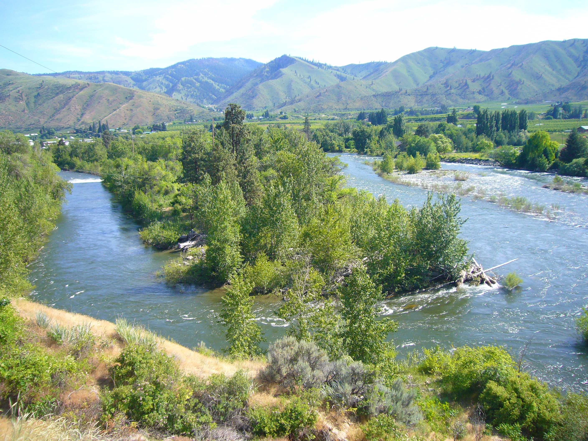

Diversion Dam to be removed in August 2013

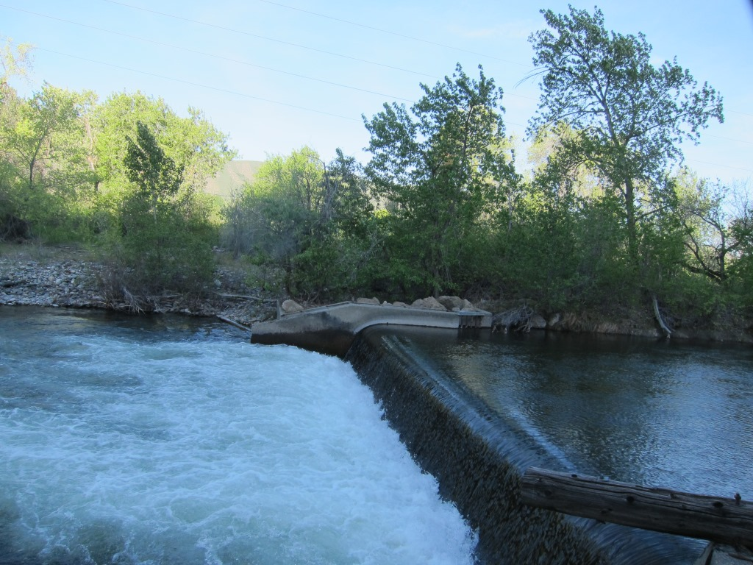

Attachment B
Sponsor Amendment Request

Attachment C
Lead Entity Support

Here’s an amendment request from Aaron P. at TU that has been recommended by RTT and CAC (see correspondence below).

Hope you had a really great vacation

Joy L. Juelson
Natural Resources Program Manager
Upper Columbia Salmon Recovery Board
Cell: 509-433-2999
Joy.Juelson@ucsrb.com
www.ucsrb.com

From: rsmithwrd@aol.com [mailto:rsmithwrd@aol.com]
Sent: Friday, June 28, 2013 8:59 AM
To: Joy Juelson
Subject: Re: Lower Wenatchee Instream Flow Proposed Project Amendment.doc

Joy,

I am in agreement as well, to support this amendment.
Rick
-----Original Message-----
From: Joy Juelson <Joy.Juelson@ucsrb.com>
To: rsmithwrd <rsmithwrd@aol.com>
Sent: Wed, Jun 26, 2013 3:45 pm
Subject: FW: FW: Lower Wenatchee Instream Flow Proposed Project Amendment.doc
Rick,

This is an amendment request form Aaron P. at TU (approx. 42K cost increase).
It is a Level 1 request so it only needs to go through you then once you weigh
in on a recommendation then on to RCO. Chuck has already reviewed it and
supports it… you can see his correspondence below.

Thank You,
Joy

Joy L. Juelson
Natural Resources Program Manager
Upper Columbia Salmon Recovery Board
Cell: 509-433-2999
Joy.Juelson@ucsrb.com<mailto:Joy.Juelson@ucsrb.com>
www.ucsrb.com<http://www.ucsrb.com/>

From: Chuck Peven [mailto:pci@nwi.net]
Sent: Monday, June 24, 2013 10:41 AM
To: Joy Juelson
Subject: Re: FW: Lower Wenatchee Instream Flow Proposed Project Amendment.doc

Looks good. I don't think u left the charger, but u can ask kathy @ 679-5599

Sent from my Verizon Wireless 4G LTE smartphone

Joy Juelson wrote:
Hi Chuck,

Let me know if this answers your questions.

J

Ps also did I forget my car charger in your car when we commuted to
presentations in Chelan?

Joy L. Juelson
Natural Resources Program Manager
Upper Columbia Salmon Recovery Board
Cell: 509-433-2999
Joy.Juelson@ucsrb.com<mailto:Joy.Juelson@ucsrb.com>
www.ucsrb.com<http://www.ucsrb.com/>

From: Aaron Penvose [mailto:APenvose@tu.org]
Sent: Monday, June 24, 2013 5:58 AM
To: Joy Juelson
Subject: RE: Lower Wenatchee Instream Flow Proposed Project Amendment.doc

We are removing the concrete with and excavator once the water in the channel
stops this august. If it doesn’t stop then we will install a gravel bag dam at
the head of the side-channel. The material will be hauled off site. All
permits are secured.

If you need more info, I will be in the office tomorrow and can write more
detail.

Thanks,

Aaron

From: Joy Juelson [mailto:Joy.Juelson@ucsrb.com]
Sent: Friday, June 21, 2013 9:33 AM
To: Aaron Penvose
Subject: Fwd: Lower Wenatchee Instream Flow Proposed Project Amendment.doc

Aaron,

Could you provide me with some further information on your amendment please?
See Chuck Peven's email below.

Thanks Joy

Begin forwarded message:
From: Peven Consulting <pci@nwi.net<mailto:pci@nwi.net>>
Date: June 21, 2013, 9:14:59 AM PDT
To: Joy Juelson <Joy.Juelson@ucsrb.com<mailto:Joy.Juelson@ucsrb.com>>
Subject: RE: Lower Wenatchee Instream Flow Proposed Project Amendment.doc
I am all for this, and I think the added request for funds is appropriate and
reasonable. My only concern would be how they are going to accomplish this.
Perhaps you could ask Aaron for a bit more information on what equipment will be
necessary and what will become of the material they are removing. Otherwise, I
recommend this project move forward with RTT approval.

