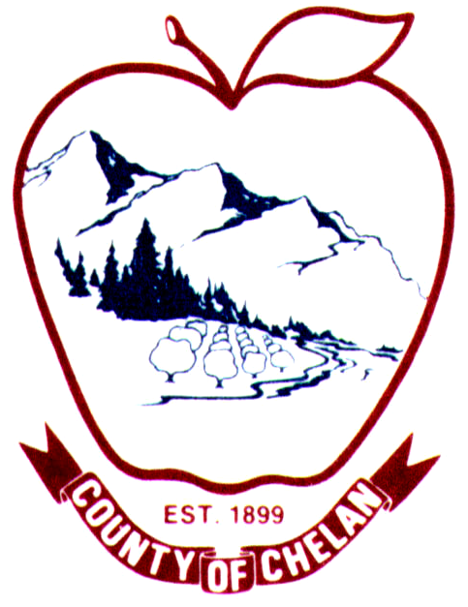Memo
To: Marc Duboiski, RCO
From: Mike Kane, CCNRD
CC: Joy Juleson, Chelan County Lead Entity Coordinator
Date: 7/30/2026
Re: Upper Chumstick Barrier Removal, RC O #11-1441R
Chelan County Natural Resources Department (CCNRD) is seeking an amendment to the Upper Chumstick Barrier Removal, RCO #11-1441R. CCNRD is requesting to increase the RCO award amount by $23,409 (original amount awarded is $332,713). CCNRD was unable to secure the original match request of $58,714 but was able to secure $35,305 from USFWS. We completed three of the four barrier replacements in 2012 and are working on design and permitting for the final replacement at the Saliby residence. Upon review of our costs incurred during construction of the three crossings completed in 2012 (Ott, Cann and Baumann), remaining spring planting at those sites and estimated budget to complete construction of the Saliby site will exceed the remaining funds we have to complete this project. The original construction cost estimate was $391,427, we were awarded $332,713 from RCO and $35,305 from USFWS for a total of $368,018, but the original cost estimate was actually very close to actual costs. We are completing geotech today at the Saliby site and based on that finding should have a 30% design soon for permit submittals and a revised cost estimate. I should be able to provide you with a new project budget based on that information within 1-2 weeks.
CCNRD has secured match from USBR for project management and design for this project which combined with the USFWS match of will exceed the 15% required.
Please let me know if you have any questions or need additional information.

