Project Partner: City of Edmonds

Partner Address: 700 Main Street Edmonds, Washington 98020

Contact Person
Mr. x Ms. Title: Parks, Recreation and Cultural Services Director
First Name: Carrie Last Name: Hite
Mailing Address: 700 Main Street, Edmonds, Washington 98020
E-Mail Address: carrie.hite@ci.edmonds.wa.us

Description of contribution to project:
The City of Edmonds will contribute in-kind match to the Willow Creek daylighting feasibility study through staff time to participate in planning meetings, assist with contractor bid process, attend meetings, provide technical advice and information through the contract period, review and comment of contractor progress reports throughout the contract period, and assist with writing progress and final reports.
City of Edmonds staff will also be the main point of contact with adjacent landowners- the Port of Edmonds and Chevron. The City has an ongoing working relationship with staff at Chevron, which will provide a means of addressing specific concerns from the WRIA 8 technical committee regarding contamination on the adjacent Chevron property. City staff will also be the main contact with DOT Ferries Division to being addressing concerns regarding future use of the adjacent Chevron site.

Estimated value to be contributed: $45,400
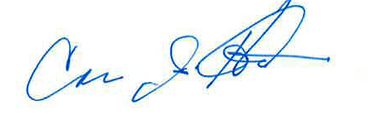
Partner’s signature: Carrie Hite Date: August 22, 2011

